**KESHAV MEMORIAL INSTITUTE OF TECHNOLOGY**

**(AN AUTONOMOUS INSTITUTION)**

### Accredited by NBA & NAAC, Approved by AICTE, Affiliated to JNTUH,

### Narayanguda, Hyderabad – 500029



**DEPARTMENT OF COMPUTER SCIENCE AND ENGINEERING**

**LAB RECORD**

**SOFTWARE ENGINEERING LAB**

**B.Tech. III YEAR I SEM (RKR21)**

**ACADEMIC YEAR 2024-25**

KESHAV MEMORIAL INSTITUTE OF TECHNOLOGY

(AN AUTONOMOUS INSTITUTE)

Accredited by NBA & NAAC, Approved by AICTE, Affiliated to JNTUH, Hyderabad

**Certificate**

This is to certify that following is a Bonafide Record of the workbook task done by ____________________________bearing Roll No________________ of ______________ Branch of ___________ year B.Tech Course in the__________________________________ Subject during the Academic year ____________ & __________ under our supervision.

Number of week tasks completed: ___________________________________________

Signature of Staff Member Incharge Signature of Head of the Dept.

Signature of Internal Examiner Signature of External Examiner

  KESHAV MEMORIAL INSTITUTE OF TECHNOLOGY

(AN AUTONOMOUS INSTITUTE)

Accredited by NBA & NAAC, Approved by AICTE, Affiliated to JNTUH, Hyderabad

**Daily Laboratory Assessment Sheet**

Name of the Lab: Name of the Student:

Class: HT. No:

|  |  |  |  |  |  |  |  |
| --- | --- | --- | --- | --- | --- | --- | --- |
| **S.No.** | **Name of the Experiment** | **Date** | **Observation Marks (3M)** | **Record Marks (4M)** | **Viva Voice Marks (3M)** | **Total Marks (10M)** | **Signature of Faculty** |
|  |  |  |  |  |  |  |  |
|  |  |  |  |  |  |  |  |
|  |  |  |  |  |  |  |  |
|  |  |  |  |  |  |  |  |
|  |  |  |  |  |  |  |  |
|  |  |  |  |  |  |  |  |
|  |  |  |  |  |  |  |  |
|  |  |  |  |  |  |  |  |
|  |  |  |  |  |  |  |  |
|  |  |  |  |  |  |  |  |
|  |  |  |  |  |  |  |  |
|  |  |  |  |  |  |  |  |
|  |  |  |  |  |  |  |  |
|  |  |  |  |  |  |  |  |
|  |  |  |  |  |  |  |  |
|  |  |  |  |  |  |  |  |
| **S.No.** | **Name of the Experiment** | **Date** | **Observation Marks (3M)** | **Record Marks (4M)** | **Viva Voice Marks (3M)** | **Total Marks (10M)** | **Signature of Faculty** |
|  |  |  |  |  |  |  |  |
|  |  |  |  |  |  |  |  |
|  |  |  |  |  |  |  |  |
|  |  |  |  |  |  |  |  |
|  |  |  |  |  |  |  |  |
|  | **TOTAL** |  |  |  |  |  |  |

**INDEX**

|  |  |  |
| --- | --- | --- |
| **S.NO** | **CONTENTS** | **PAGE NO** |
| I | Vision/Mission /PEOs/POs/PSOs |  |
| II | Syllabus |  |
| III | Course outcomes, C0-PO Mapping |  |
| **Exp No:** | **List of Experiments** |  |
| 1 | INSTALLATION OF STARUML, GIT BASH AND GITHUB ACCOUNT CREATION |  |
| 2 | 1. IEEE – SRS (SOFTWARE REQUIREMENTS SPECIFICATION) WITH UML DIAGRAMS |  |
| 3 | 1. INSTALLATION OF ECLIPSE, MAVEN, JDK, TOMCAT, CONFIGURING TOMCAT TO ECLIPSE |  |
| 4 | 1. A. BASIC GIT COMMANDS - VERSION, CONFIG, INIT, STATUS, ADD, COMMIT, DIFF, HELP 2. B. GIT COMMANDS: WORKING WITH LOCAL AND REMOTE REPOSITORIES - BRANCHES, CHECKOUT, MERGE, REVERT, LOG 3. C. GIT COMMANDS: WORKING WITH REMOTE REPOSITORIES - REMOTE, CLONE, PULL, PUSH, FORK |  |
| 5 | 1. A. CREATING MAVEN JAVA PROJECT USING ECLIPSE AND PUSH INTO TO GITHUB. 2. B. CREATING MAVEN WEB PROJECT USING ECLIPSE AND PUSH INTO TO GITHUB. 3. C. INSTALLATION OF JENKINS. |  |
| 6 | 1. BUILDING THE CI/CD FREESTYLE PIPELINE USING JENKINS FOR MAVEN JAVA PROJECT 2. BUILDING THE CI/CD FREESTYLE PIPELINE USING JENKINS FOR MAVEN WEB PROJECT WITH POLL SCM 3. BUILDING THE CI/CD SCRIPTED PIPELINE USING JENKINS FOR MAVEN JAVA PROJECT WITH POLL SCM |  |
| 7 | 1. A. INSTALLATION OF DOCKER, MINIKUBE, ACCOUNT IN DOCKERHUB 2. B. DOCKER CLI COMMANDS 3. C. MODIFYAND PUSH DOCKER IMAGE 4. D. CREATE AND PUSH DOCKER FILE IMAGE 5. E. RUNNING MULTIPLE CONTAINERS USING DOCKER COMPOSE 6. F. DEPLOYING AND SCALING APPLICATIONS USING MINIKUBE 7. G. DEPLOYING AND MANAGING MONITORING SYSTEMS USING NAGIOS IN DOCKER |  |
| **Exp No:** | **List of Experiments** | **PAGE NO** |
| 8 | 1. A. AWS ACADEMY LEARNING ACCOUNT CREATION 2. B. PROJECT DEPLOYMENT IN THE AWS CLOUD USING EC2 INSTANCE 3. C. MAVEN WEB PROJECT DEPLOYMENT IN THE AWS CLOUD USING EC2 INSTANCE |  |

**KESHAV MEMORIAL INSTITUTE OF TECHNOLOGY**

**(AN AUTONOMOUS INSTITUTE)**

**Accredited by NBA & NAAC, Approved by AICTE, Affiliated to JNTUH,**

**Narayanguda, Hyderabad – 500029**

**Department of Computer Science & Engineering**

**Vision of the Institution:**

To be the fountain head of latest technologies, producing highly skilled, globally competent engineers.

### Mission of the Institution:

* To provide a learning environment that inculcates problem solving skills, professional, ethical responsibilities, lifelong learning through multi modal platforms and prepare students to become successful professionals.
* To establish Industry Institute Interaction to make students ready for the industry.
* To provide exposure to students on latest hardware and software tools.
* To promote research-based projects/activities in the emerging areas of technology convergence.
* To encourage and enable students to not merely seek jobs from the industry but also to create new enterprises
* To induce a spirit of nationalism which will enable the student to develop, understand India’s challenges and to encourage them to develop effective solutions.
* To support the faculty to accelerate their learning curve to deliver excellent service to students

# KESHAV MEMORIAL INSTITUTE OF TECHNOLOGY

## (AN AUTONOMOUS INSTITUTE)

### Accredited by NBA & NAAC, Approved by AICTE, Affiliated to JNTUH,

### Narayanguda, Hyderabad – 500029

**Department of Computer Science & Engineering**

**Vision of the Department**:

To be among the region's premier teaching and research Computer Science and Engineering departments producing globally competent and socially responsible graduates in the most conducive academic environment.

### Mission of the Department:

* + To provide faculty with state-of-the-art facilities for continuous professional development and research, both in foundational aspects and of relevance to emerging computing trends.
  + To impart skills that transform students to develop technical solutions for societal needs and inculcate entrepreneurial talents.
  + To inculcate an ability in students to pursue the advancement of knowledge in various specializations of Computer Science and Engineering and make them industry-ready.
  + To engage in collaborative research with academia and industry and generate adequate resources for research activities for seamless transfer of knowledge resulting in sponsored projects and consultancy.
  + To cultivate responsibility through sharing of knowledge and innovative computing solutions that benefits the society-at-large.
  + To collaborate with academia, industry and community to set high standards in academic excellence and in fulfilling societal responsibilities.

# KESHAV MEMORIAL INSTITUTE OF TECHNOLOGY

## (AN AUTONOMOUS INSTITUTE)

### Accredited by NBA & NAAC, Approved by AICTE, Affiliated to JNTUH,

### Narayanguda, Hyderabad – 500029

**Department of Computer Science & Engineering**

**PROGRAM OUTCOMES (POs)**

**PO1: Engineering Knowledge**: Apply the knowledge of mathematics, science, engineering fundamentals, and an engineering specialization to the solution of complex engineering problems.

**PO2: Problem Analysis**: Identify, formulate, review research literature, and analyze complex engineering problems reaching substantiated conclusions using first principles of mathematics, natural sciences, and engineering sciences.

**PO3: Design/Development of Solutions**: Design solutions for complex engineering problems and design system components or processes that meet the specified needs with appropriate consideration for the public health and safety, and the cultural, societal, and environmental considerations.

**PO4: Conduct Investigations of Complex Problems**: Use research-based knowledge and research methods including design of experiments, analysis and interpretation of data, and synthesis of the information to provide valid conclusions.

**PO5: Modern Tool Usage**: Create, select, and apply appropriate techniques, resources, and modern engineering and IT tools including prediction and modelling to complex engineering activities with an understanding of the limitations.

**PO6: The Engineer and Society**: Apply reasoning informed by the contextual knowledge to assess societal, health, safety, legal and cultural issues and the consequent responsibilities relevant to the professional engineering practice.

**PO7: Environment and Sustainability**: Understand the impact of the professional engineering solutions in societal and environmental contexts, and demonstrate the knowledge of, and need for sustainable development.

**PO8: Ethics**: Apply ethical principles and commit to professional ethics and responsibilities and norms of the engineering practice.

**PO9: Individual and Team Work**: Function effectively as an individual, and as a member or leader in diverse teams, and in multidisciplinary settings.

**PO10: Communication**: Communicate effectively on complex engineering activities with the engineering community and with society at large, such as, being able to comprehend and write effective reports and design documentation, make effective presentations, and give and receive clear instructions.

**PO11: Project Management and Finance**: Demonstrate knowledge and understanding of the engineering and management principles and apply these to one’s own work, as a member and leader in a team, to manage projects and in multidisciplinary environments.

**PO12: Life-long Learning**: Recognize the need for, and have the preparation and ability to engage in independent and life-long learning in the broadest context of technological change.

# KESHAV MEMORIAL INSTITUTE OF TECHNOLOGY

## (AN AUTONOMOUS INSTITUTE)

### Accredited by NBA & NAAC, Approved by AICTE, Affiliated to JNTUH,

### Narayanguda, Hyderabad – 500029

**Department of Computer Science & Engineering**

**PROGRAM SPECIFIC OUTCOMES (PSOs)**

**PSO1**: An ability to analyze the common business functions to design and develop appropriate Computer Science solutions for social upliftment.

**PSO2**: Shall have expertise on the evolving technologies like Python, Machine Learning, Deep Learning, Internet of Things (IOT), Data Science, Full stack development, Social Networks, Cyber Security, Big Data, Mobile Apps, CRM, ERP etc.

# KESHAV MEMORIAL INSTITUTE OF TECHNOLOGY

## (AN AUTONOMOUS INSTITUTE)

### Accredited by NBA & NAAC, Approved by AICTE, Affiliated to JNTUH,

### Narayanguda, Hyderabad – 500029

**Department of Computer Science & Engineering**

**PROGRAM EDUCATIONAL OBJECTIVES (PEOs)**

**PEO1:** Graduates will endeavor to excel in their chosen careers as professionals, researchers and entrepreneurs on a global platform.

**PEO2:** Graduates will demonstrate the ability to solve challenges in the fields of Engineering and Technology simultaneously catering to societal needs.

**PEO3:** Graduates will strive to improve their learning curve by practicing Continuing Professional Development (CPD).

**PEO4:** Graduates will, at all times, adopt a professional demeanor by communicating effectively, working collaboratively, and maintaining the ethics & core values as befitting their education in interdisciplinary and emerging fields.

**KESHAV MEMORIAL INSTITUTE OF TECHNOLOGY**

(AN AUTONOMOUS INSTITUTE)

Accredited by NBA & NAAC, Approved by AICTE, Affiliated to JNTUH, Hyderabad

**B. Tech. in COMPUTER SCIENCE AND ENGINEERING**

**III Year I Semester Syllabus (RKR21) SOFTWARE ENGINEERING LAB (21CC505PC)**

**Common to CSE, IT, CSE (AI&ML) and CSE (DS)**

**Pre-requisites/ Co-requisites:**

1. 21CC502PC – Software Engineering Course
2. 21CS401PC- Java Programming Course

**Course Objectives: The course will help to**

**L T P C**

**0 0 3 1.5**

1. Formulate problem statements and Software Requirement Specifications by comprehensively grasping project requirements.
2. Demonstrate proficiency in designing, developing, and testing diverse project modules.
3. Utilize Git Framework and GitHub while implementing Continuous Integration/Continuous Deployment (CI/CD) pipelines through Jenkins.
4. Implement project deployment using Docker and Kubernetes.
5. Acquire knowledge in AWS cloud infrastructure.

**Course Outcomes: After learning the concepts of this course, the student is able to**

1. Transform end-user needs into system and software requirements through a structured process.
2. Depict the system's high-level design using CASE tools based on the software requirements.
3. Employ Jenkins CI/CD for project building purposes.
4. Implement project deployment utilizing Docker and Kubernetes.
5. Create a project within the AWS Cloud environment.

**Software to be used:** The students must use JDK 11/17/21 Version, STAR UML, GIT Bash, Jenkins, Dockers Desktop, Mini KUBE, Eclipse, Tomcat, and Visual Studio Editor.

**List of Experiments:**

Do the following exercises for any one project given in the list of sample projects or any other projects?

1. Development of problem statement.
2. Preparation of Software Requirement Specification Document, Design Documents and Testing Phase related documents.
3. Study and usage of any Design phase CASE tool
4. Creating the project and committing using Git and GitHub
5. Creating Maven Java and Maven Web project using Eclipse and Push them to GitHub.
6. Building the CI/CD pipeline using Jenkins for the project in the previous experiment.
7. Local Deployment of project using Docker, Kubernetes and Monitoring using Nagios tool.
8. Cloud Deployment of a project in the AWS Cloud using EC2 instance.

**Sample Projects:**

1. Book Bank
2. Online course reservation system
3. E-ticketing
4. Recruitment system
5. Hospital Management system
6. Online Banking System

**TEXT BOOKS:**

1. Software Engineering, A practitioner’s Approach- Roger S. Pressman, 6th edition, Mc Graw Hill International Edition, 2015.
2. Software Engineering- Sommerville, 7th edition, Pearson Education, 2017.
3. The unified modeling language user guide Grady Brooch, James Rumbaugh, Ivar Jacobson, Pearson Education, 2016.
4. The DevOps Handbook: How to Create World-Class Agility, Reliability, and Security in Technology Organizations, 2015.

**REFERENCE BOOKS:**

1. https://kubernetes.io/docs/tutorials/hello-minikube/
2. https://minikube.sigs.k8s.io/docs/start/
3. https://[www.jenkins.io/doc/](http://www.jenkins.io/doc/)
4. https://docs.aws.amazon.com/AWSEC2/latest/UserGuide/concepts.html
5. Introducing Maven by, Balaji Varanasi and Sudha Belida, APRESS publications.

# KESHAV MEMORIAL INSTITUTE OF TECHNOLOGY

## (AN AUTONOMOUS INSTITUTE)

### Accredited by NBA & NAAC, Approved by AICTE, Affiliated to JNTUH,

### Narayanguda, Hyderabad – 500029

**Department of Computer Science & Engineering**

**Course Outcomes and CO-PO-PSO Mapping**

**Course Outcomes:**

After learning the contents of this course, the student is able to

|  |  |
| --- | --- |
| **CO1** | Transform end-user needs into system and software requirements through a structured process. |
| **CO2** | Depict the system's high-level design using CASE tools based on the software requirements. |
| **CO3** | Employ Jenkins CI/CD for project building purposes. |
| **CO4** | Implement project deployment utilizing Docker and Kubernetes. |
| **CO5** | Create a project within the AWS Cloud environment. |

## CO-PO-PSO MAPPING:

|  |  |  |  |  |  |  |  |  |  |  |  |  |  |  |  |
| --- | --- | --- | --- | --- | --- | --- | --- | --- | --- | --- | --- | --- | --- | --- | --- |
|  | **CO** | **PO1** | **PO2** | **PO3** | **PO4** | **PO5** | **PO6** | **PO7** | **PO8** | **PO9** | **PO10** | **PO11** | **PO12** | **PSO-1** | **PSO-2** |
| **Software Engineering Lab** | **CO1** | 3 | 3 | 3 | 2 |  |  |  |  |  | 2 |  |  | 2 | 1 |
| **CO2** | 2 | 3 | 3 | 3 | 3 |  |  |  |  | 2 |  |  | 2 | 1 |
| **CO3** |  |  |  |  | 3 |  |  |  | 2 | 2 | 2 |  | 1 | 2 |
| **CO4** |  |  |  | 3 | 3 | 2 | 2 |  | 2 | 2 | 2 | 2 | 2 | 3 |
| **CO5** | 3 |  |  |  | 3 | 2 | 2 |  |  |  | 3 | 3 | 3 | 3 |

### Experiment 1: Installation of STARUML, GIT BASH AND GITHUB ACCOUNT CREATION

1.STAR UML

**Step:-1**

I have downloaded and installed star UML from <https://staruml.io/>

**Step:-2**

Click on download for windows button based on your system architecture

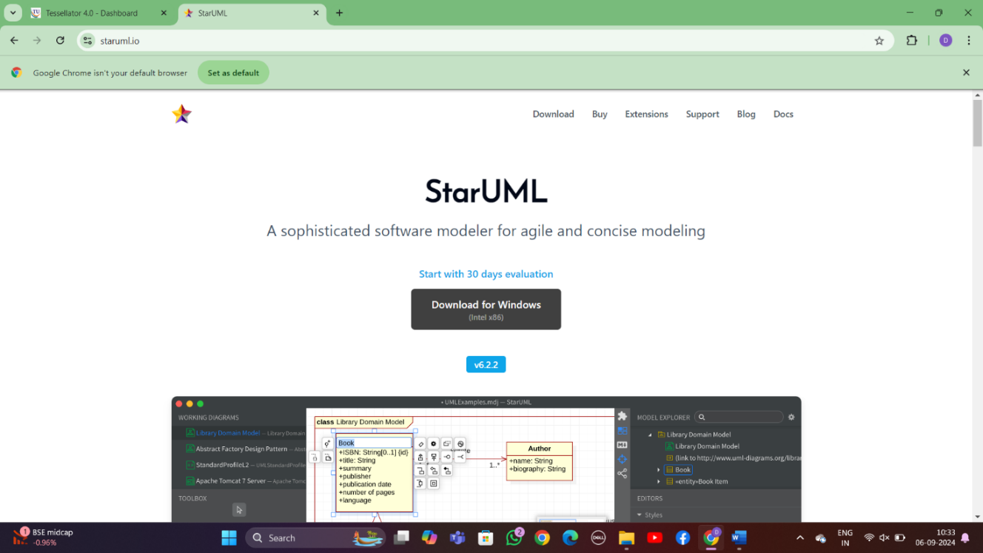

**Step:-3**

Install the downloaded star UML software

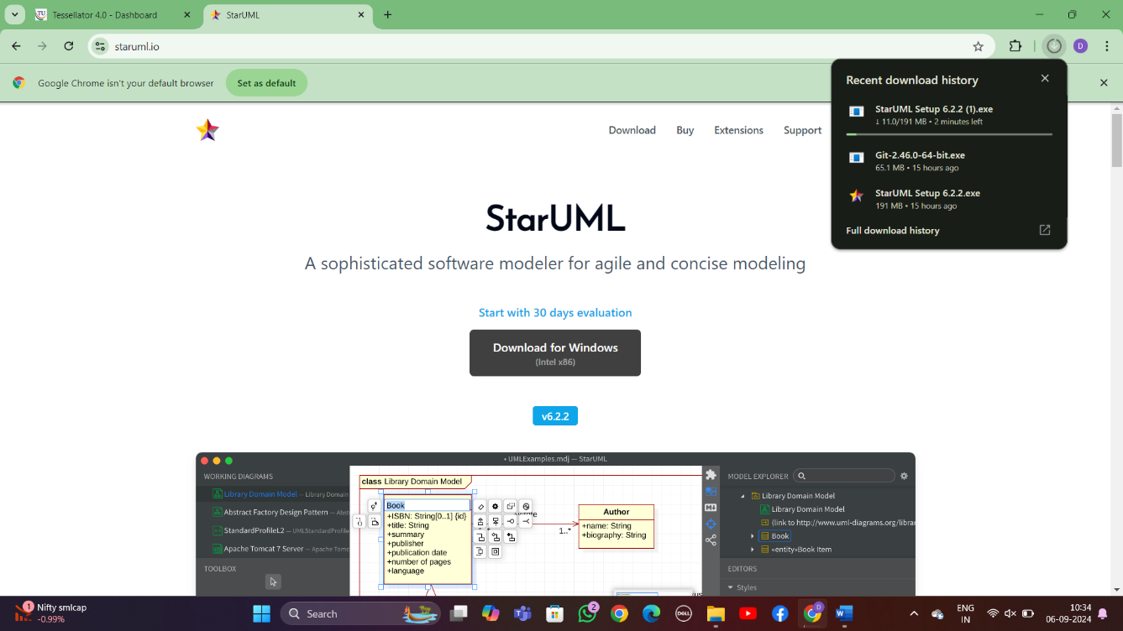

**Step:-4**

Explore with tool bar option

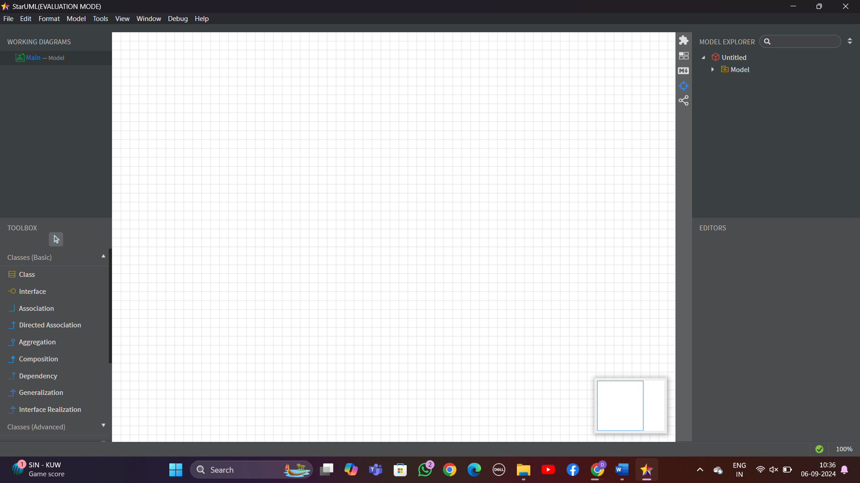

**2.INSTALLATION OF GIT – SCM**

**Step:-1**

Download and install Git from the <https://git-scm.com/>

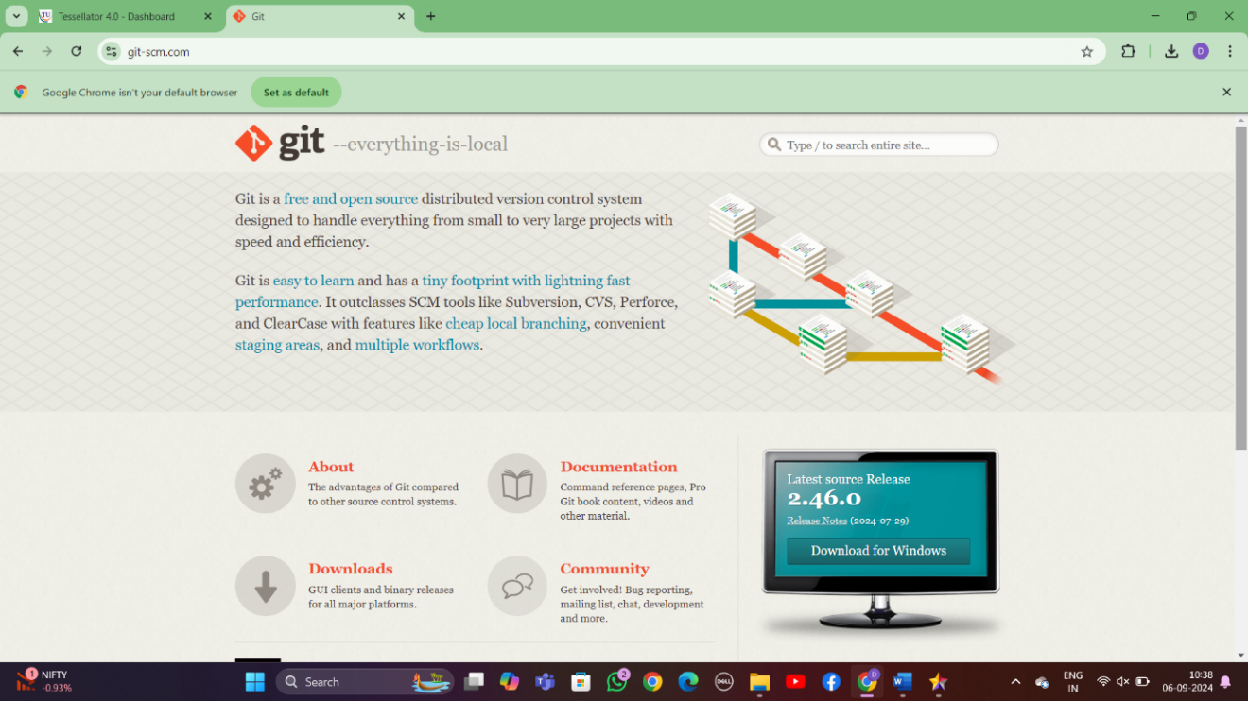

**Step:-2**

Select the Git software for the required OS

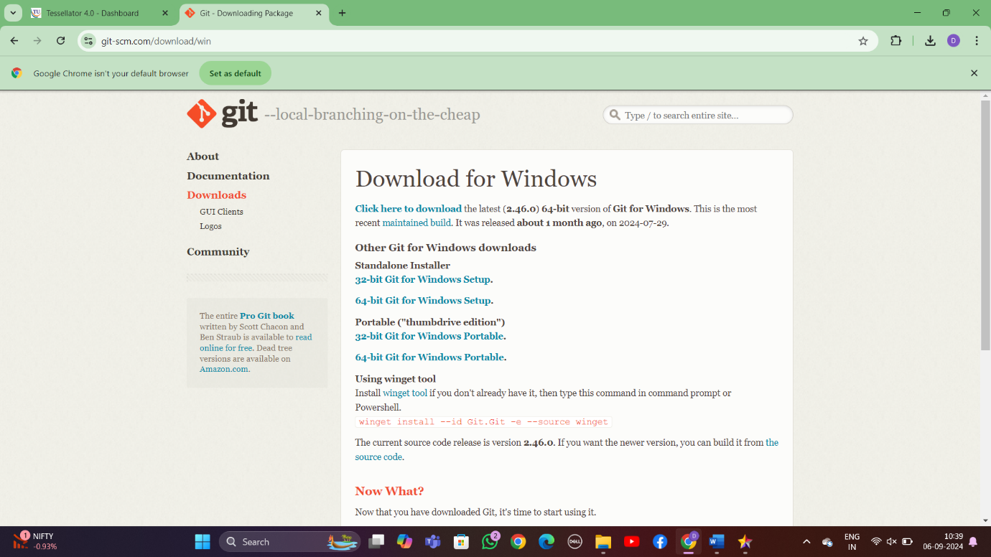

**Step:-3**

Install the downloaded Git software

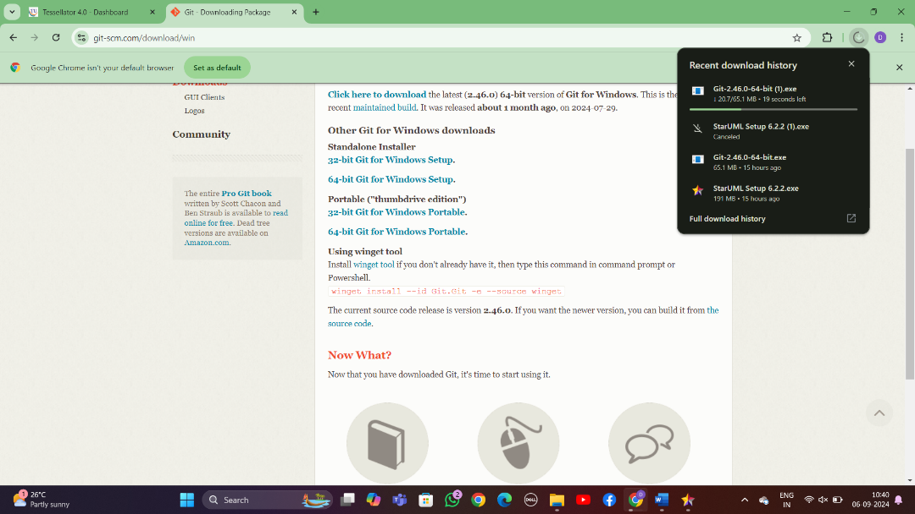

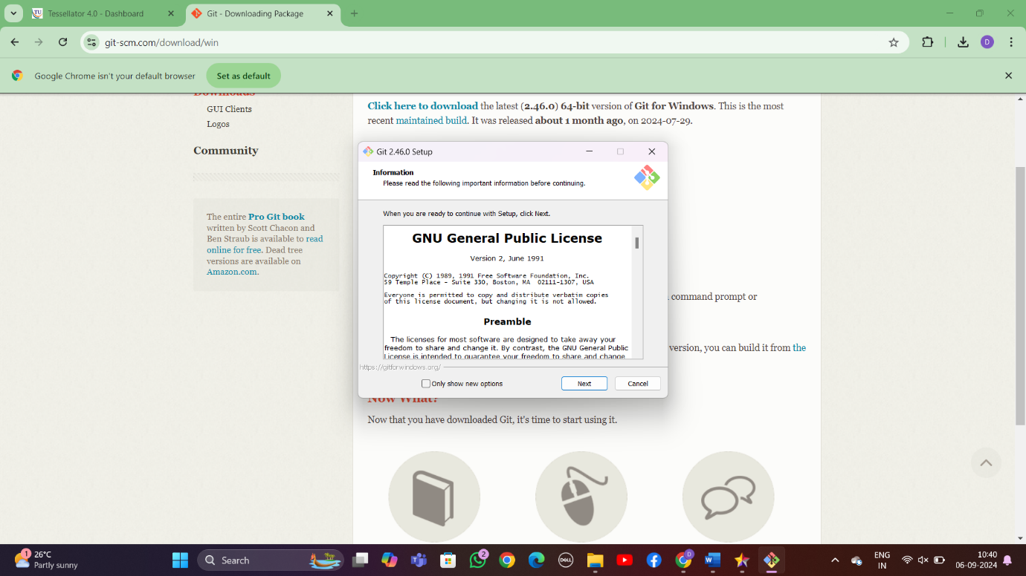

**Step:-4**

While installing select the option Use Git from Git Bash only option and click Next.

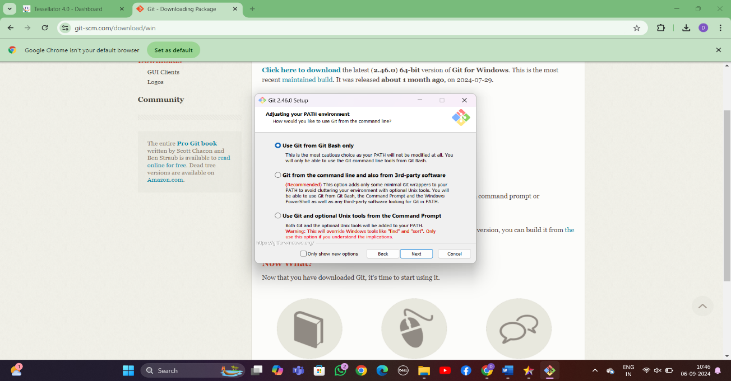

**Step 5 :-** You will now find the Git Bash after successful installation

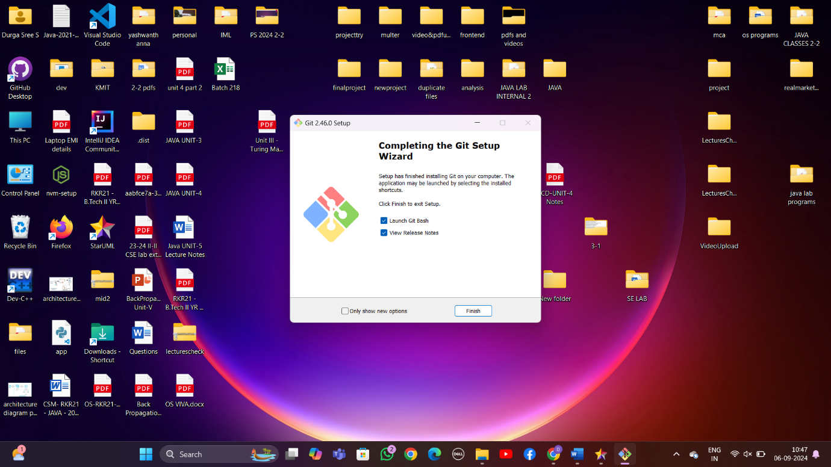

**3. CREATION OF GIT-HUB ACCOUNT**

**Step:-1** Browse the website https://github.com and click on Signup

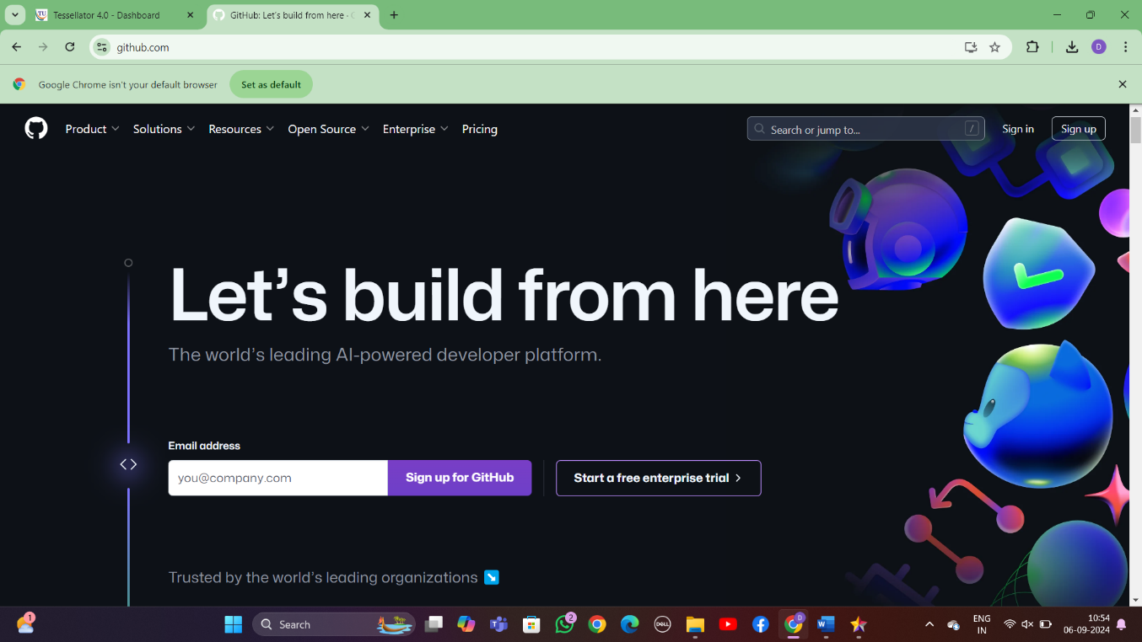

Step:-2

Enter your email address with which you want to access git hub and also create a   
password for the same, select Notifications received through email—’y

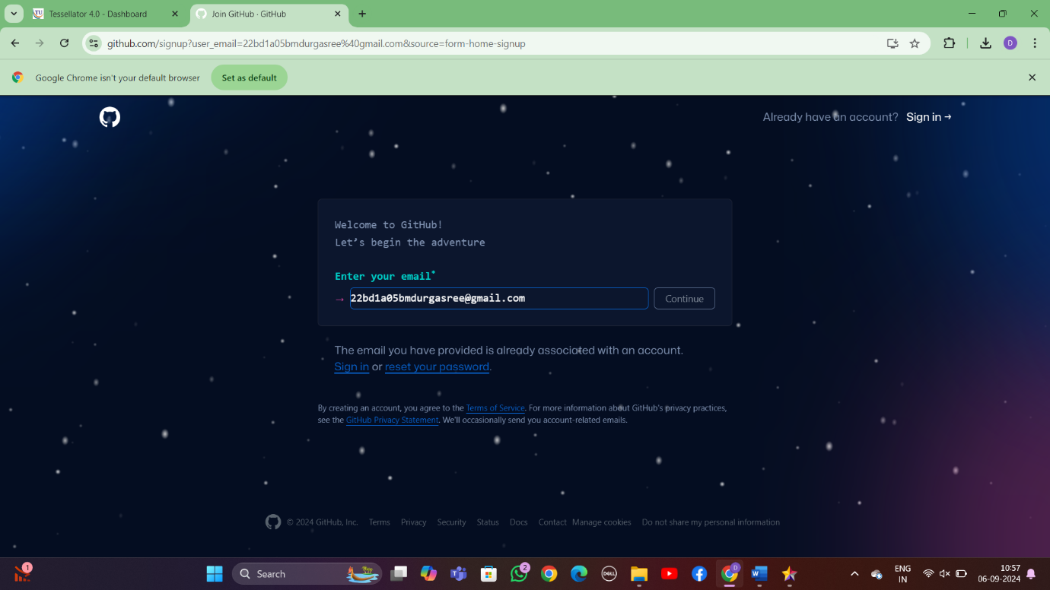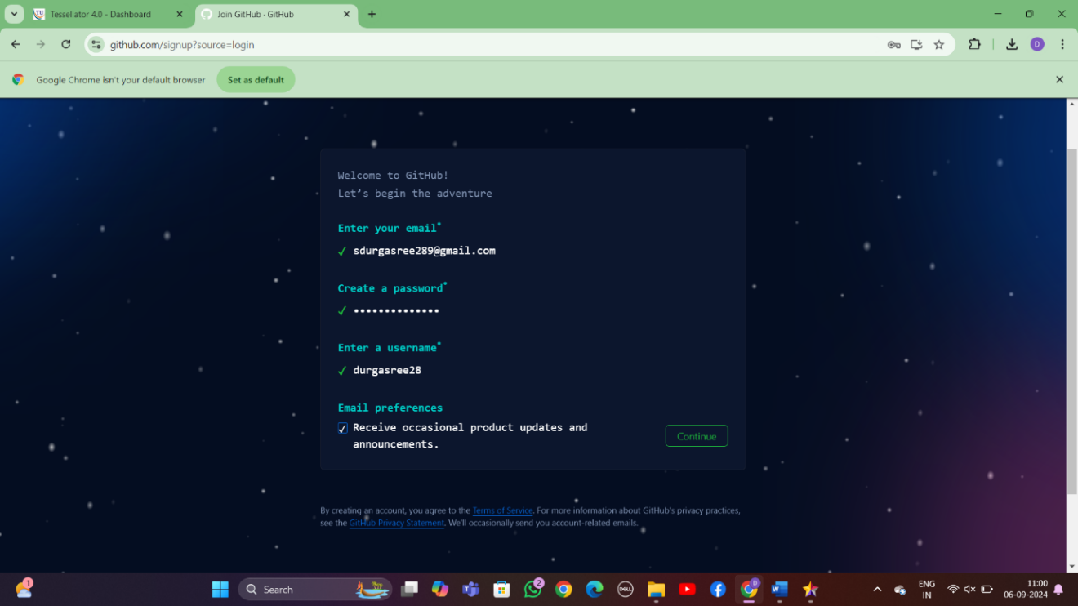

**Step:-3** Complete the verification process by selecting the spiral galaxy in the given set of images

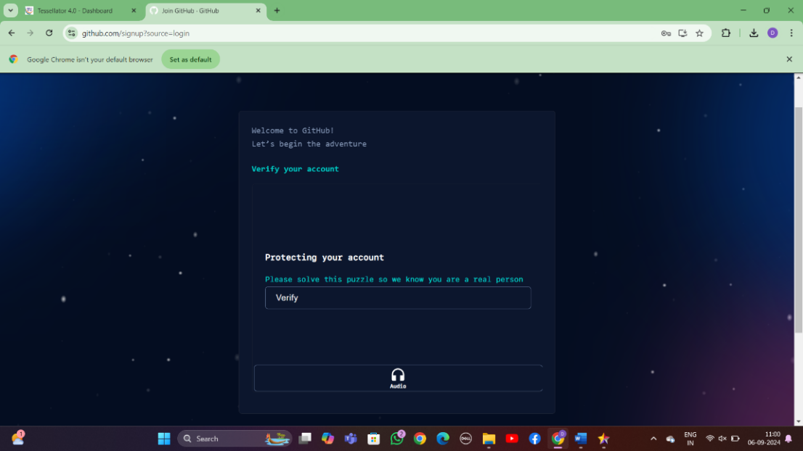

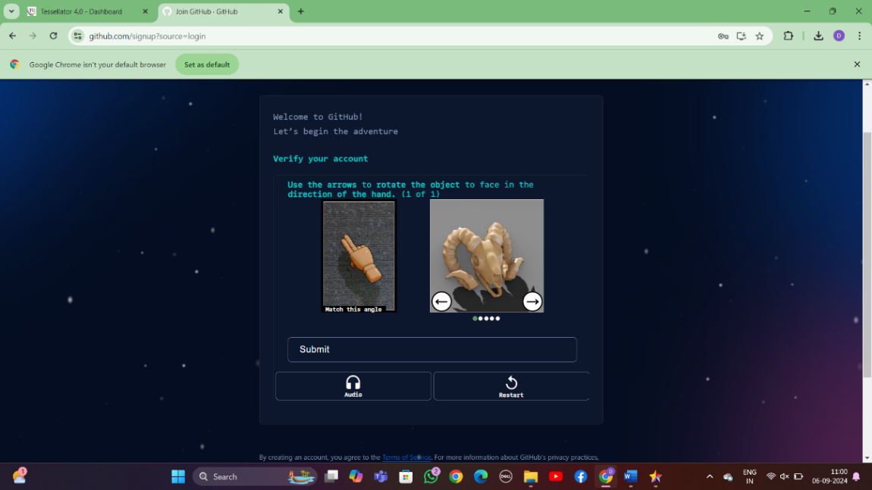

**Step:-4**

Skip personalization and your account is ready

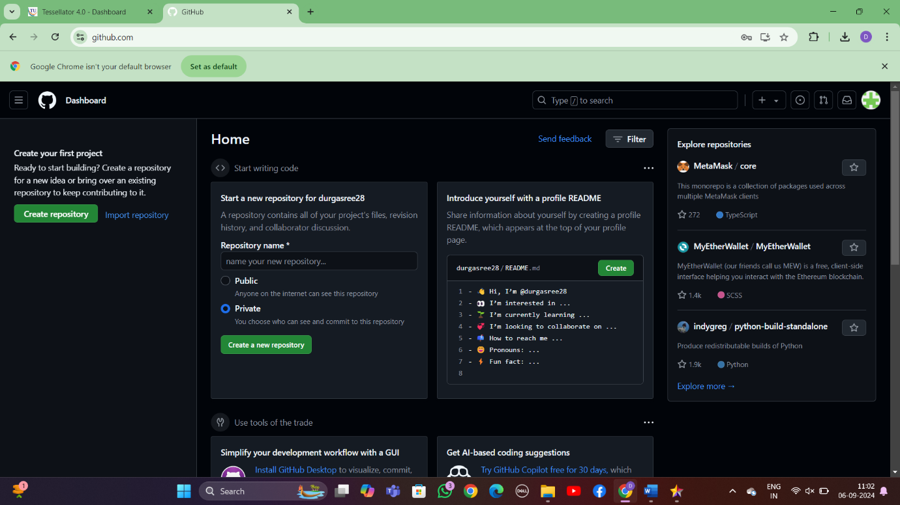

### Experiment 2: IEEE – SRS (SOFTWARE REQUIREMENTS SPECIFICATION) WITH UML DIAGRAMS

Recruitment System

1. Pragathi Vanamala - 22BD1A05BT

2. Anuna Urabai - 22BD1A05BR

3. Bhavya Vankudoth - 22BD1A05BU

4. Shankari Durga Sree - 22BD1A05BM

5. Shree Keerthi - 22BD1A05BN

**Problem Statement:**

Recruitment systems must enable users to easily find relevant job opportunities. Candidates expect a quick, intuitive search process with filters like job title, skills, location, and salary. However, challenges arise with maintaining accurate job categorization and ensuring that search results display relevant positions.

Additionally, job listings must be updated in real-time, so new roles are added immediately and closed positions are removed promptly. Ensuring data security and privacy for both recruiters and applicants is also critical. The system must be responsive, easy to navigate, and capable of handling data from various databases.

**Software Requirement Specification**

For Recruitment System

Version 1.0 approved

Prepared by:

1. Pragathi Vanamala - 22BD1A05BT

2. Anuna Urabai - 22BD1A05BR

3. Bhavya Vankudoth - 22BD1A05BU

4. Shankari Durga Sree - 22BD1A05BM

5. Shree Keerthi - 22BD1A05BN

**Keshav Memorial Institute of Technology**

**21-09-2024**.

**Table of Contents**

**1.Introduction**

1.1 Purpose ..................................................................... 1

1.2 Document Conventions ..................................................................... 1

1.3 Intended Audience and Reading Suggestions .................................................................... 2

1.4 Product Scope ..................................................................... 2

1.5 References ..................................................................... 3

**2.Overall Description**

2.1 Product Perspective ................................................................... 3

2.2 Product Functions .................................................................... 4

2.3 Operating Environment .................................................................... 4

2.4 User Characteristics .....................................................................4

2.5 Design and Implementation Constraints ..................................................................... 5

2.6 User Documentation ..................................................................... 5

2.7 Assumptions and Dependencies ..................................................................... 5

## 3.Specific Requirements

## 3.1 Functional Requirements ………………………………………………… 6

## 3.2 Non-Functional Requirements …………………………………………………10

**Revision History**

| **Name** | **Date** | **Reason for changes** | **Version** |
| --- | --- | --- | --- |
| Week-1 | 22-09-2024 | SRS creation | 1.0 |
| Week-2 |  | SDLC,UML,Use-Case Diagram and Template | 2.0 |
| Week-3 |  | Class diagram | 3.0 |

**1. Introduction**

**1.1 Purpose:**

This document is the Software Requirements Specification (SRS) for our Recruitment System. The primary goal of this project is to simplify and streamline the recruitment process by providing an online platform where recruiters can post jobs, and candidates can apply for positions. This system will facilitate interactions between job seekers and employers, making it easier for companies to find suitable candidates and for candidates to explore relevant job opportunities.

**1.2 Document Convention:**

* **Heading:**
  + Font-Size: 16
  + Font-Style: Bold
  + Font: Times New Roman
* **Subheading:**
  + Font-Size: 14
  + Font-Style: Bold
  + Font: Times New Roman
* **Content:**
  + Font-Size: 12
  + Font: Times New Roman

**1.3 Intended Audience and Reading Suggestions:**

This document serves as a prototype for the Recruitment System. It is valuable for various stakeholders:

* Developers: To design and implement the system based on these specifications.
* Managers: To monitor time, budget, and resources efficiently.
* Recruiters: To understand how to post job listings and manage applications.
* Candidates: To get an overview of how the system will help in job searches and applications.
* Testers: To verify the system’s functionalities and non-functional requirements. This document provides comprehensive details to aid in development, testing, and future system improvements.

**1.4 Product Scope:**

Our recruitment platform is similar to other job portals but incorporates new advancements for a smoother experience. The system will be available 24/7, with monthly maintenance. The primary goal is to facilitate recruitment processes for both candidates and recruiters. Key features include:

* A user-friendly interface that simplifies the job search and application process.
* Tools for recruiters to post jobs, filter candidates, and manage interviews.
* Secure storage and management of user and application data.
* An advanced search engine to quickly match candidates with relevant jobs. The system will ensure data security, and regular user surveys will help improve the platform. Feedback from users (recruiters and candidates) will be encouraged to continually refine the system.

**1.5 References:**

We have drawn inspiration from various job portals and recruitment systems such as LinkedIn, Indeed, Glassdoor, Monster, and Workday. Additional references include:

* <http://users.csc.calpoly.edu/~csturner/courses/308w09/Ch9_DocReqts.pdf>
* <https://www.academia.edu/8831452/Software_Requirements_Specification_for_FSoft_D>

**2.** **Overall Description**

**2.1 Product Perspective**

Our project is designed as an advanced **Recruitment System**, similar to popular job portals but with additional improvements. It will offer functionalities for recruiters to post jobs, candidates to apply for jobs, and administrators to manage job listings and oversee recruitment processes. It is a mobile-friendly platform that supports customizable themes. This system introduces innovations such as an advanced search engine for efficient job searching, enhanced data security to protect personal information, and an interactive user interface for ease of use by both candidates and recruiters.

**2.2 Product Functions**

**2.2.1 Administrator**

* Admins should be able to insert, modify, and delete job listings.
* Can accept or reject candidate and recruiter profiles according to company policies.
* Manage and organize job categories based on industry and role.
* Send notifications about new job openings, deadlines, and application statuses to both candidates and recruiters.
* Can track applications, interview schedules, and the progress of recruitment processes.

**2.2.2 Recruiters**

* Recruiters will receive notifications about the latest applications.
* Able to post job openings, update job descriptions, and filter applications based on qualifications.
* Have the ability to schedule interviews, communicate with shortlisted candidates, and update their application status.
* Recruiters can provide feedback to the administrator on platform functionalities and suggest improvements.

**2.2.3 Candidates**

* Candidates can create profiles, upload resumes, and submit applications for open positions.
* They can track the status of their applications, such as interview schedules or hiring decisions.
* Ability to edit personal details and view job postings, sorted by category or filtered by preferred criteria like role, industry, or location.
* Candidates can review the recruitment process and provide feedback on their experience.

**2.3 Operating Environment**

* The recruitment system will be compatible with all major web browsers, such as Chrome, Firefox, Safari, and Microsoft Edge. For this model, we focus on Internet Explorer versions 7.0, 8.0, and 9.0.
* It can be accessed via Windows (XP, 7, 8, 10), Mac OS, and Linux, and it is also optimized for mobile operating systems such as iOS and Android.
* The system can run smoothly on devices with at least a Pentium 4 processor or higher and with a minimum of 1GB RAM.

**2.4 User Characteristics**

The users of the recruitment system include administrators, recruiters, hiring managers, and candidates. All users are expected to have basic computer literacy, including internet browsing skills.

* **Administrators** will manage the recruitment processes and have knowledge of the internal modules.
* **Recruiters** will post job openings, review applications, and manage interviews. They should be familiar with hiring workflows and company recruitment policies.
* **Candidates** are expected to have basic knowledge of online job application systems and be capable of navigating the website or mobile app.

**2.5 Design and Implementation Constraints**

* The system must be accessible on devices with a stable internet connection and a web browser.
* All user data, including applications, job listings, and activity logs, will be stored in a centralized database that the website can access.
* The website will be available 24/7 to allow for round-the-clock access by global users.
* The platform should be highly secure, requiring valid usernames and passwords for accessing candidate, recruiter, and administrator accounts.

**2.6 Assumptions and Dependencies**

The success of the recruitment system depends on the following third-party tools and technologies:

* **Microsoft SQL Server** for storing the recruitment database.
* **ASP.NET** for developing the backend.
* **JSON** will be used for exchanging data between the front-end and the database.

**Key assumptions include:**

* Availability of stable internet access for all users.
* All users, including administrators, recruiters, and candidates, are comfortable with basic computer and internet usage.
* The system should be user-friendly, providing clear and simple navigation options for all types of users.
* The search mechanism must be fast, secure, and able to handle large volumes of job listings and applications efficiently.

**3. Specific Requirements**

**3.1 Functional Requirements**

These requirements include the development of search tools, sorting, filtering, navigation, as well as the visual components of the site which can be maintained by the administrator.

**3.1.1 Administrator:**

Requirement ID : RS.01.01

Title : Candidate Database Management

Description : The administrator should control the entire database, tracking all candidate records including resumes, applications, and interview results. Any issues with accessing or updating candidate information should be resolved promptly.

Priority : 2

Requirement ID : RS.01.02

Title : Posting Job Openings

Description : The administrator is responsible for posting job openings, including job descriptions, qualifications, and deadlines. They can also update or remove job listings as needed.

Priority : 1

Requirement ID : RS.01.03

Title : Managing Recruiters and Permissions

Description : Admin must provide permissions to recruiters, allowing them to post job openings, manage candidate applications, and perform other recruiting-related tasks.

Priority : 2

Requirement ID : RS.01.04

Title : Viewing Recruitment Analytics

Description : Administrators should be able to view all statistics and reports, including hiring rates, job post performance, and recruiter efficiency.

Priority : 3

**3.1.2 Recruiters:**

Requirement ID : RS.02.01

Title : Job Posting Management

Description : Recruiters should be able to create and manage job postings, update requirements, and review candidate applications associated with each job.

Priority : 1

Requirement ID : RS.02.02

Title : Reviewing and Shortlisting Candidates

Description : Recruiters can review applications, shortlisting candidates based on their qualifications and suitability for the job.

Priority : 1

Requirement ID : RS.02.03

Title : Scheduling Interviews

Description : Recruiters are responsible for scheduling interviews with shortlisted candidates and notifying both candidates and interviewers of the schedule.

Priority : 2

Requirement ID : RS.02.04

Title : Candidate Feedback Management

Description : Recruiters can gather feedback from interviewers and candidates, helping to improve the recruitment process.

Priority : 3

**3.1.3 Candidates:**

Requirement ID : RS.03.01

Title : Registration and Profile Creation

Description : Candidates should register on the site by creating a profile with their personal and professional details, including uploading a resume and cover letter.

Priority : 1

Requirement ID : RS.03.02

Title : Searching and Applying for Jobs

Description : Candidates can search for available job openings, filter based on job title, location, and experience level, and apply to relevant positions.

Priority : 1

Requirement ID : RS.03.03

Title : Viewing and Editing Own Profile

Description : Candidates should be able to view and edit their profile details, including contact information, resume, and work experience.

Priority : 2

Requirement ID : RS.03.04

Title : Tracking Application Status

Description : Candidates can track the status of their job applications, from submission to interview scheduling and final selection.

Priority : 2

Requirement ID : RS.03.05

Title : Providing Feedback to Recruiters

Description : Candidates are encouraged to provide feedback on their experience during the recruitment process, which will help improve future hiring efforts.

Priority : 3

**3.1.4 Hiring Managers:**

Requirement ID : RS.04.01

Title : Reviewing Shortlisted Candidates

Description : Hiring managers can review the list of shortlisted candidates, provided by recruiters, and select those to be interviewed.

Priority : 1

Requirement ID : RS.04.02

Title : Providing Interview Feedback

Description : After conducting interviews, hiring managers provide detailed feedback on each candidate, helping recruiters make informed hiring decisions.

Priority : 2

Requirement ID : RS.04.03

Title : Final Candidate Selection

Description : Hiring managers are responsible for making the final selection of candidates after the interview process.

Priority : 1

Requirement ID : RS.04.04

Title : Requesting New Job Postings

Description : Hiring managers can request recruiters to post new job openings when there is a need for additional staff.

Priority : 2

**3.2 Non-functional Requirements**

**3.2.1 Performance Requirements**

* The system shall accommodate a high number of items and users without any fault.
* Responses to view information shall take no longer than 5 seconds to appear on the screen.

**3.2.2 Safety Requirements**

* System use shall not cause any harm to human users.

**3.2.3 Security Requirements**

* System will use secured database
* Normal users can just read information but they cannot edit or modify anything except their personal and some other information.
* System will have different types of users and every user has access constraints.

**3.2.4 Error handling**

* site shall handle expected and unexpected errors in ways that prevent loss in information and long downtime period.

**USE-CASE DIAGRAM**

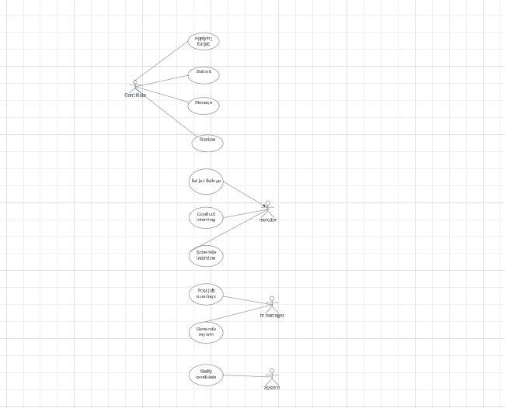

**CLASS DIAGRAM**

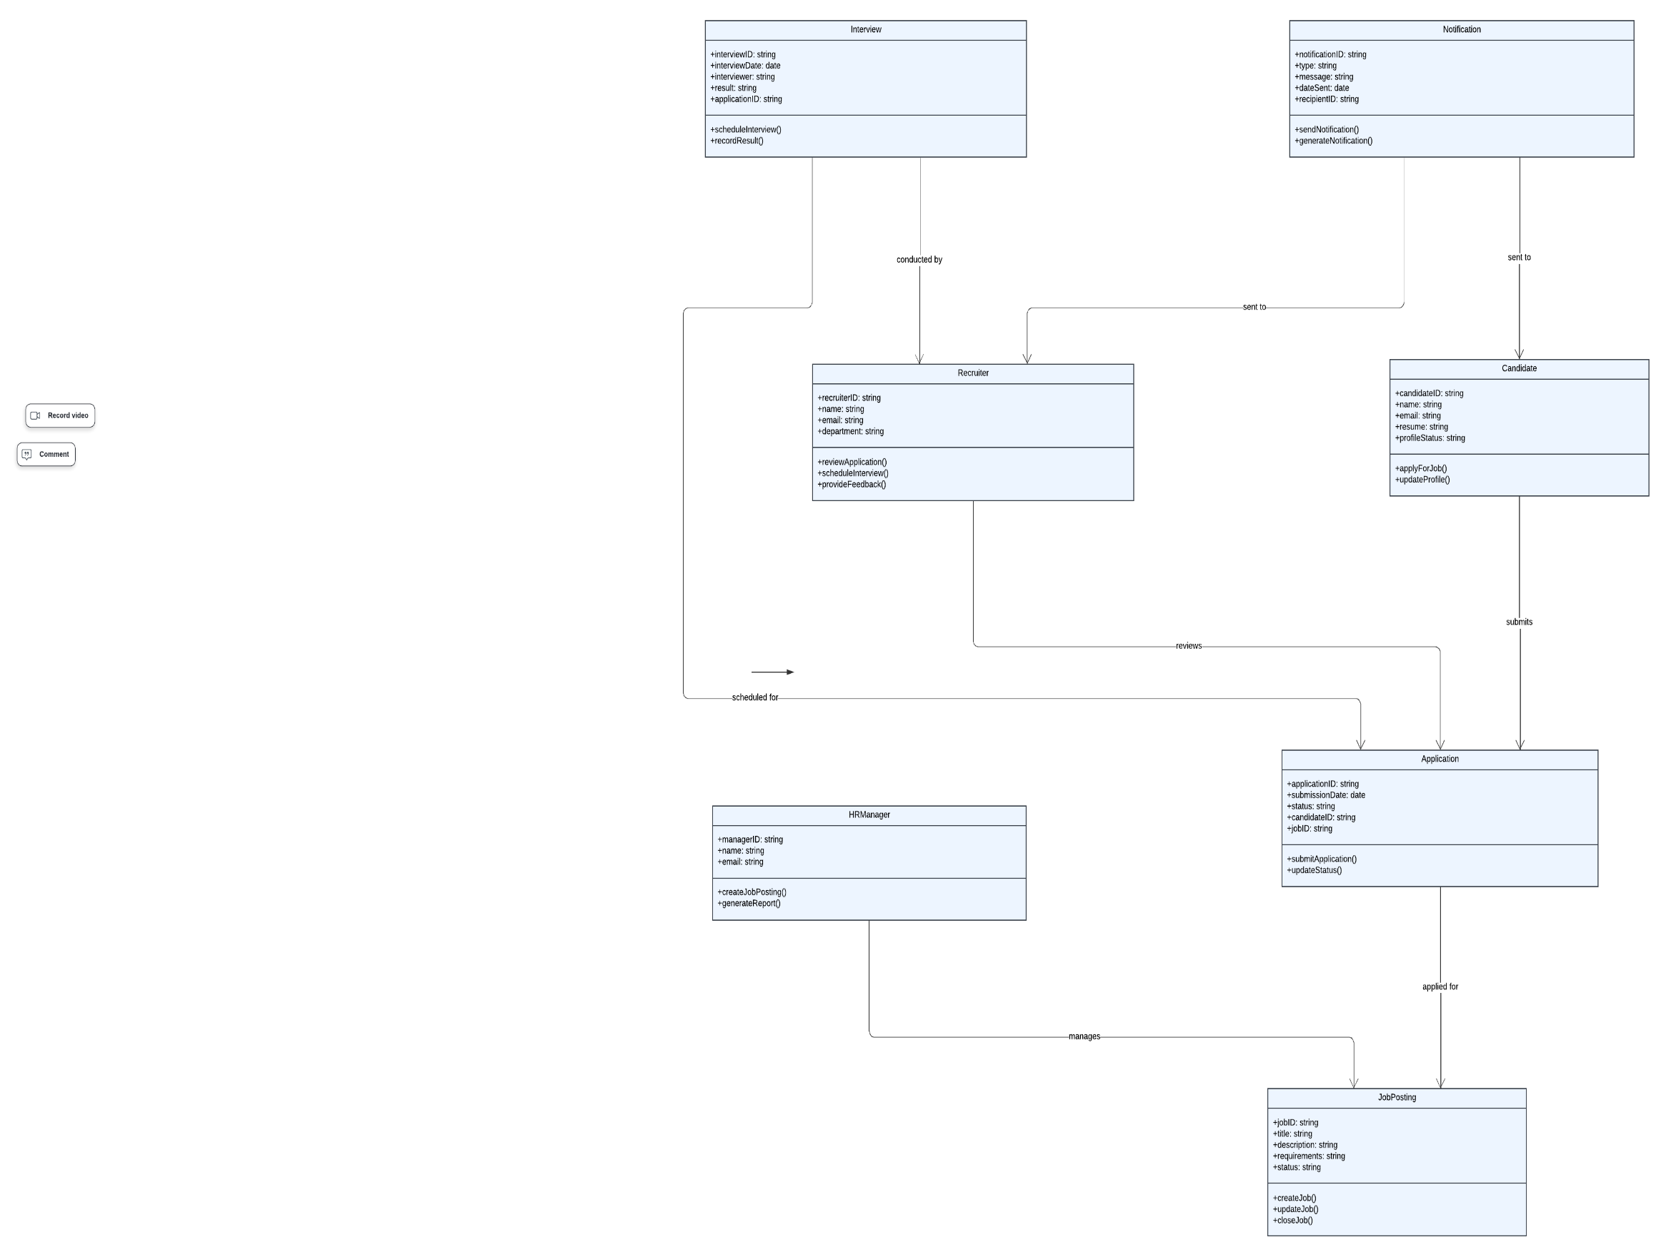

**SEQUENCE DIAGRAM**

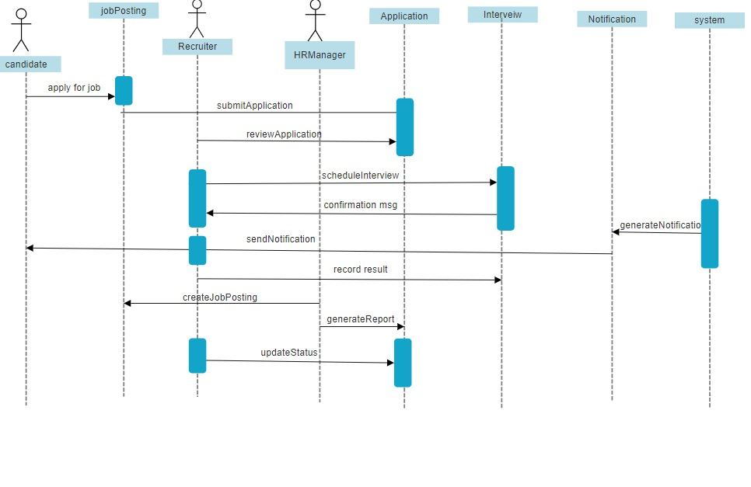

**COMPONENT DIAGRAM**

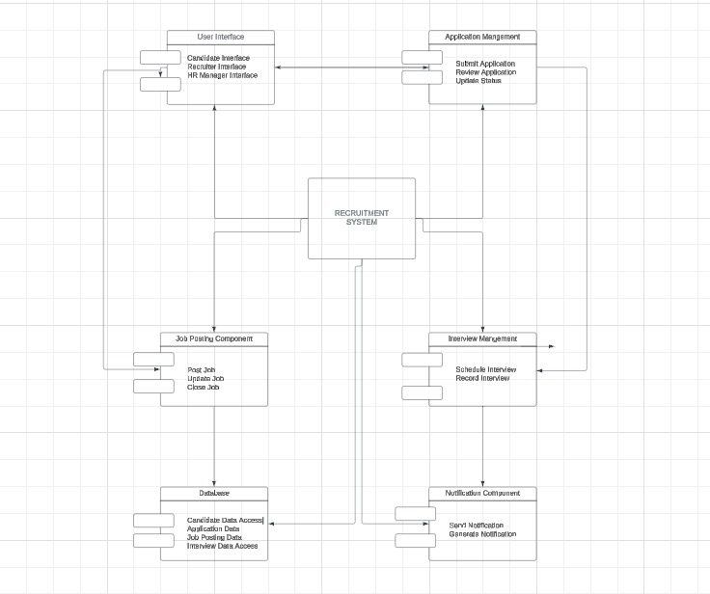

### Experiment 3: INSTALLATION OF ECLIPSE, MAVEN, JDK, TOMCAT, CONFIGURING TOMCAT TO ECLIPSE

**INSTALLATION OF ECLIPSE**

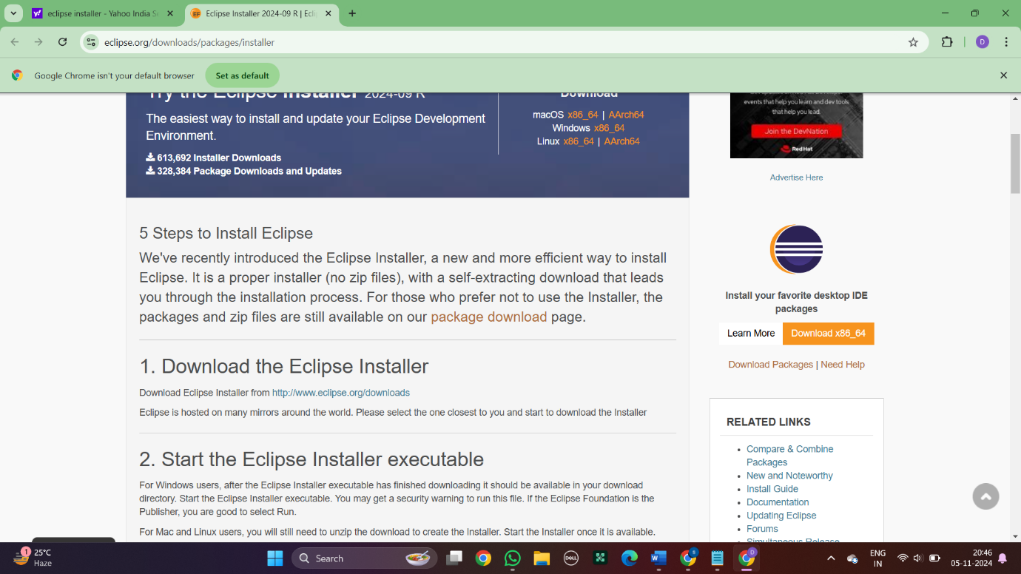

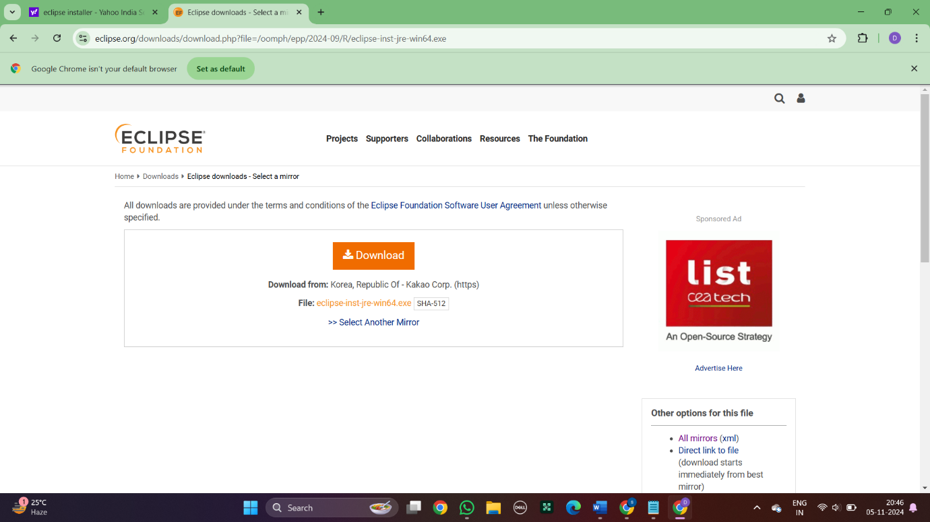

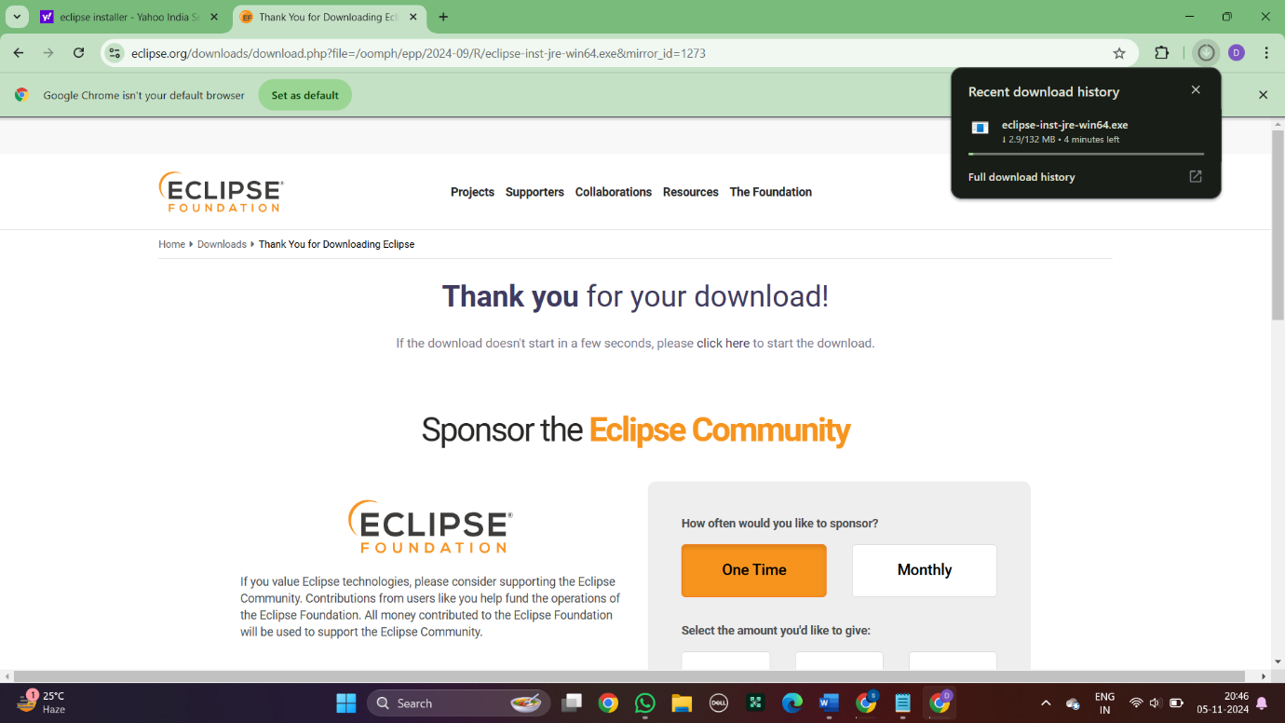

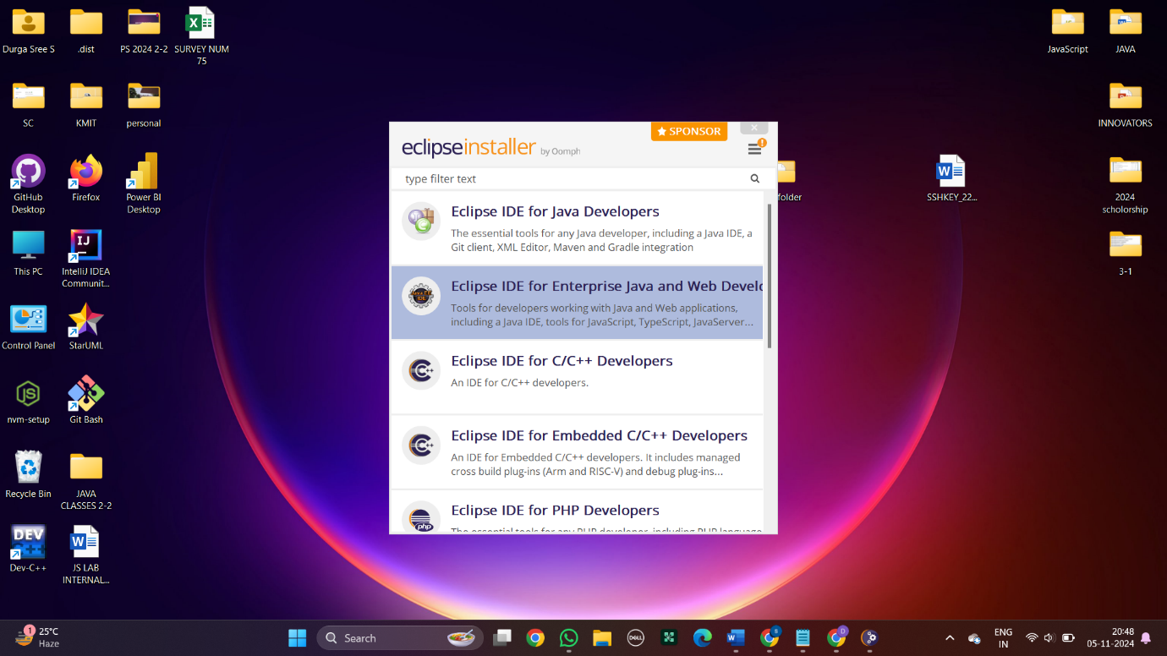

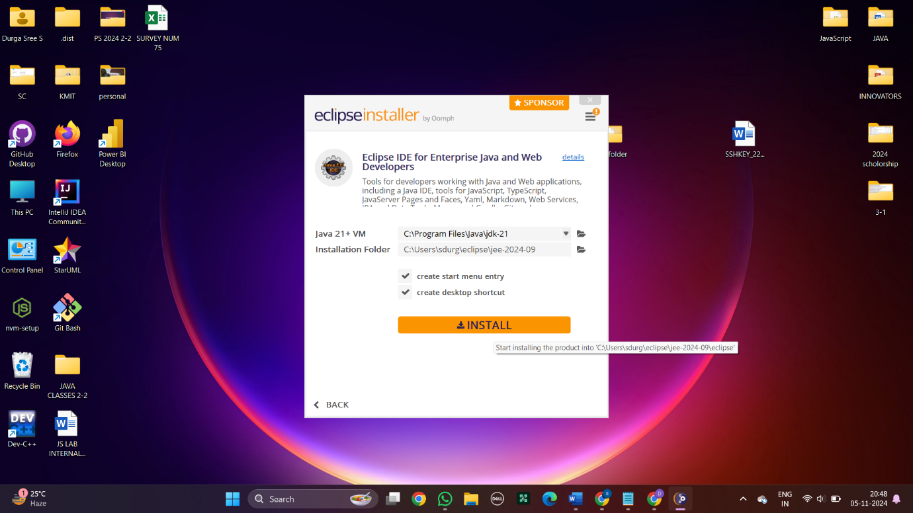

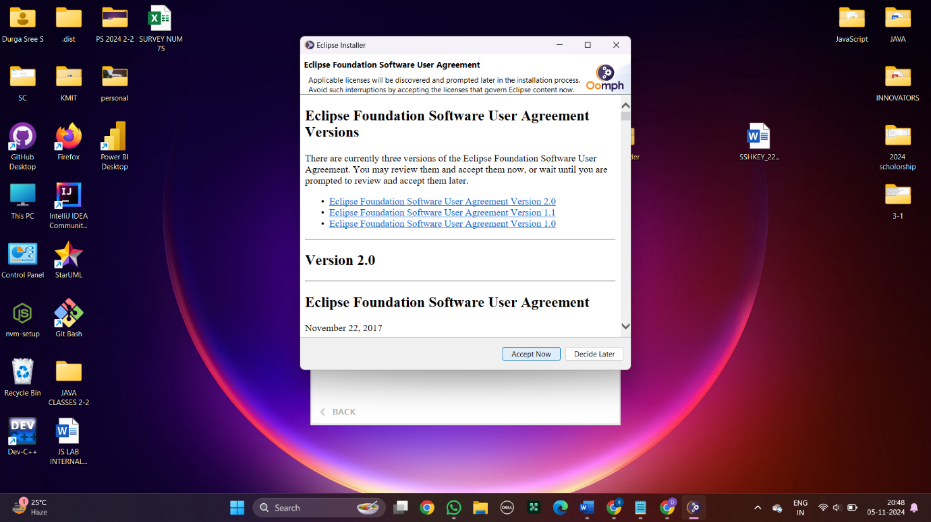

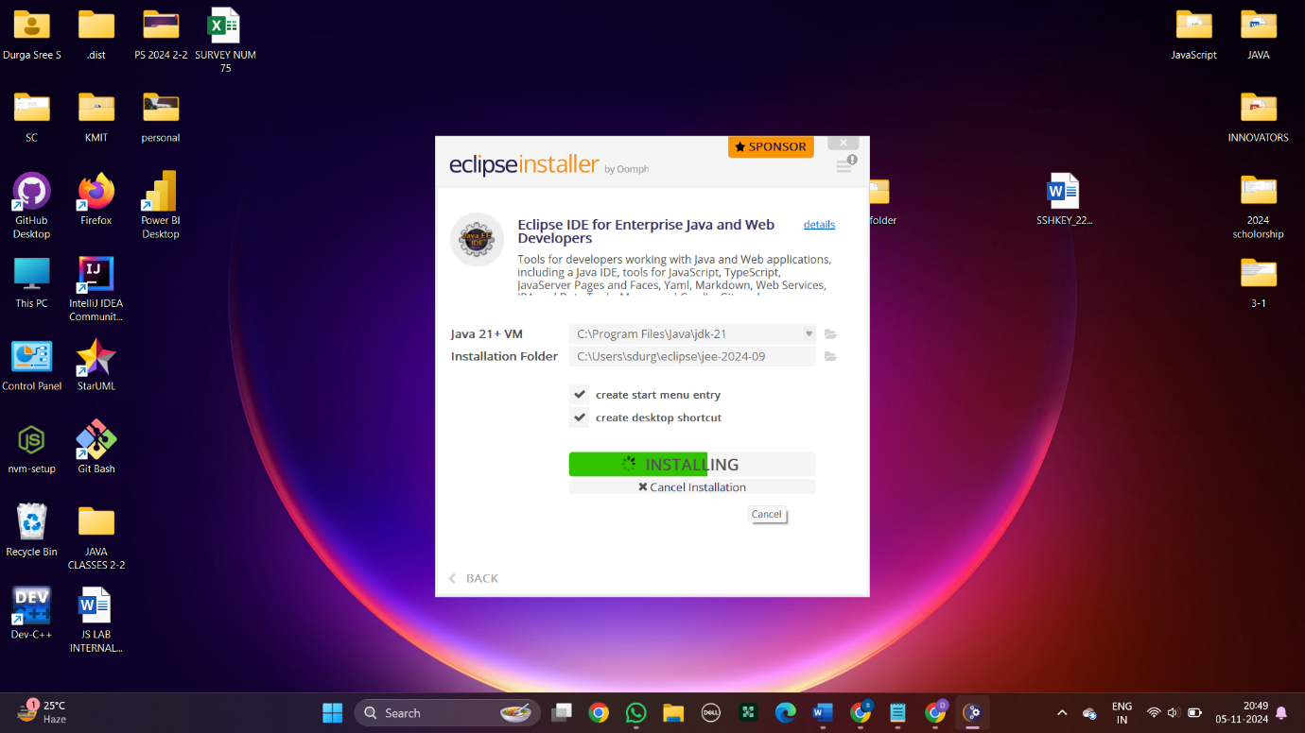

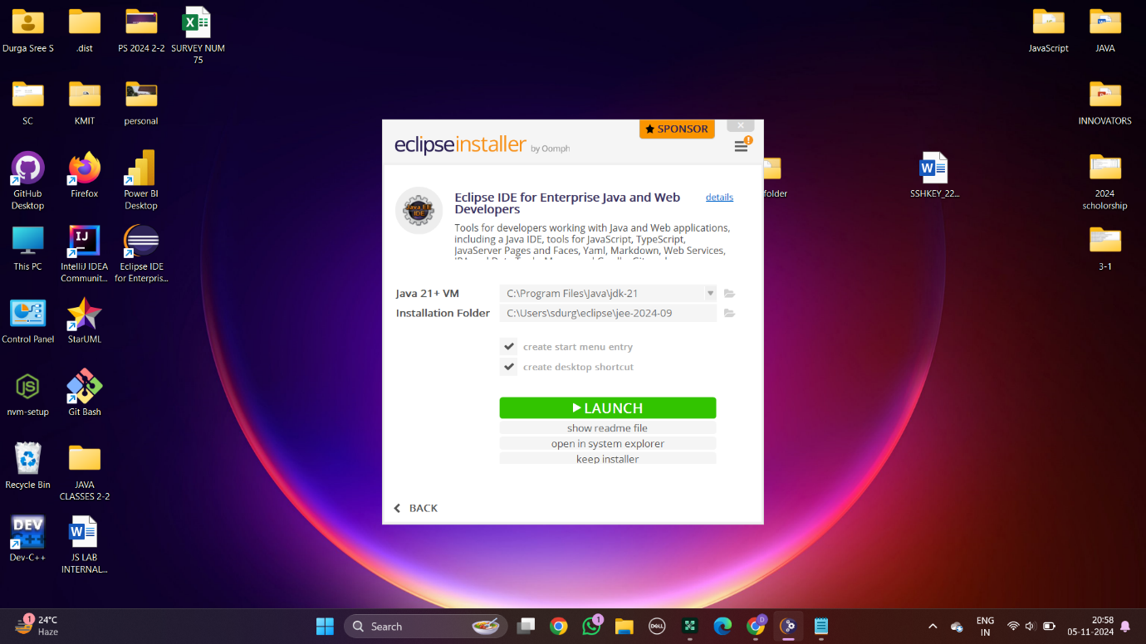

### INSTALLATION OF MAVEN INSTALLATION OF JDK

### INSTALLATION OF TOMCAT

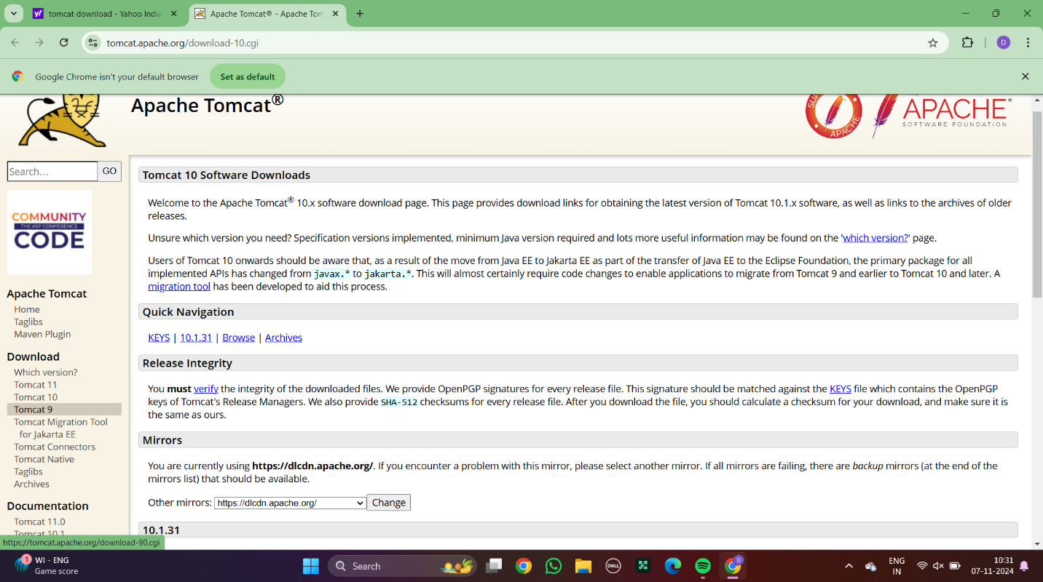

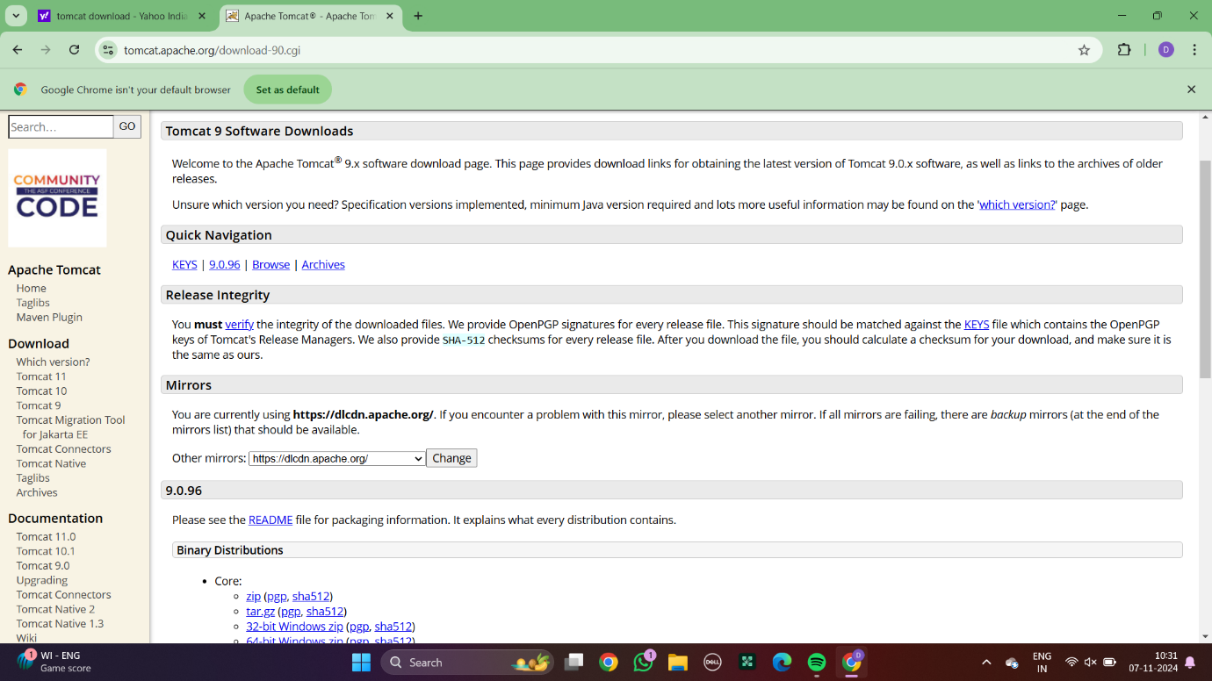

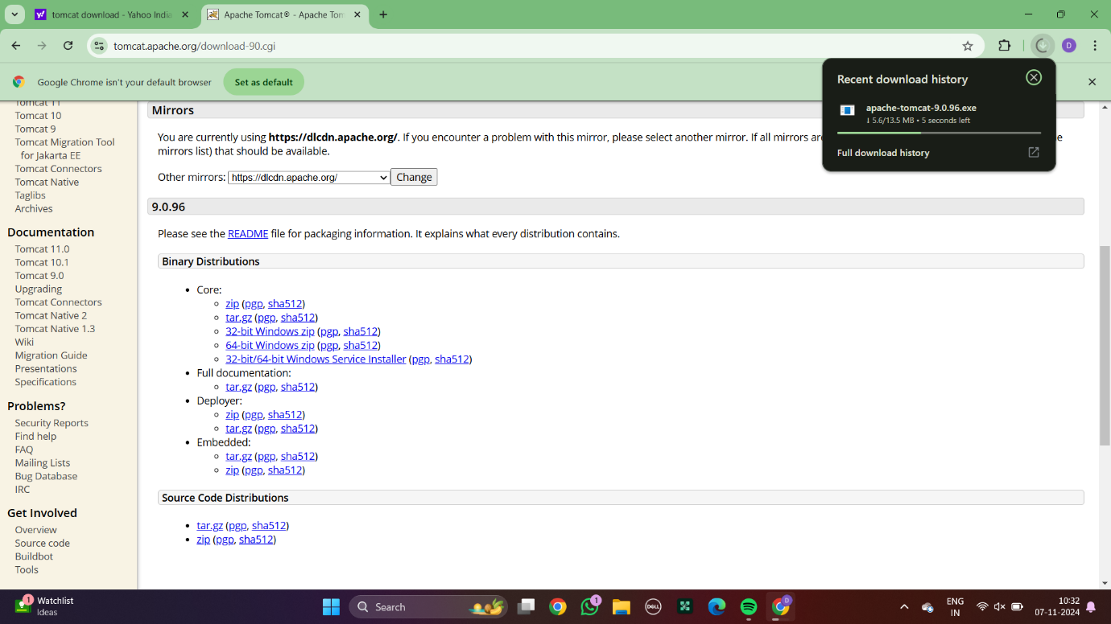

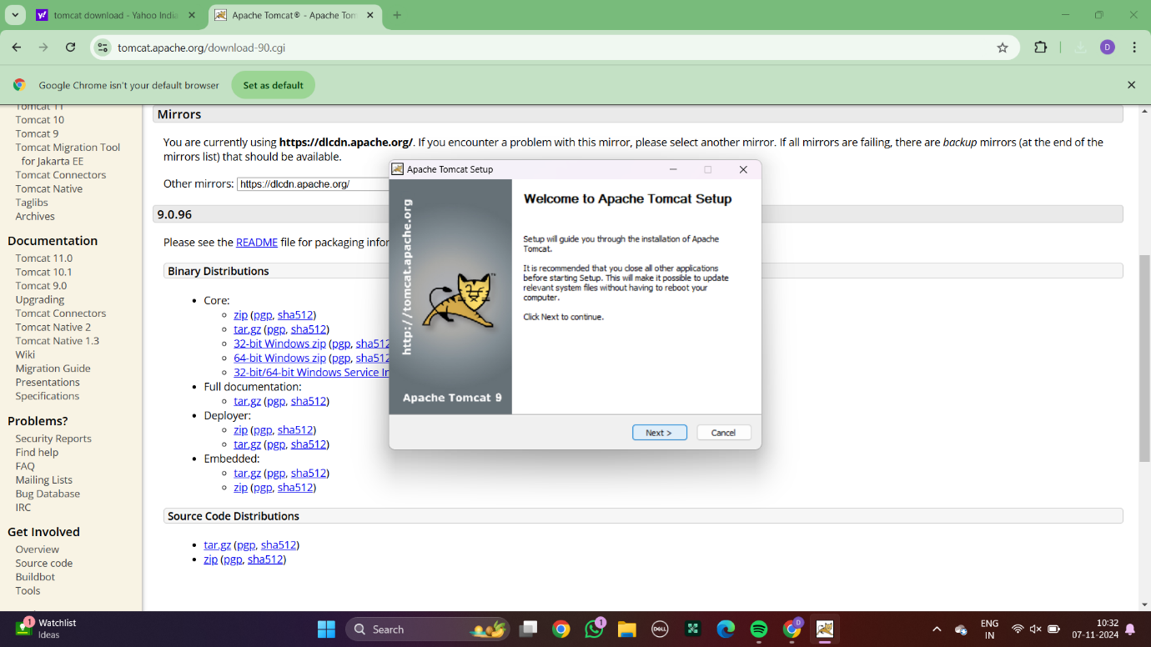

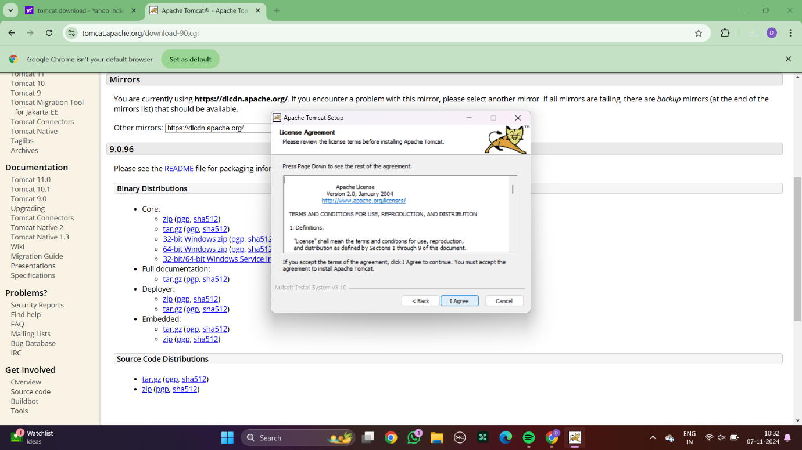

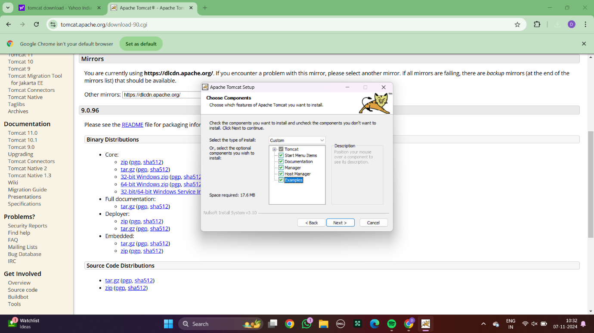

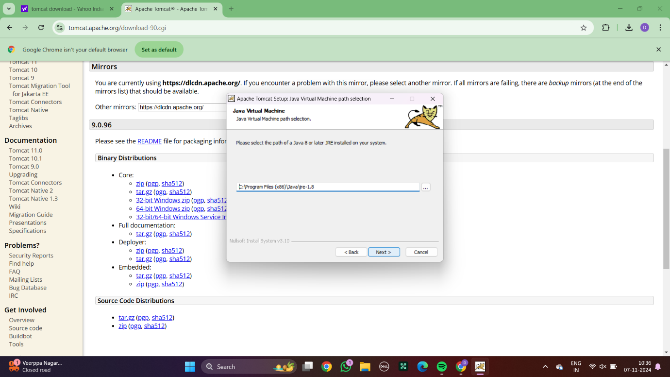

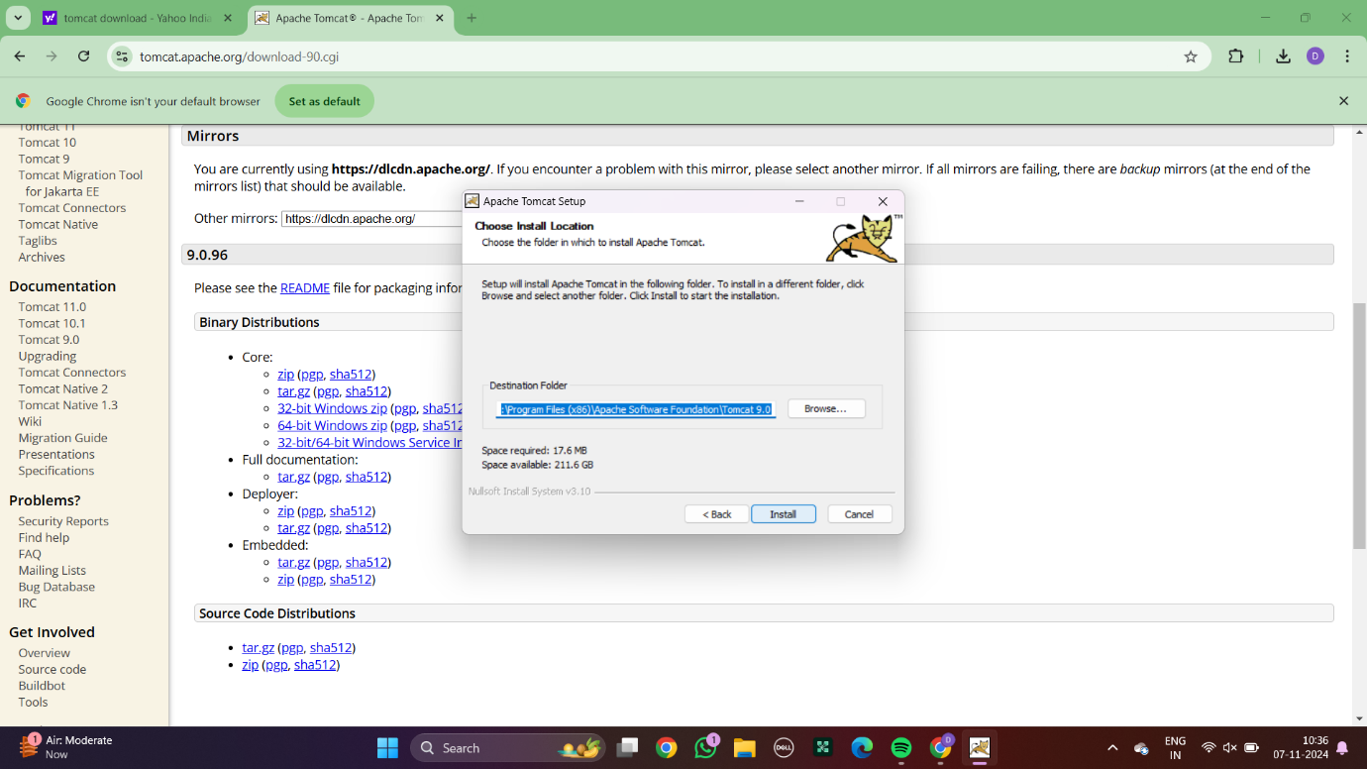

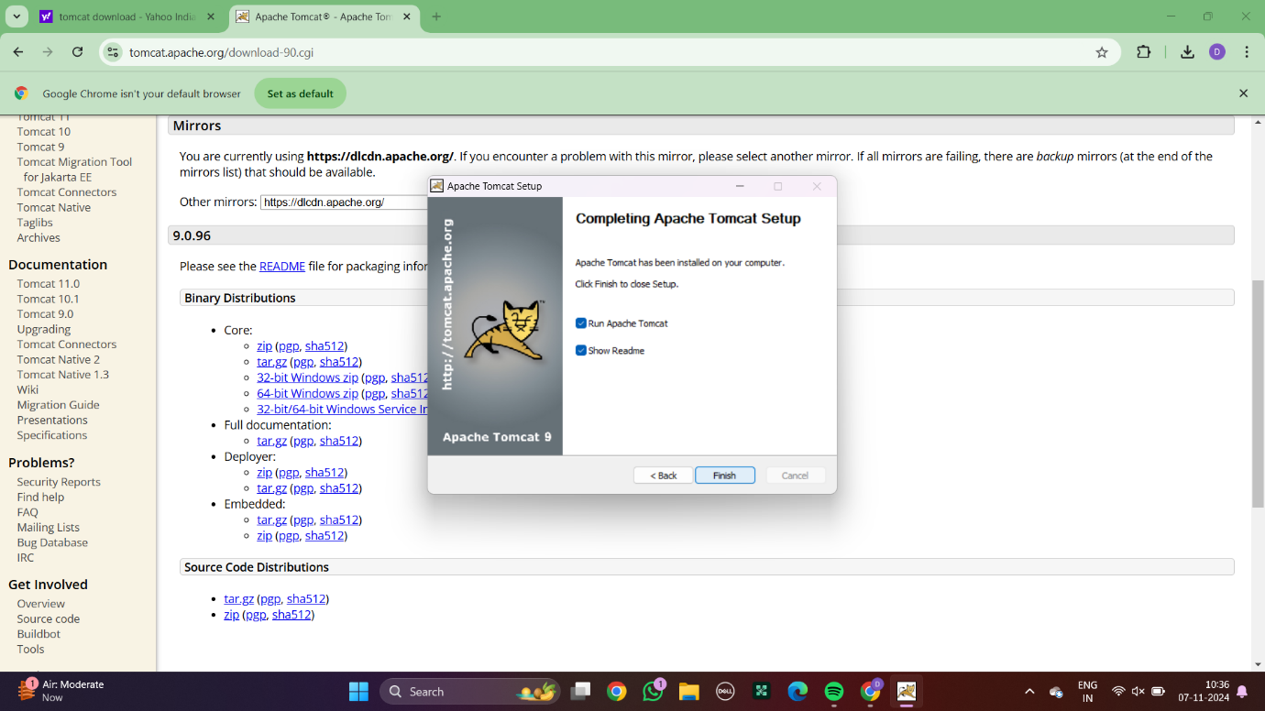

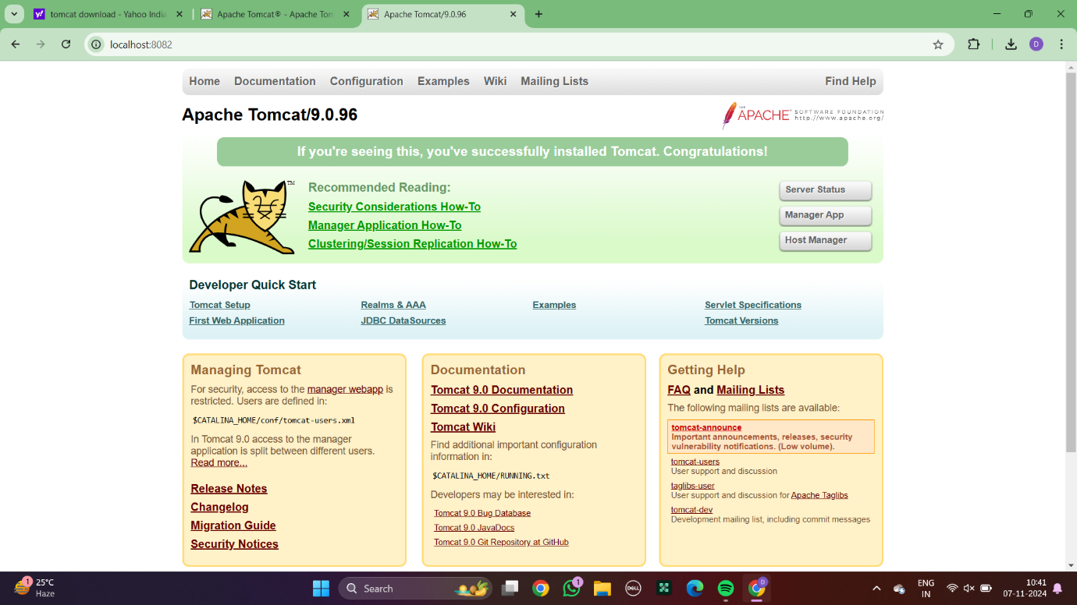

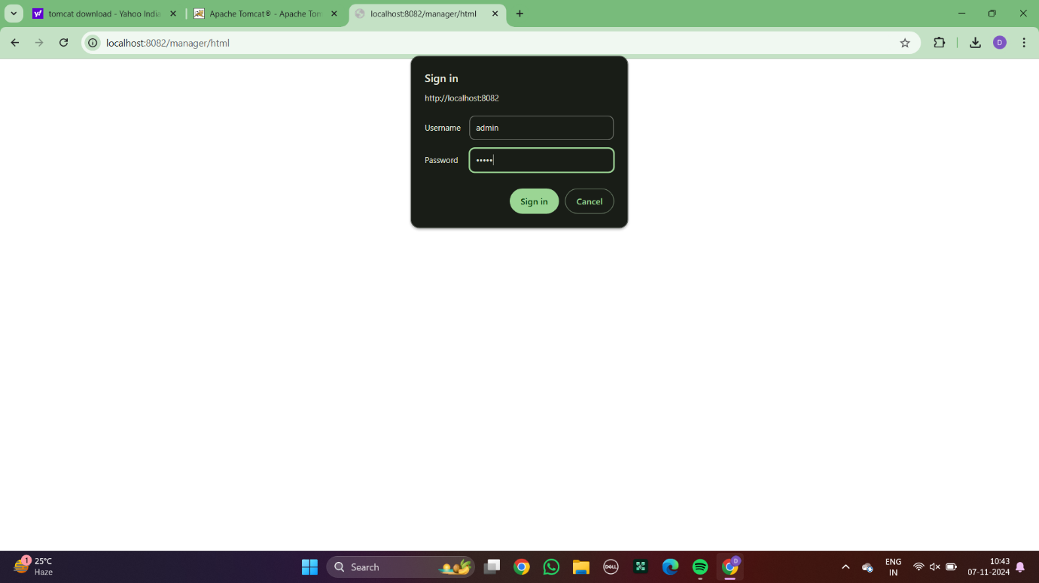

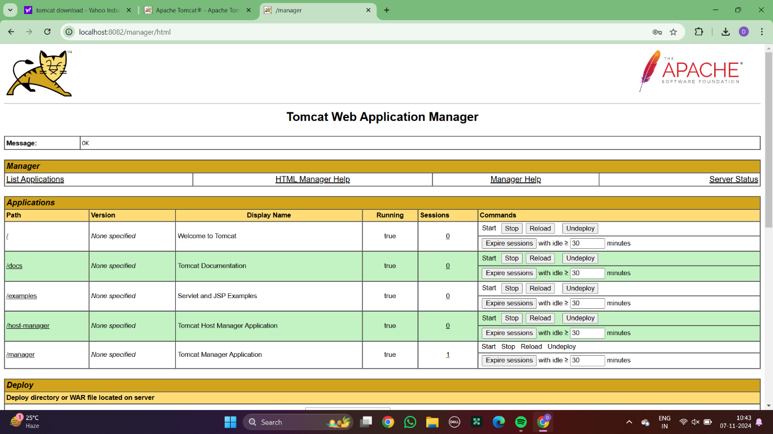

### 

### CONFIGURING TOMCAT TO ECLIPSE

### Experiment 4:

### BASIC GIT COMMANDS - VERSION, CONFIG, INIT, STATUS, ADD, COMMIT, DIFF, HELP

**1.git –version**

Displays the installed Git version.



**2.git init**

Initializes a new Git repository.



**3.git status**

Shows the current status of the working directory and staging area. Highlighting changes of untracked files. Green coloured is a tracked file and untracked is red coloured.

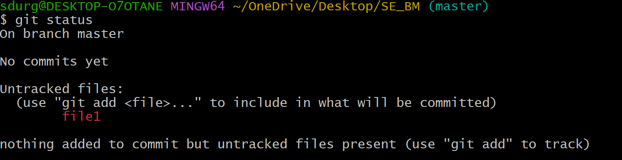

**4.git add**

Adds changes from the working directory to the staging area, preparing them to be committed.



**5.git commit**

Records changes to the repository with a message.

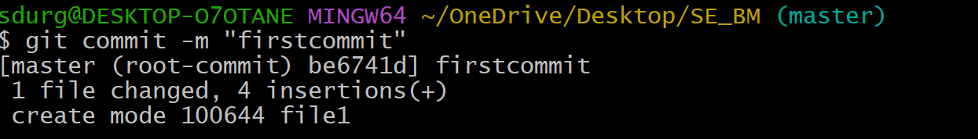

**6.git congif**

Configures Git settings (e.g., username, email).

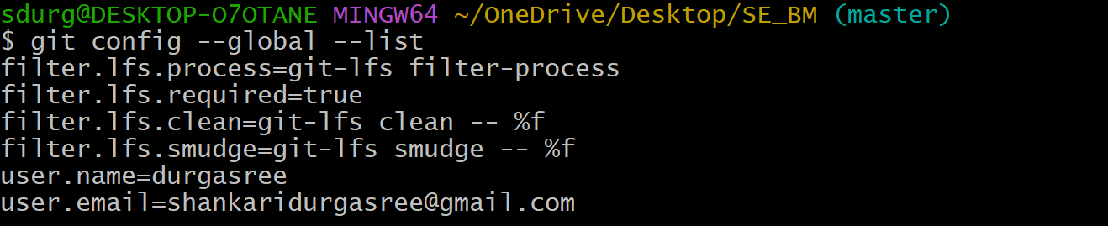

**9.git diff**

Shows the differences between commits, branches, or files.

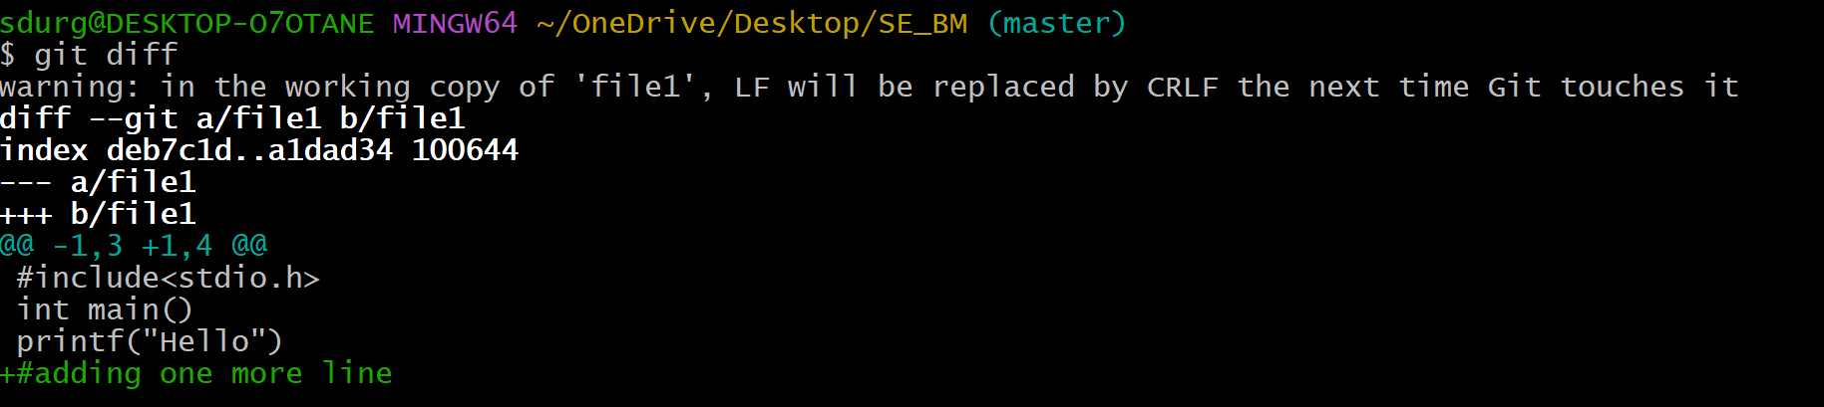

**9.cat**

It displays the contents of the files.

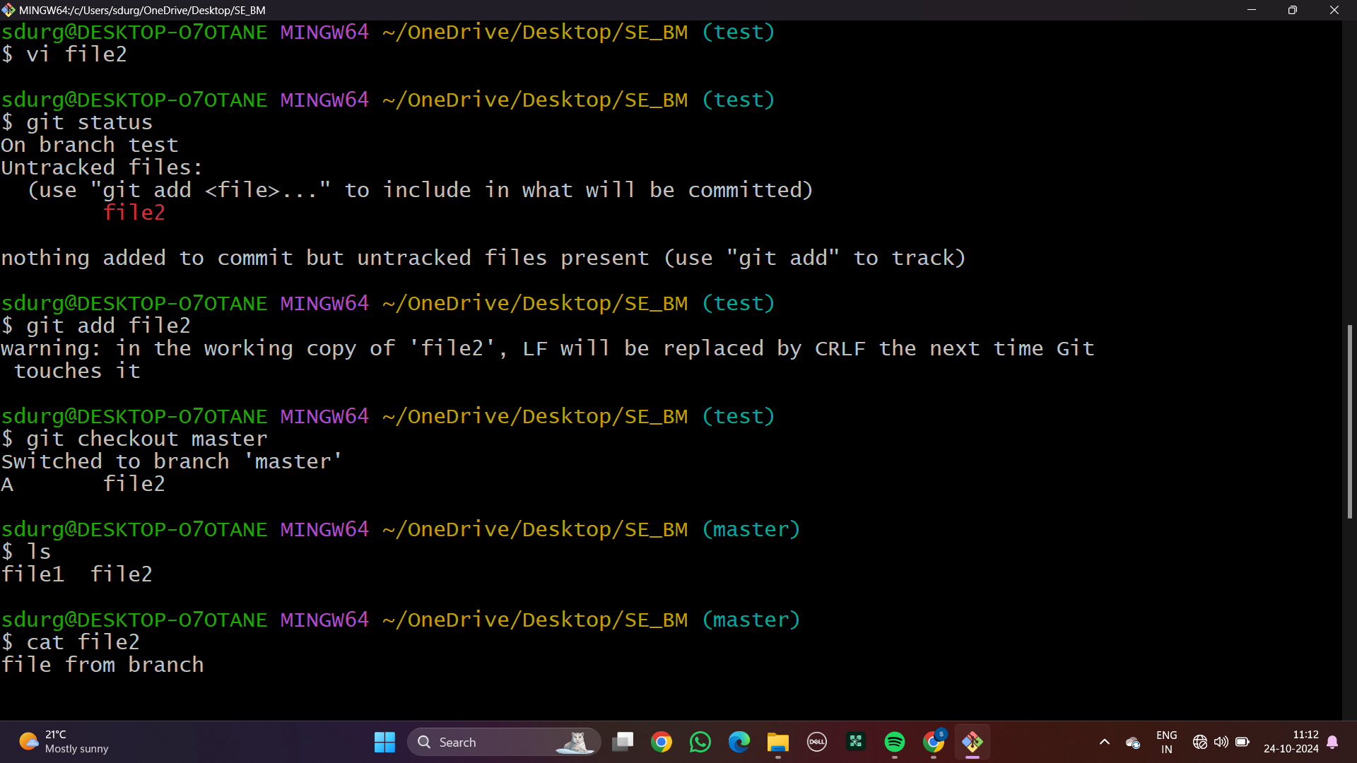

### GIT COMMANDS: WORKING WITH LOCAL AND REMOTE REPOSITORIES - BRANCHES, CHECKOUT, MERGE, REVERT, LOG

**MERGING**

**1.git branch test**

Creates a new branch named "test"

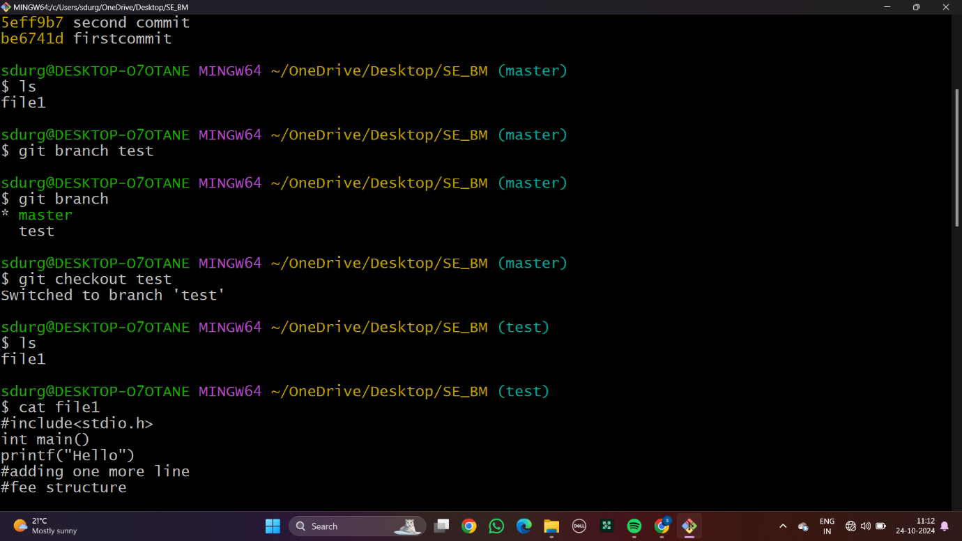

**2.git branch**

Lists all branches in the repository.

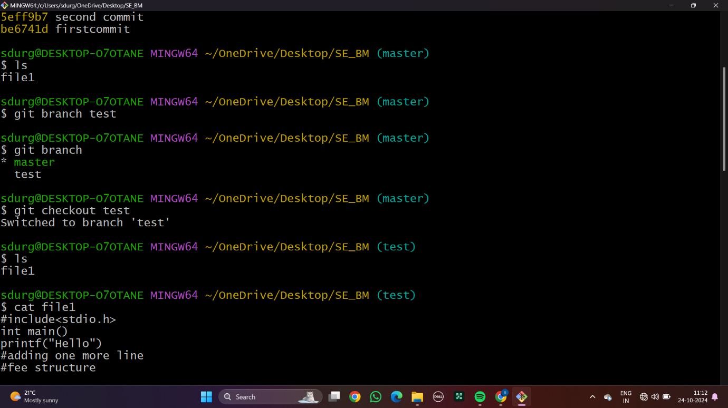

**3.git checkout**

Switches to a specified branch or commit.



**4.git merge test**

Merges the "test" branch into the current branch.

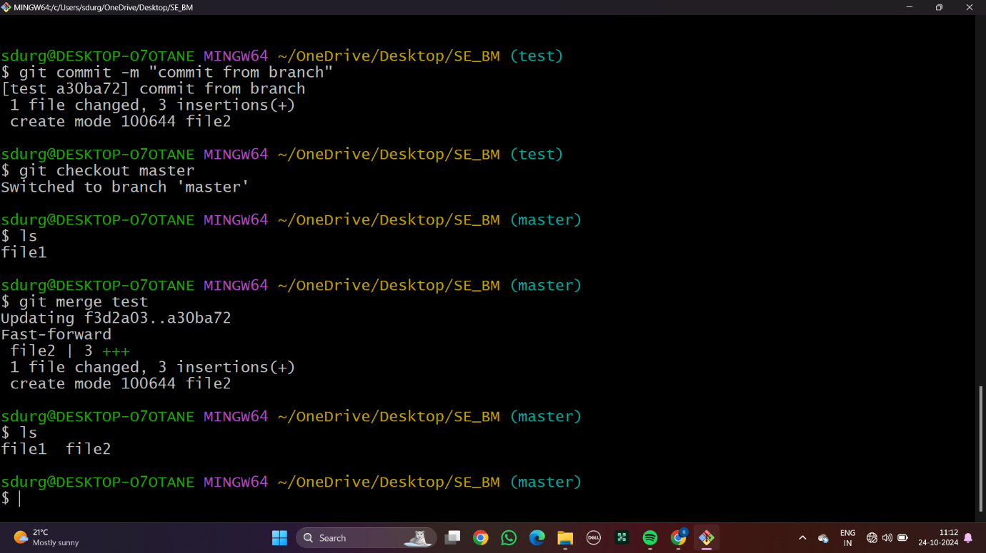

**7.git log**

Displays the commit history.

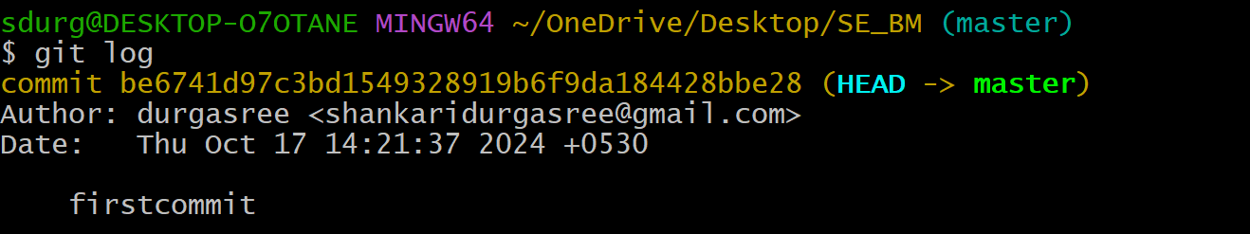

**8.git revert**

Reverts a specific commit by creating a new one that undoes it.

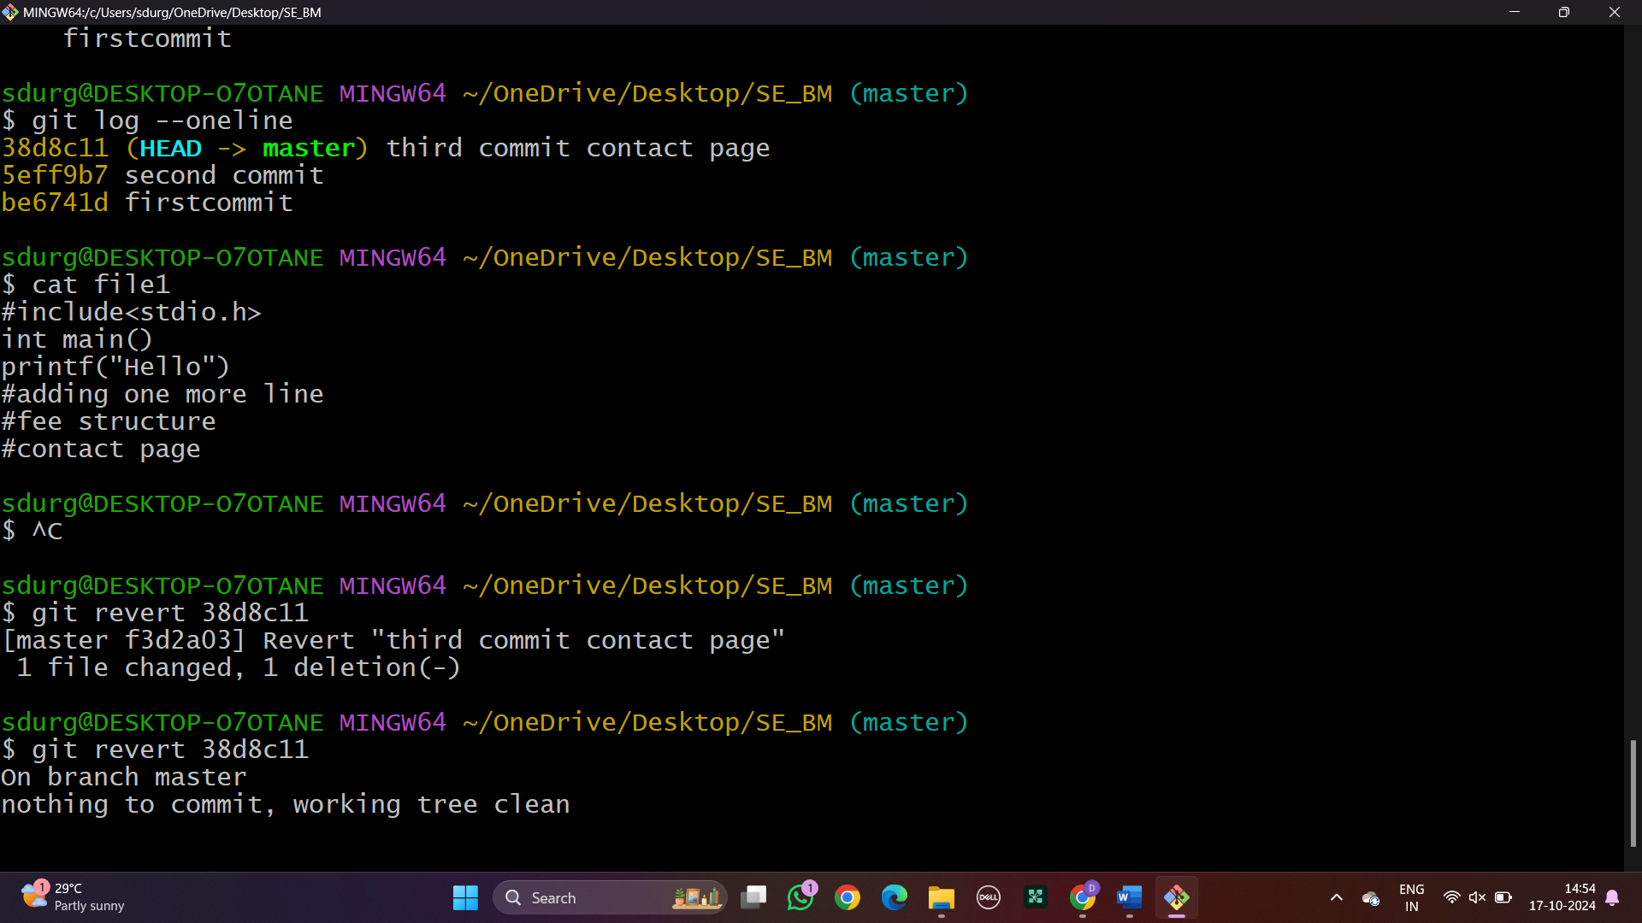

### 

### GIT COMMANDS: WORKING WITH REMOTE REPOSITORIES - REMOTE, CLONE, PULL, PUSH, FORK

### Experiment 5:

### CREATING MAVEN JAVA PROJECT USING ECLIPSE AND PUSH INTO TO GITHUB.

**MAVEN JAVA PROJECT**

**1.Creating a new maven java project in eclipse :** Select Project name and location ,use default workspace

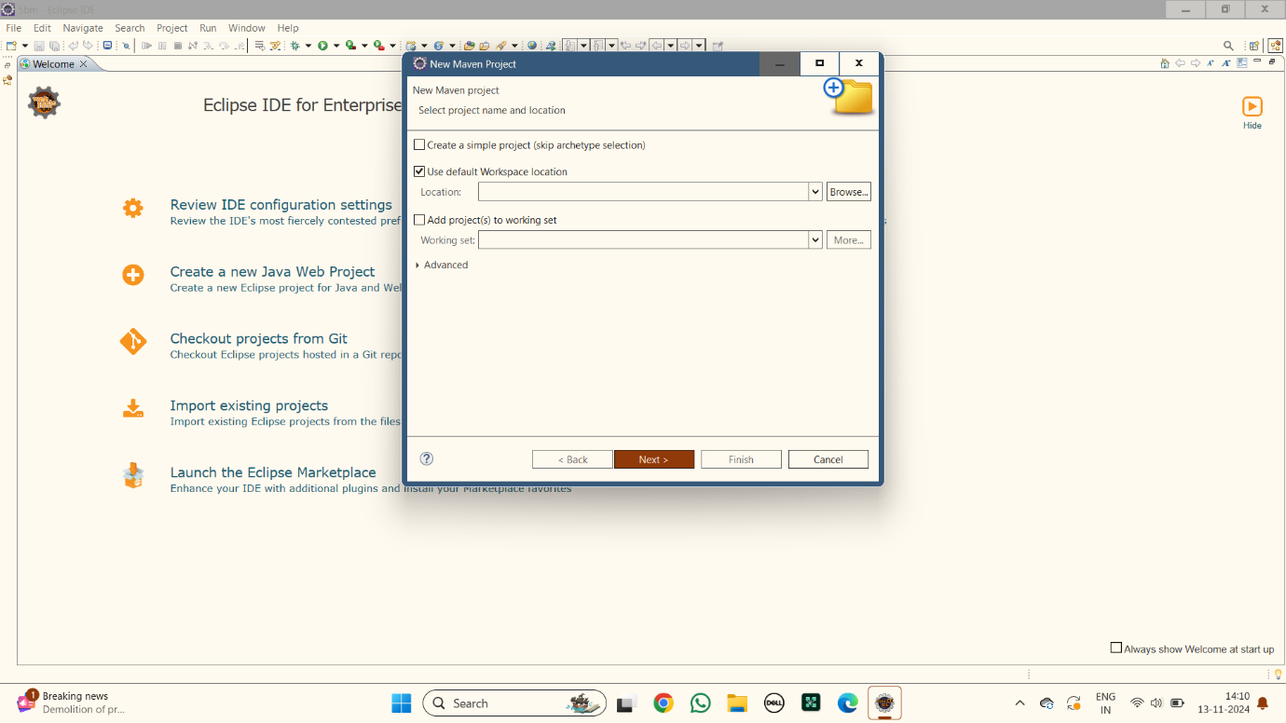

**2.Select An Archetype:** Selecting the archetype as quick start

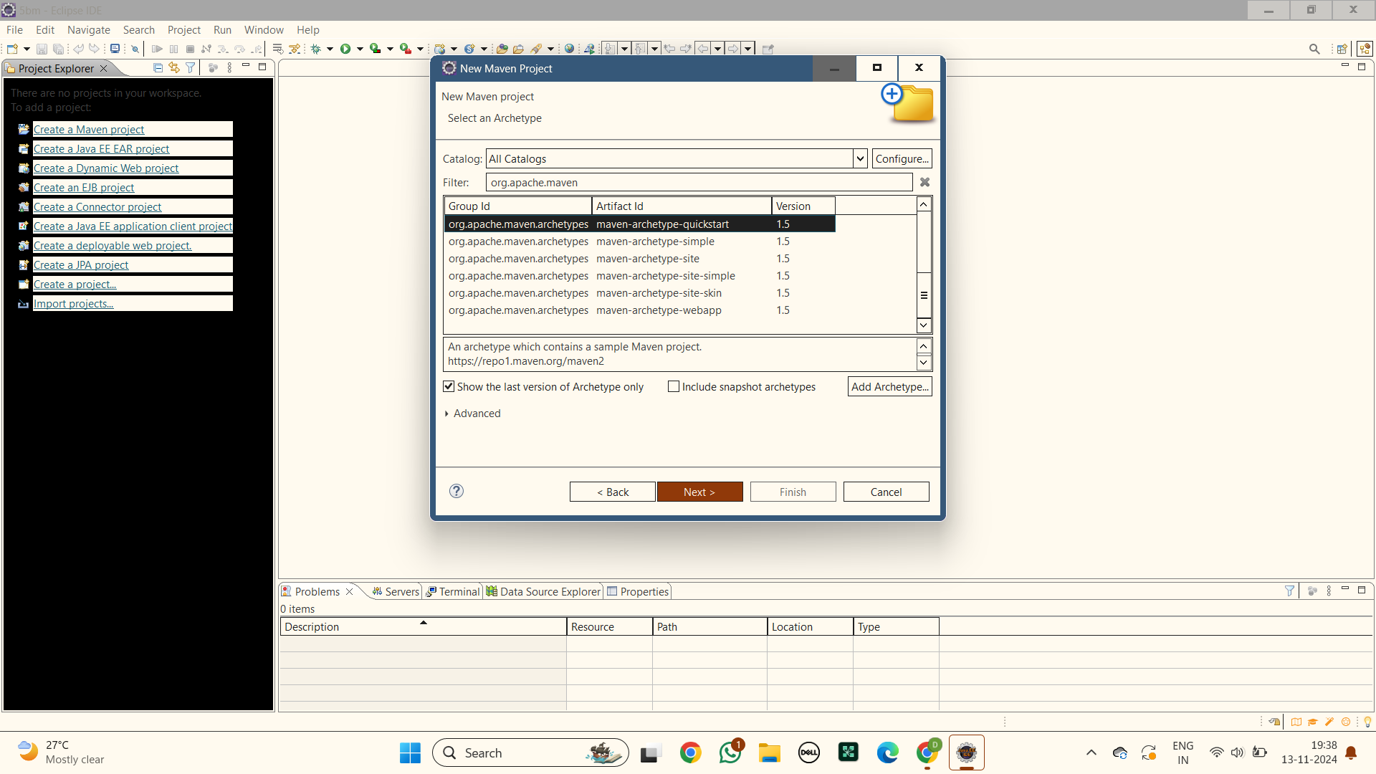

**3.Specify Archetype parameters :** Add GroupId as mavenjava.com and Artifact Id as 22bd1a05bm or else any other name for ArtifactId and finish

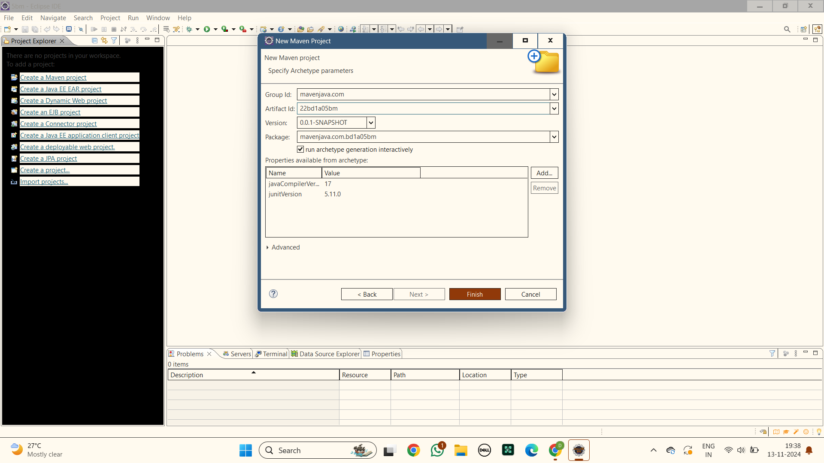

**4.Building of a new maven project is done**

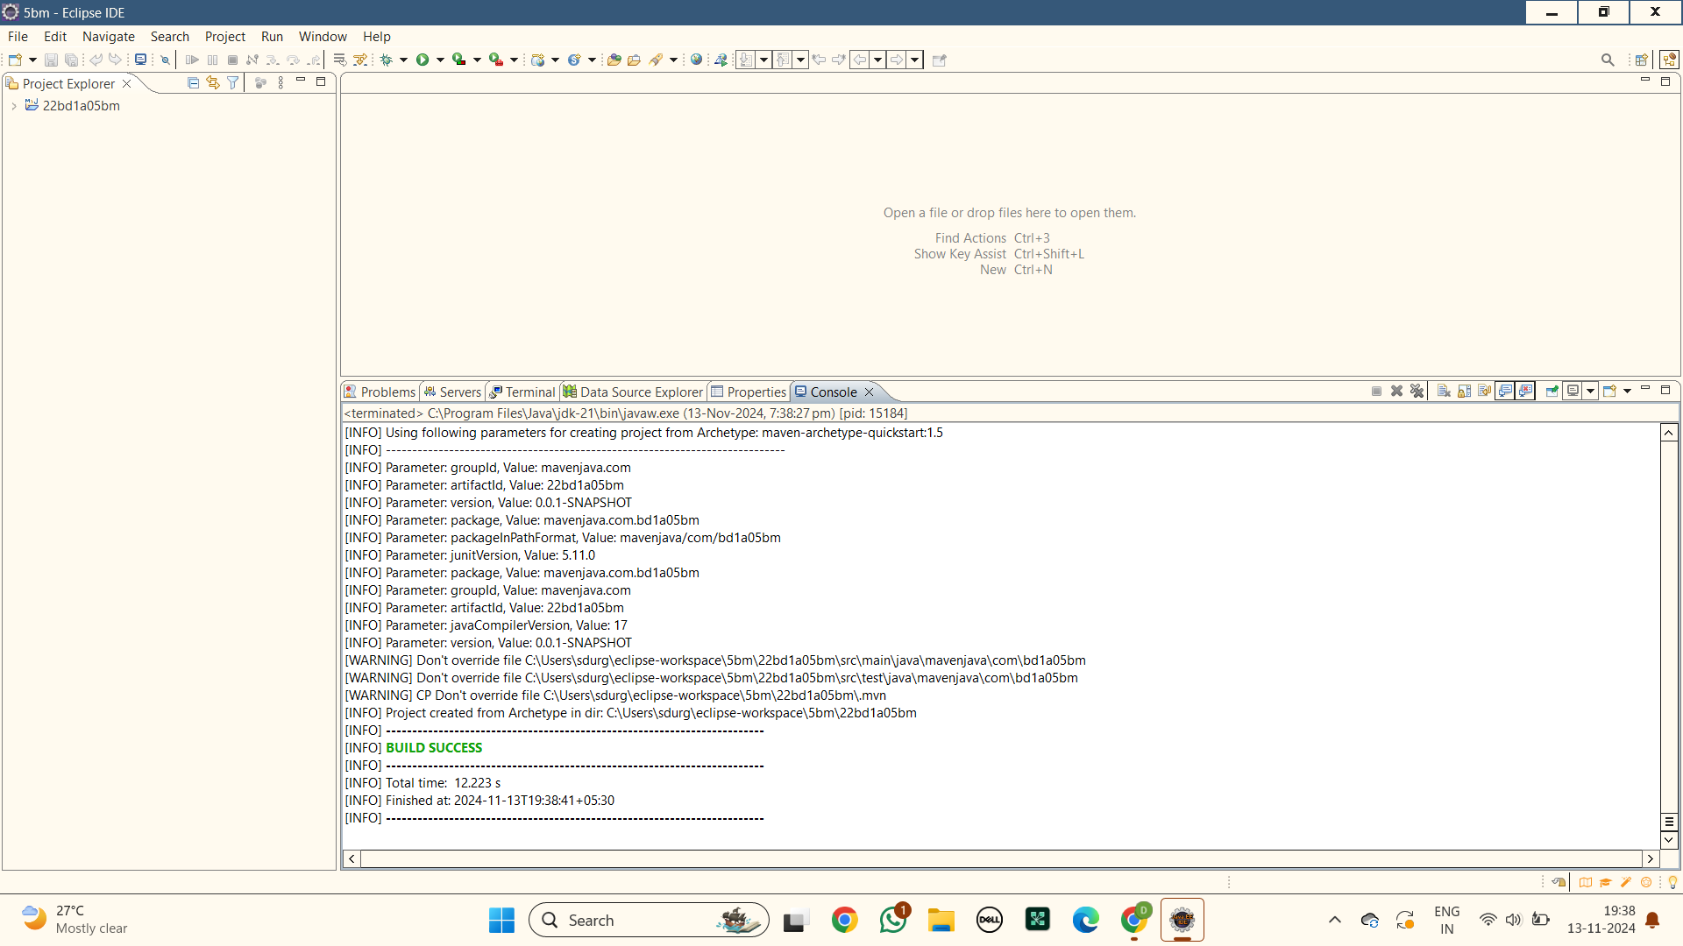

**6.Open App.java:** Open app.java file in the folder src>main>java>com>kmit>bd1a05bm>App.java and write a java code.

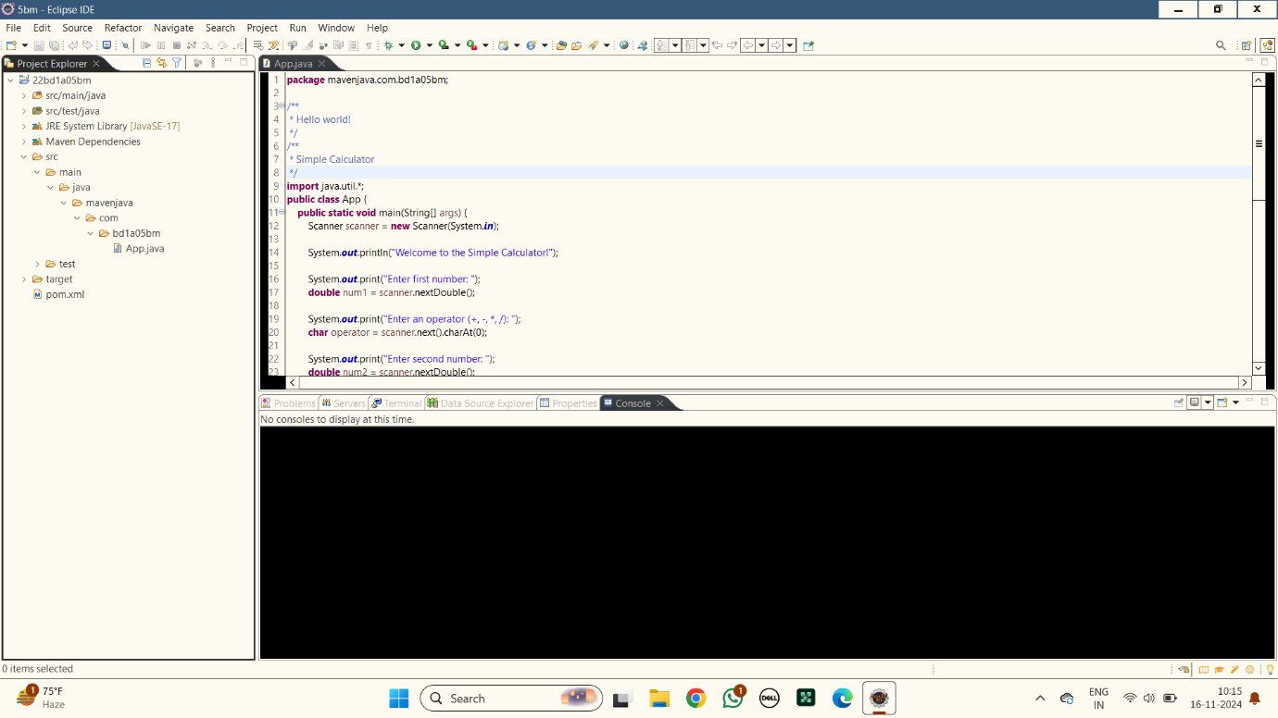

**7.Maven Clean :**Right click the maven project file and select Run as the select Maven clean

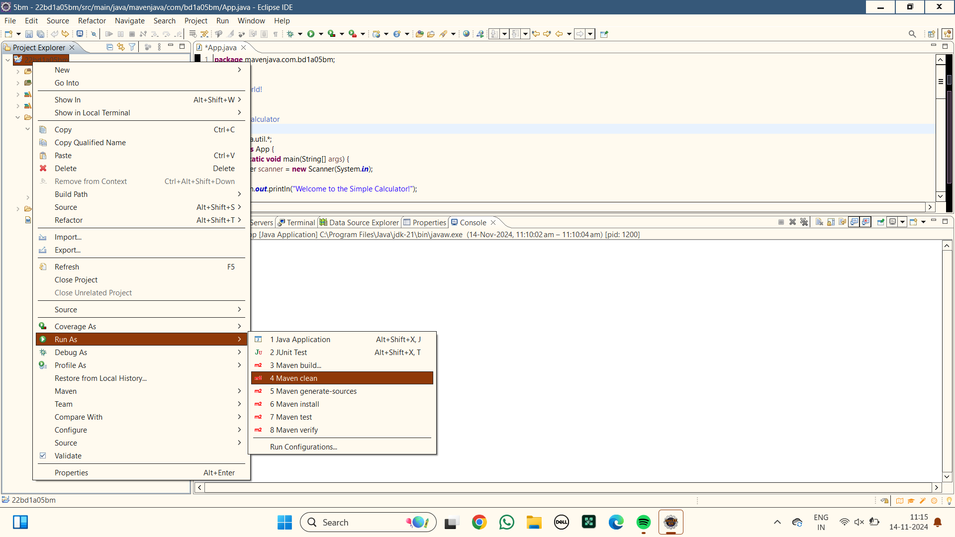

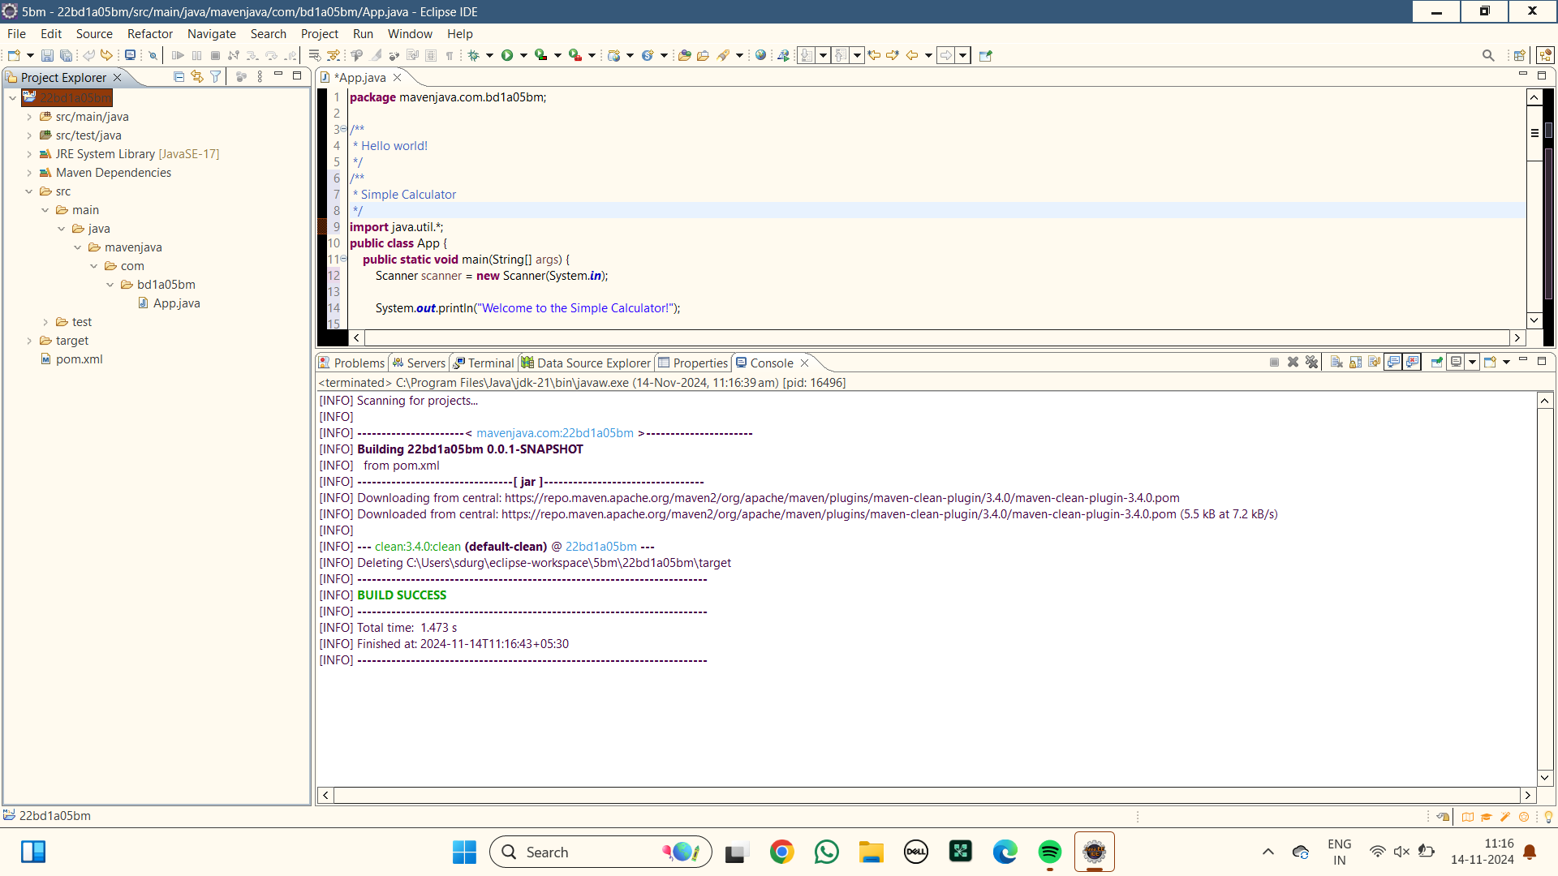

**8.Maven install :** Right click the maven project file and select Run as the select Maven install

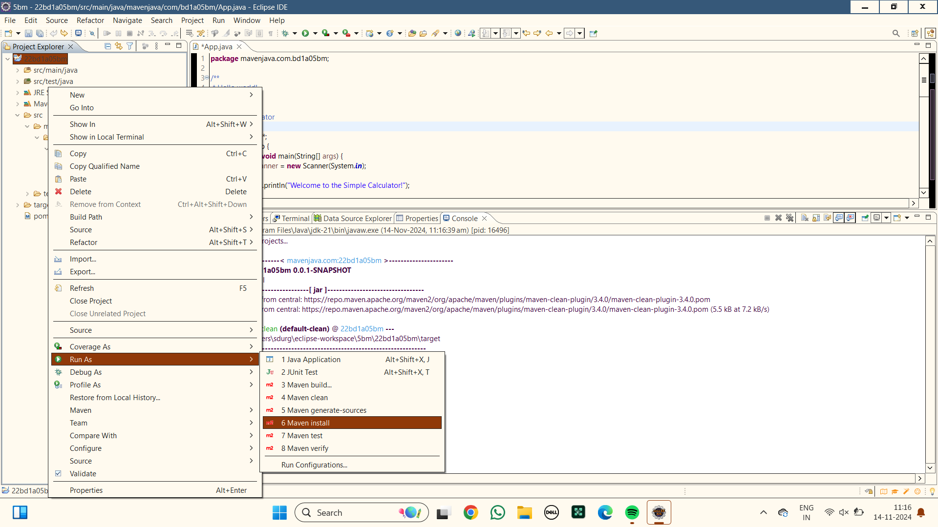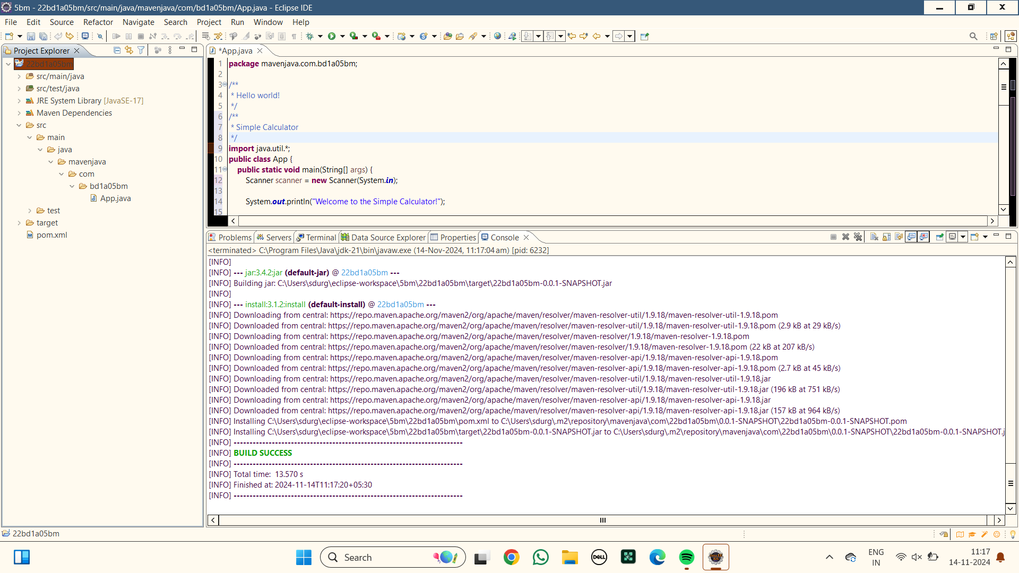

**9.Maven build :** Right click the maven project file and select Run as the select Maven build

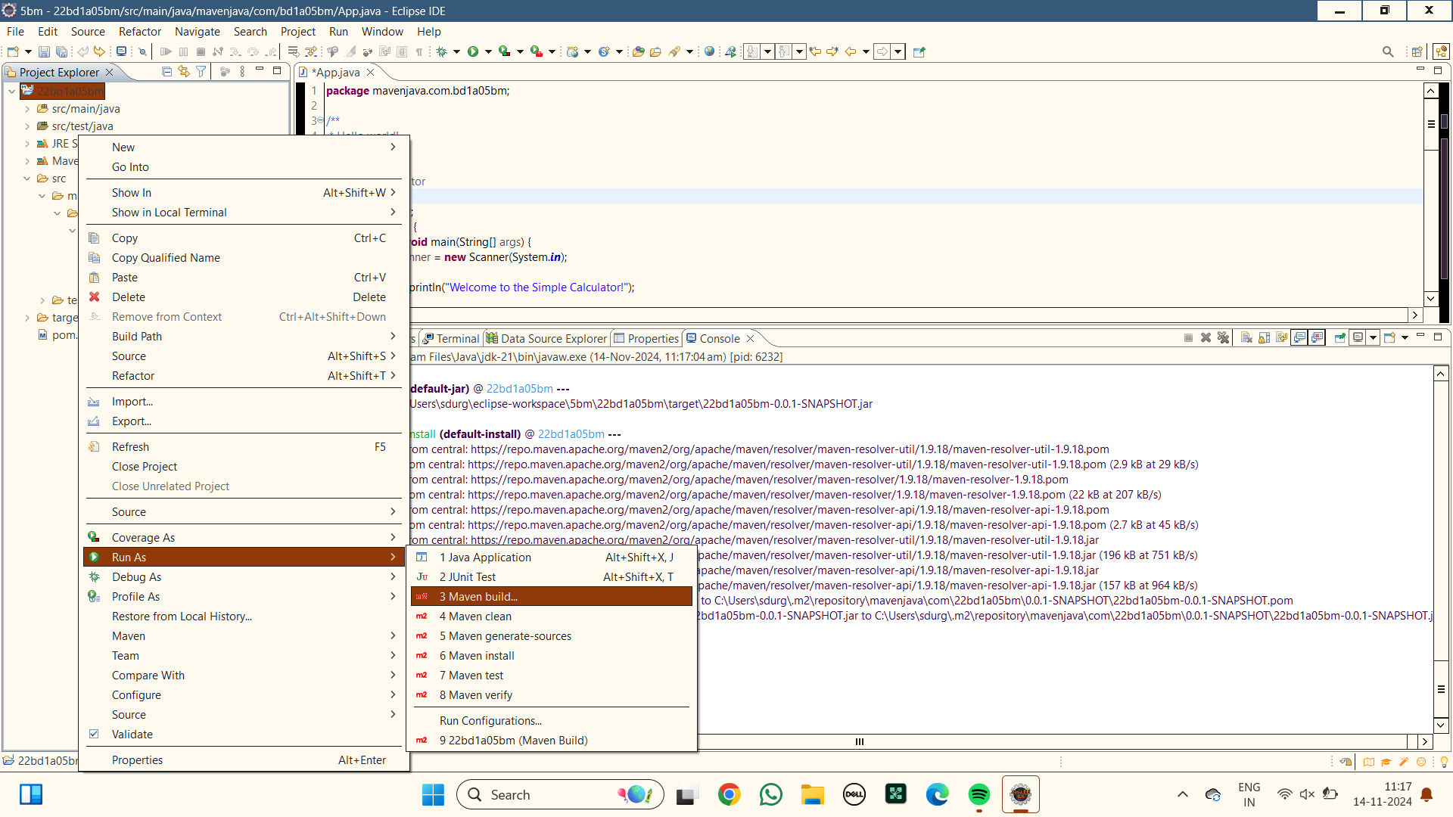

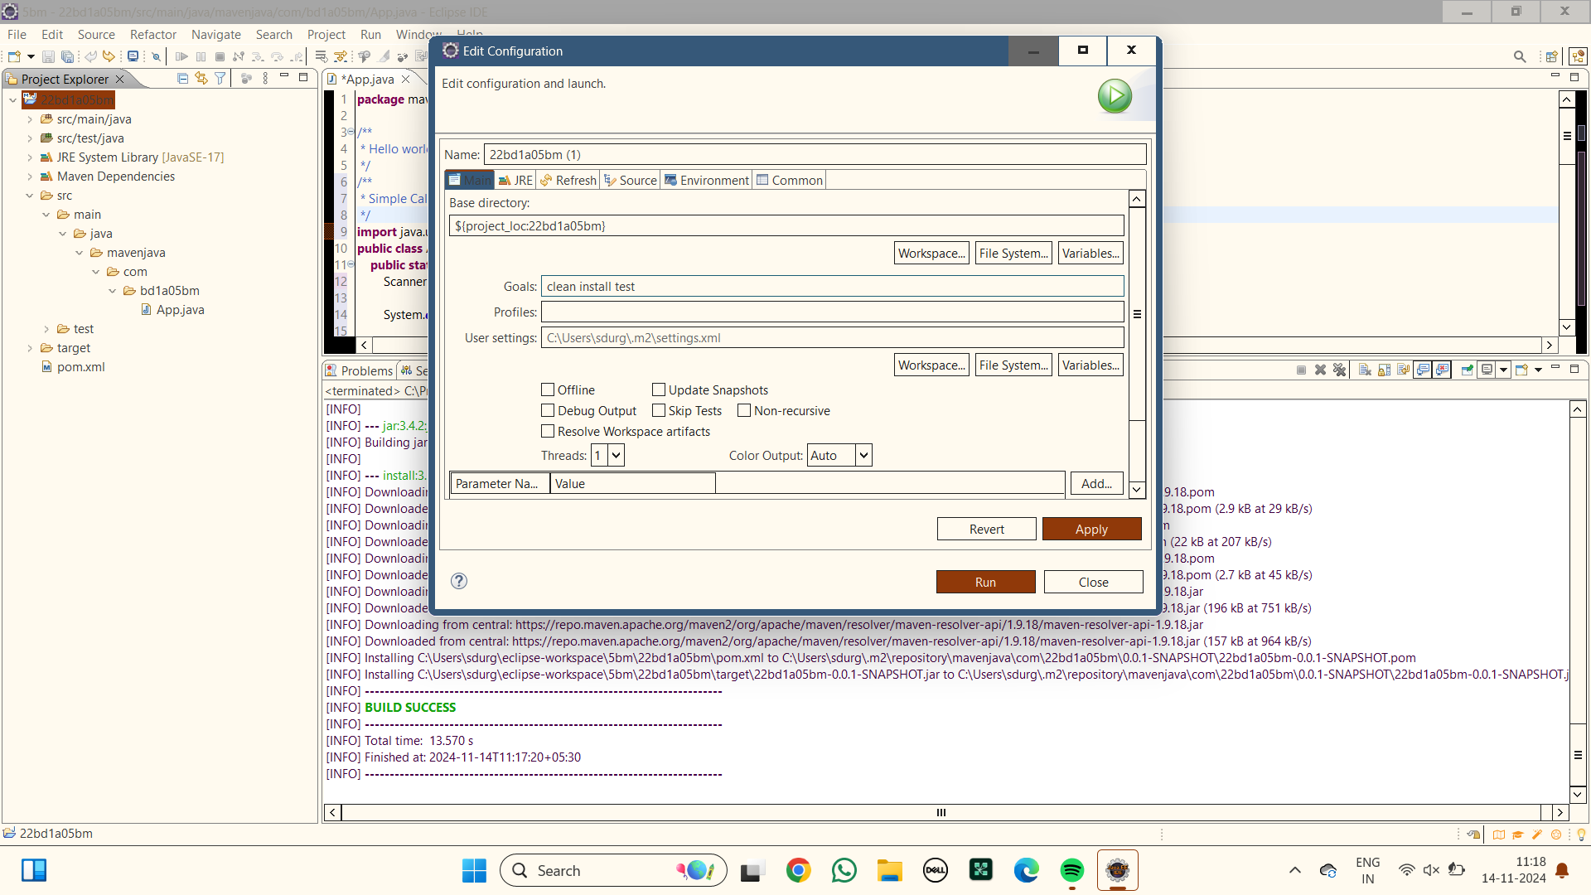

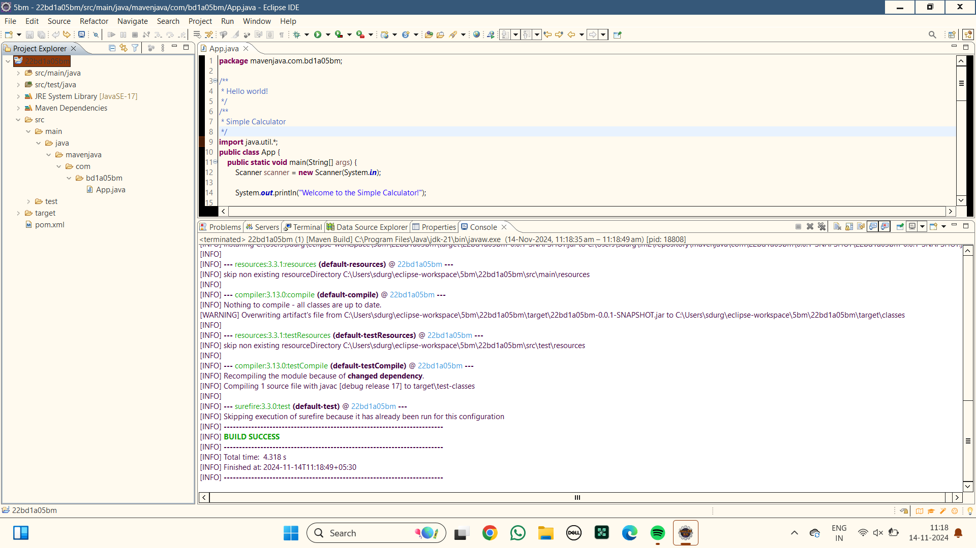

**10.Maven test :** Right click the maven project file and select Run as the select Maven test

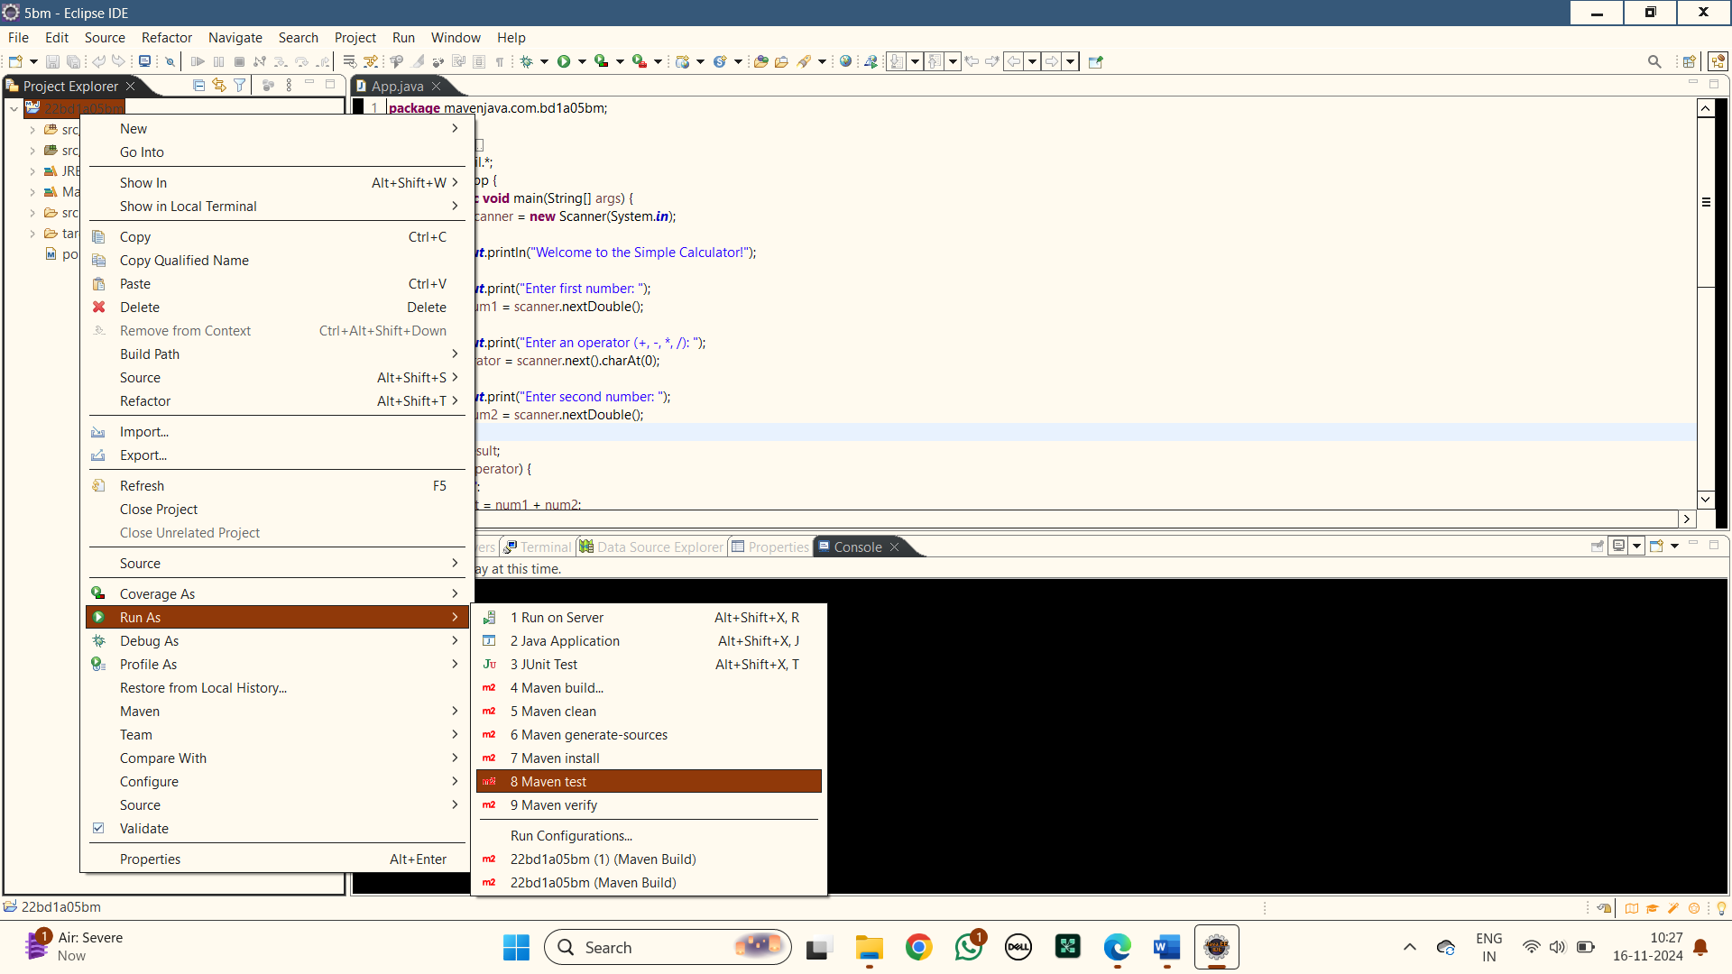

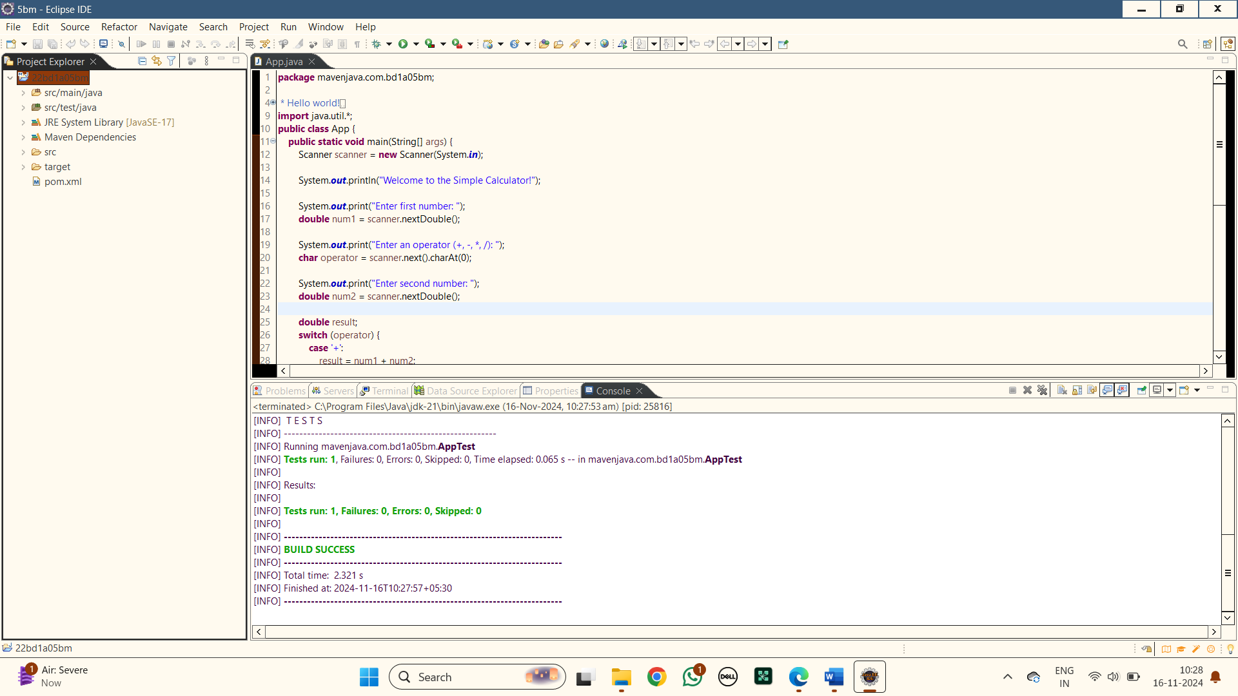

**11.Run as Java Application :** Right click the maven project file and select Run as the Java Application

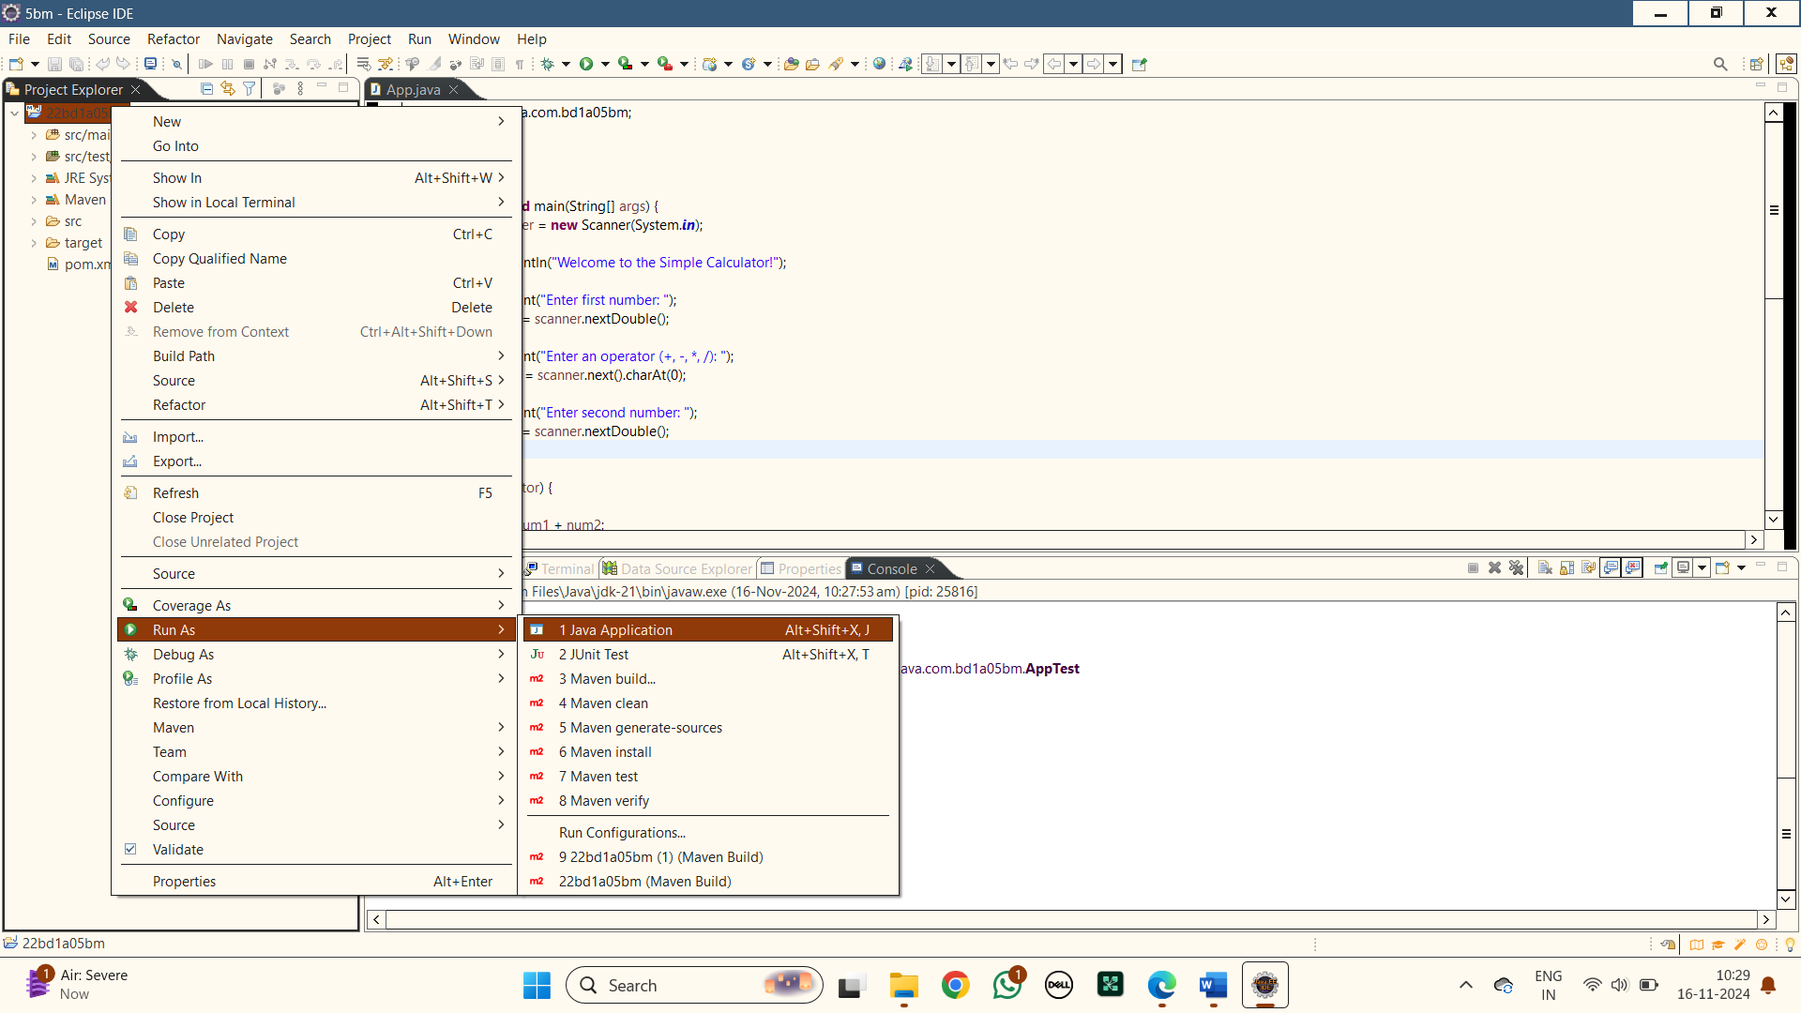

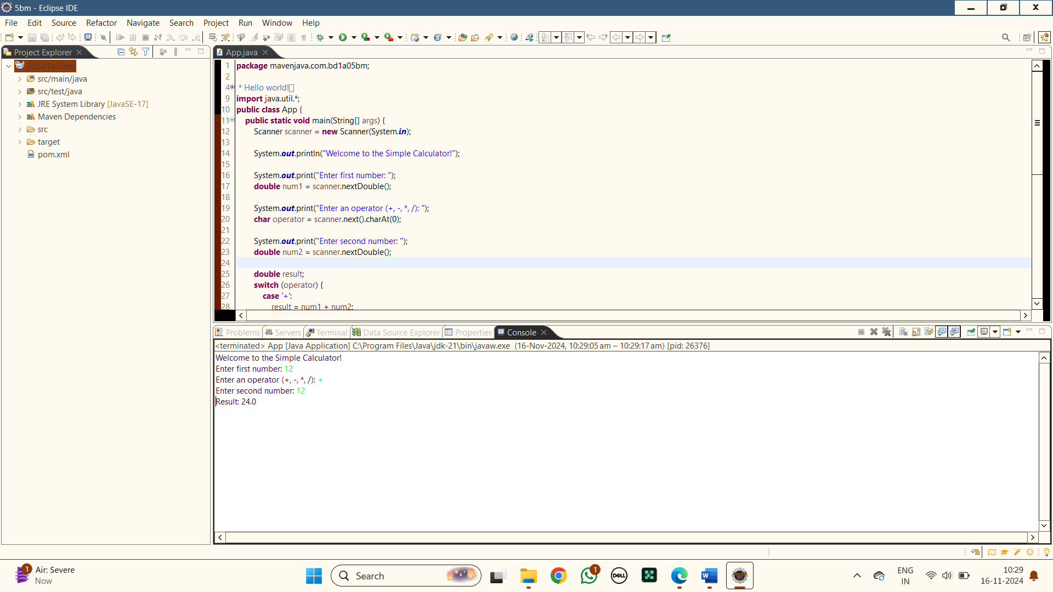

**12.Open with git bash :** Right click the maven project file and select show in local terminal and then select Git bash

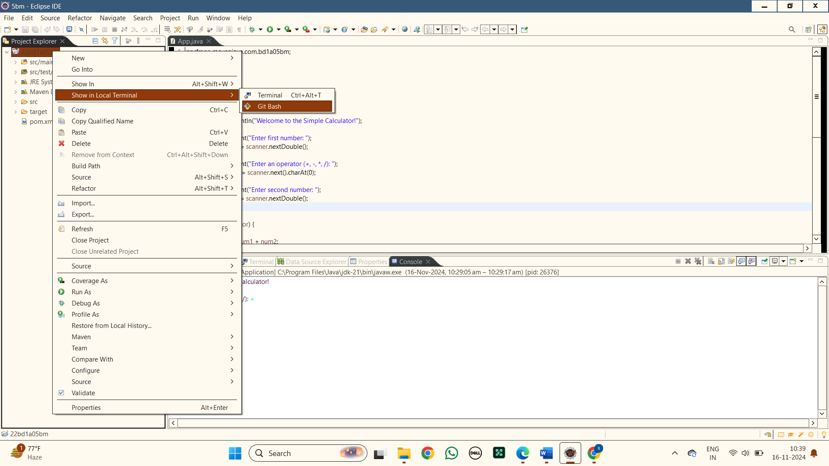

**13.Push the files into git hub**

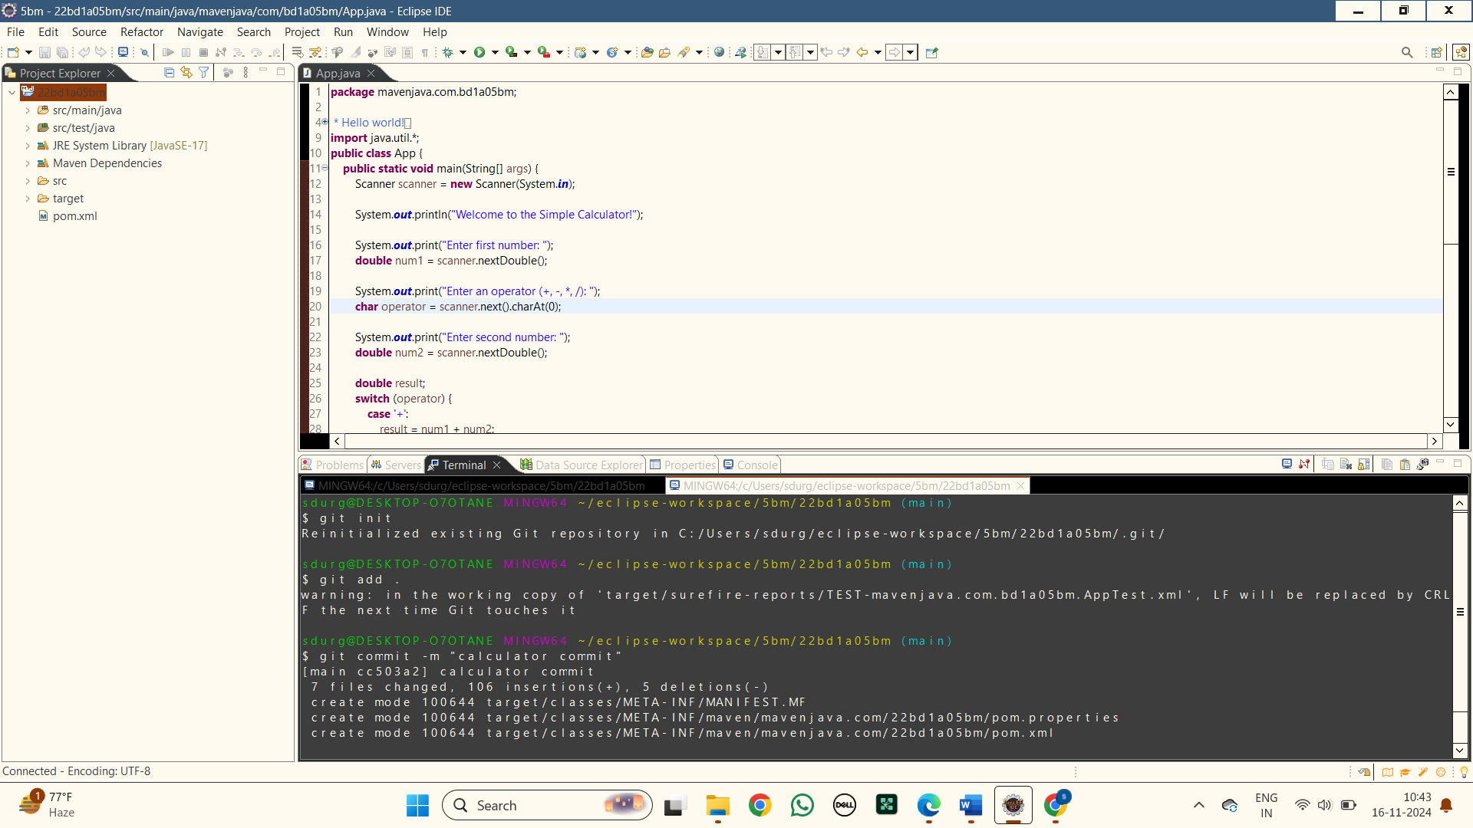

**14.Create a new repository in git hub to push the files**

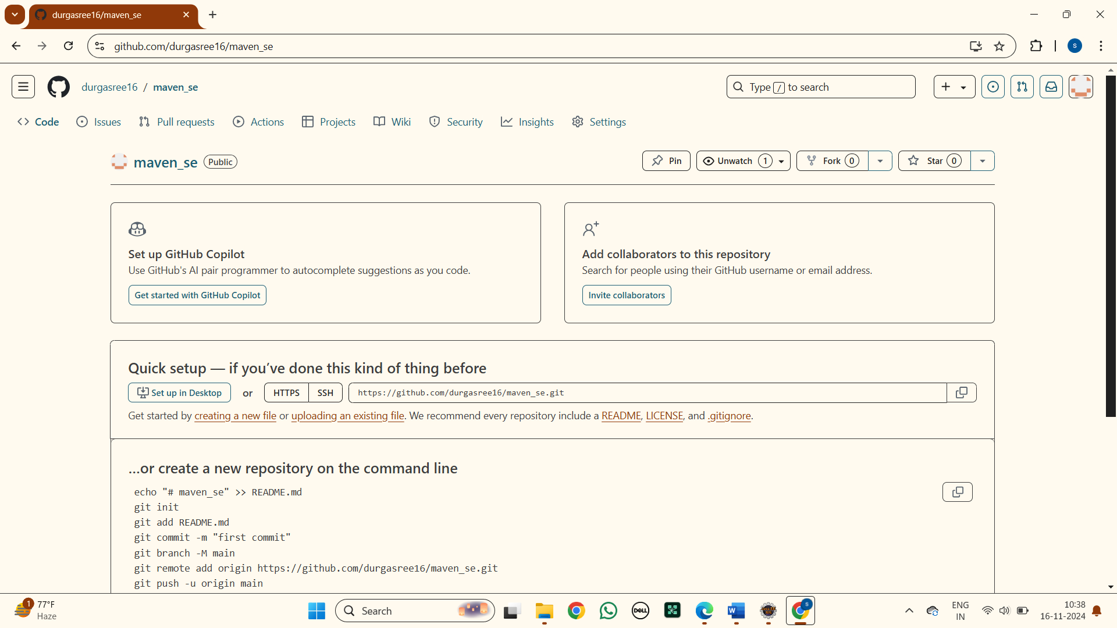

**15.Enter the following commands in order to push**

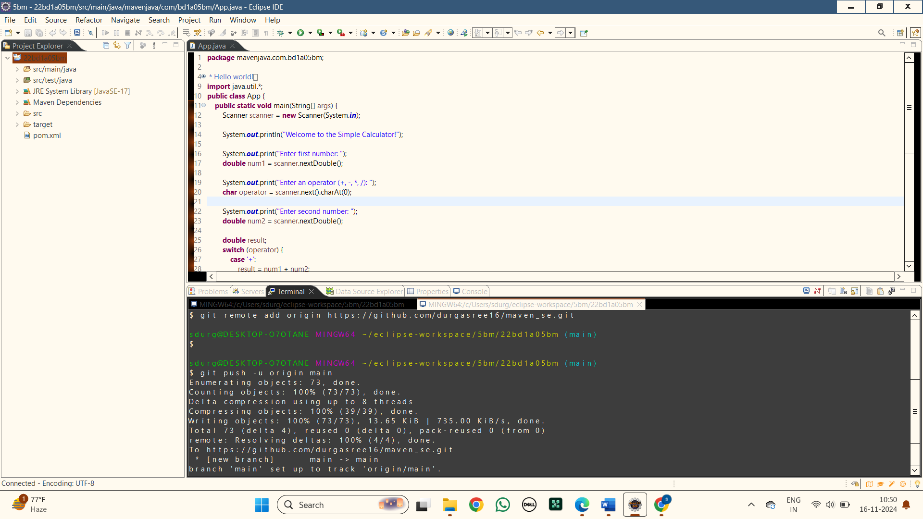

**16.Here are the files pushed into git hub of the MAVEN PROJECT**

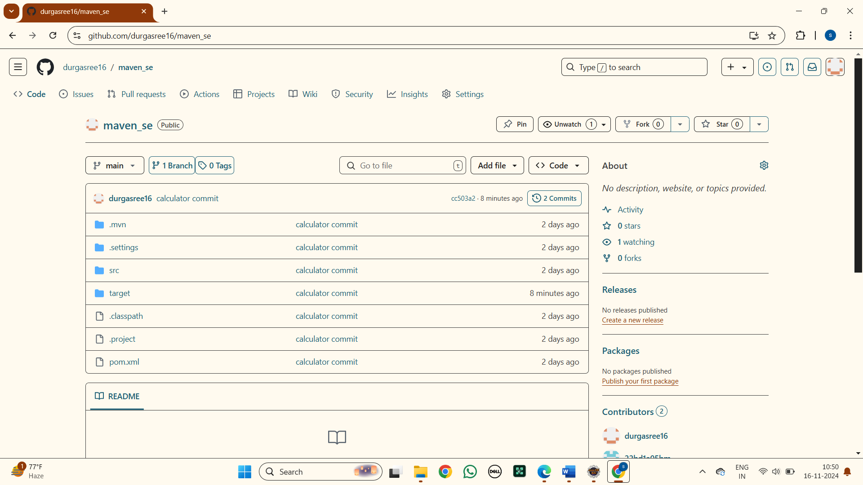

**17. Here is the link for the maven project in git hub :**

<https://github.com/durgasree16/maven_se>

**b) CREATING MAVEN WEB PROJECT USING ECLIPSE AND PUSH INTO TO GITHUB.**  
  
**MAVEN WEB PROJECT**

**1.Creating a new maven java project in eclipse :** Select Project name and location ,use default workspace

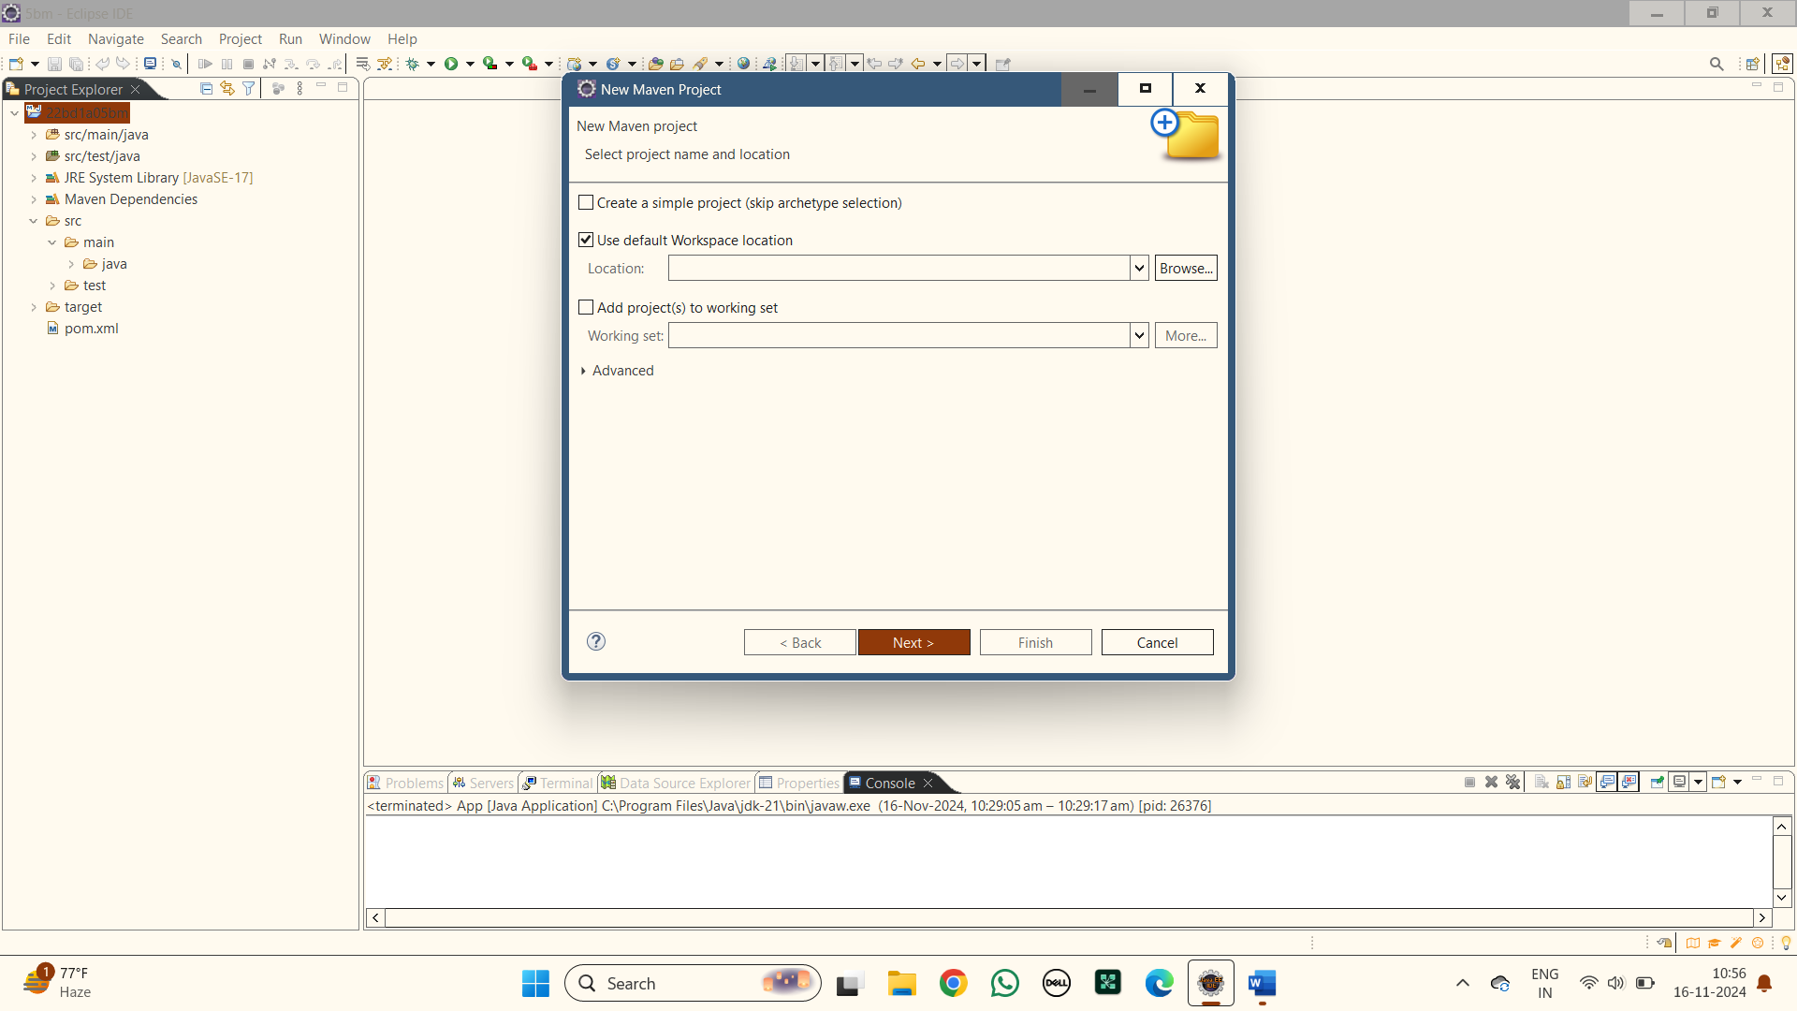

**2.Select An Archetype:** Selecting the archetype as webapp

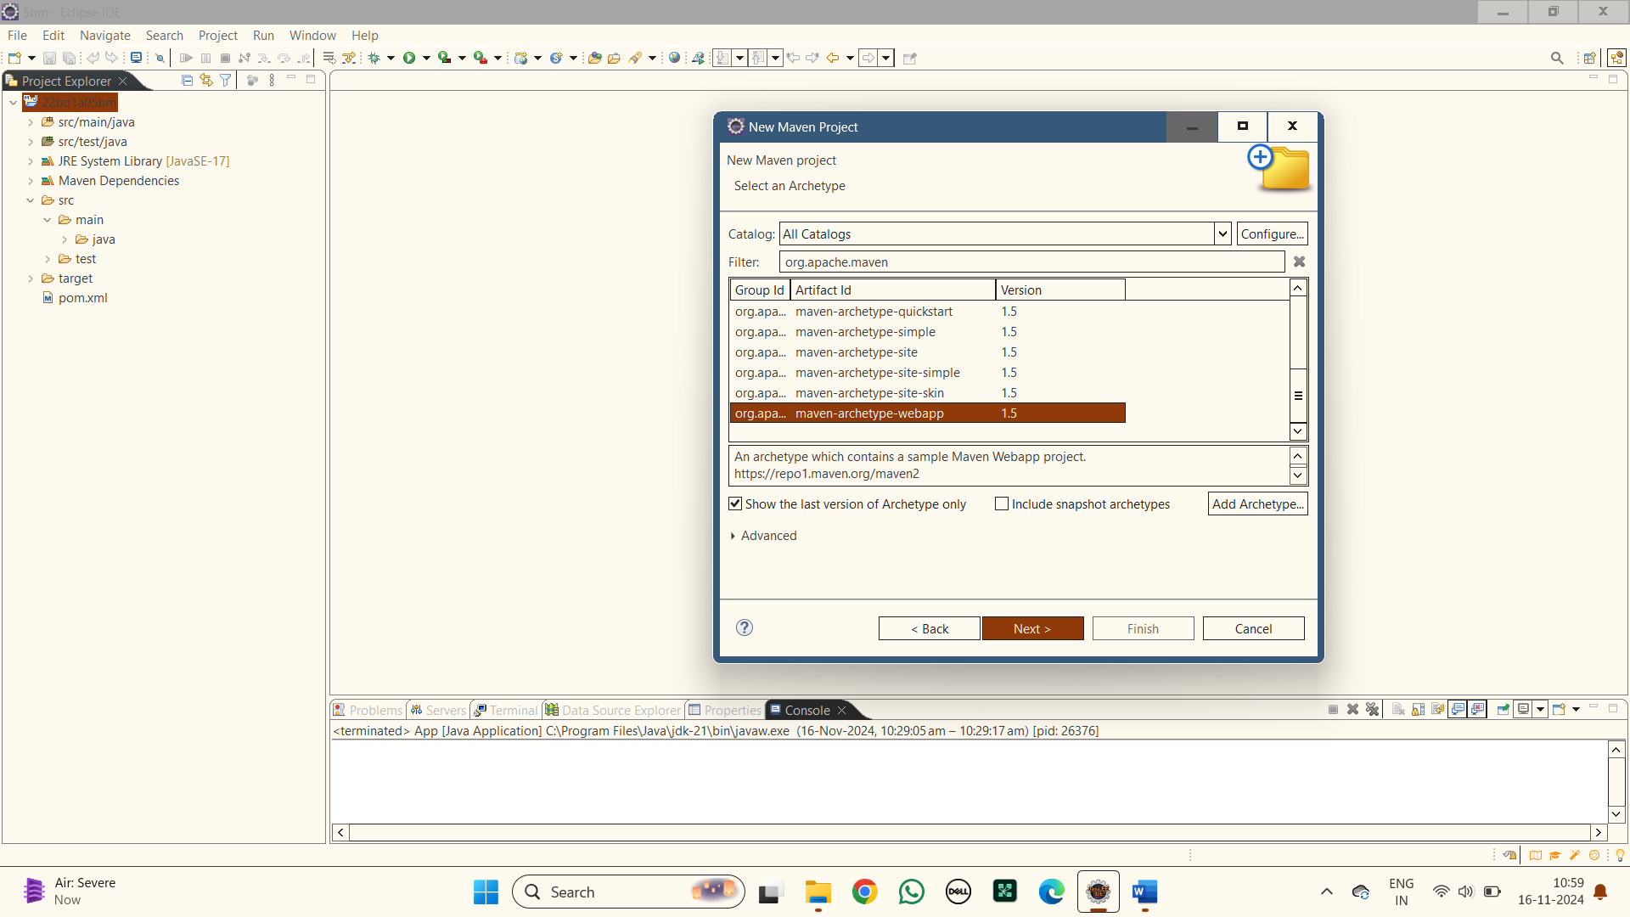

**3.Specify Archetype parameters :** Add GroupId as com.kmit and Artifact Id as maven_web_java1 or else any other name for ArtifactId and finish

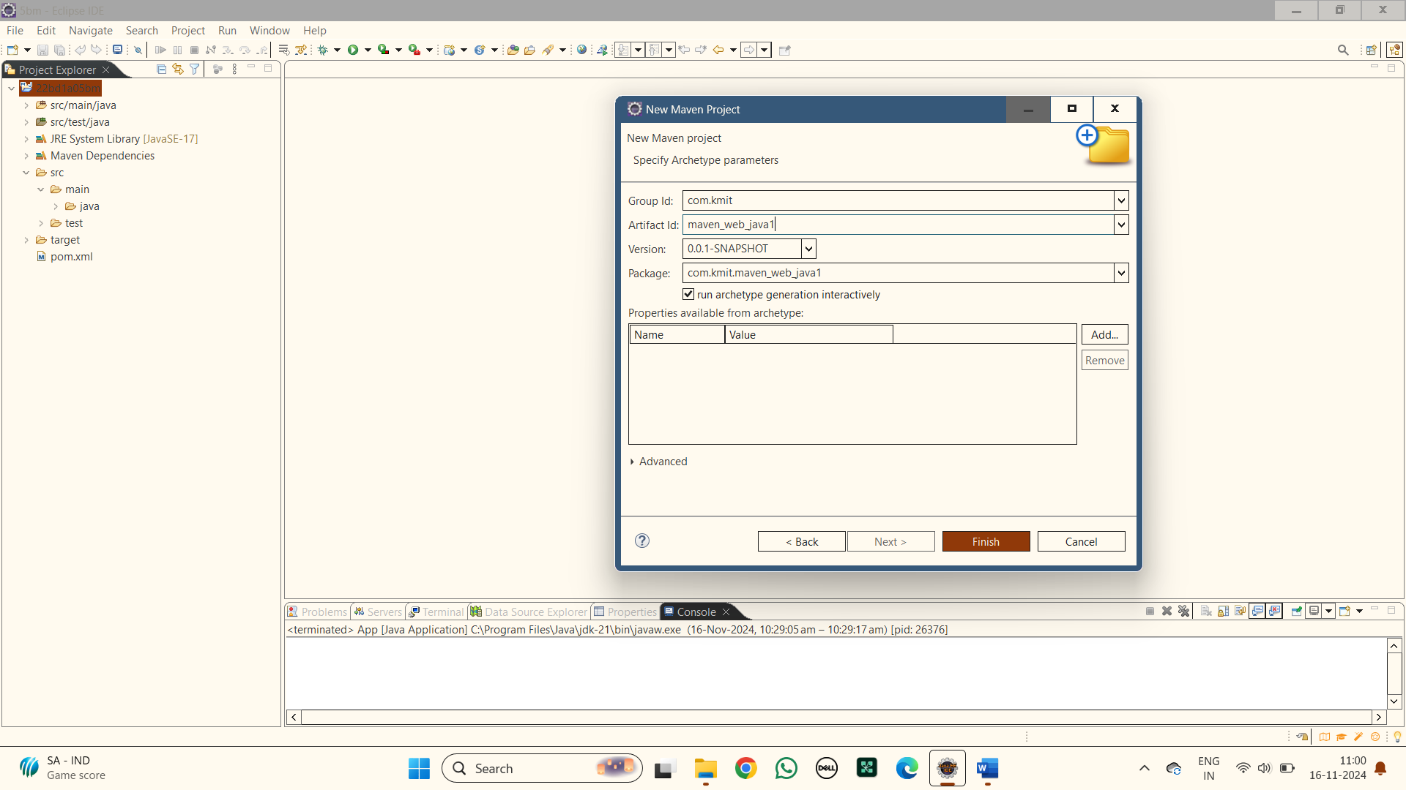

**4.Building of a new maven project is done**

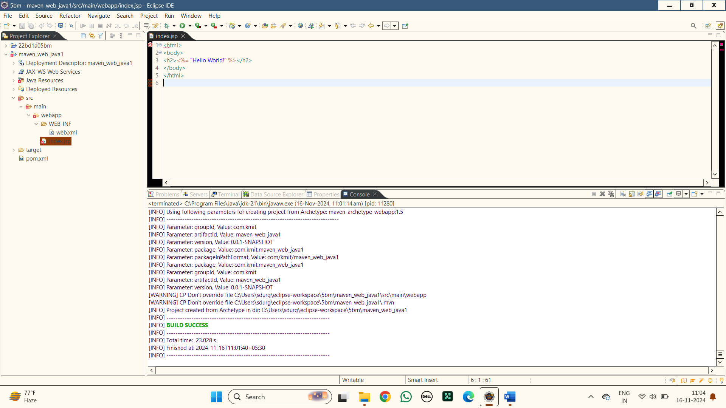

**6.Open App.java:** Open app.java file in the folder src>main>webapp>WEB-INF>index.jsp and write a simple html code

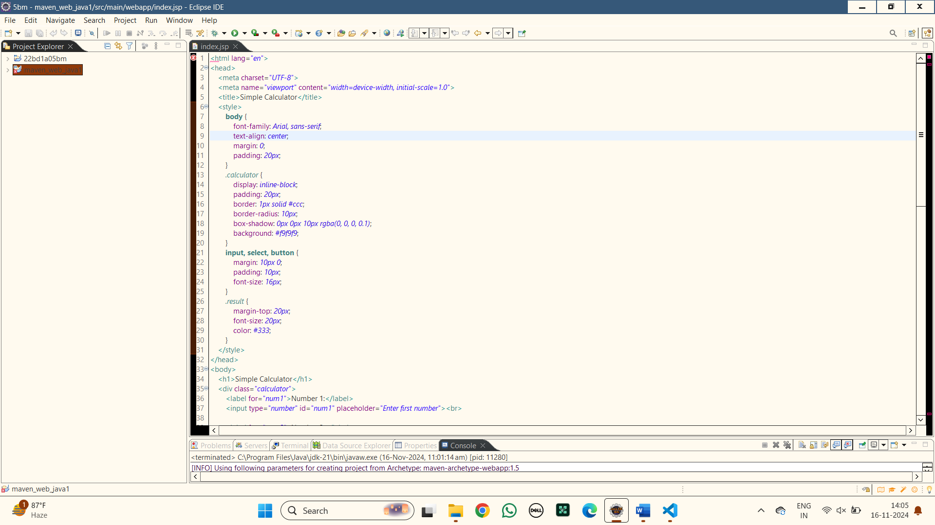

**7.Maven Clean :**Right click the maven project file and select Run as the select Maven clean

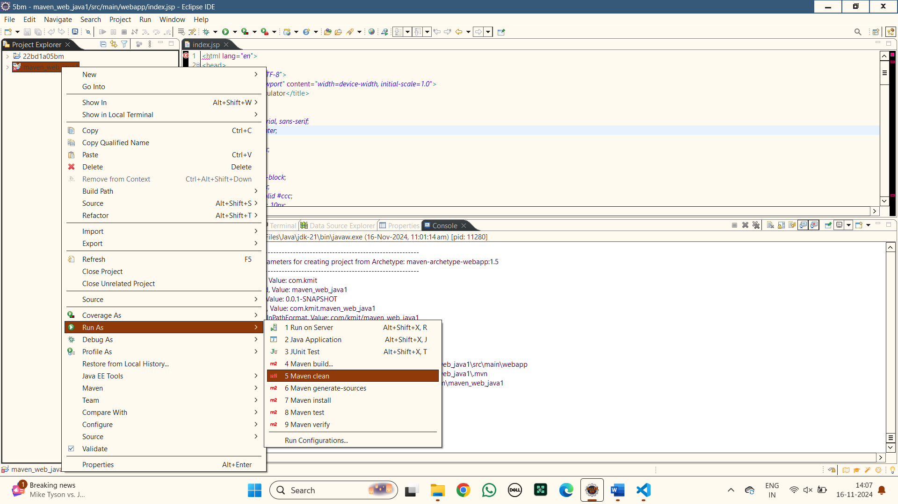

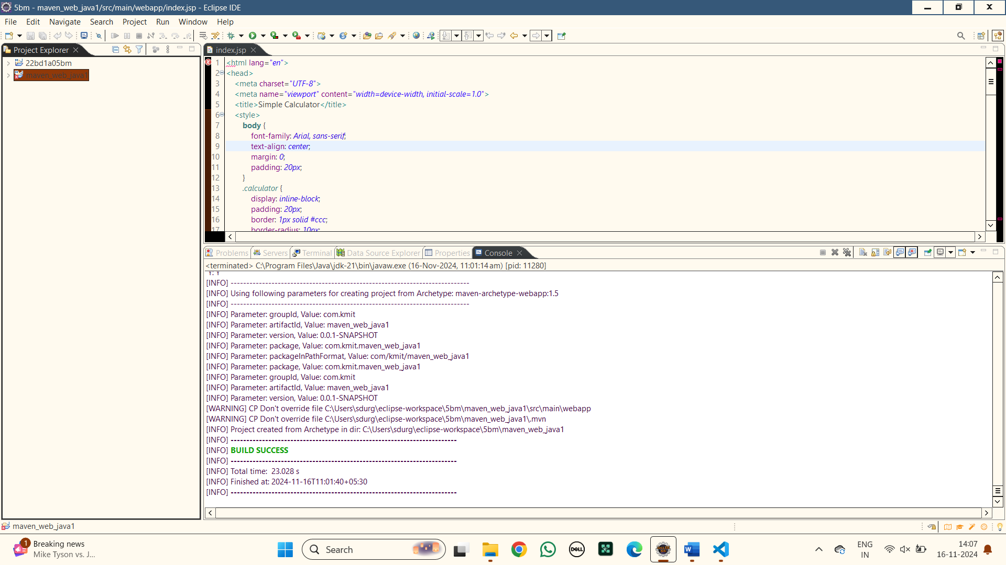

**8.Maven install :**Right click the maven project file and select Run as the select Maven install

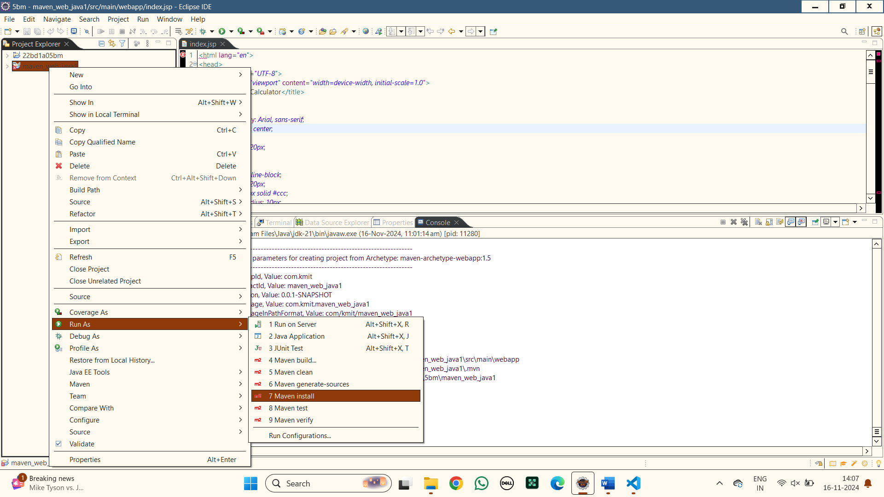

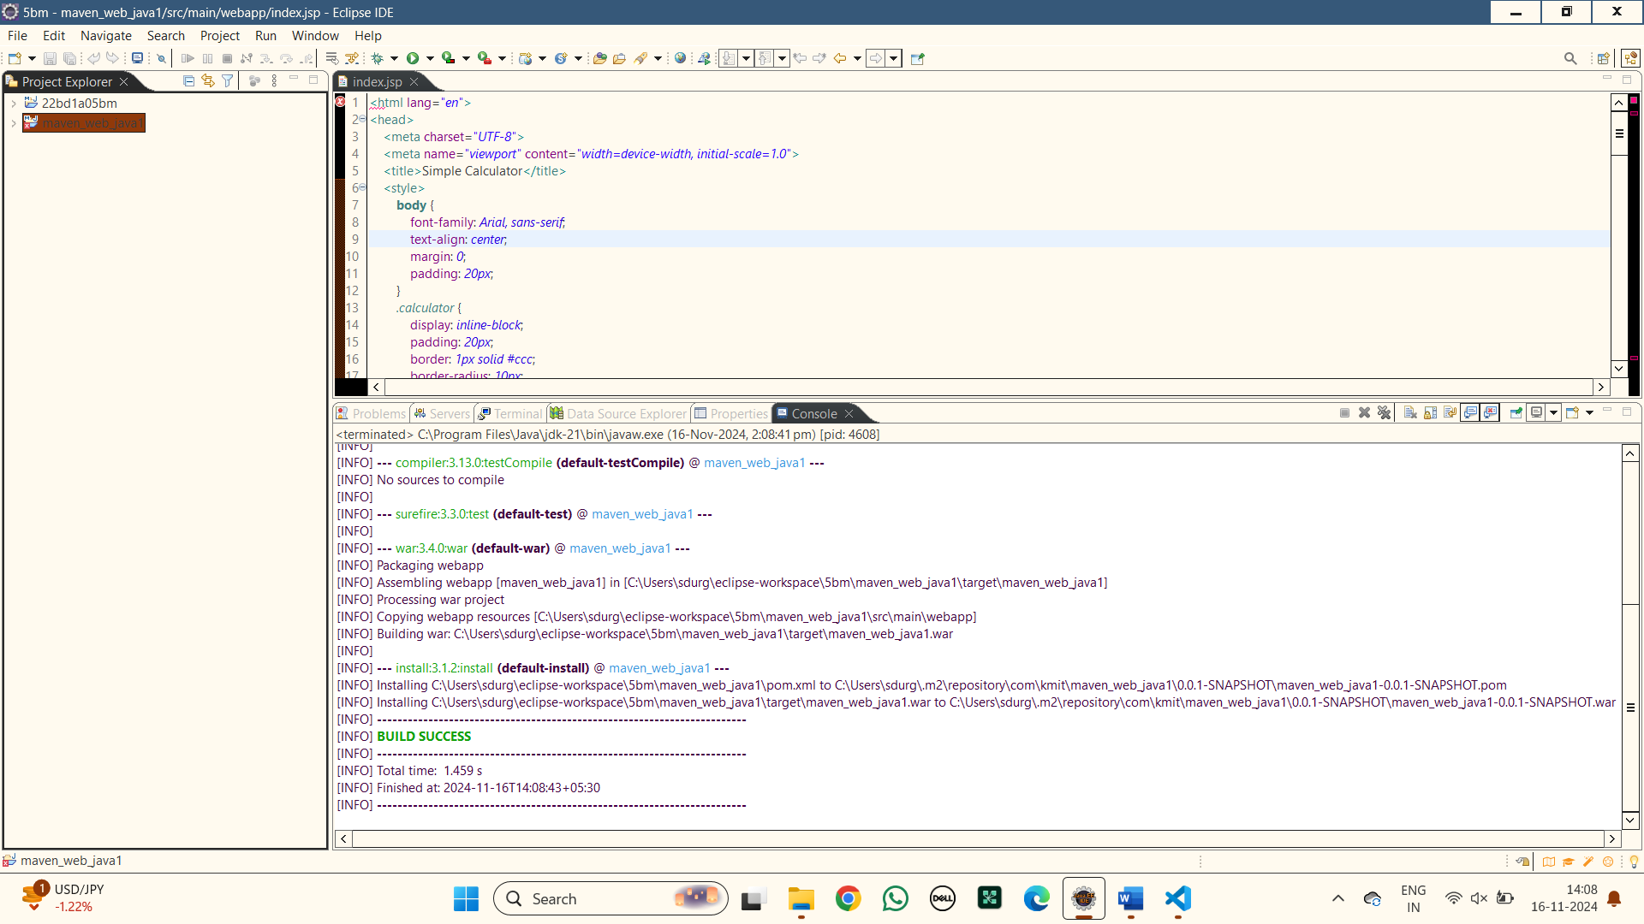

**9.Maven build:**Right click the maven project file and select Run as the select Maven build

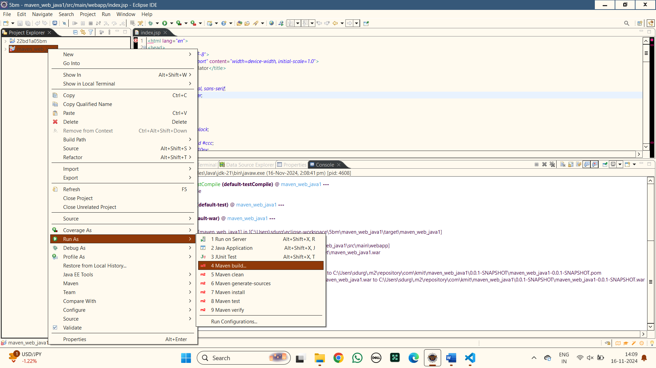

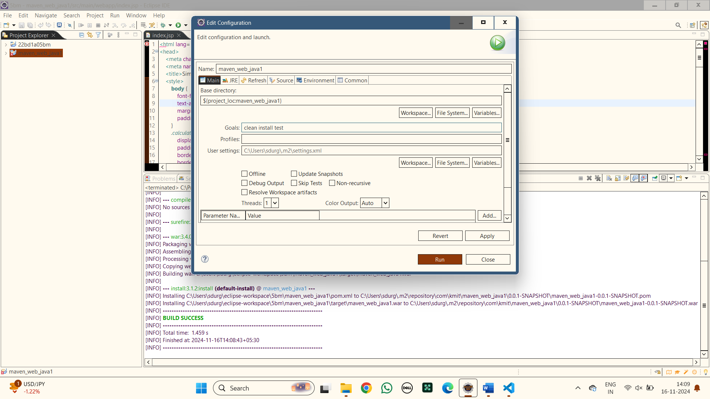

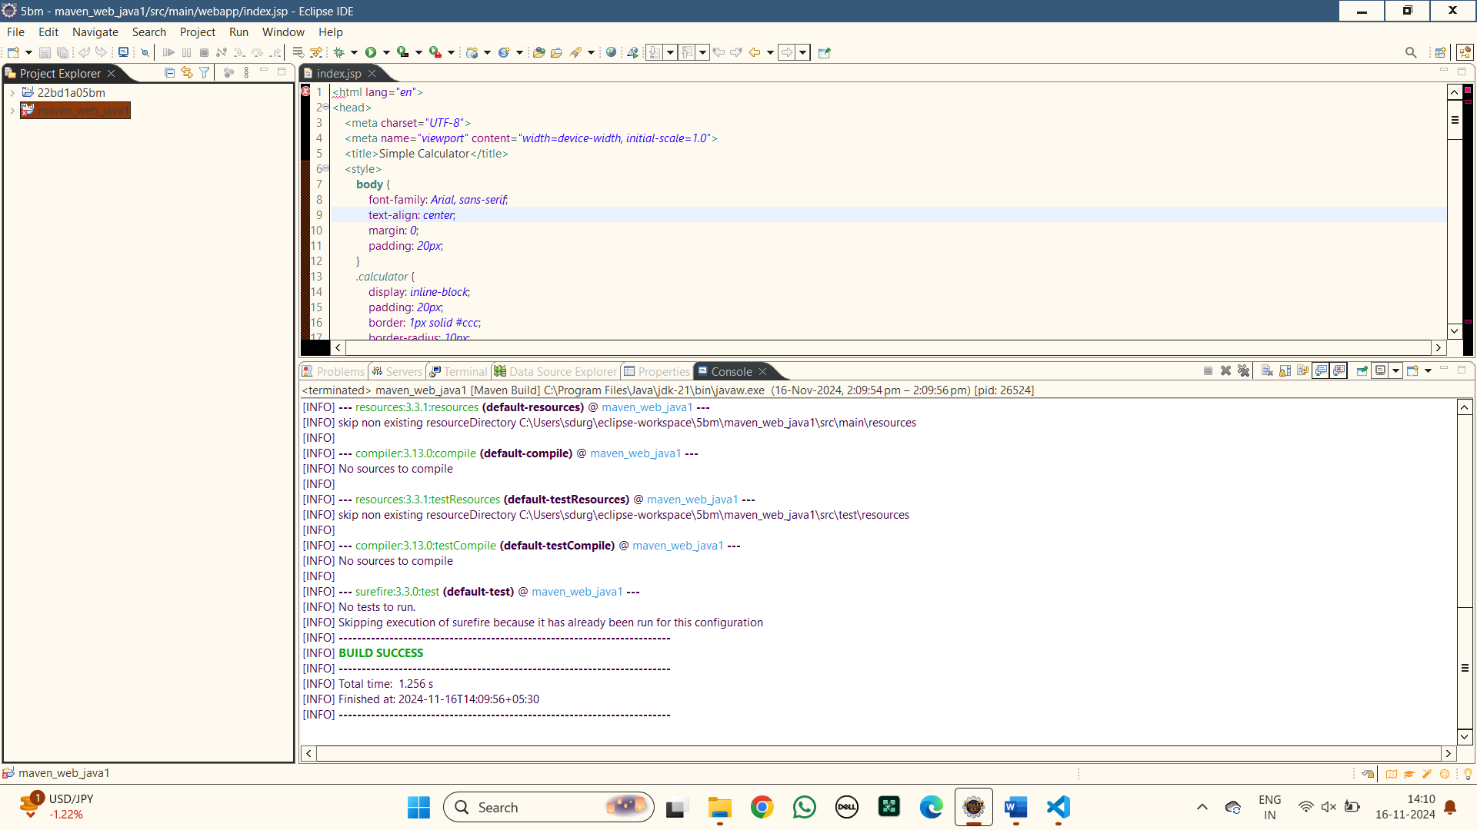

**10.Maven test:** Right click the maven project file and select Run as the select Maven test

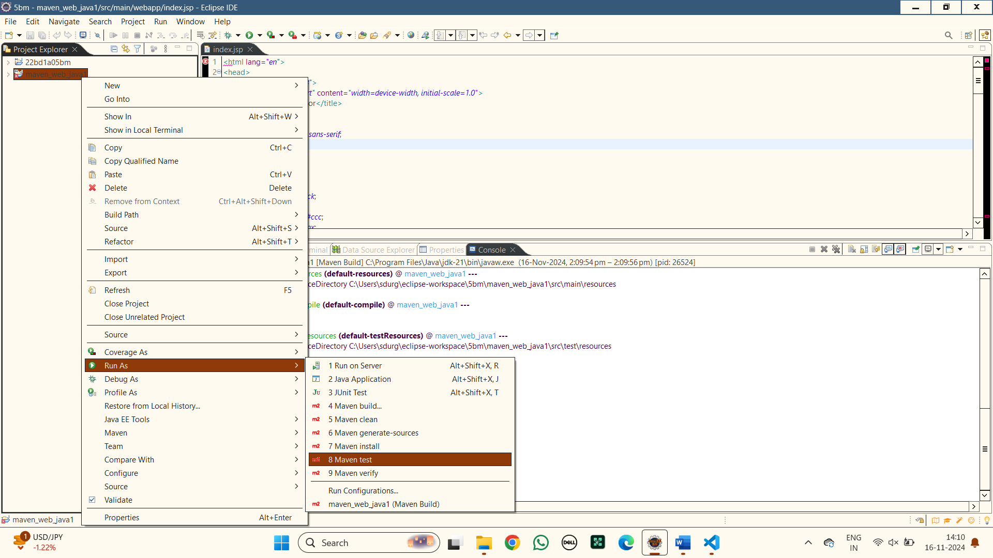

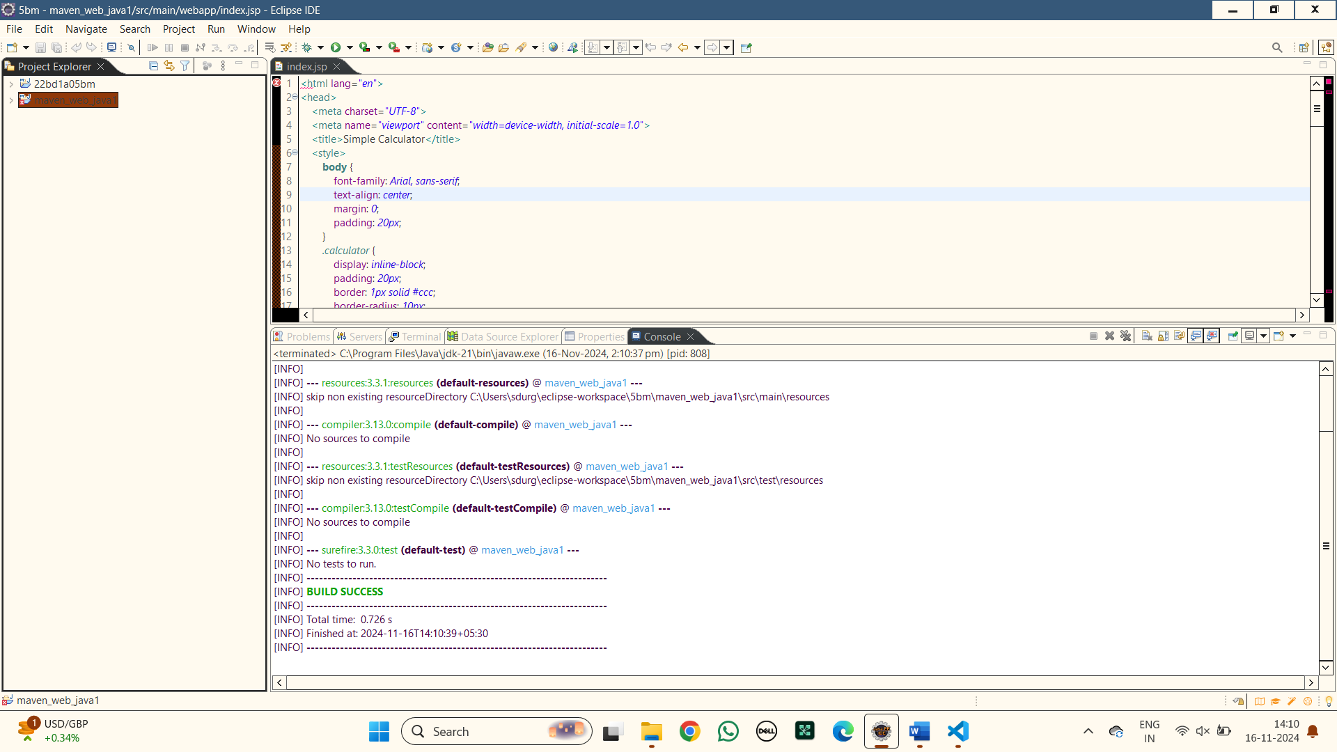

**11.Run as server :** Right click the maven project file and select Run as the select run as server

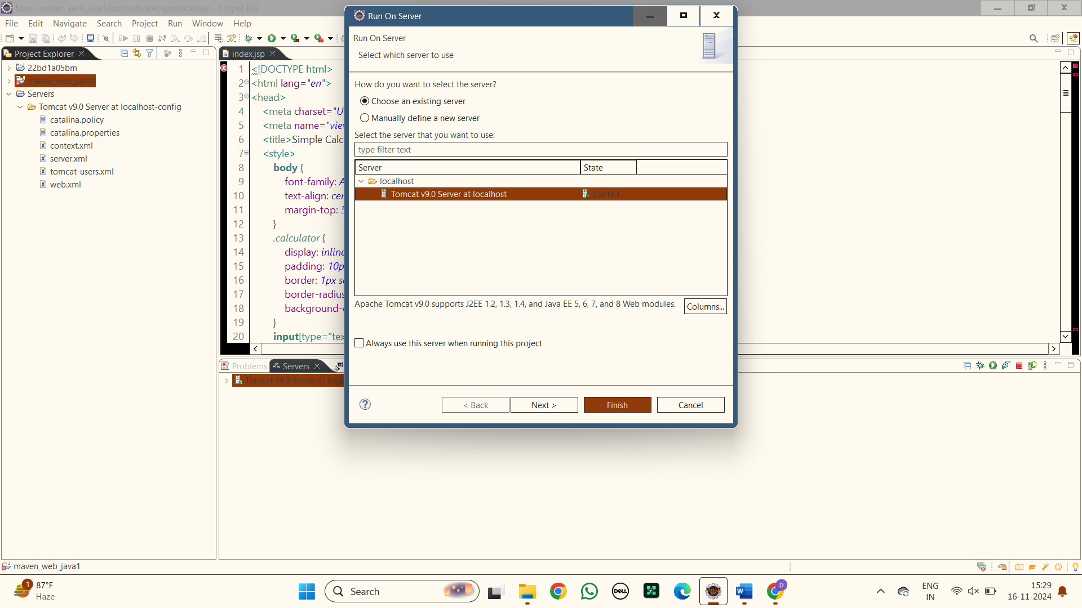

**12.Output:**

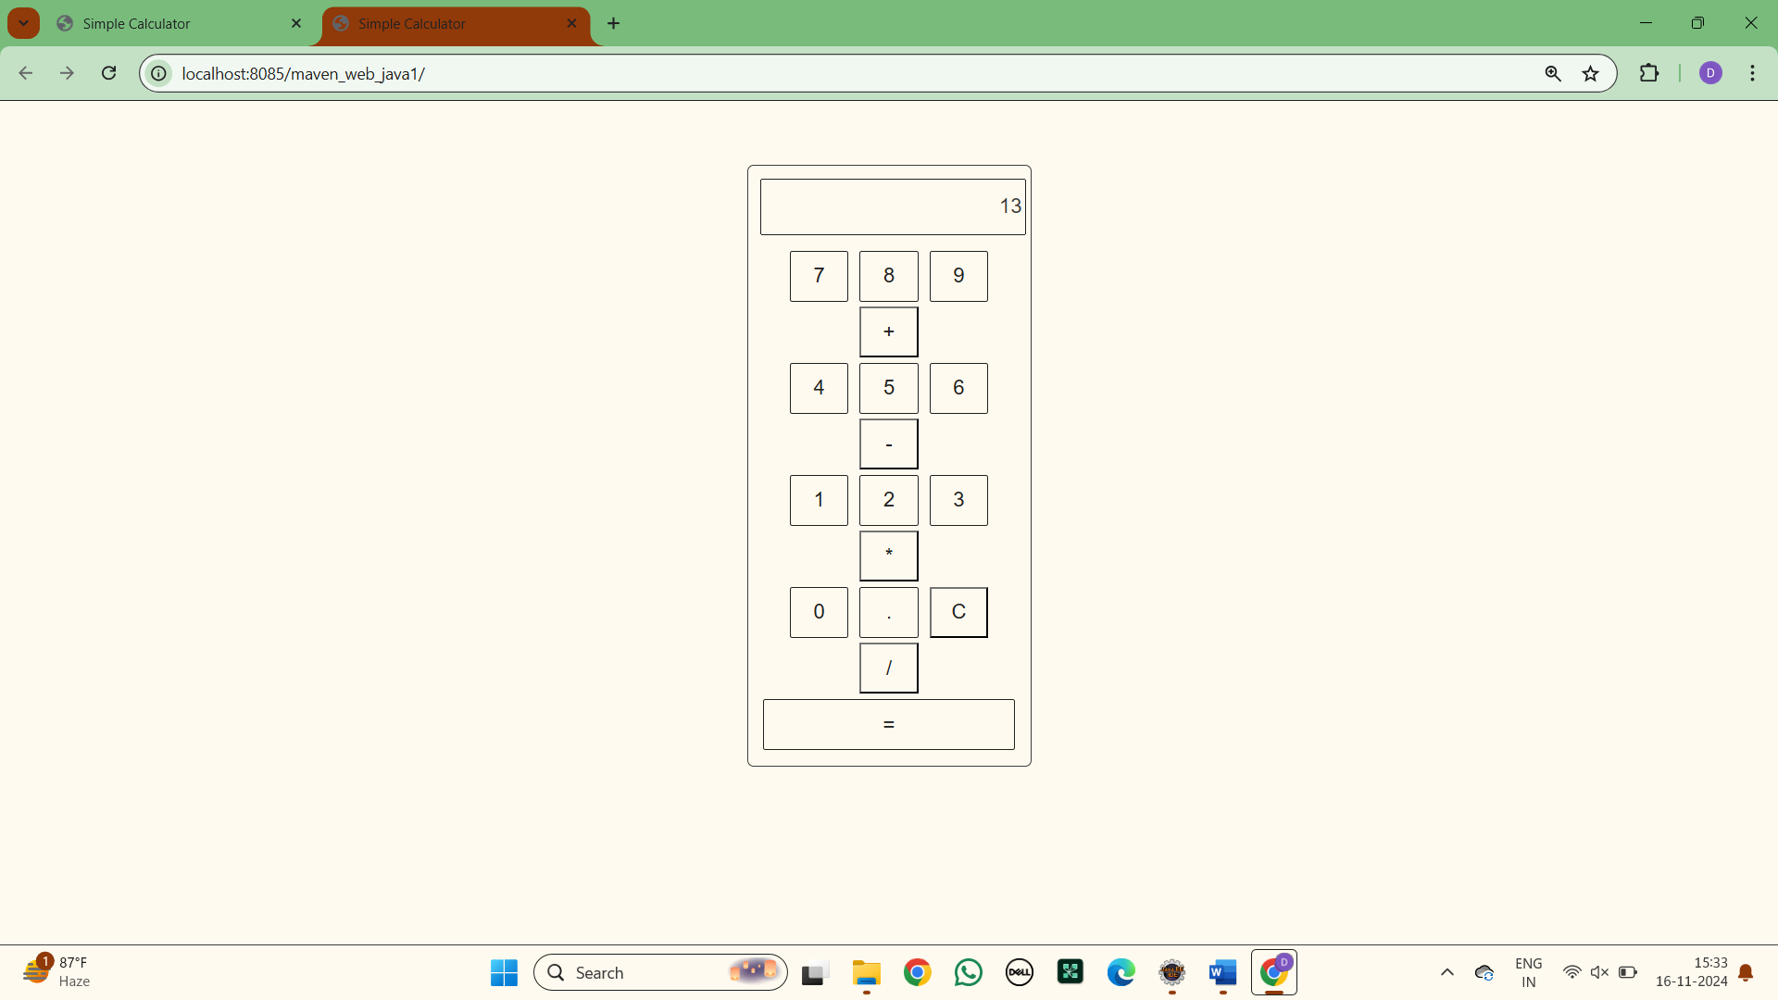

**13.Open with git bash :** Right click the maven project file and select show in local terminal and then select Git bash

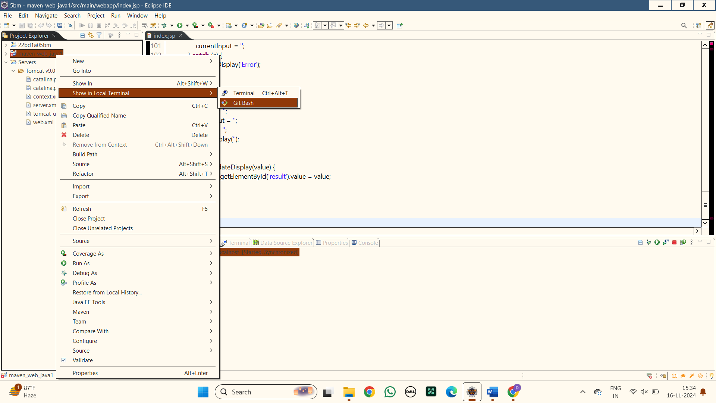

**14.Push the files into git hub**

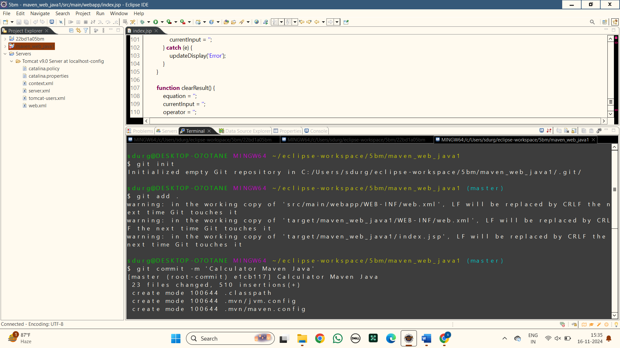

**15.Create a new repository in git hub to push the files**

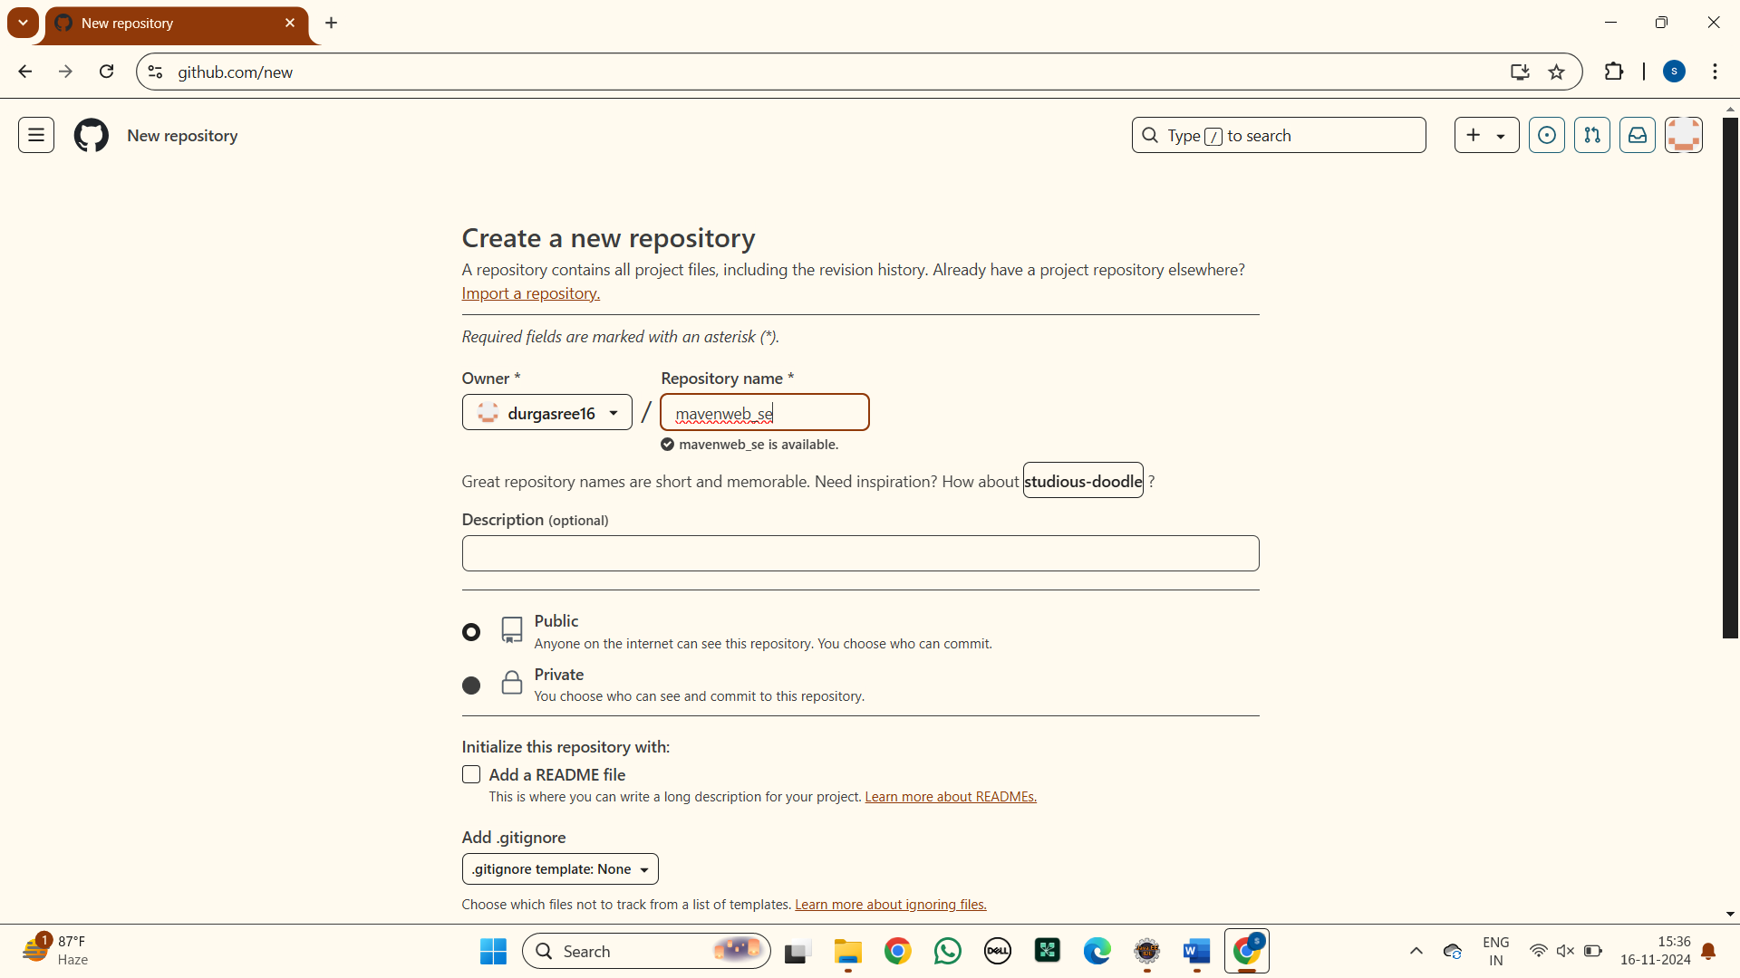

**16.Enter the following commands in order to push**

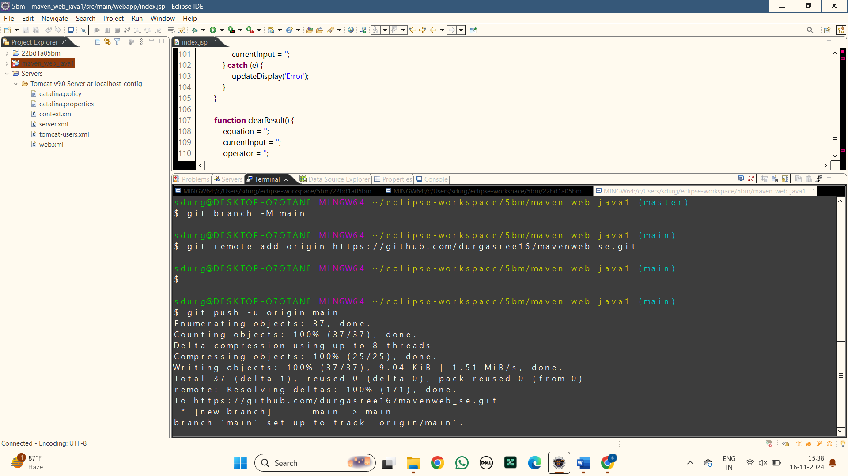

**17.Here are the files pushed into git hub of the MAVEN WEB PROJECT**

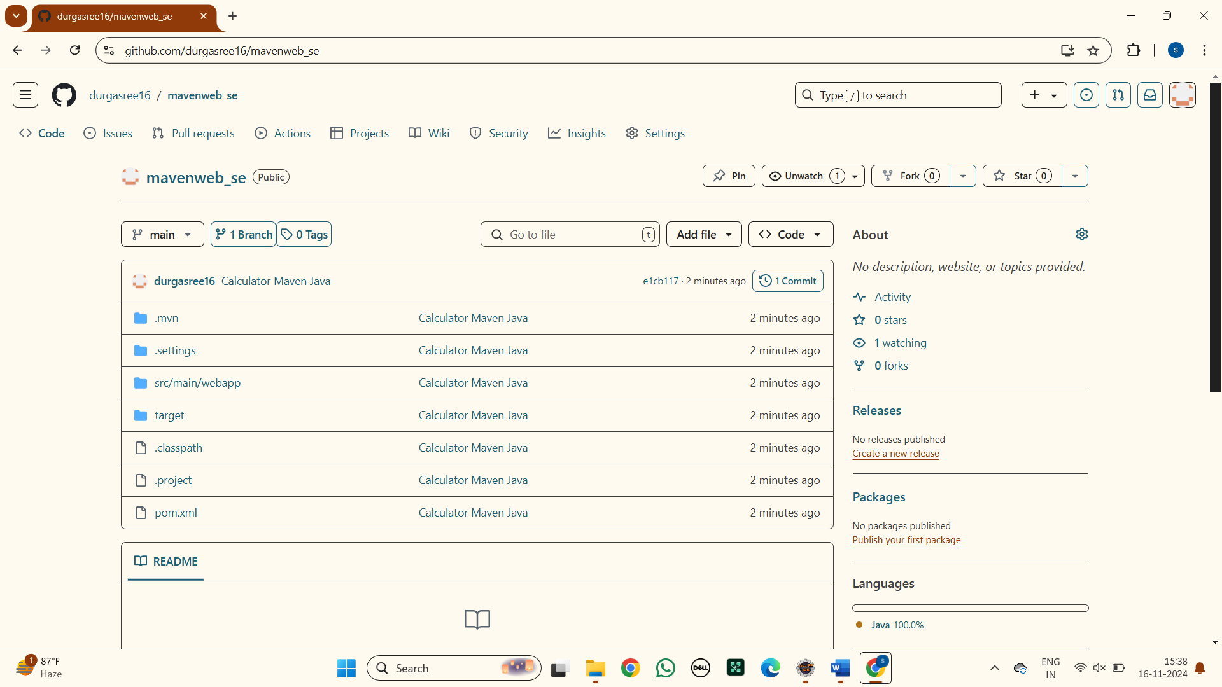

**17. Here is the link for the maven project in git hub :**

<https://github.com/durgasree16/mavenweb_se>

### C. INSTALLATION OF JENKINS

**JENKINS INSTALLATION**

1) Go to <https://www.jenkins.io/download/> and select the platform. In our case choose Windows under LTS.

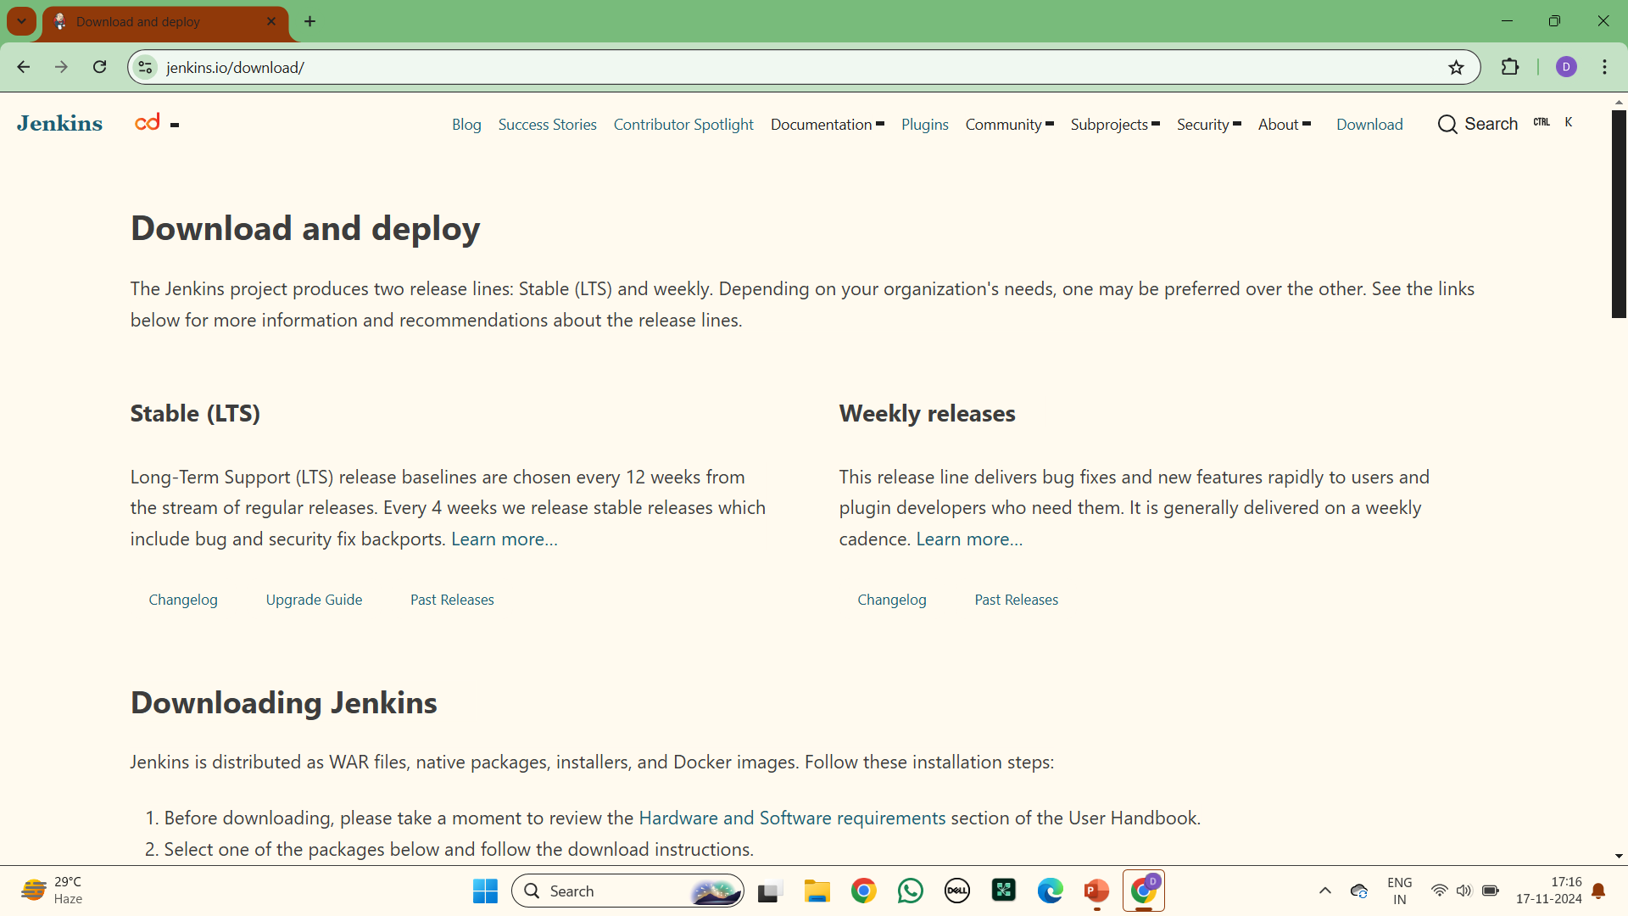

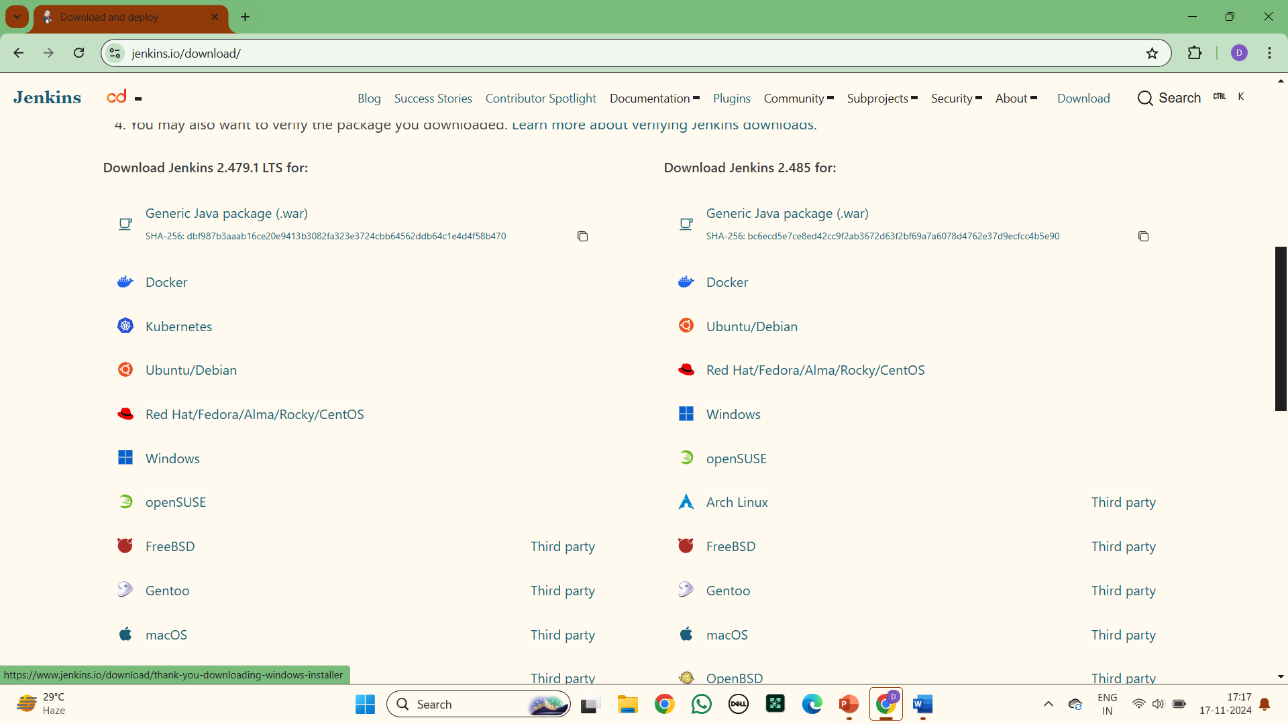

**2.** **Click on the download and then we get a page with thankyou for downloading**

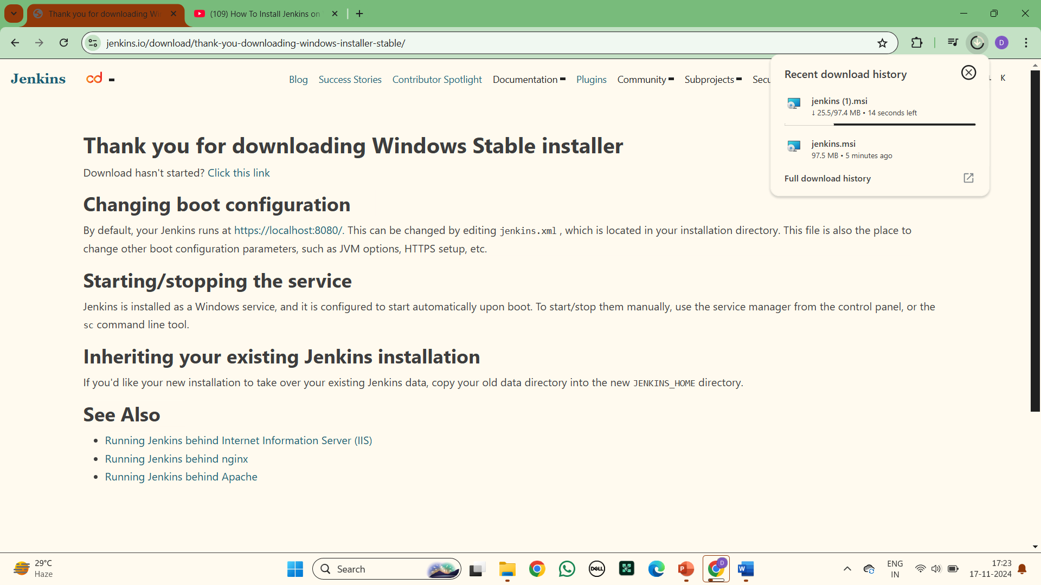

**3. Open the downloaded Jenkins file : we can see welcome to jenkins and enter next**

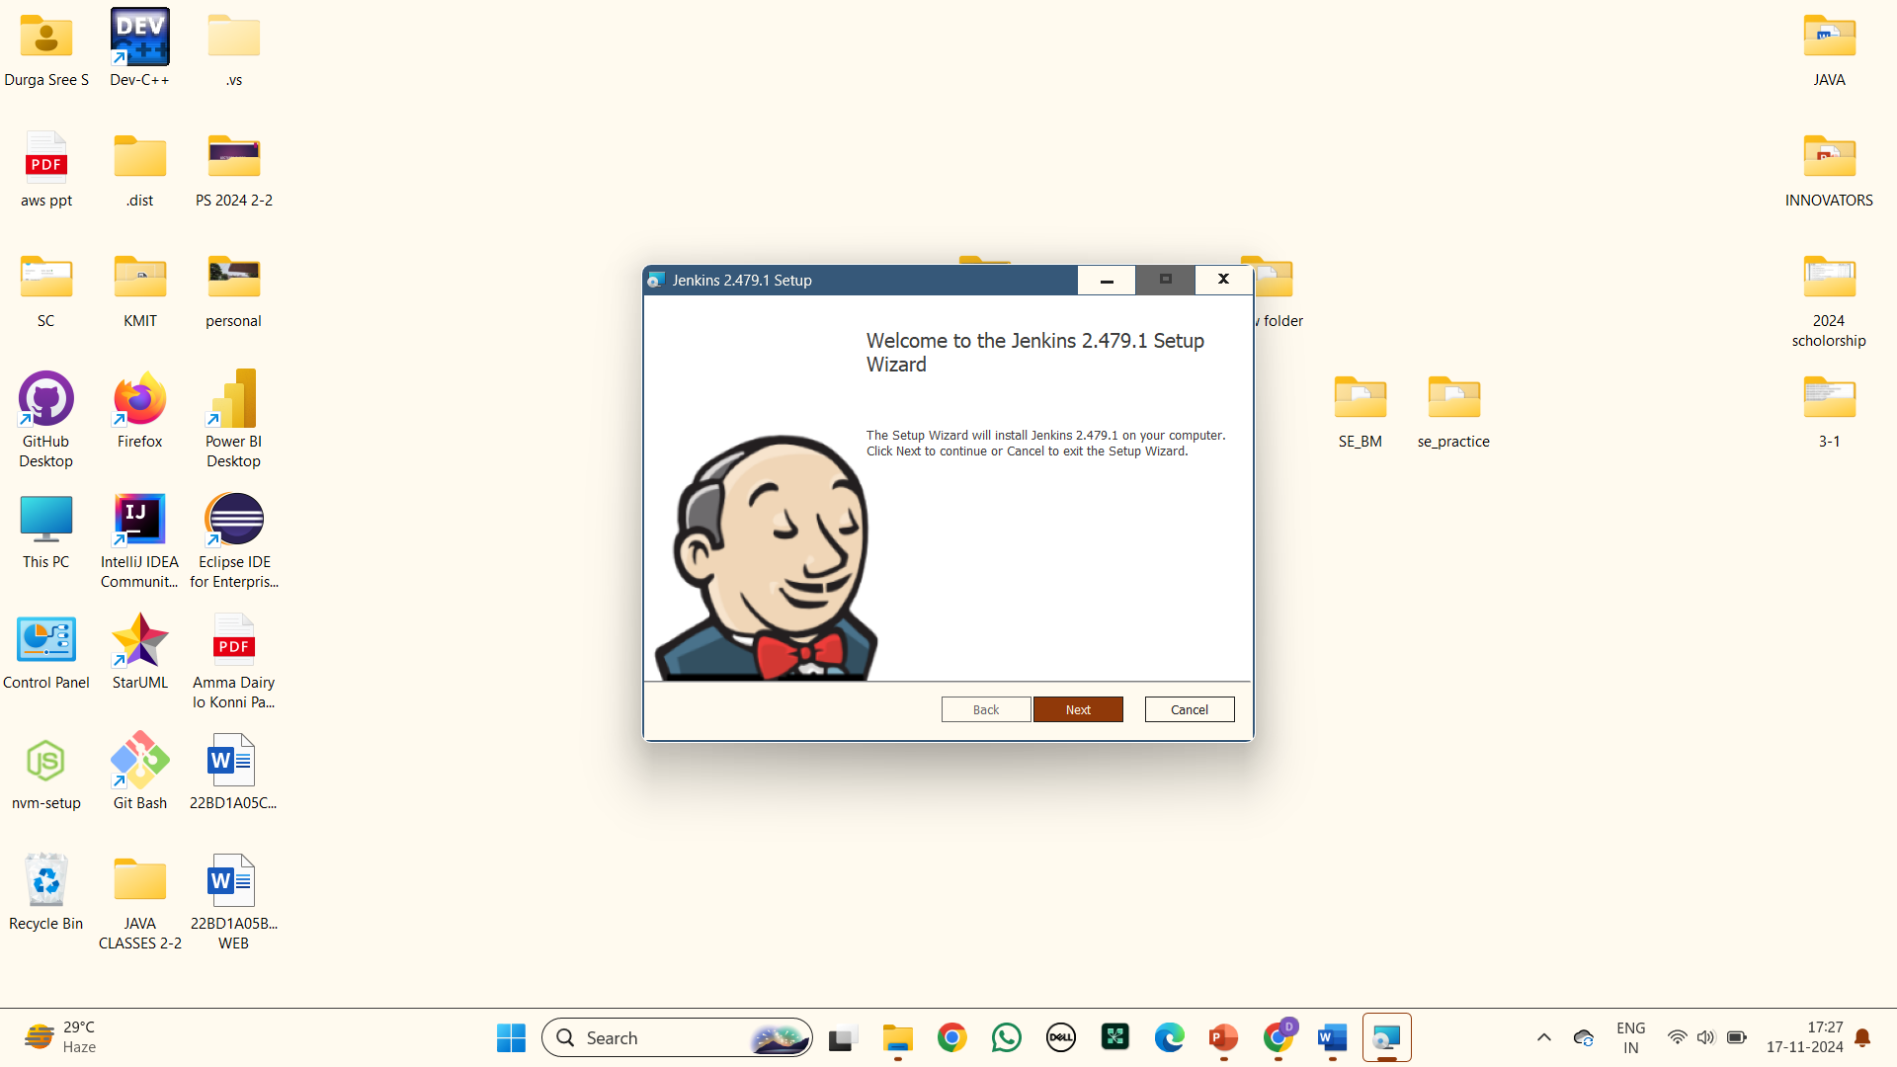

**4.Select the destination folder and enter next**

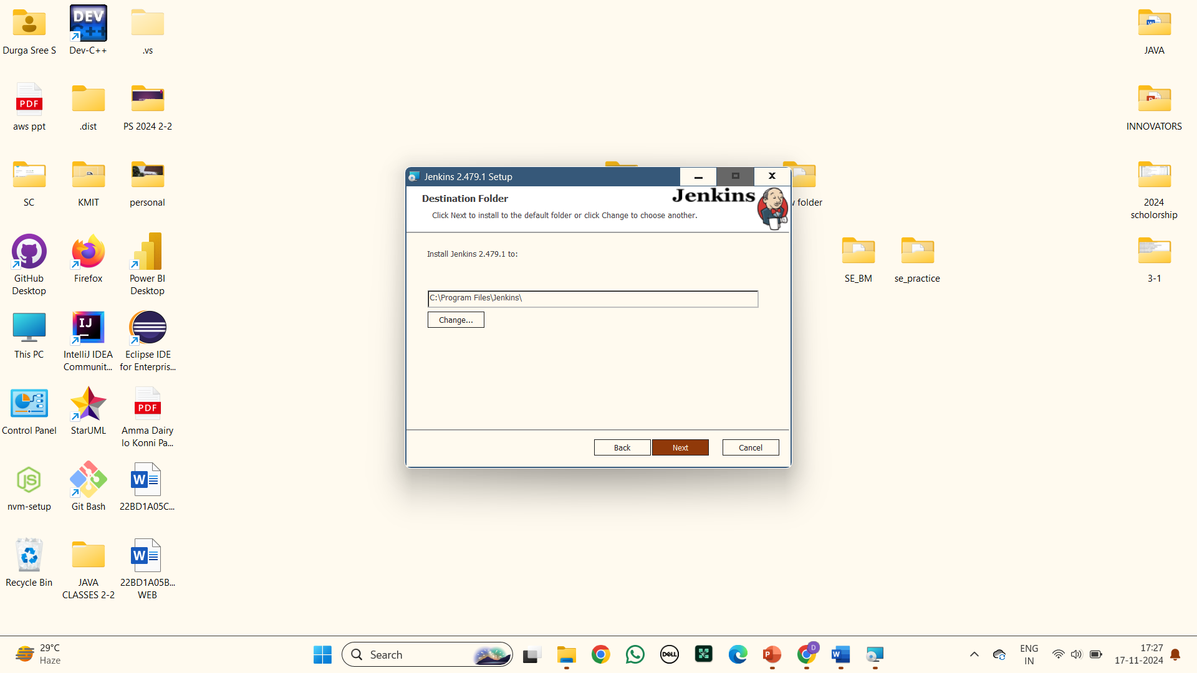

**5.Enter service login credentials : Select Run service as local system**

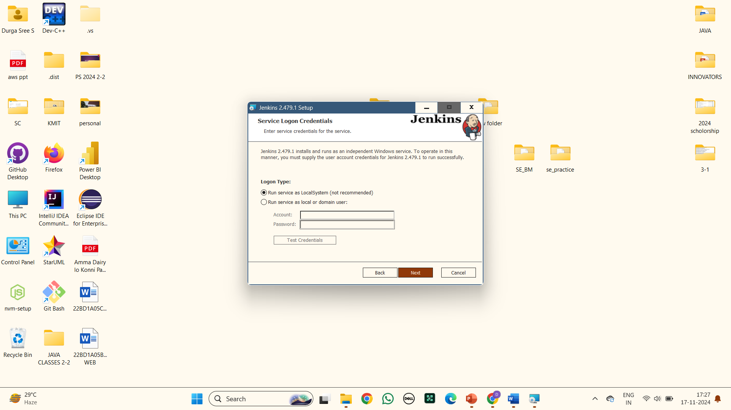

**6.Choose a port number for the service :Enter port as 8081 and click on test port, next**

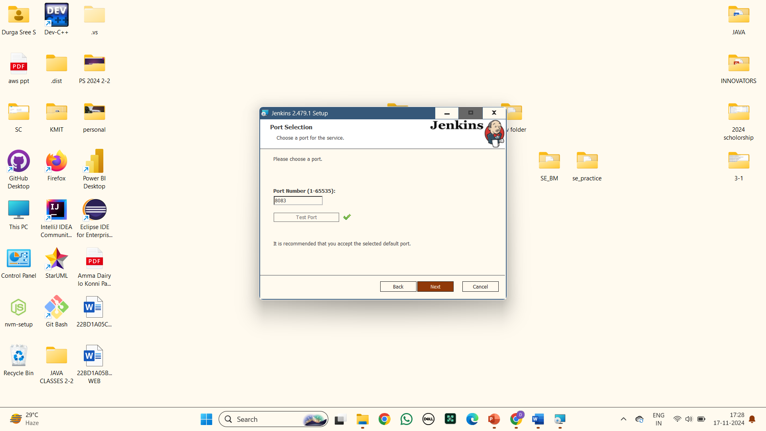

**7. Select java home directory : only java 17 and 21 are supported by Jenkins and click on next**

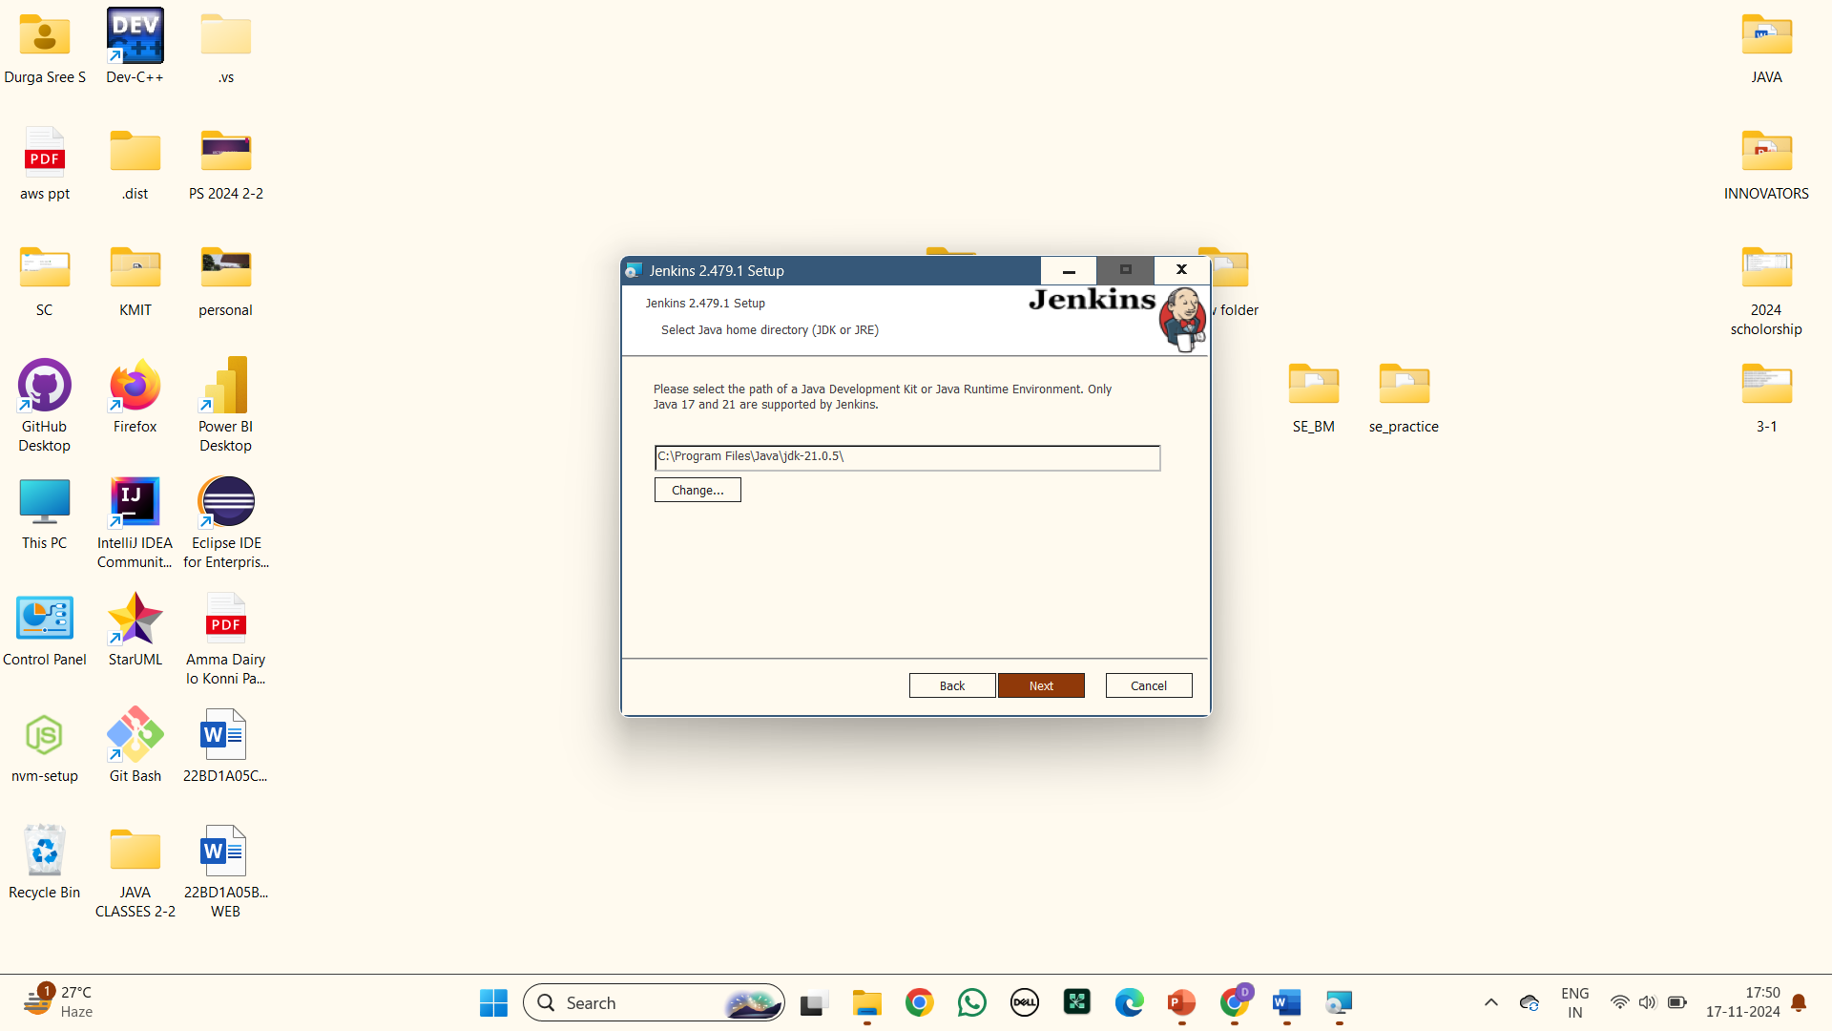

**8.Select the way you want features to be installed**

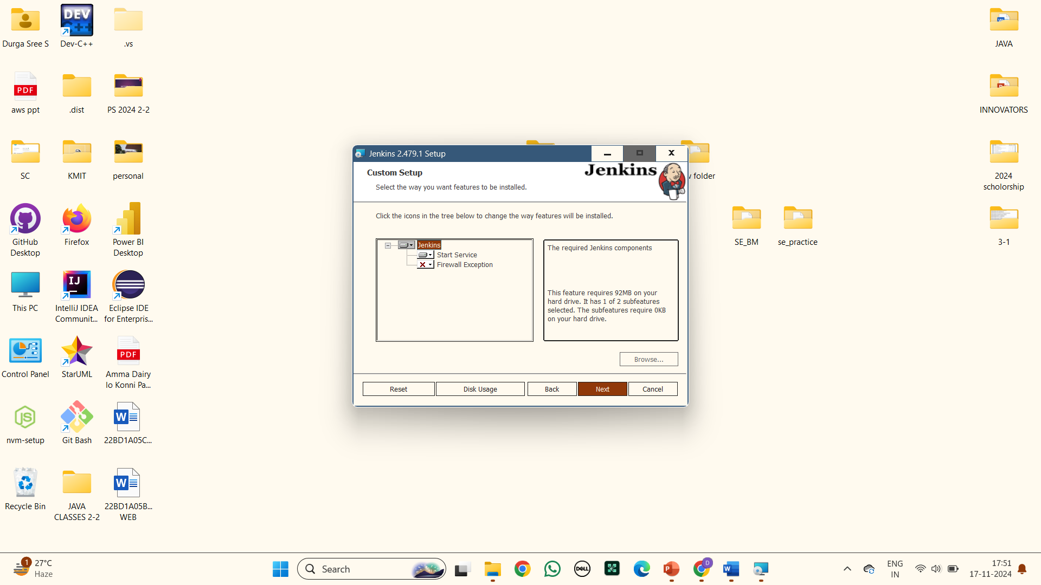

**9.Now jenkins is ready to install : Click on install**

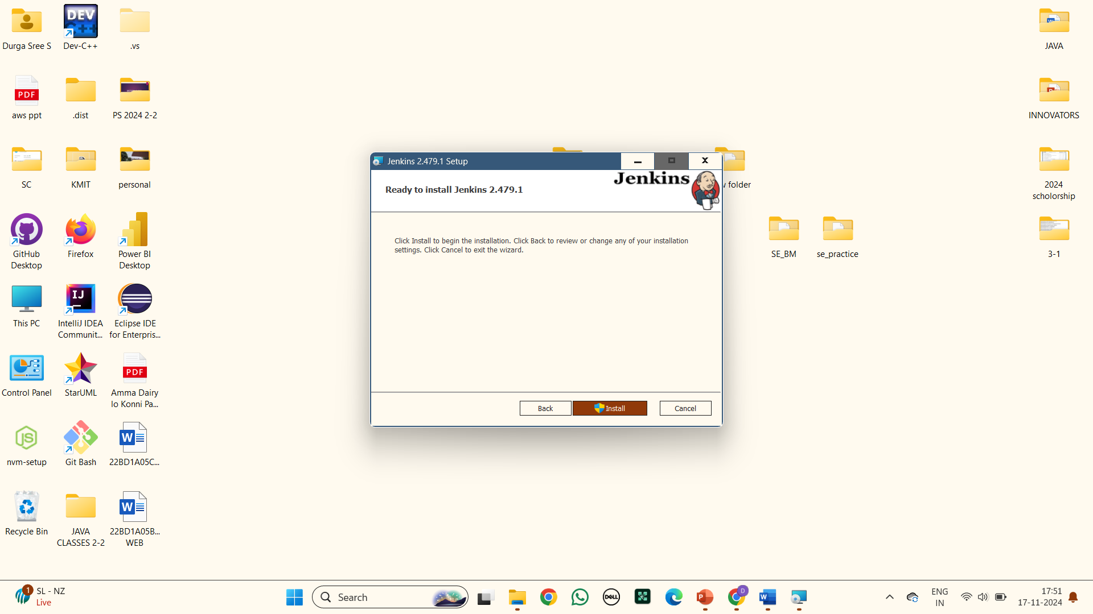

**10.Your Jenkins Installation was done :Click on finish**

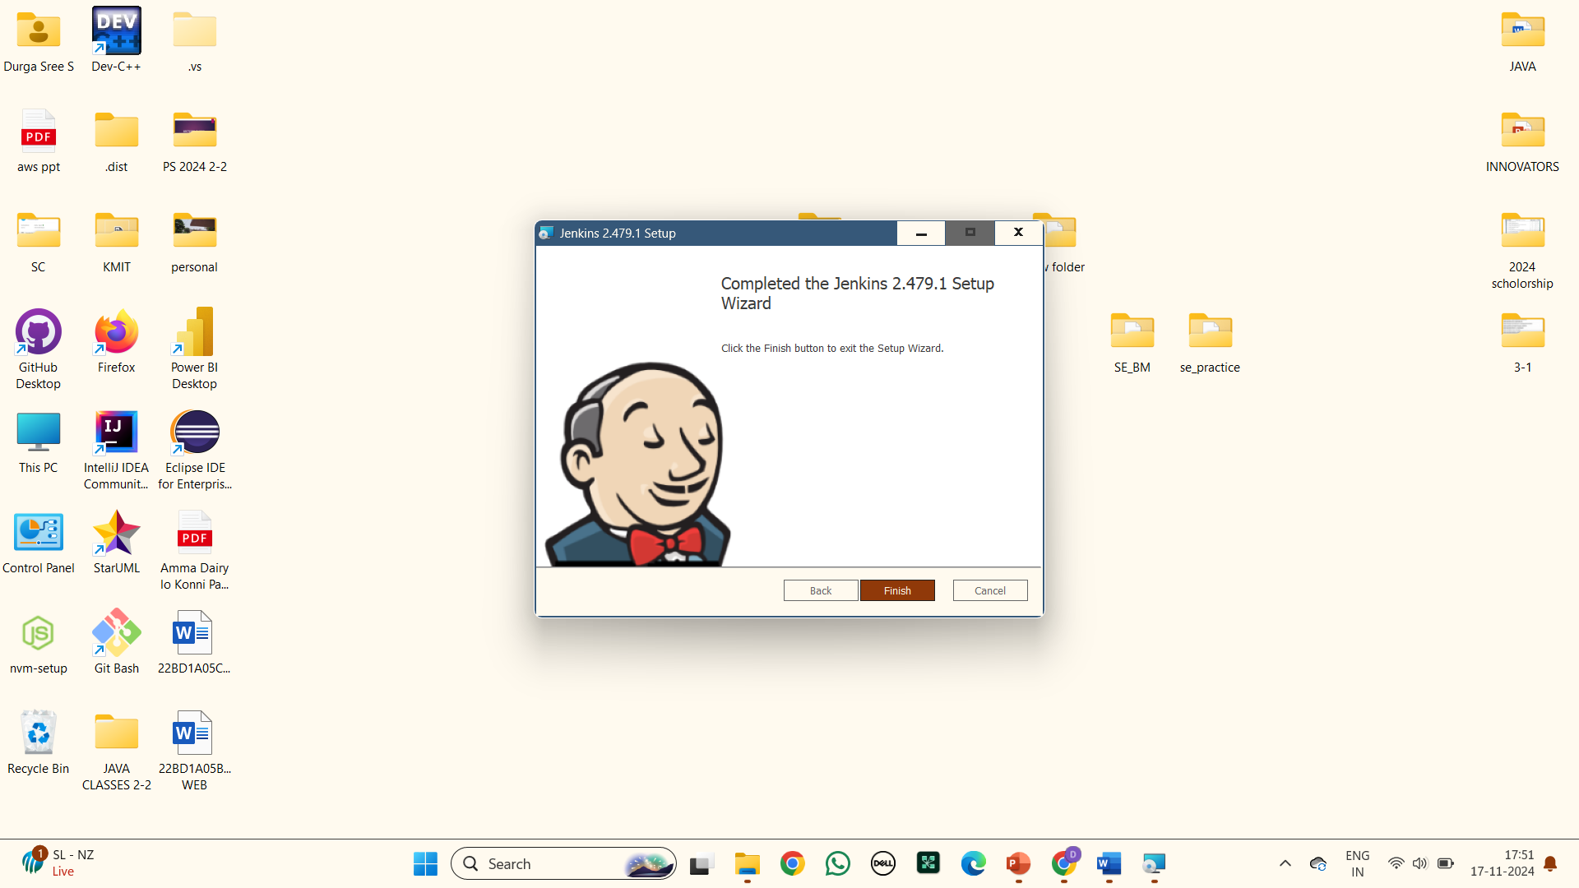

**11.Search for Sign in [Jenkins] in any browser :Unlock Jenkins by entering the Administrator password from the displayed specific location**

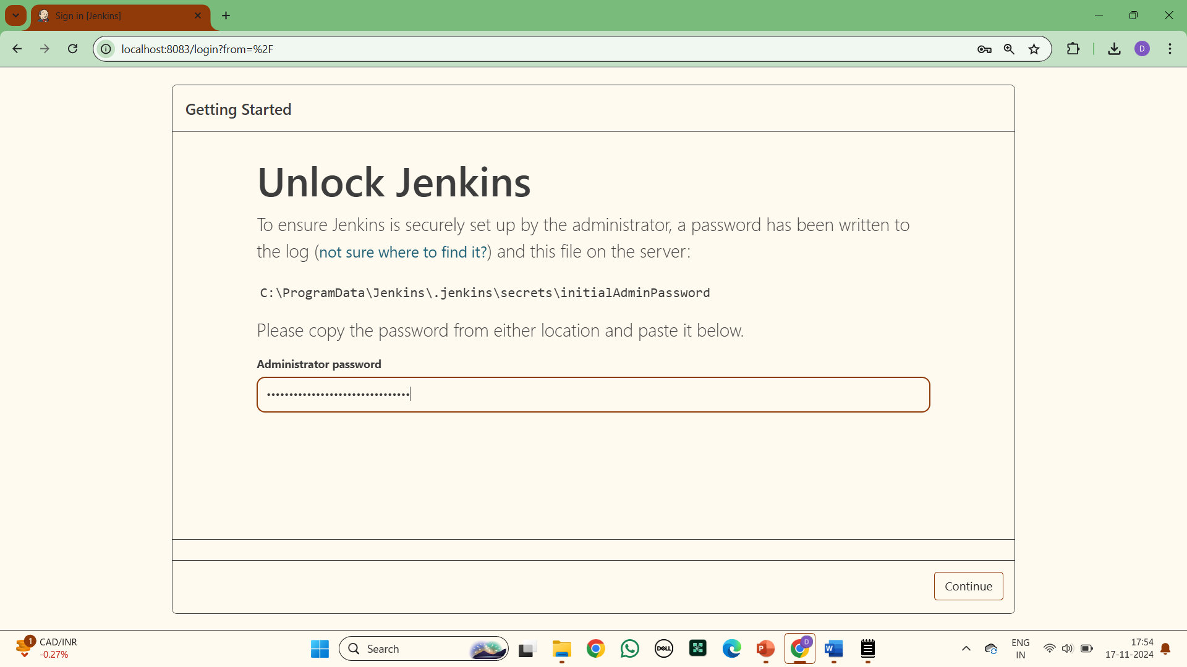

**12.Getting started : Wait till all the features installation gets completed**

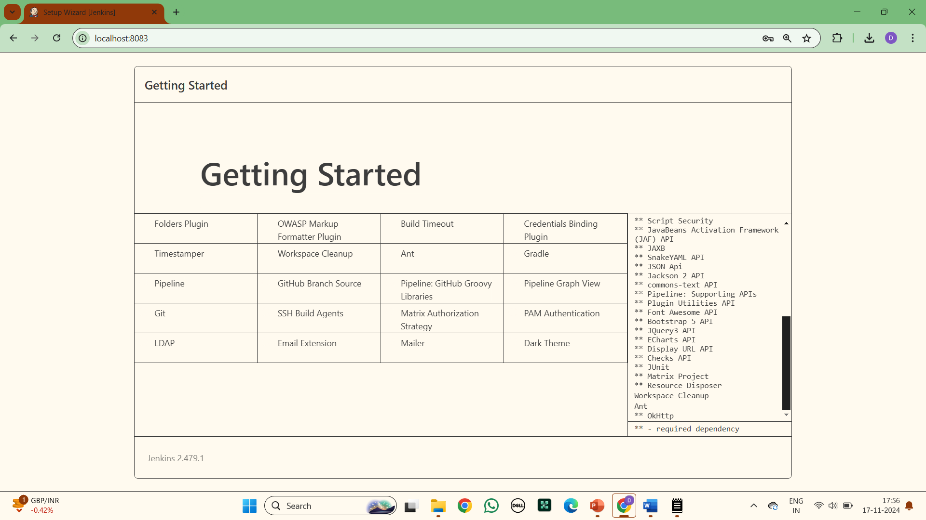

**13. Create First Admin User: Enter your Username, password, confirmation password, Full name**

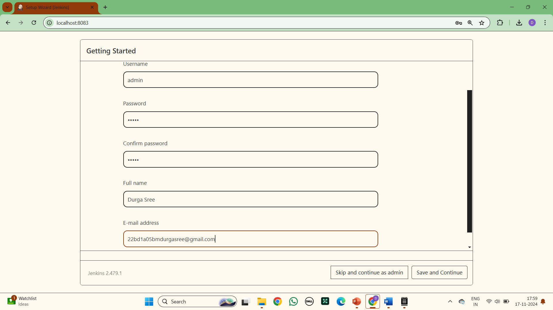

**14.Instance Configuration : Make sure the correct port number is entered, save and finish**

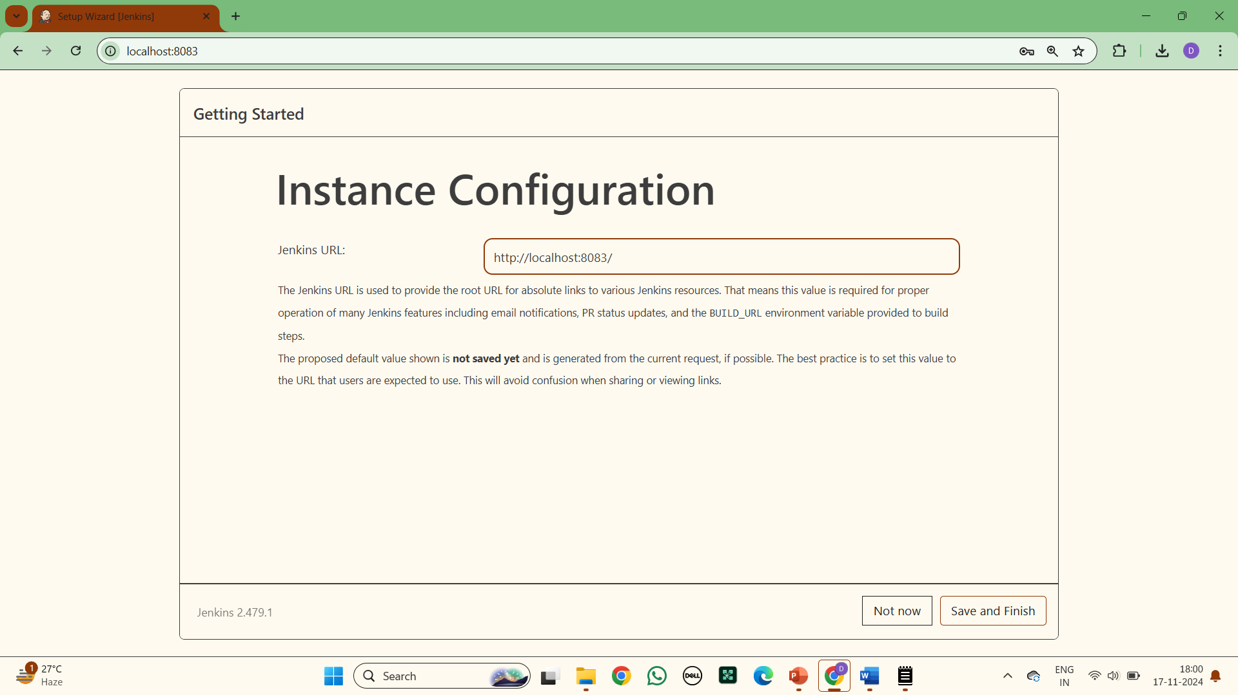

**15. Your Jenkins is ready : Click on start using Jenkins**

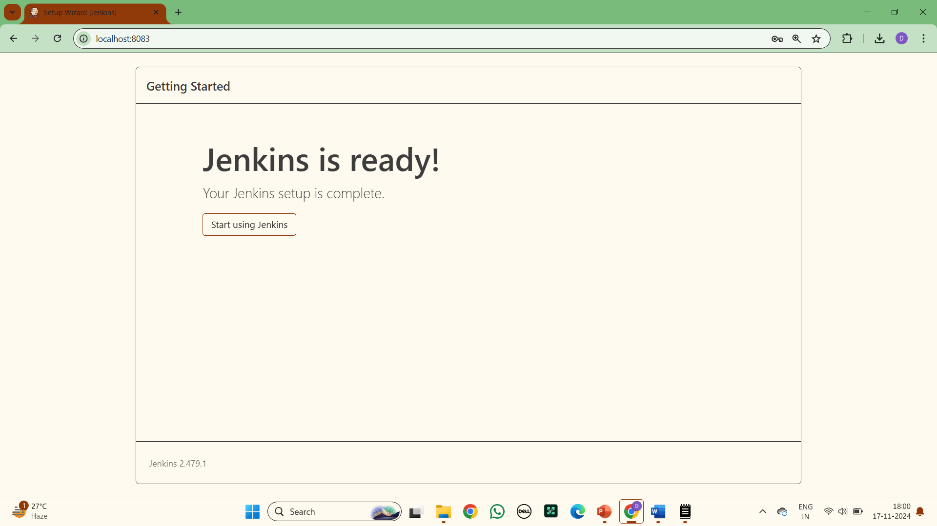

**16. A page of signin will be popped up**

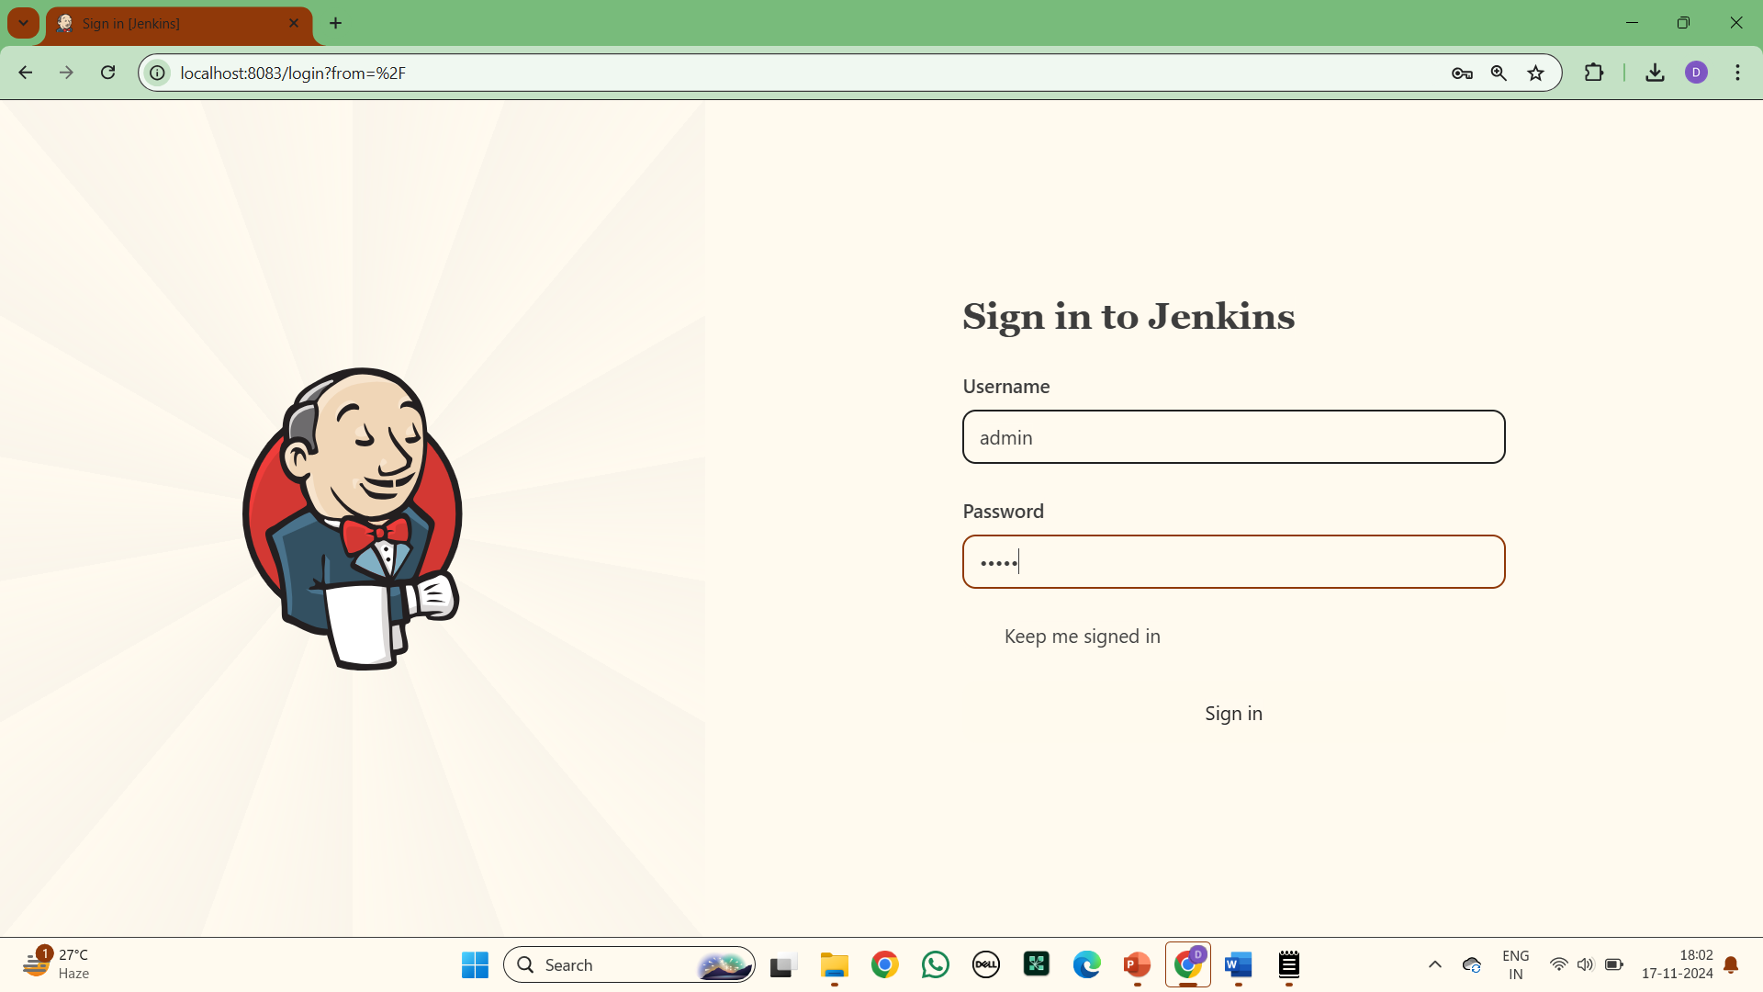

**17. Dashboard of Jenkins**

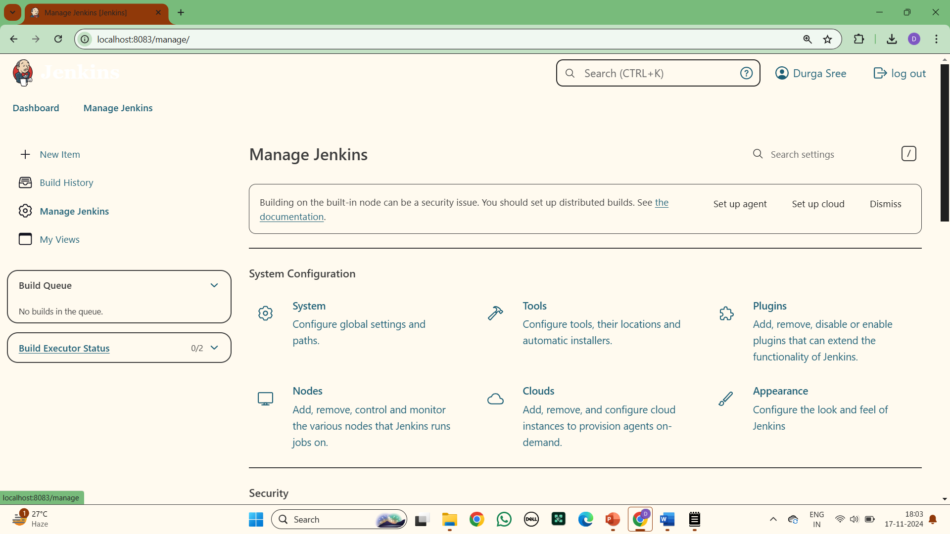

**18. Go to Manage Jenkins :**

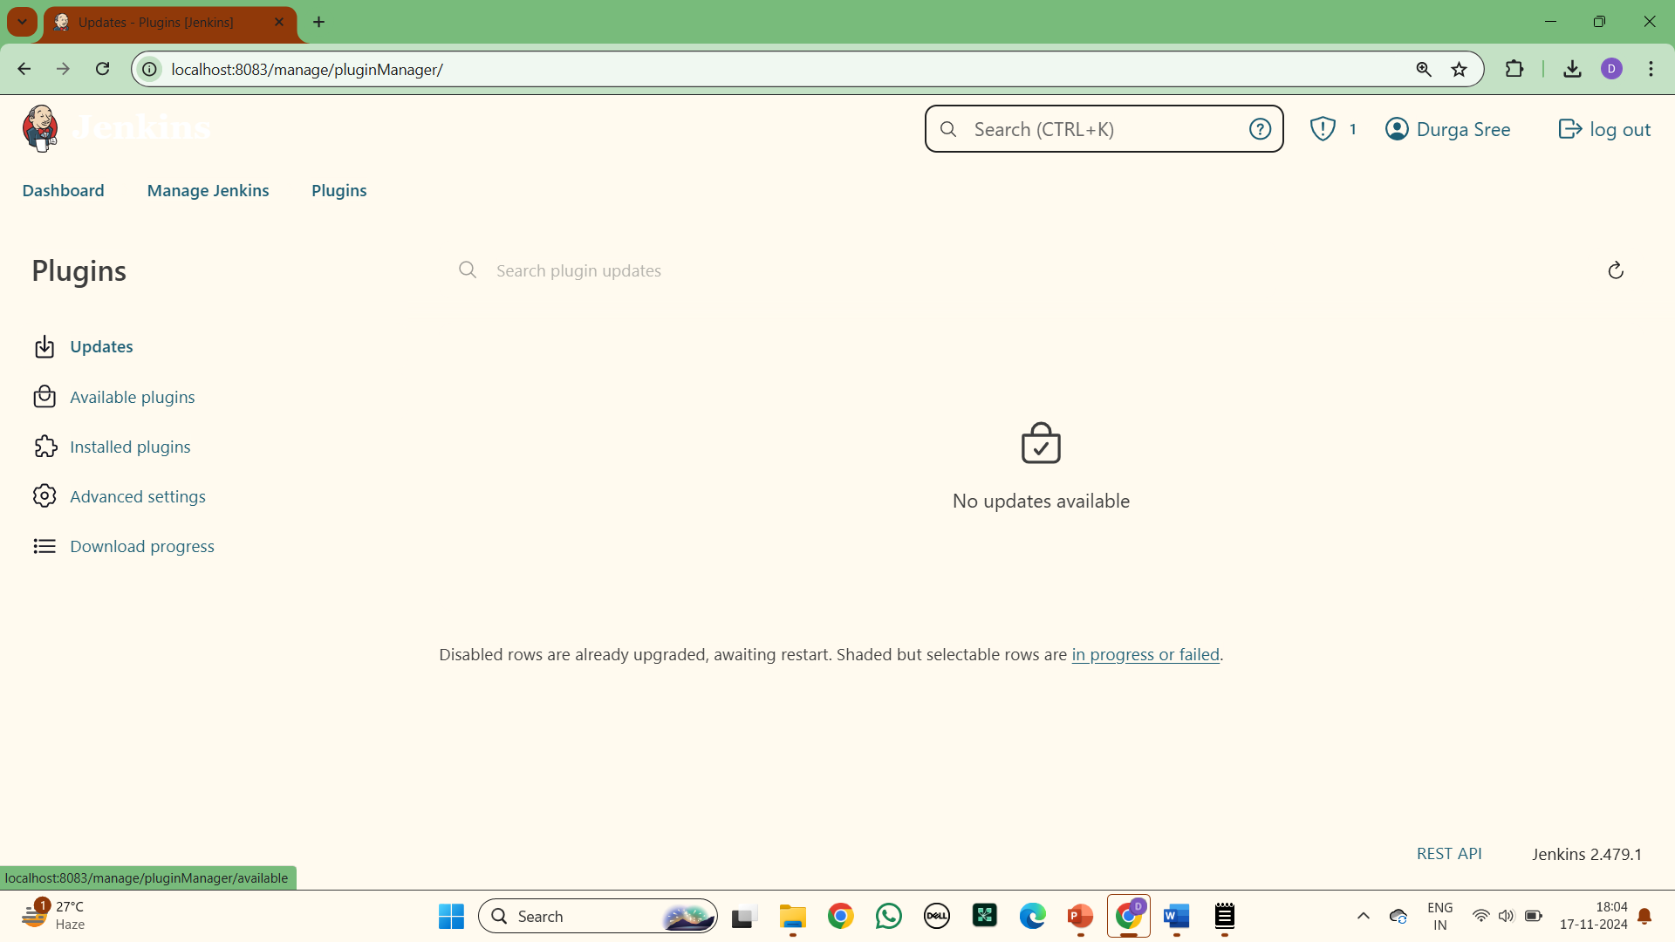

**19.Go to available plugins and search for Maven Integration and install:**

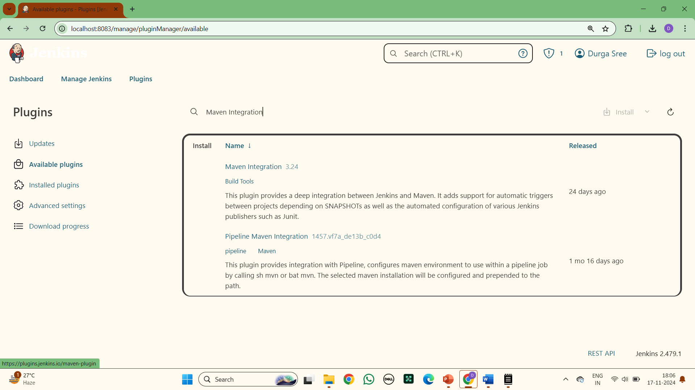

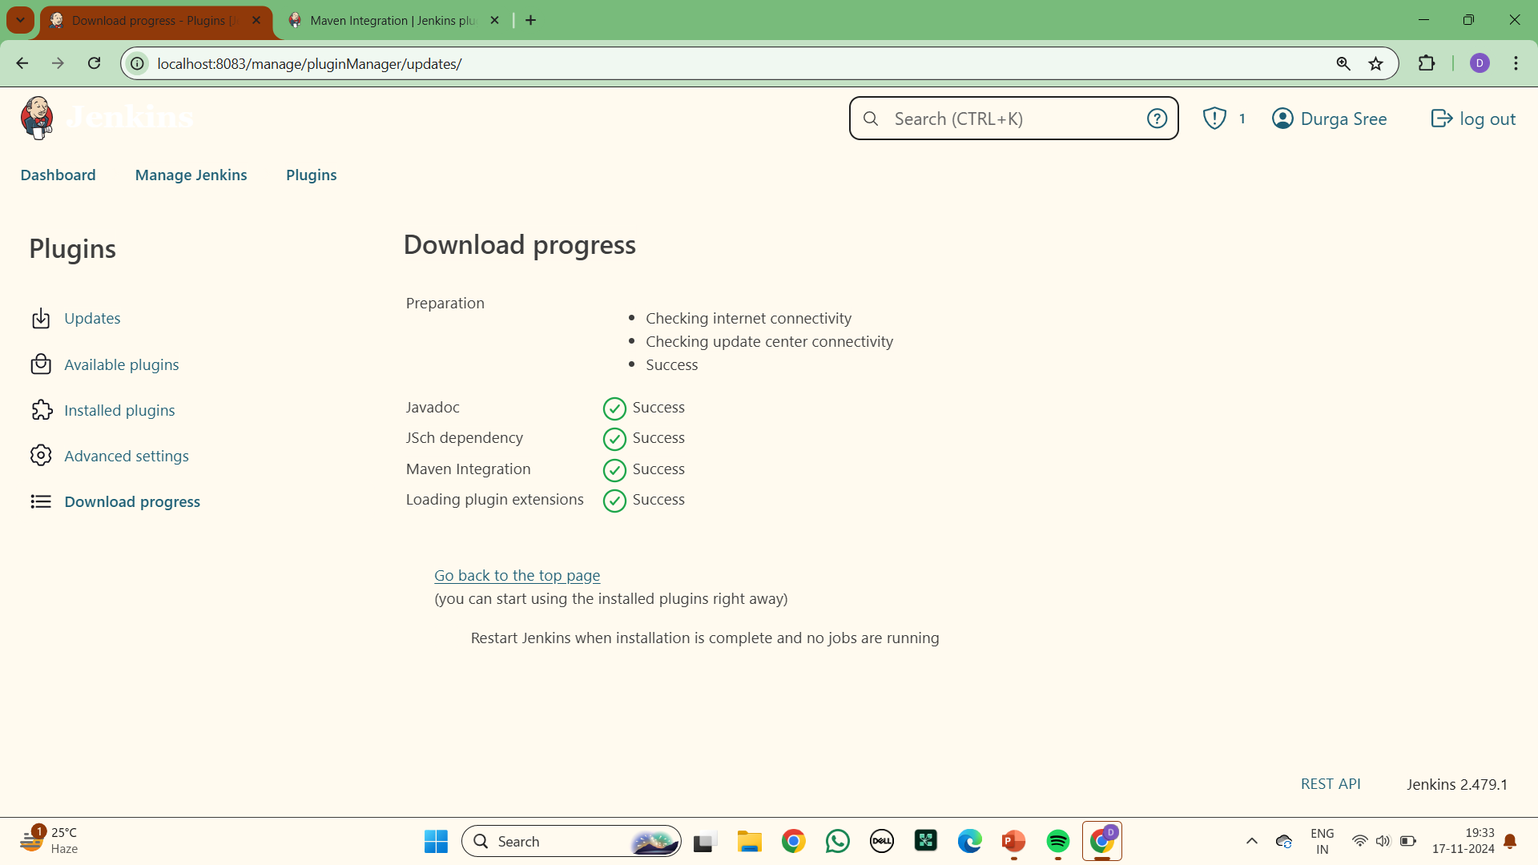

**20.Go to available plugins and search for Build Pipeline and install:**

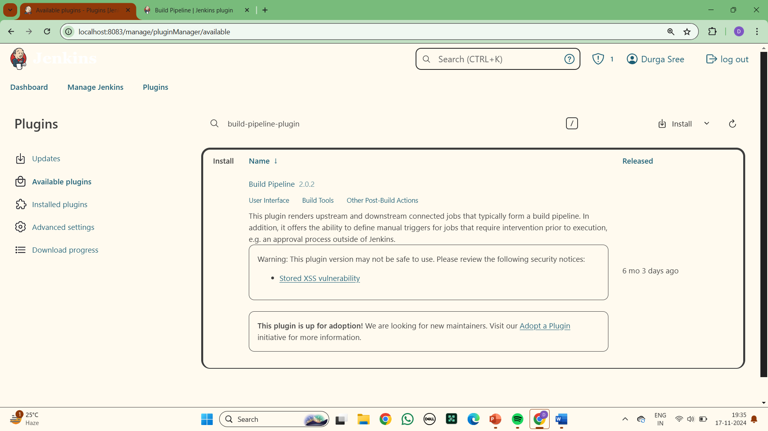

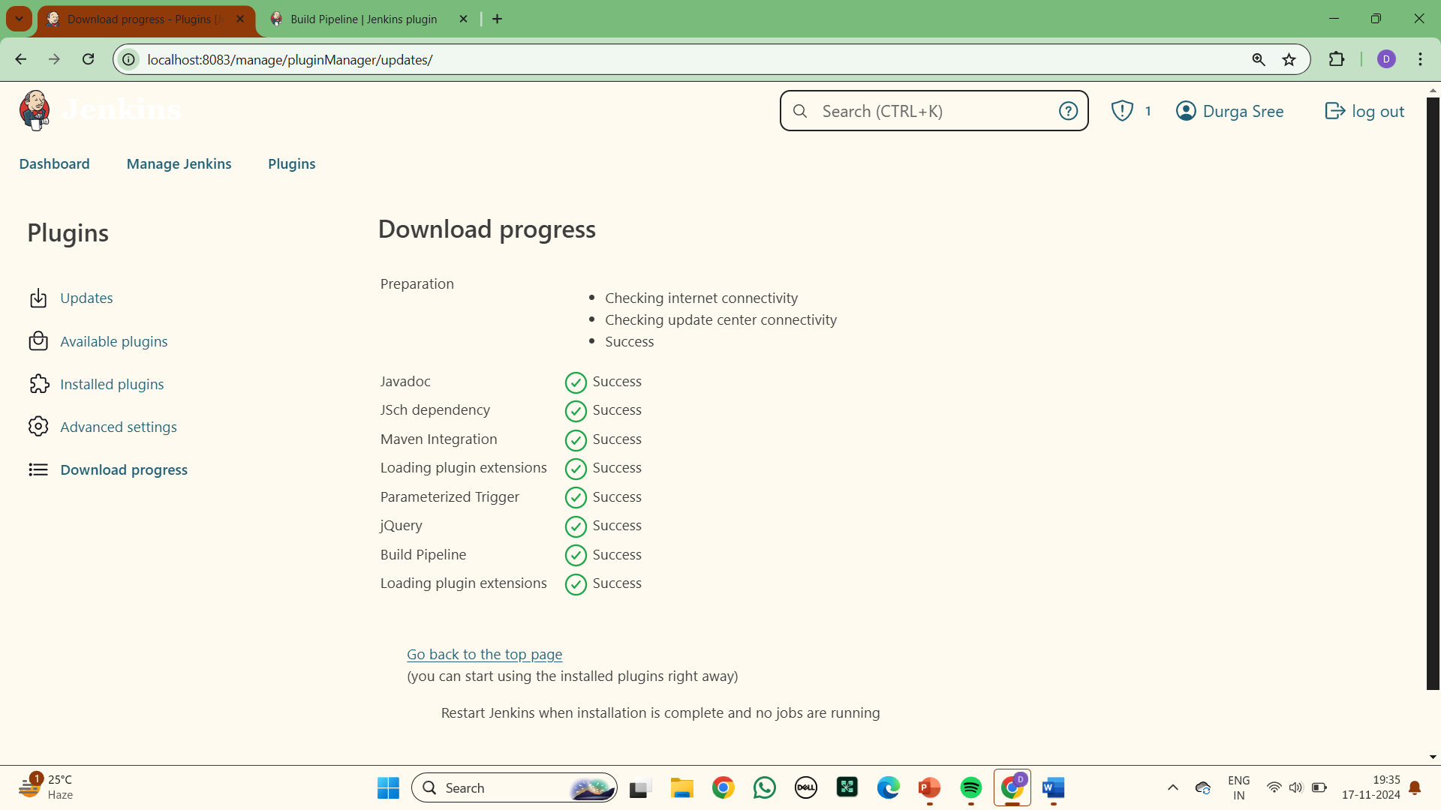

**21.Go to available plugins and search for Pipeline utility and install:**

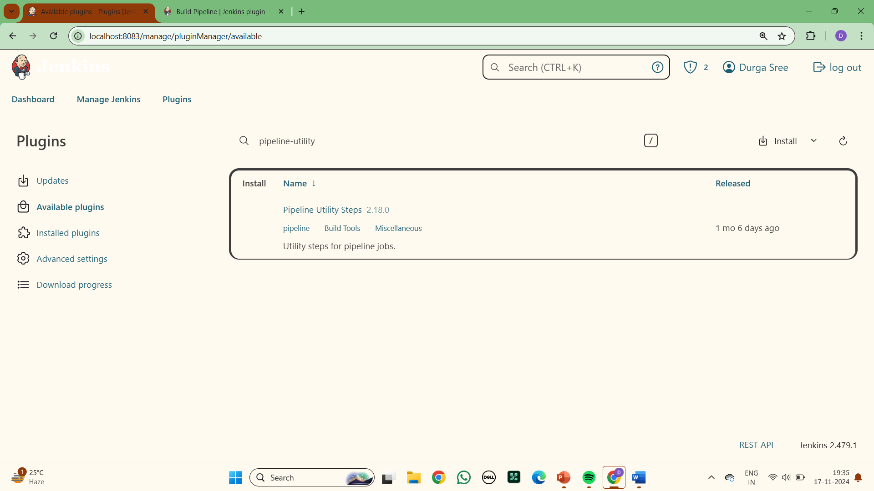

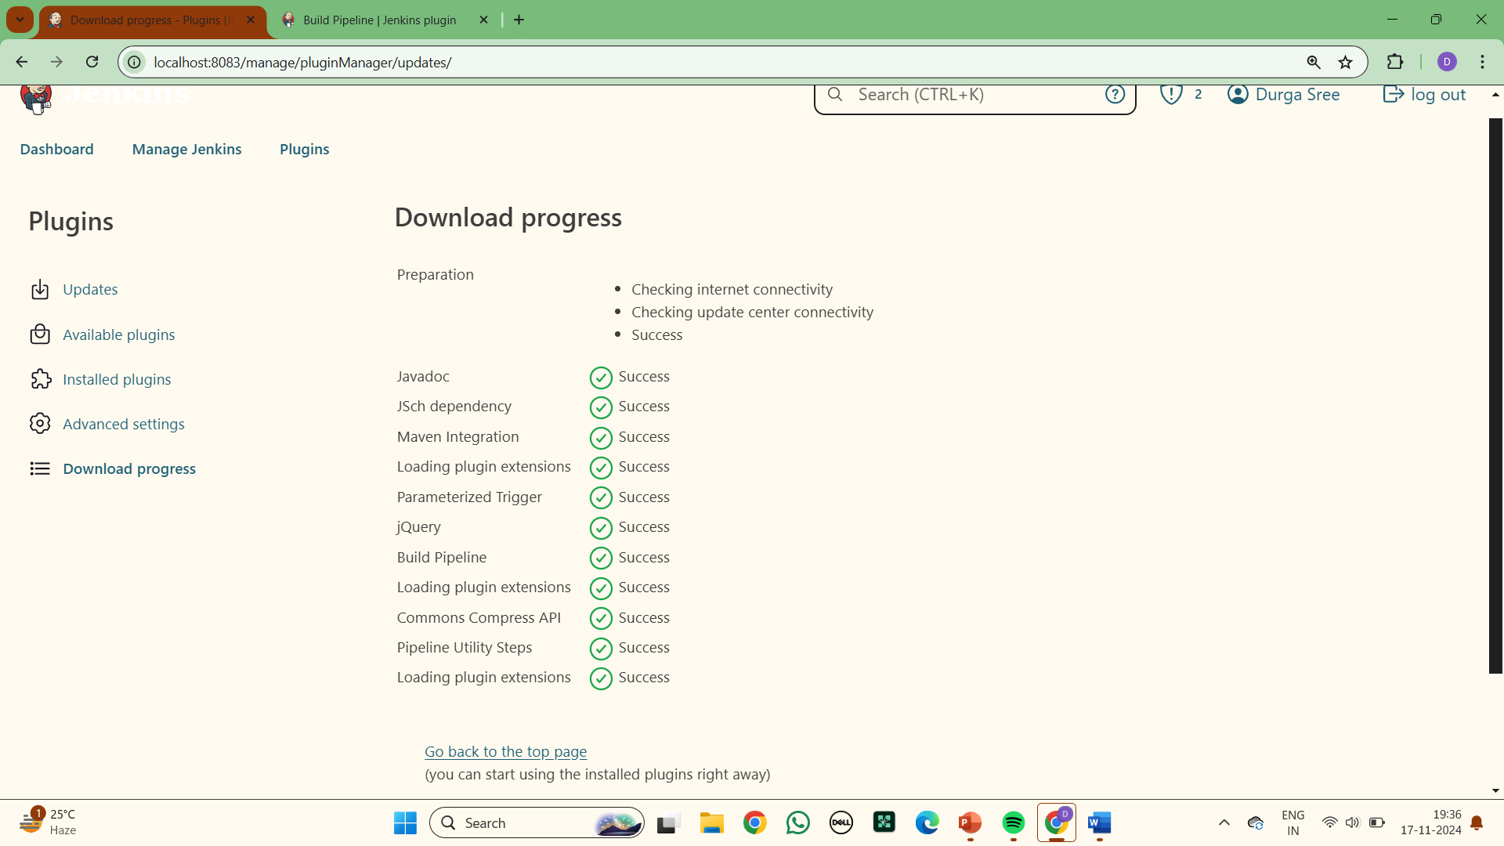

**22.Go to available plugins and search for Copy artifacts and install:**

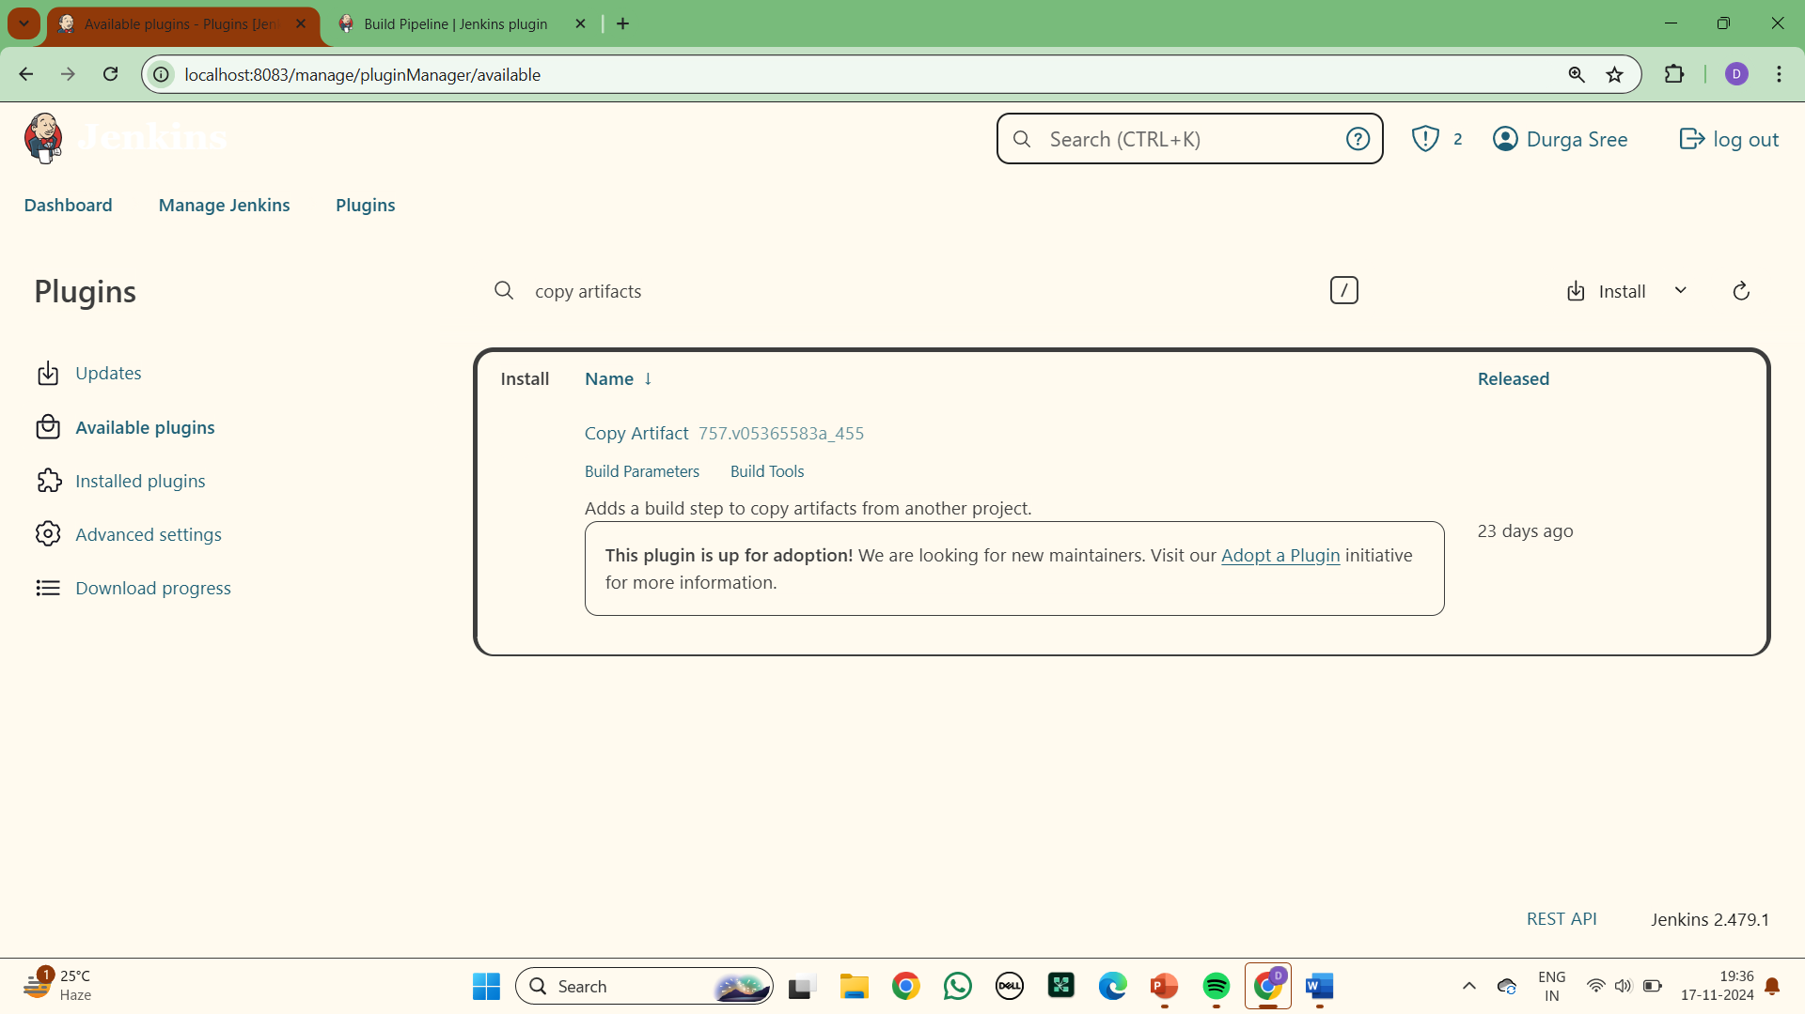

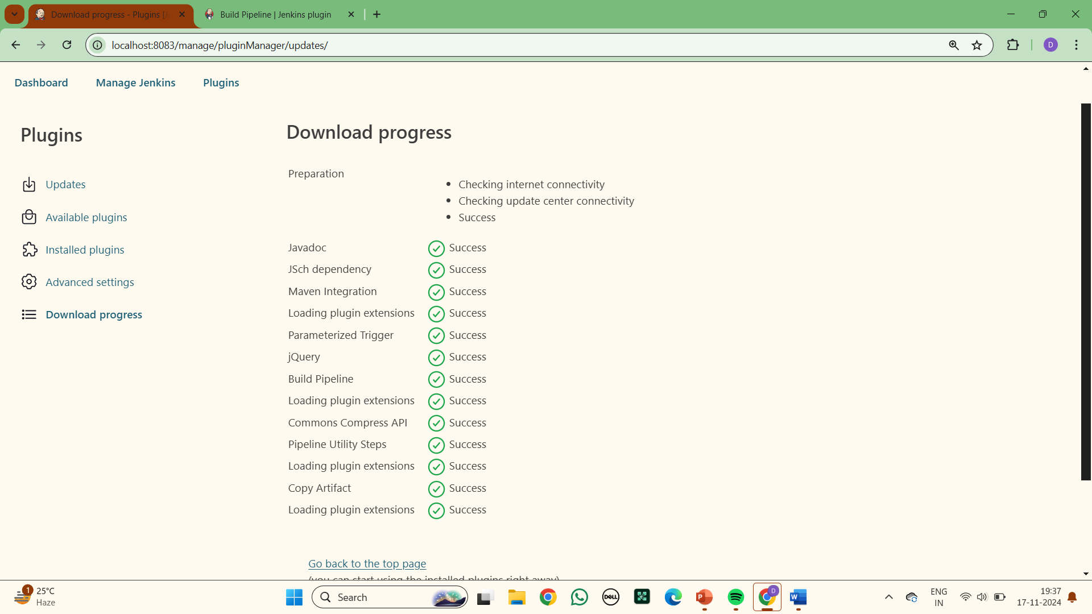

**23.Go to available plugins and search for deploy container and install:**

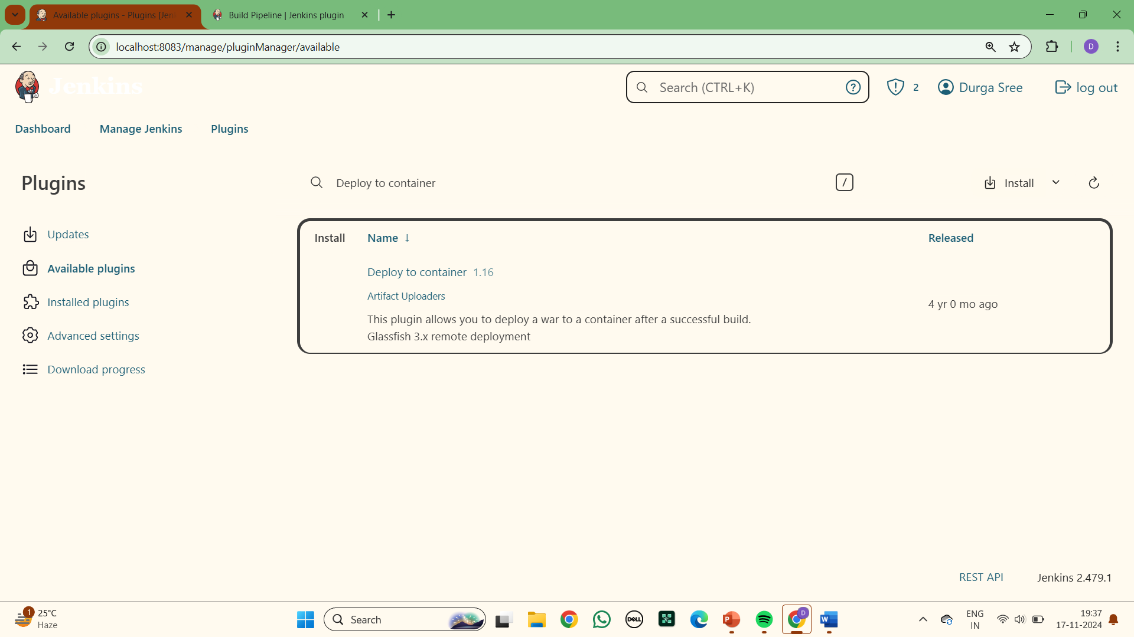

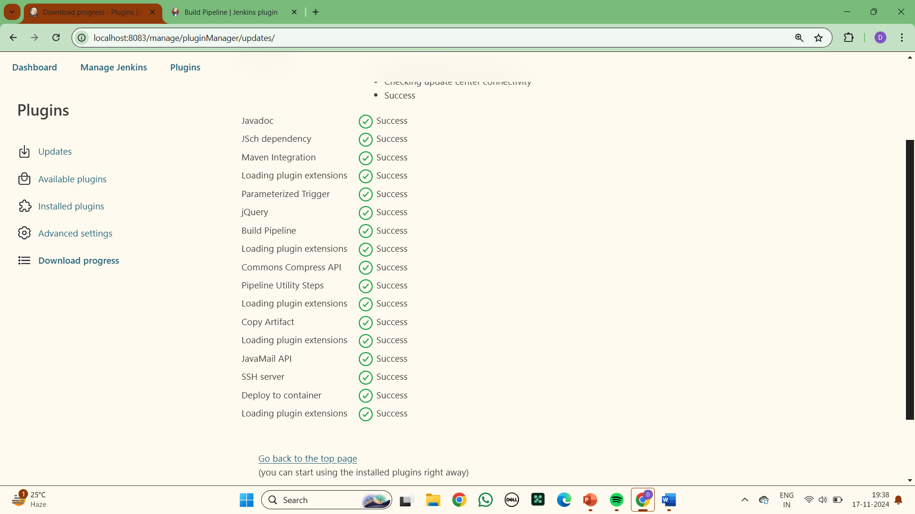

**24.In Dashboard select Manage jenkins >Tools :**

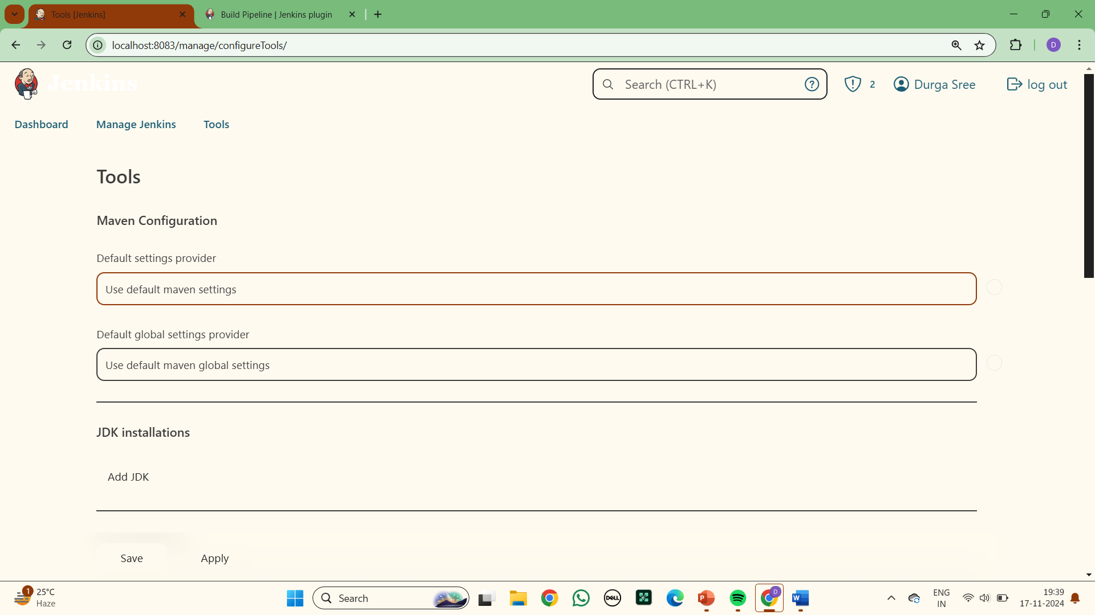

**25.Add JDK installations : Give name as JAVA_HOME**

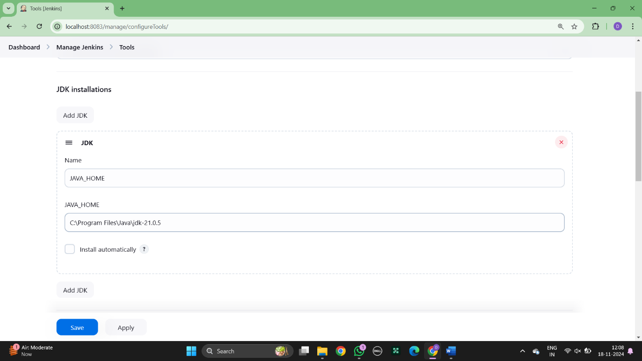

**26. Add Maven Installations :Give name as MAVEN_HOME**

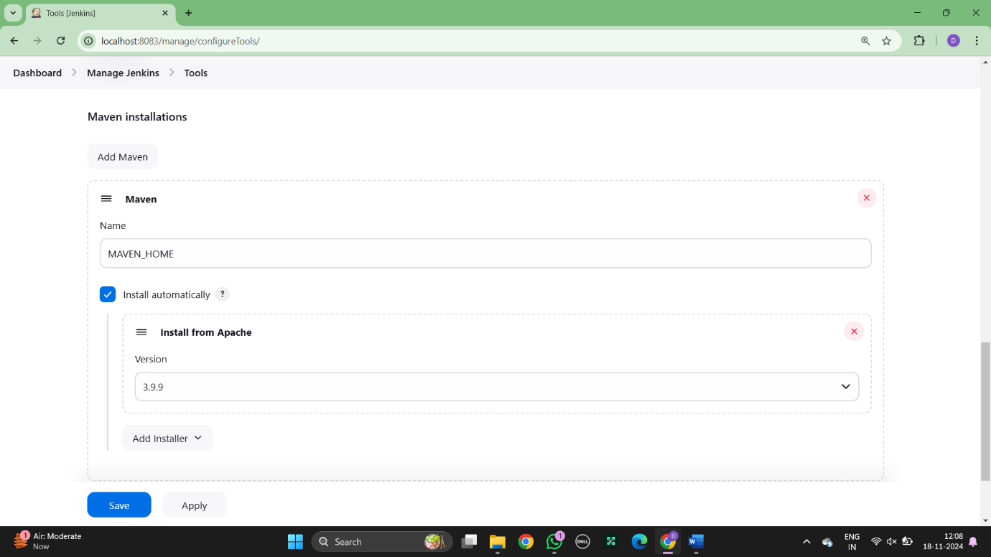

**27. Save and Apply**

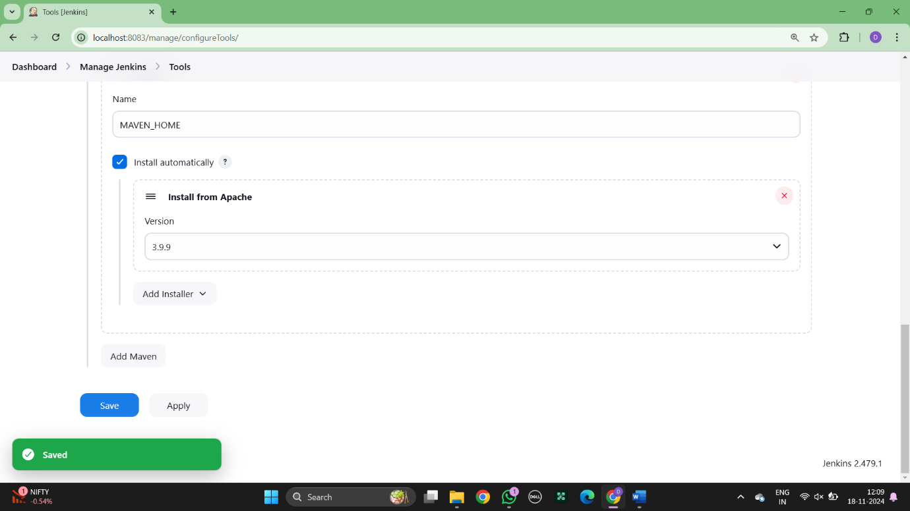

### Experiment 6:

* 1. **BUILDING THE CI/CD FREESTYLE PIPELINE USING JENKINS FOR MAVEN   
      JAVA PROJECT  
       
     Creating two pipeline in Jenkins**

Step 1:open Jenkins and click on new item, enter the item as “name-build” and select freestyle and ok.

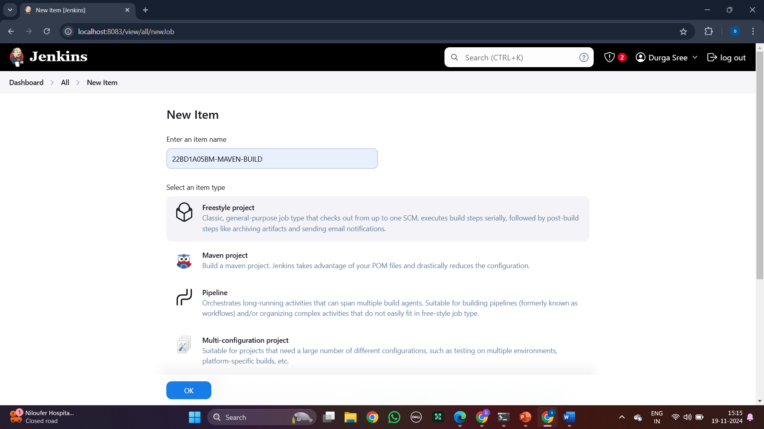

Step 2: write description.

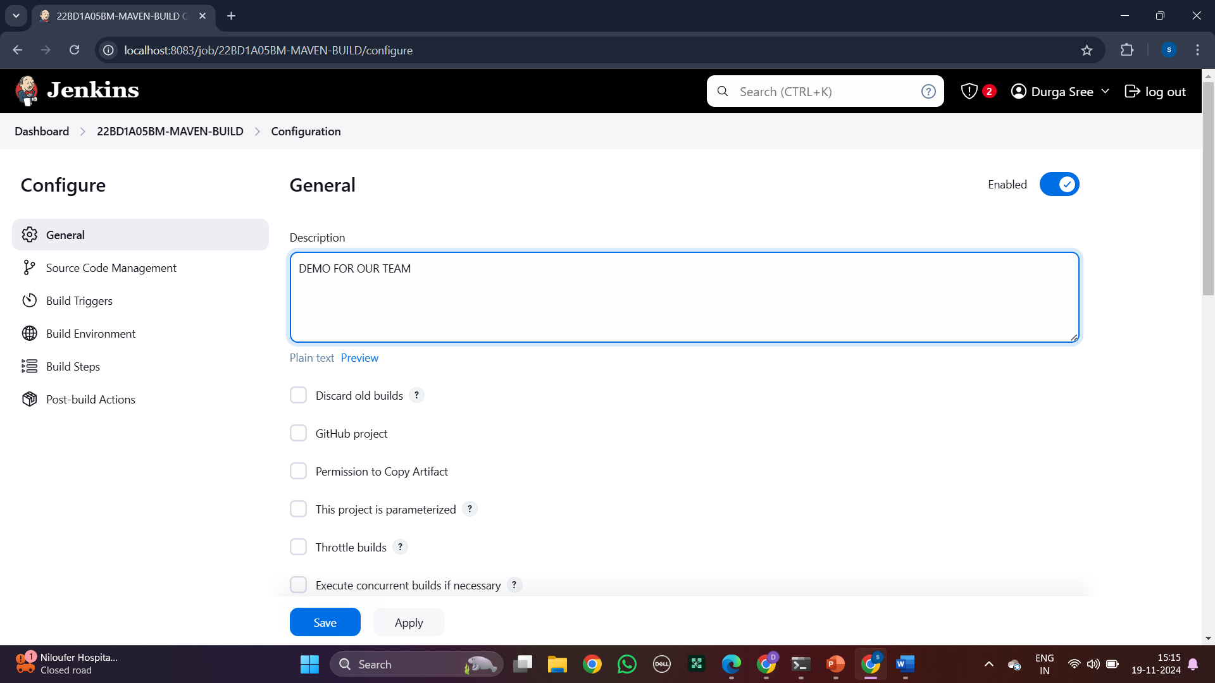

Step 3: Now go to GitHub and copy the https link from code and paste the link in repository URL.

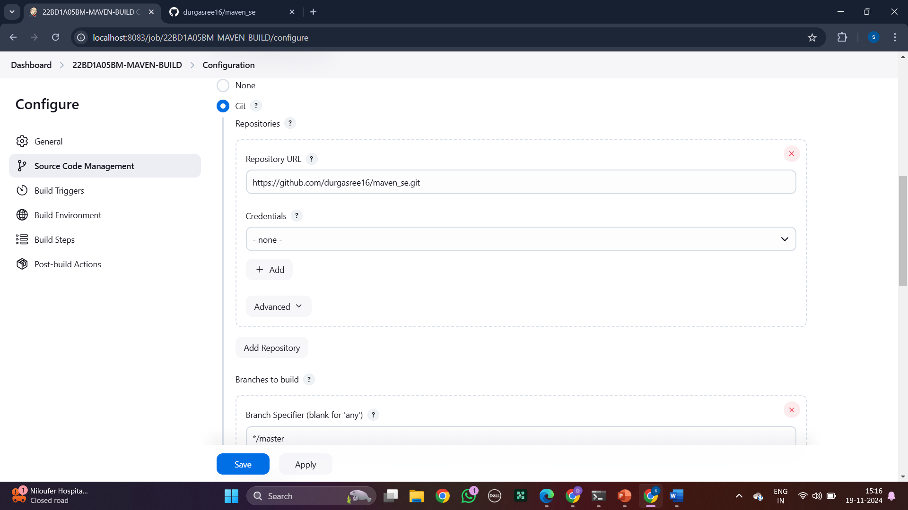

Step 4: check for which branch it is in.

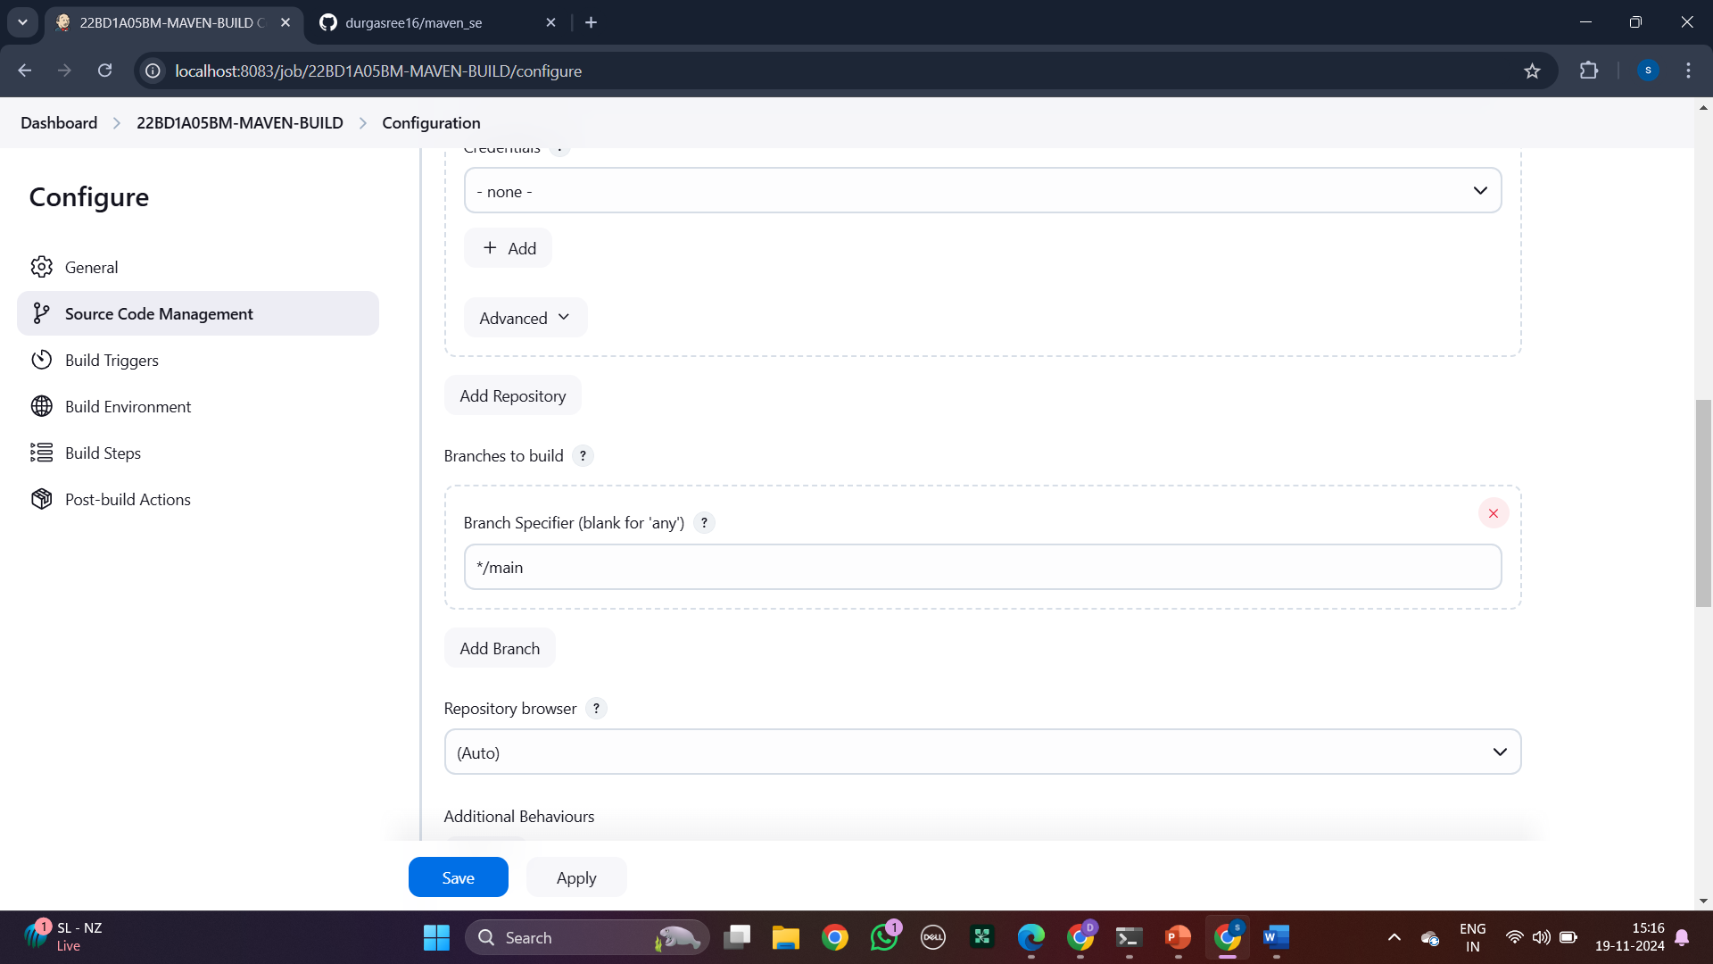

Step 5: Go to build triggers and click on build periodically and type “H/5 * * * *”.

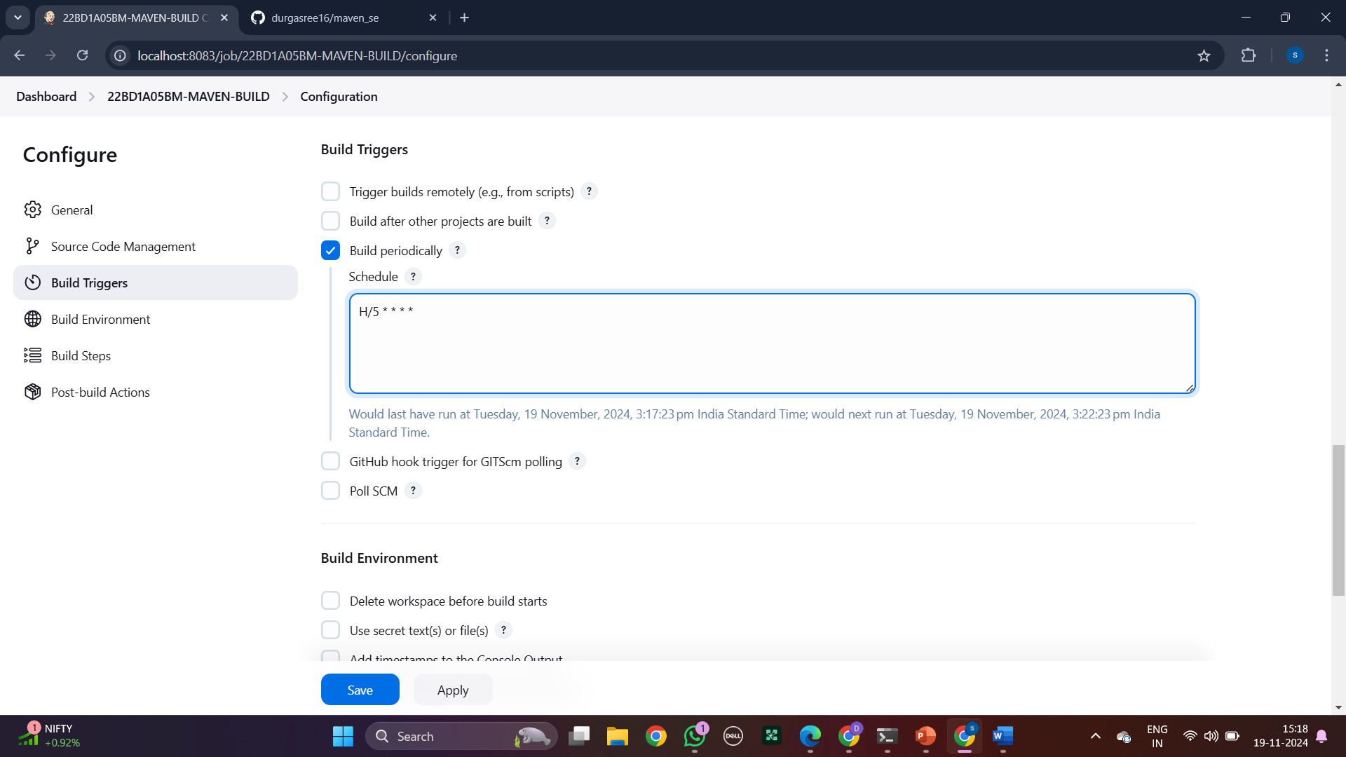

Step 6: Now go build environment and select delete workspace before build starts.

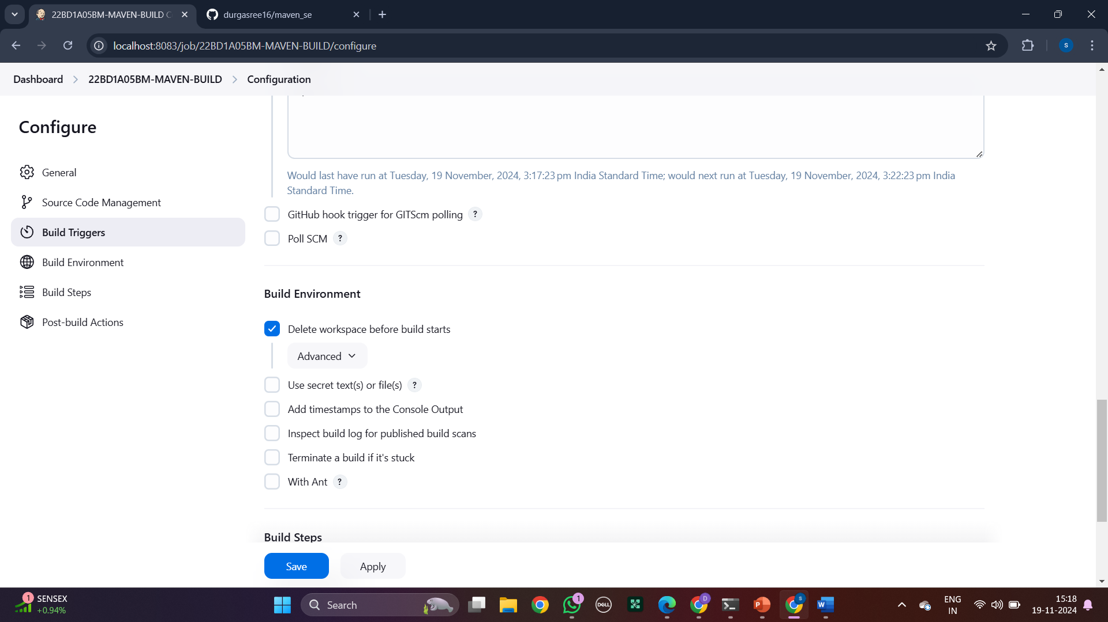

Step 7: click on build step and select invoke top-level maven targets.

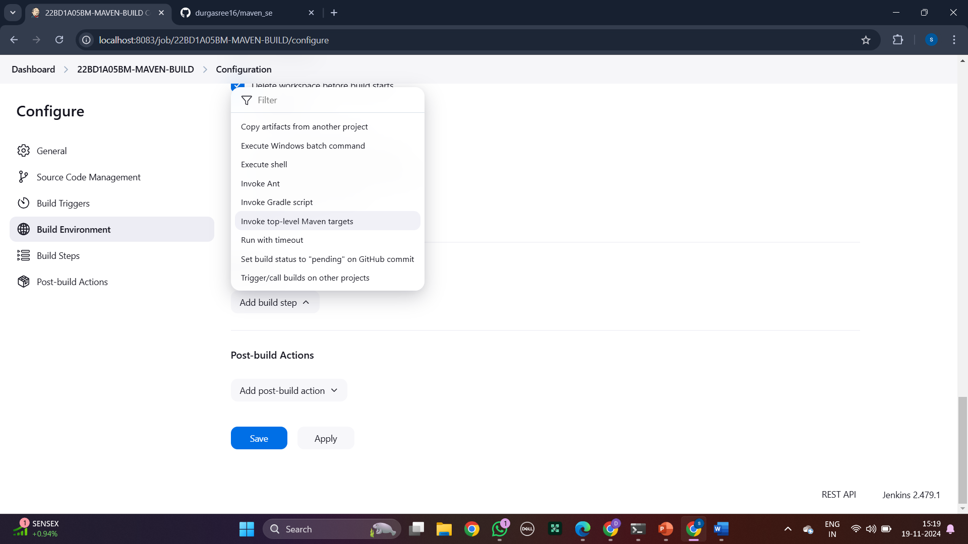

Step 8: select maven home and in goals type “clean install”.

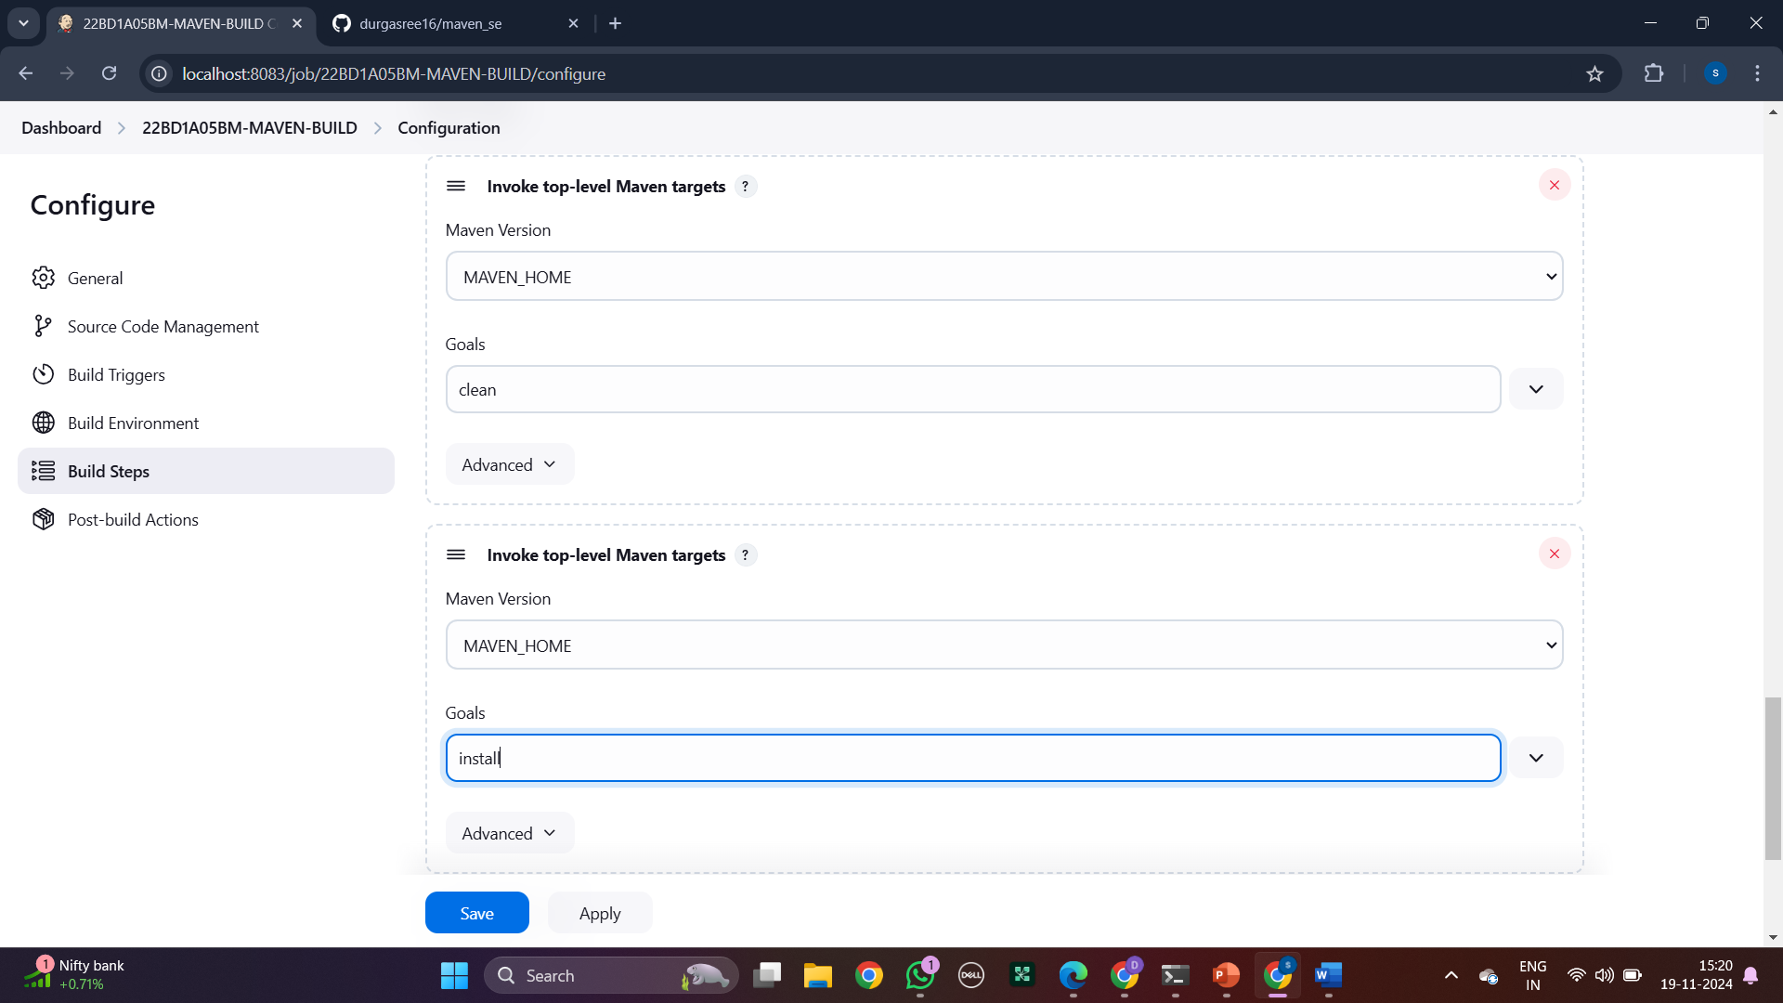

Step9: click in post build actions and select archive the artifacts.

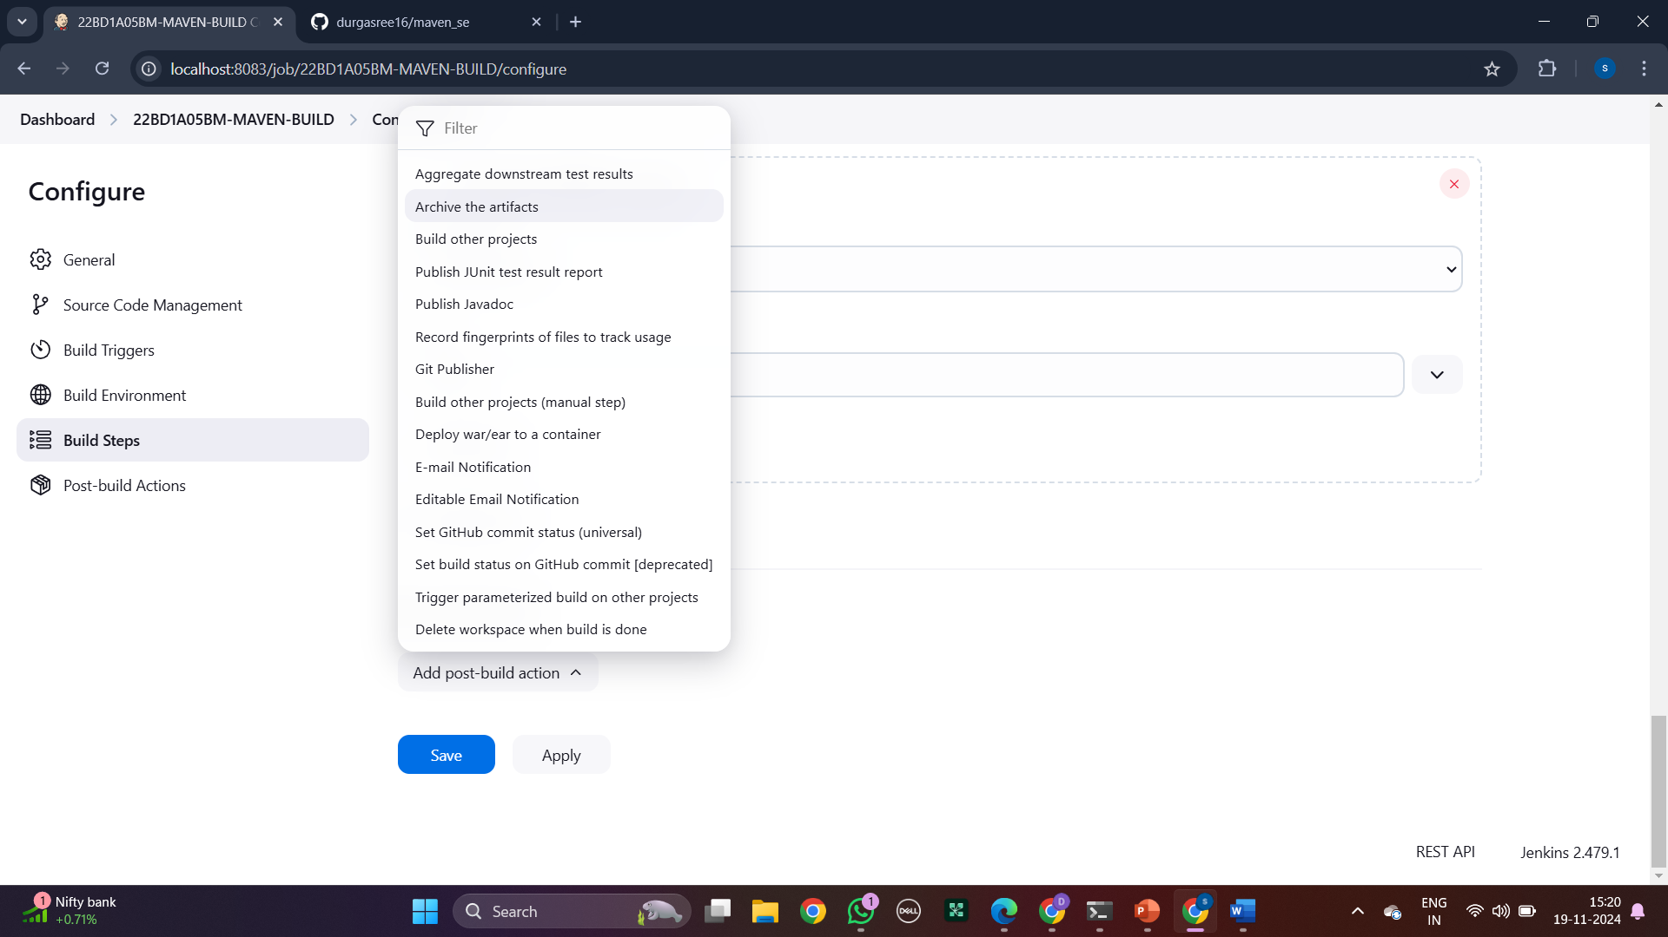

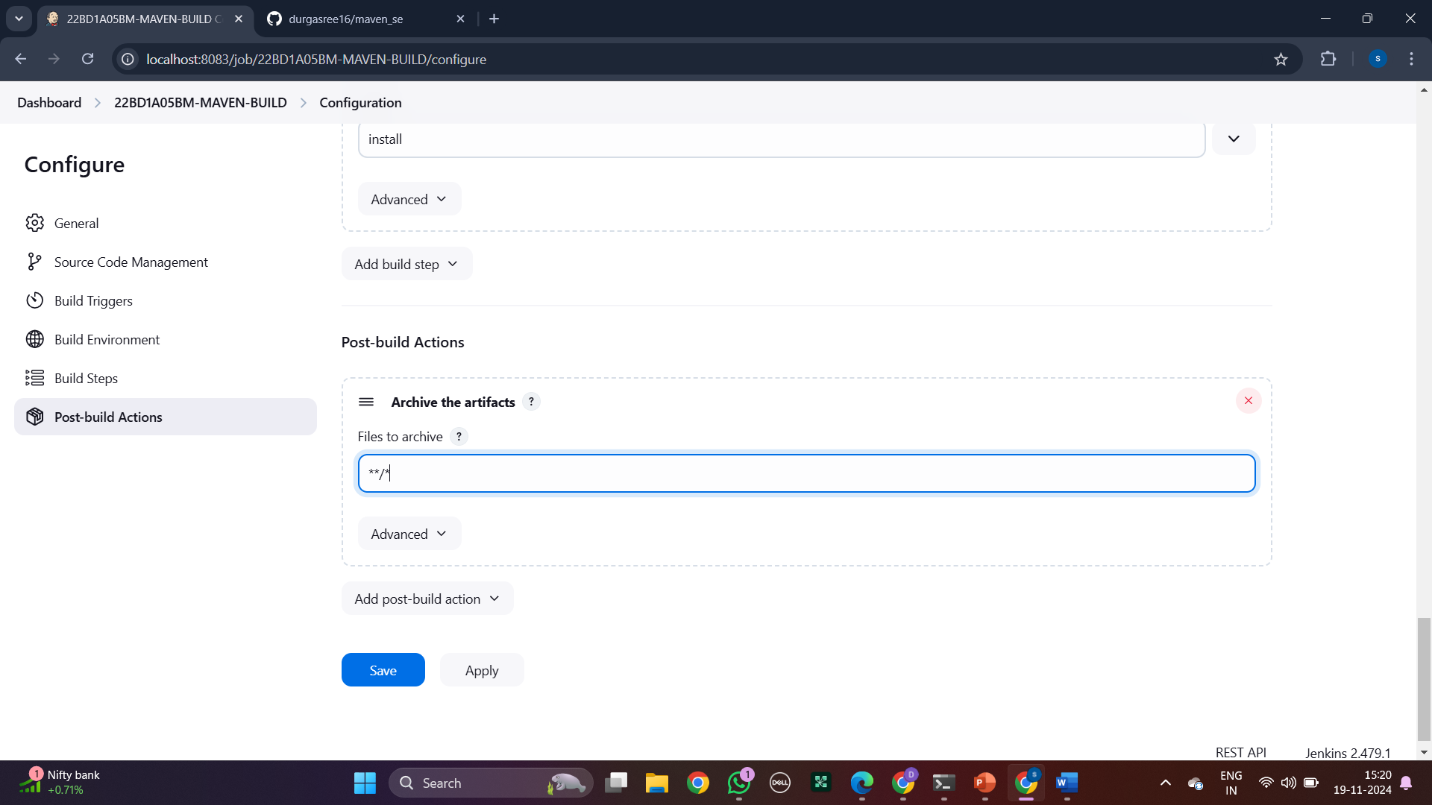

Step 10: Now, same but select build other projects. Then apply and save

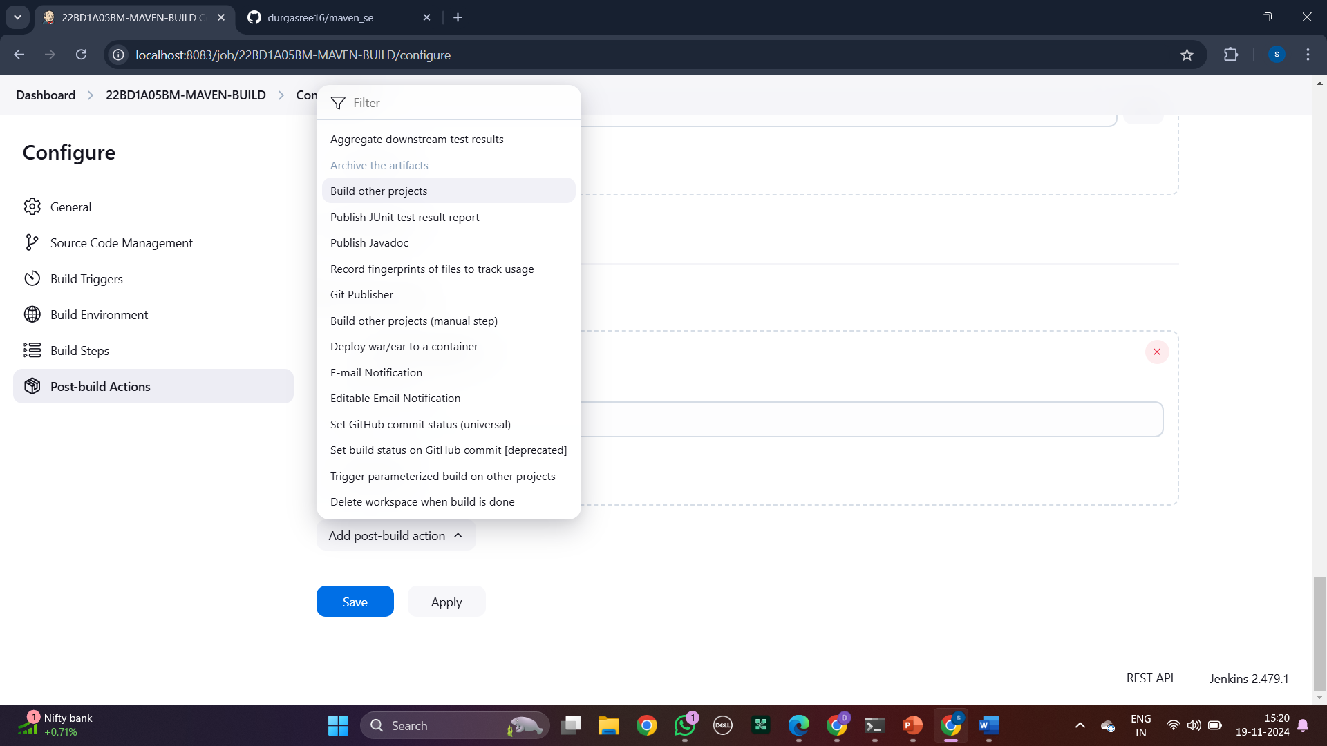

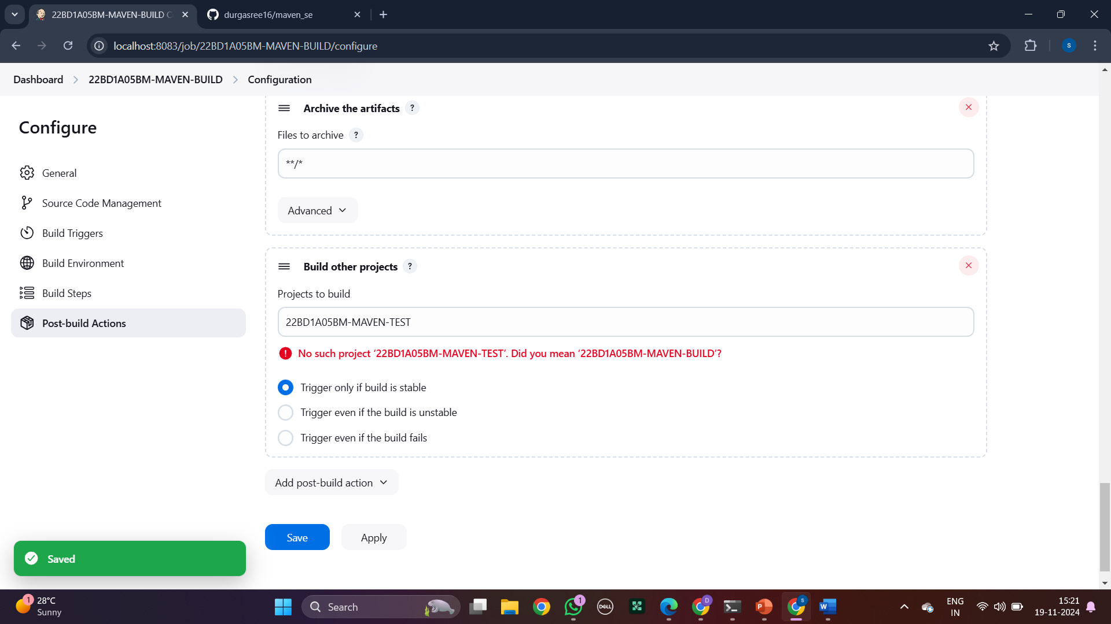

Step 11: Now make a new item named, “Maven Test”

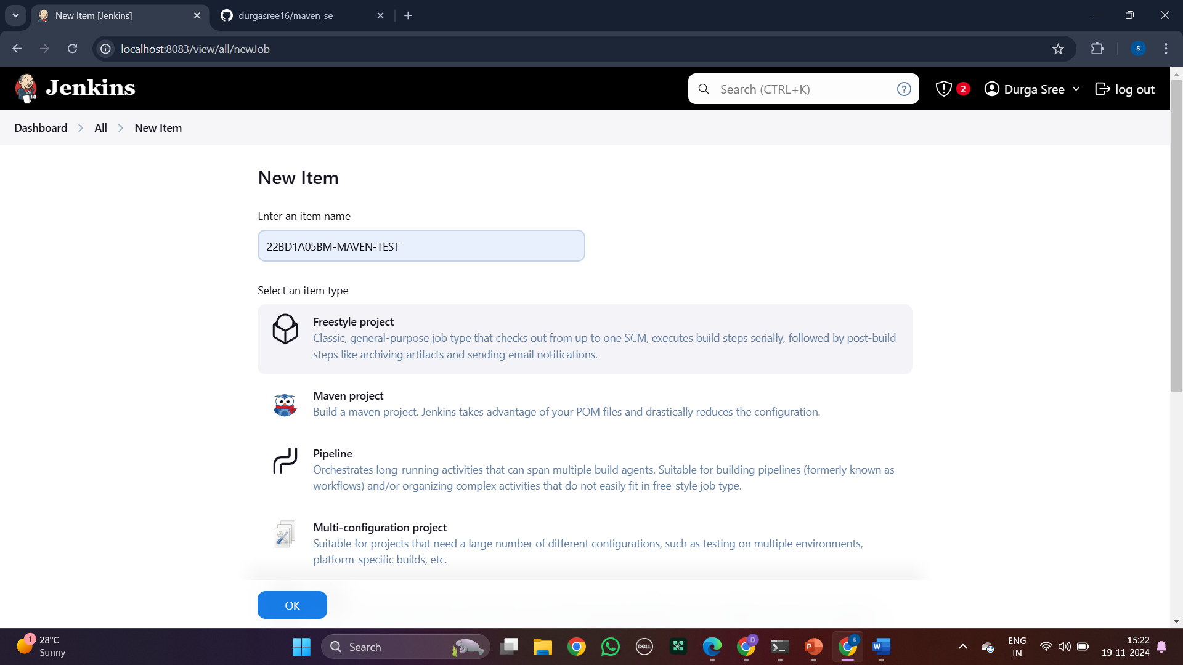

Step 12: Select ‘None’ in Source Code Management

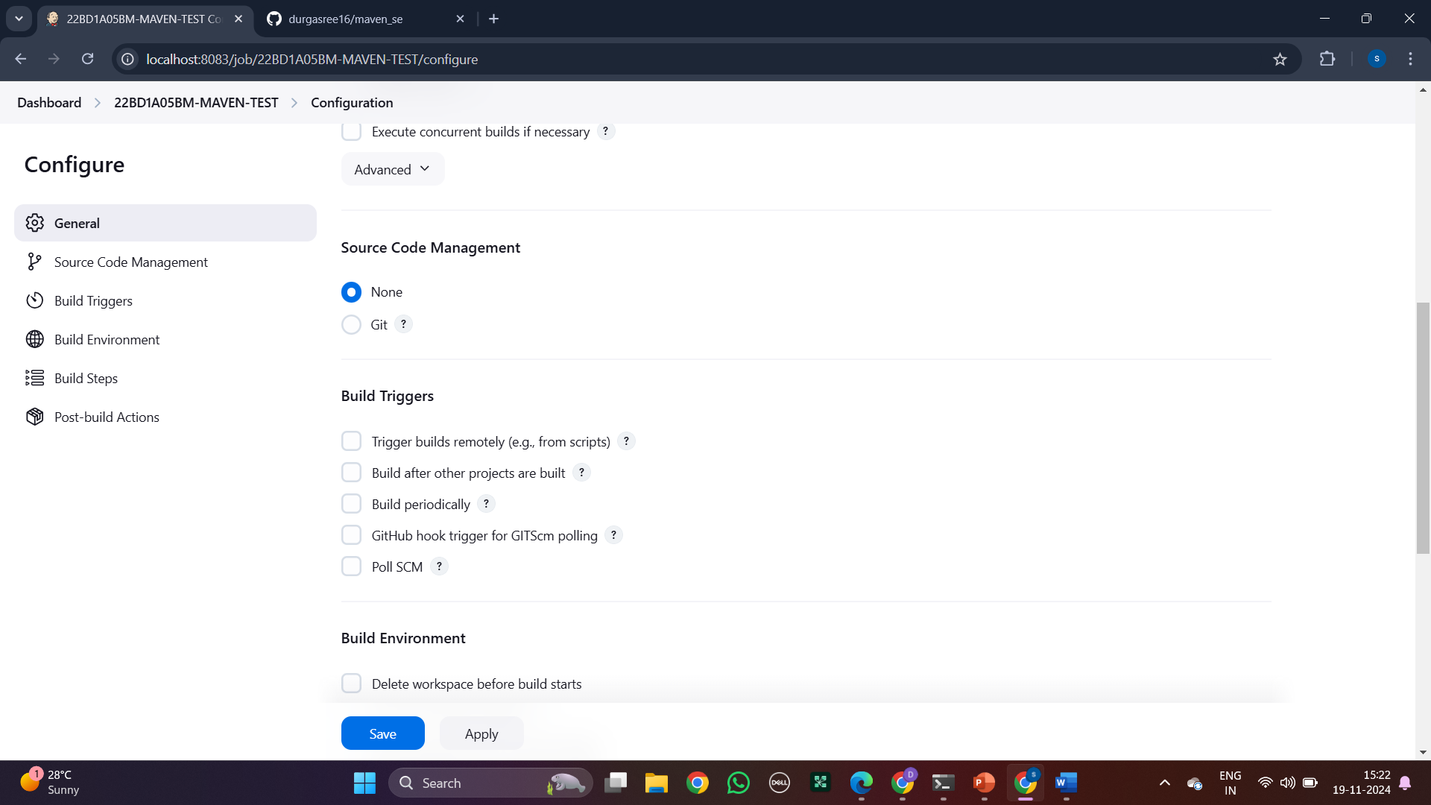

Step 13: Go to build environment and select delete workspace.

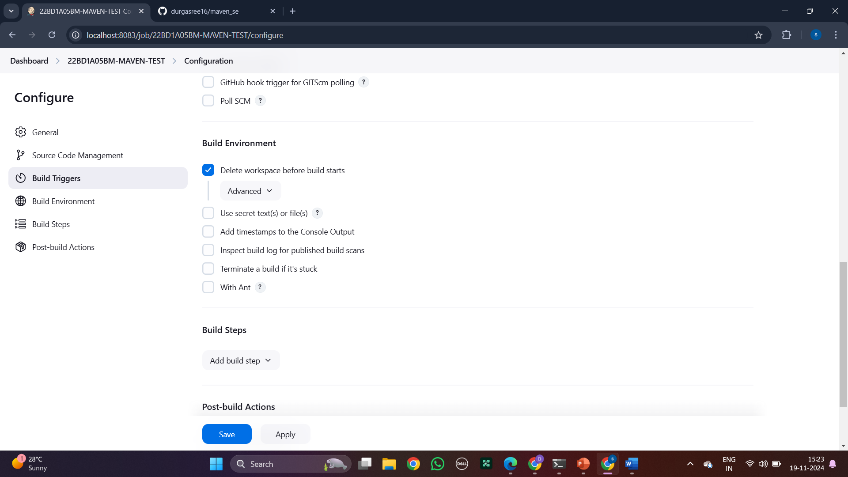

Step 14: Same step but select copy artifacts and select maven build and type “*/**’ in artifacts to copy .

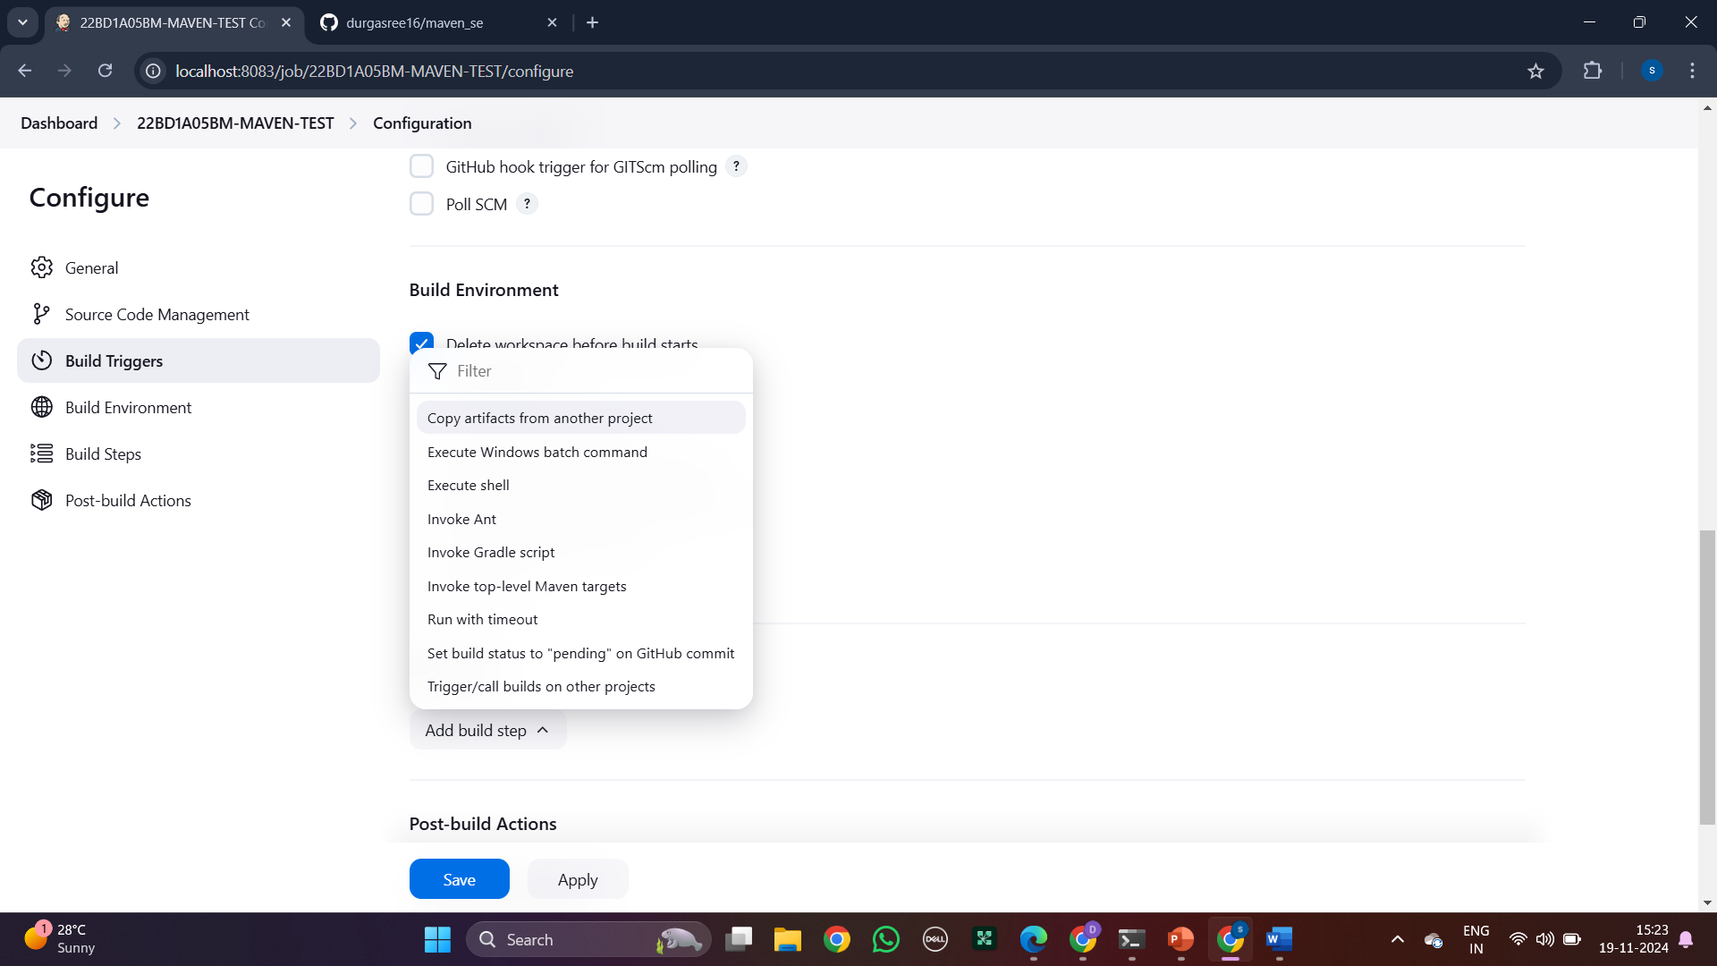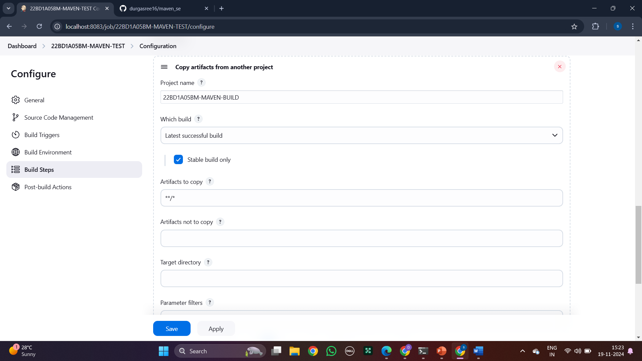

Step 15: Go to build steps and select invoke top-level and select maven-home and in goals type test.

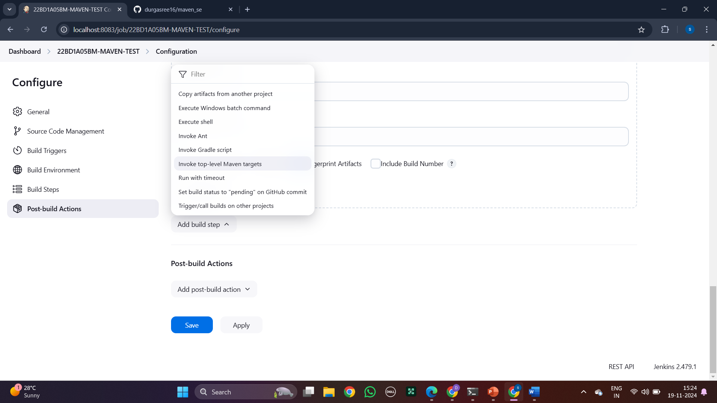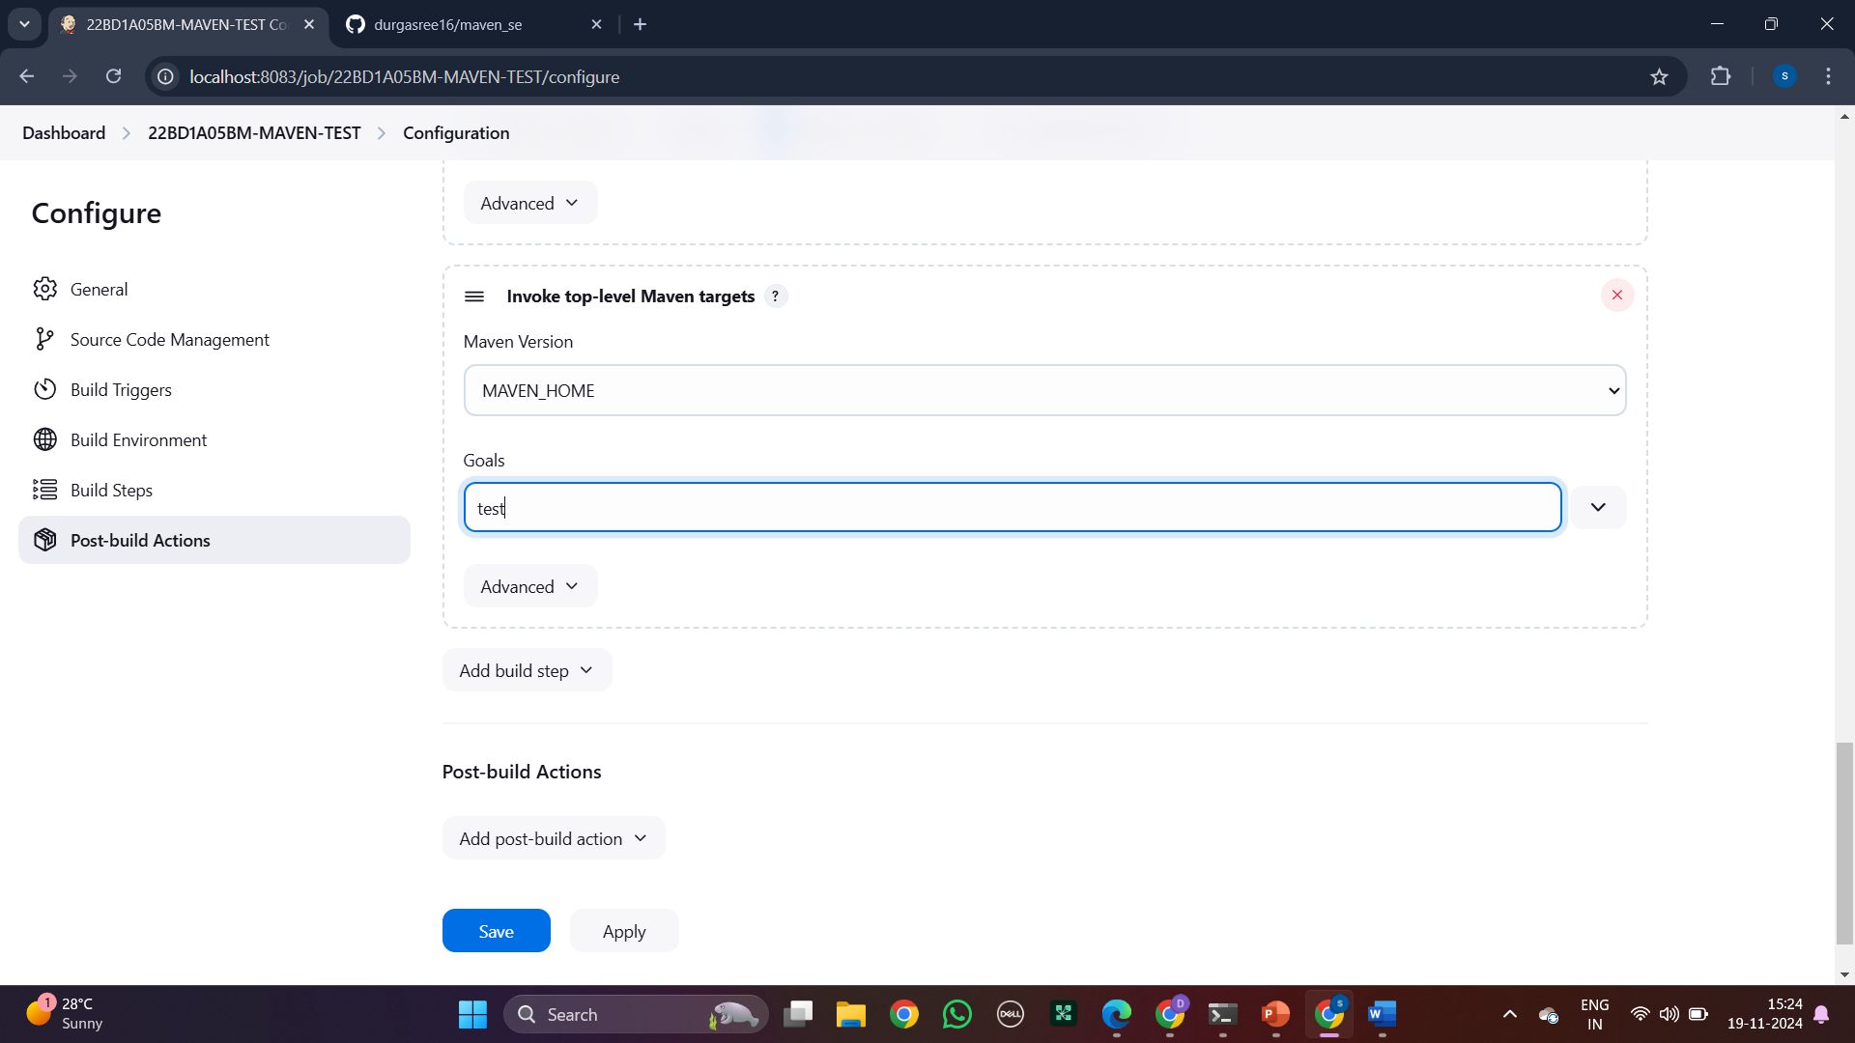

Step 16: Go to post build and select to archive the artifacts and type “*/**” and apply and save

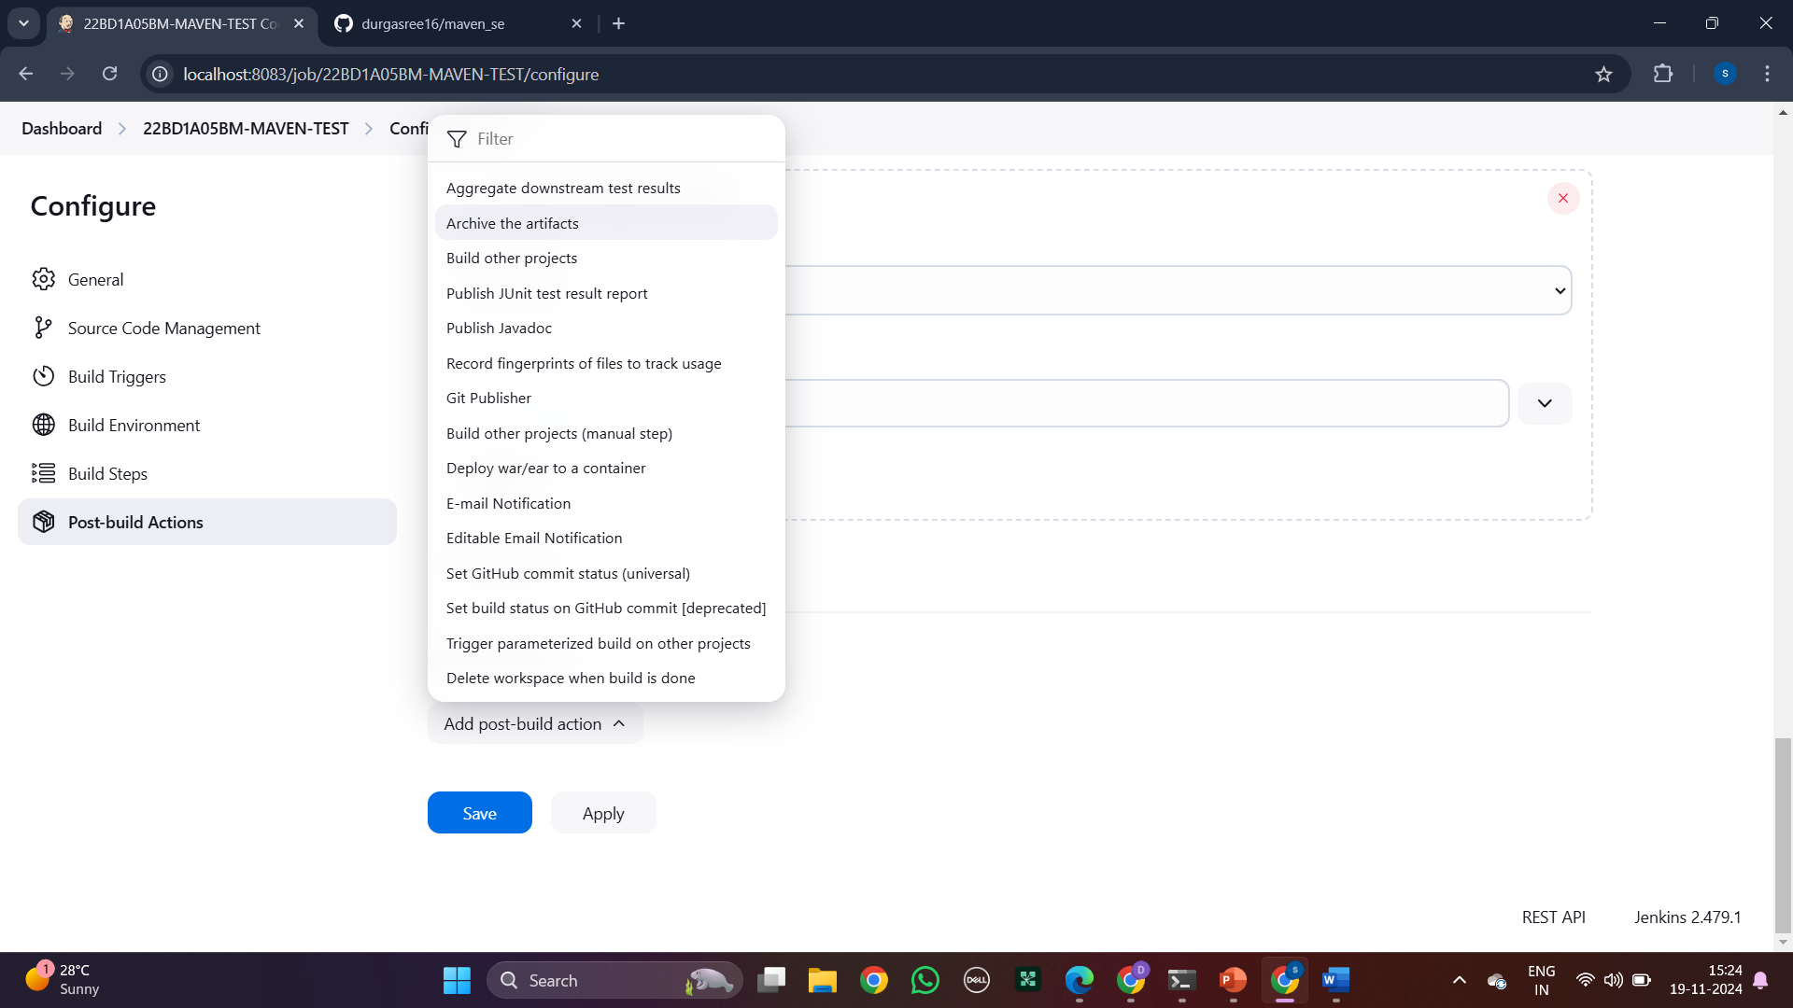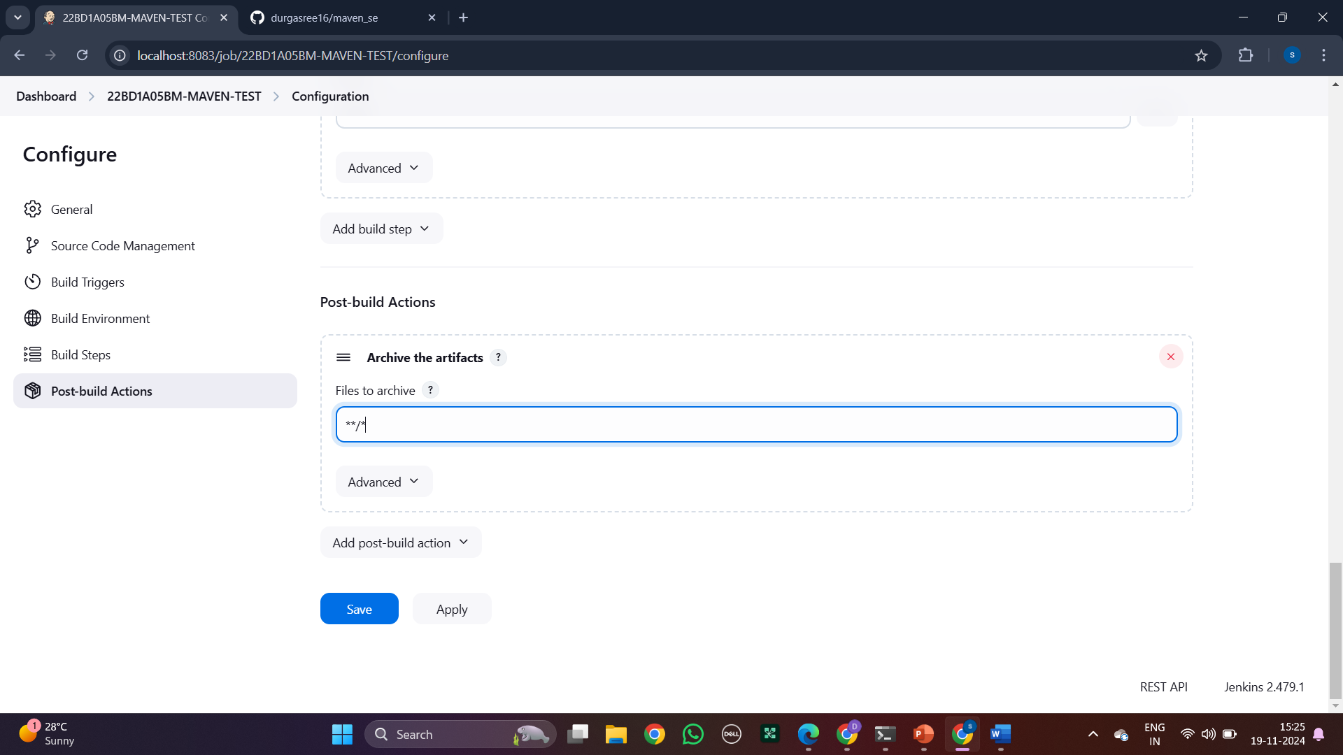

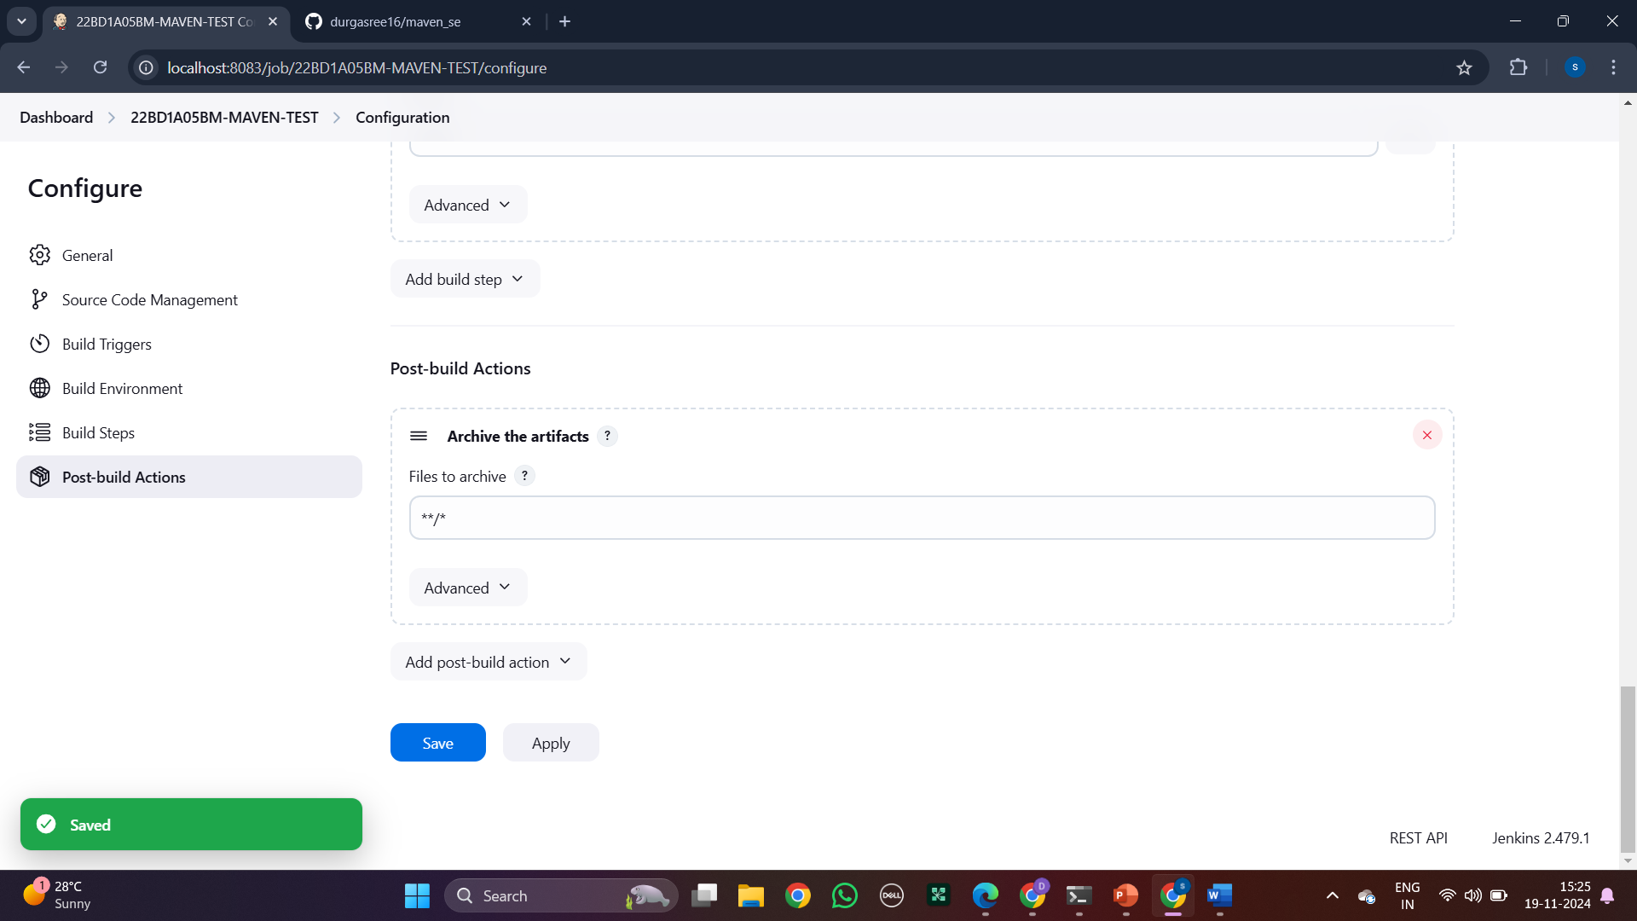

Step 17: Go to dashboard and click on + to create pipeline.

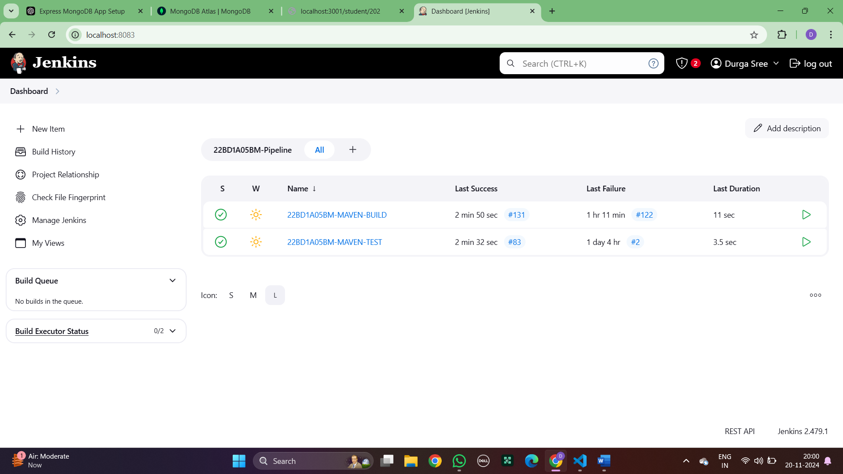

Step 18: Name it and select the build pipeline and apply and ok.

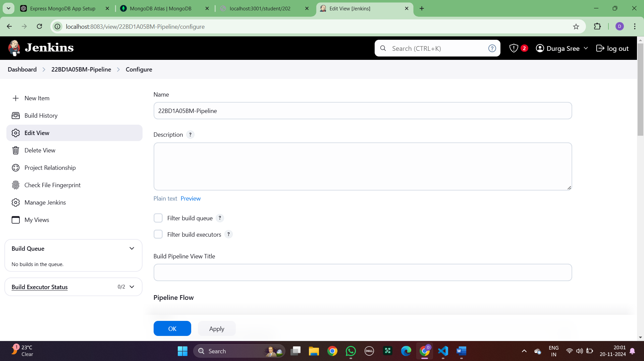

Step 19: Select initial job as Maven build

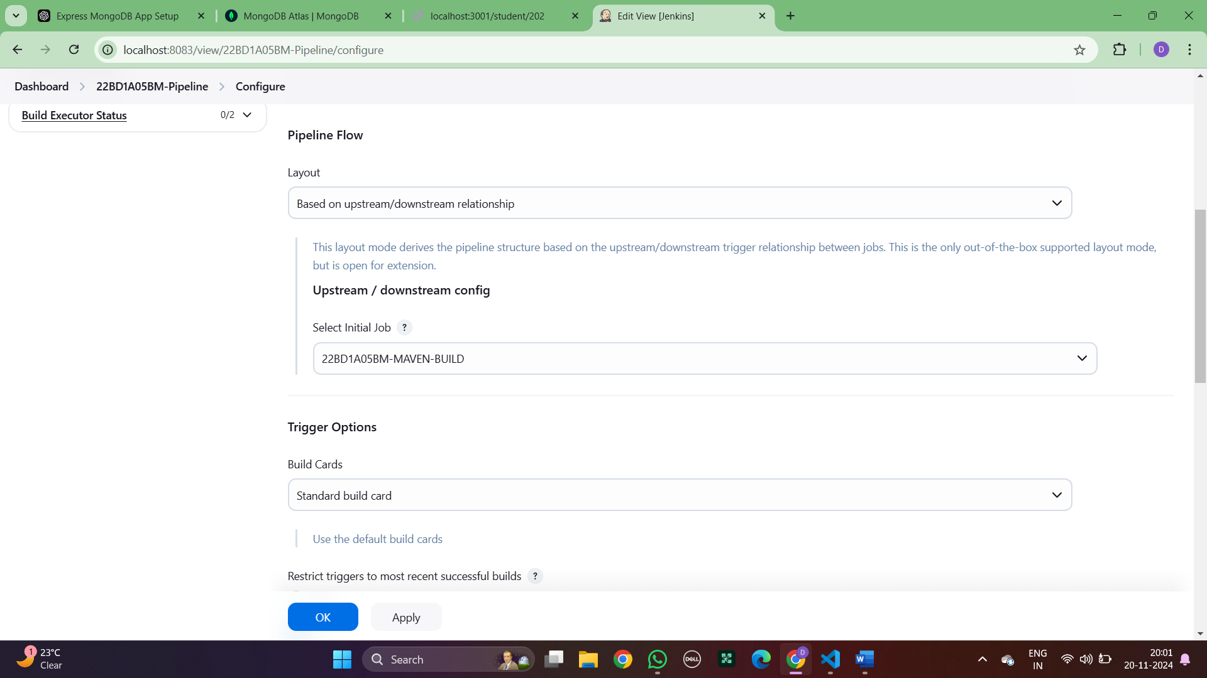

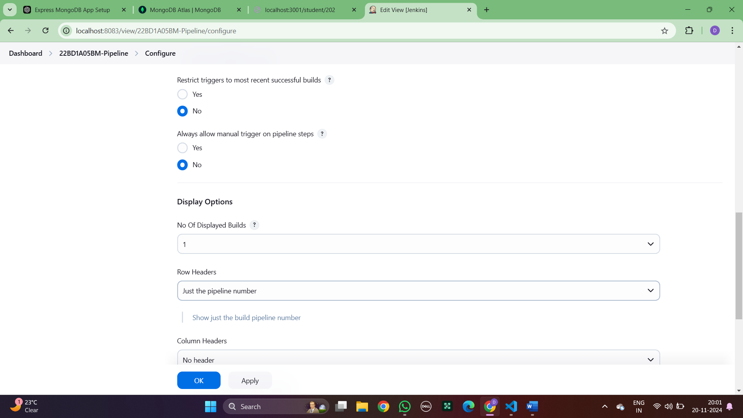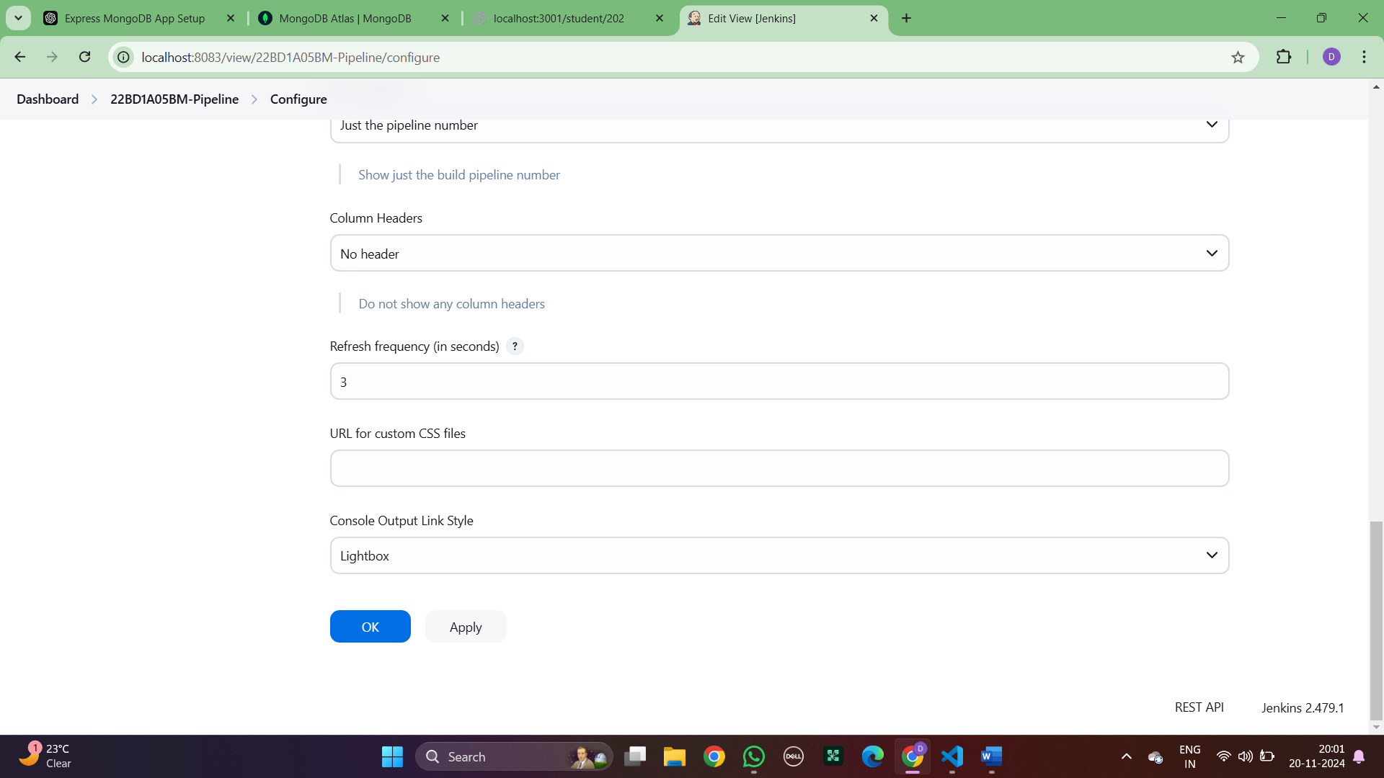

Step 20: This is two pipeline

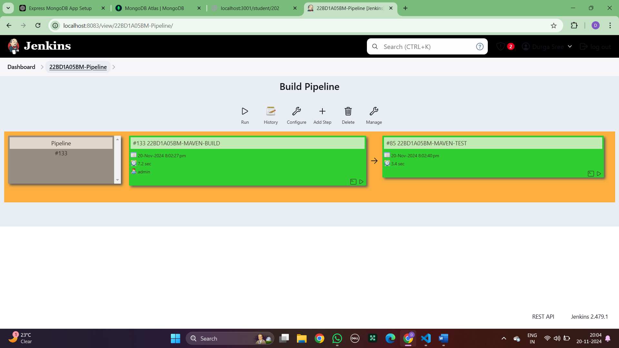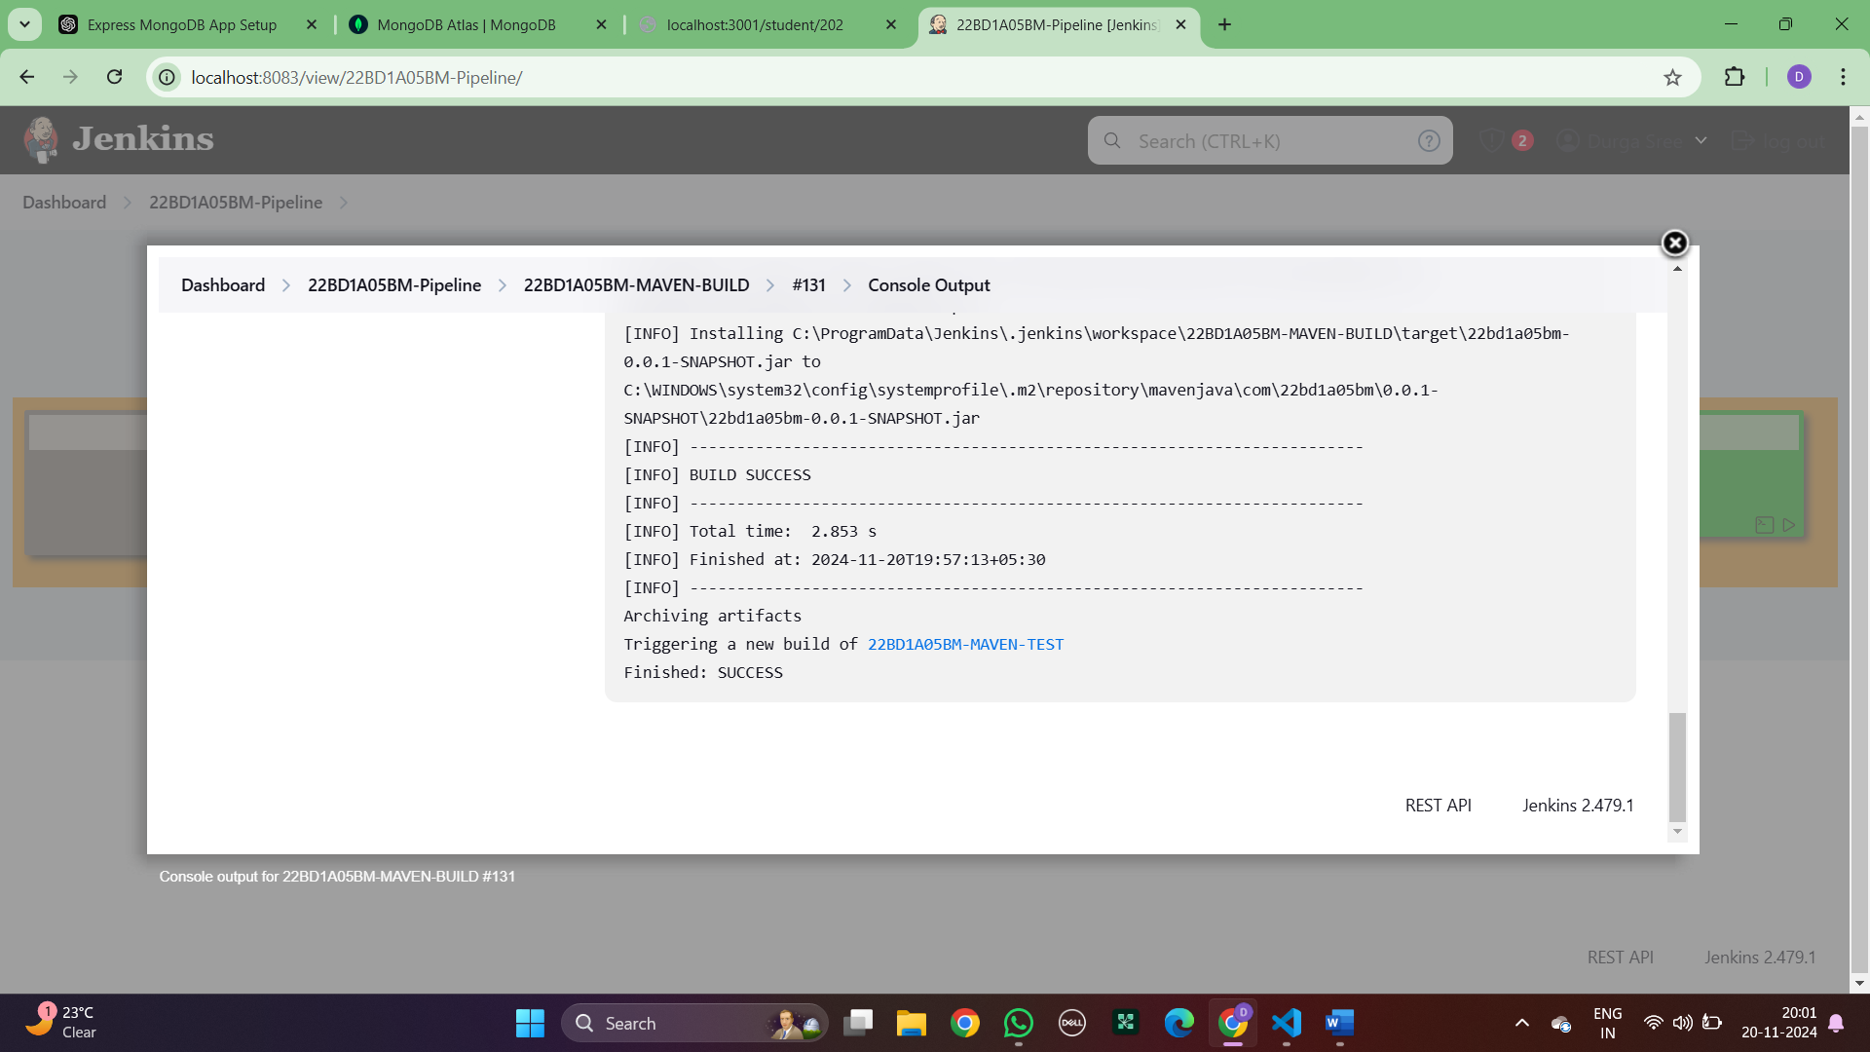

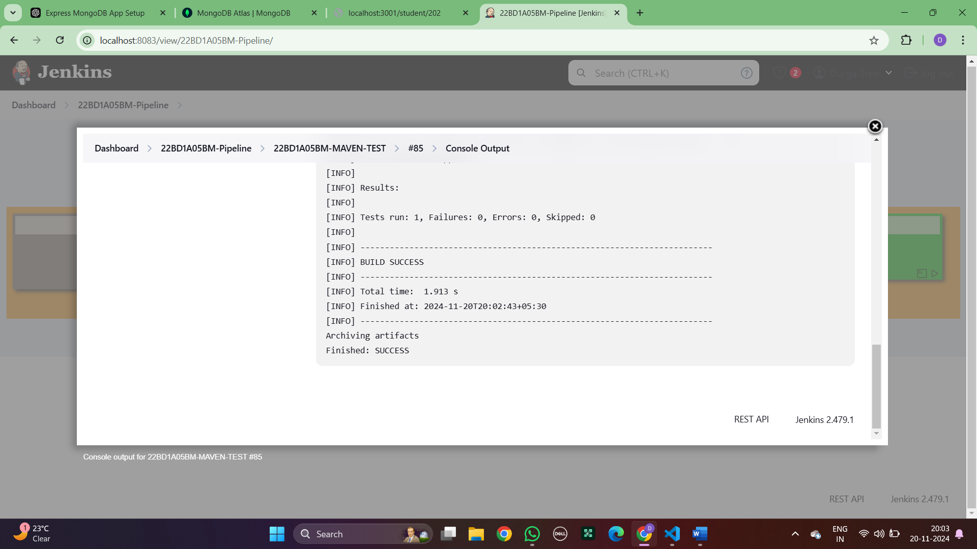

1. **BUILDING THE CI/CD FREESTYLE PIPELINE USING JENKINS FOR MAVEN WEB PROJECT WITH POLL SCM**
2. **Creating three pipeline in Jenkins**
3. Step 1:open Jenkins and click on new item.

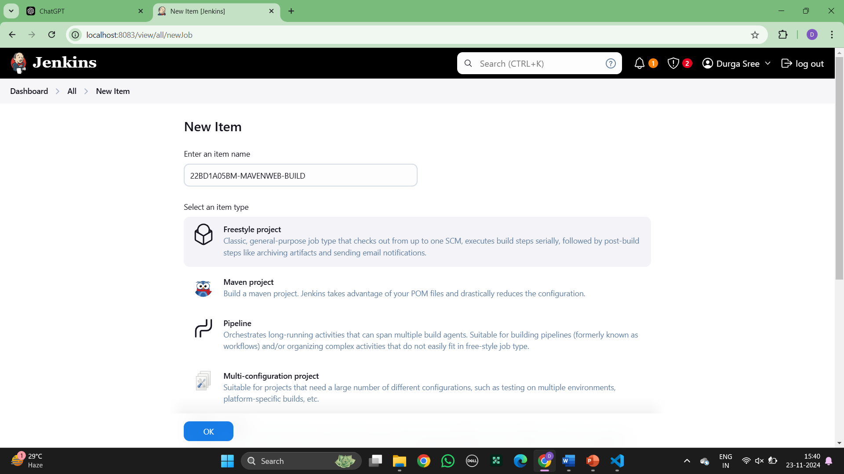

1. Step 2: enter the item as “name-build” and select freestyle and ok , Now go to GitHub and copy the https link form code.

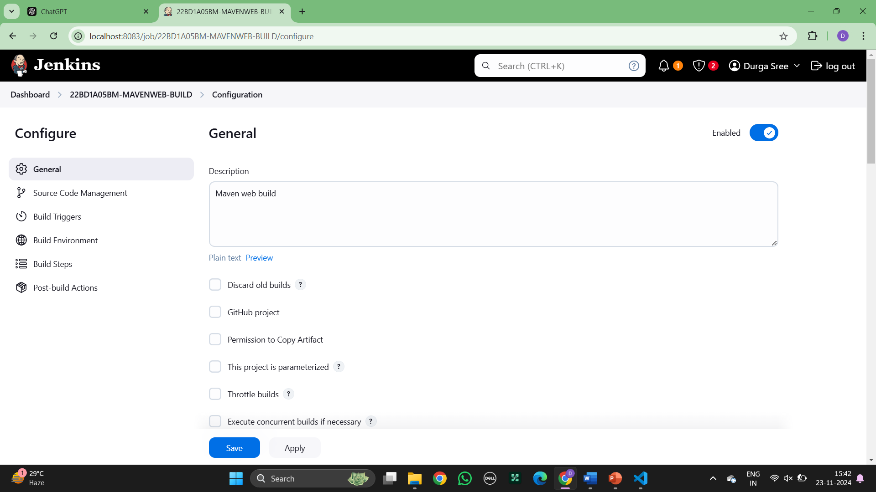

Step 3: Paste the link in repository URL and check for which branch it is in

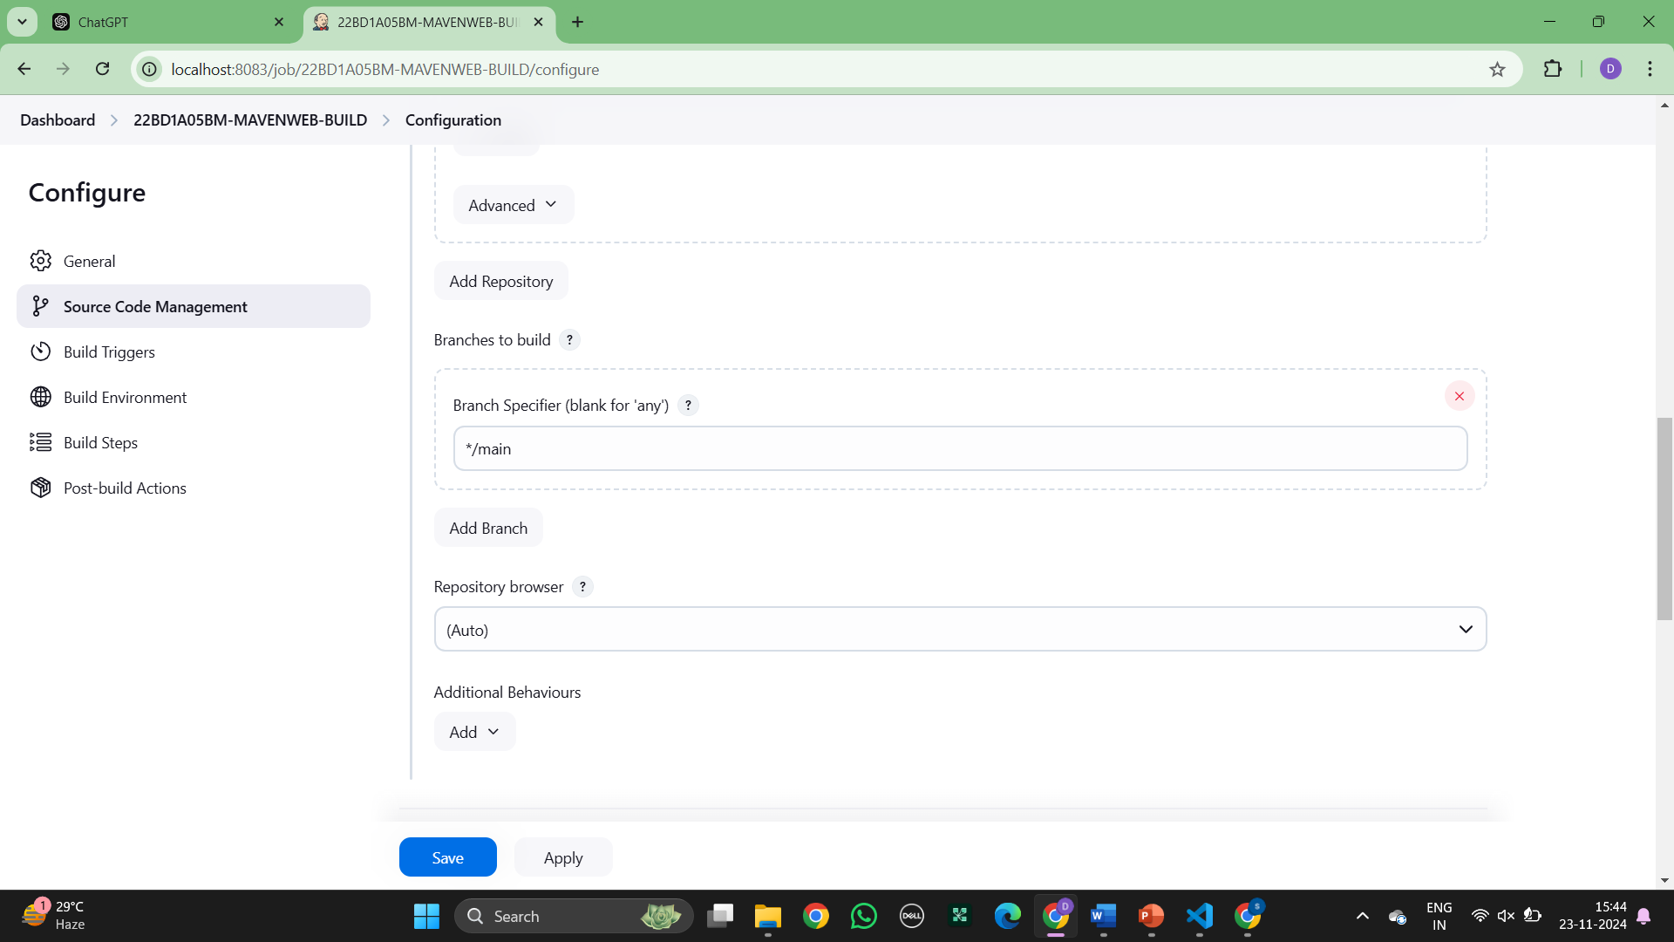

1. Step 6:Click on build step and select invoke top-level maven targets.

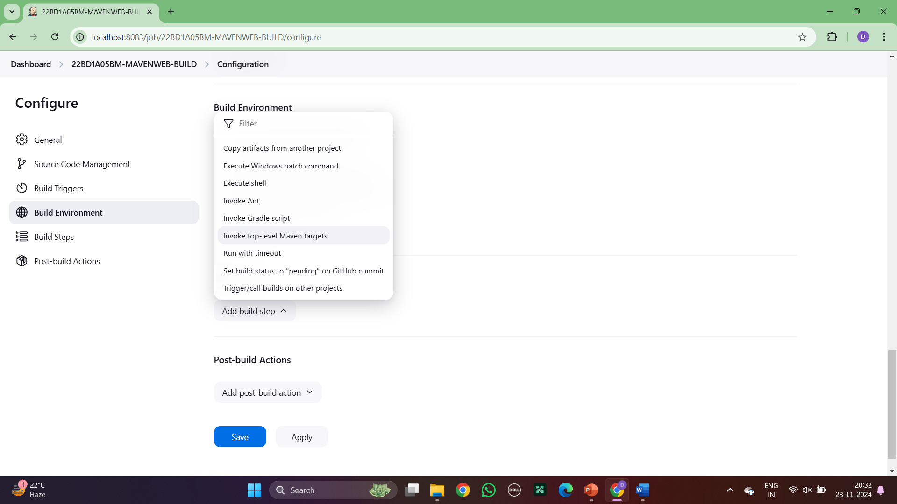

1. Step: Click on Invole top level Maven targets and click goals as clean and install

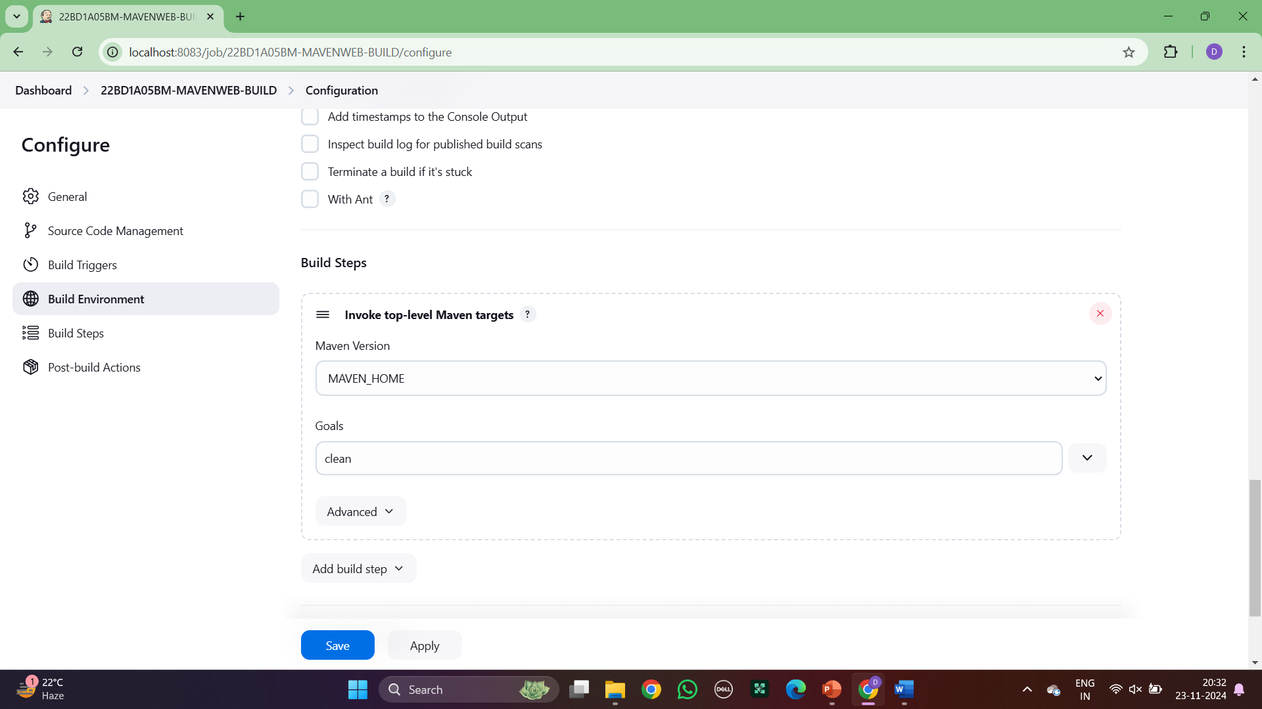

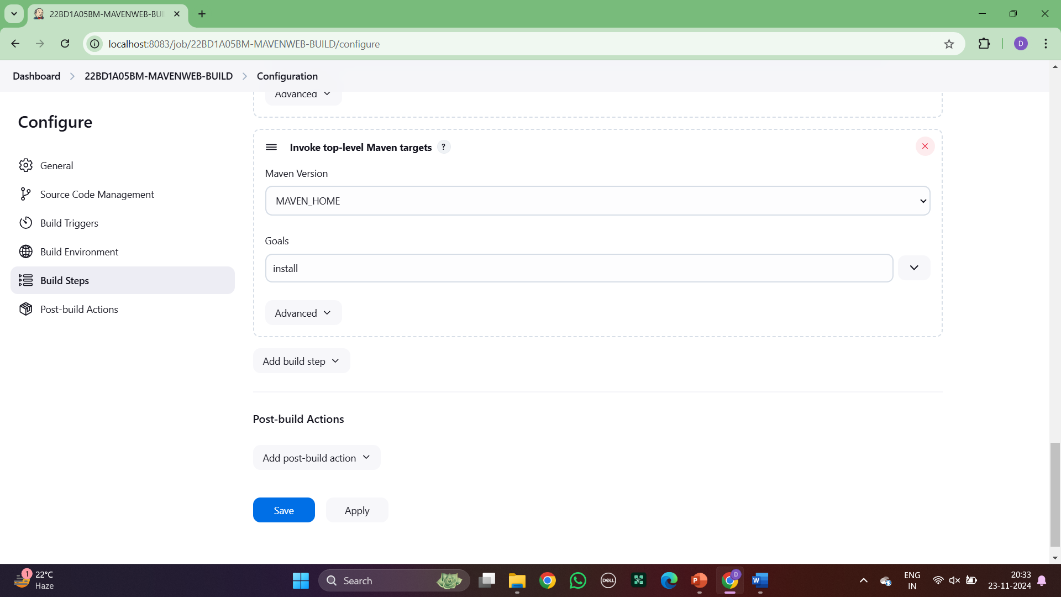

1. Step7: click in post build actions and select archive the artifacts.

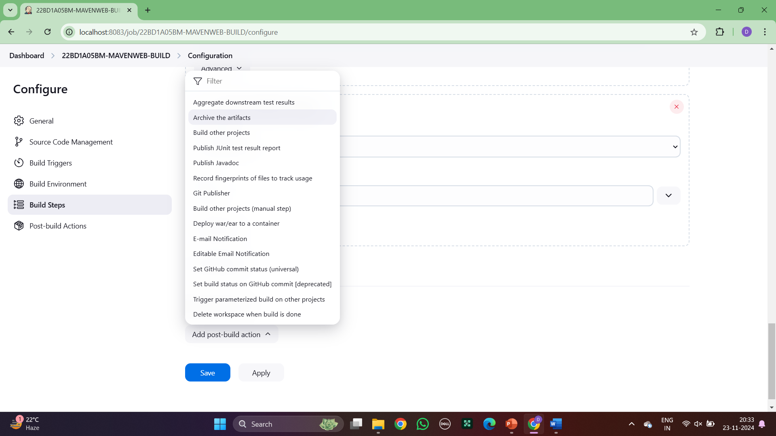

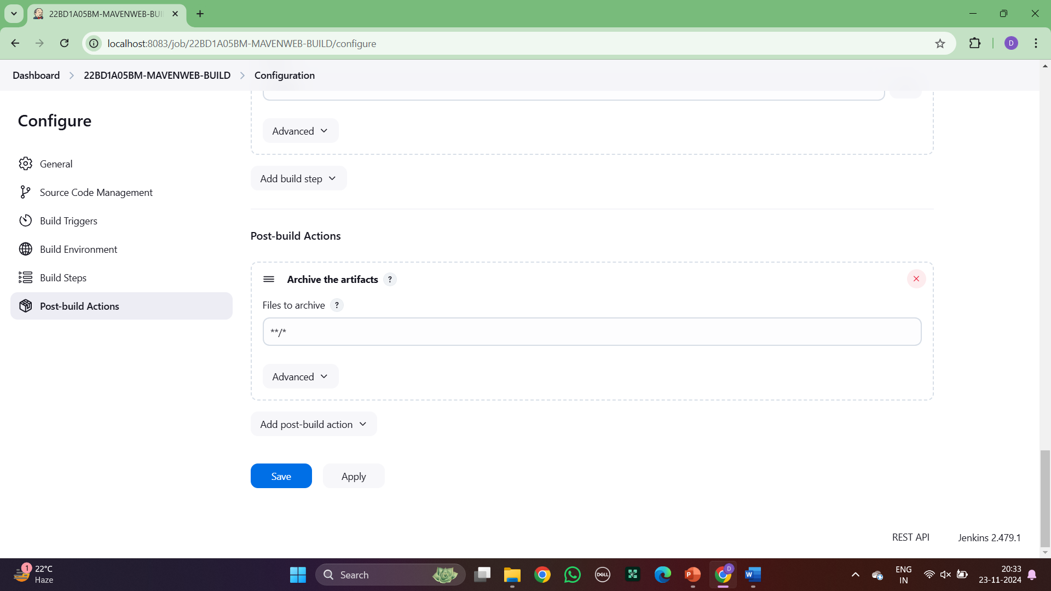

1. Step 8:Now, same but select build other projects.

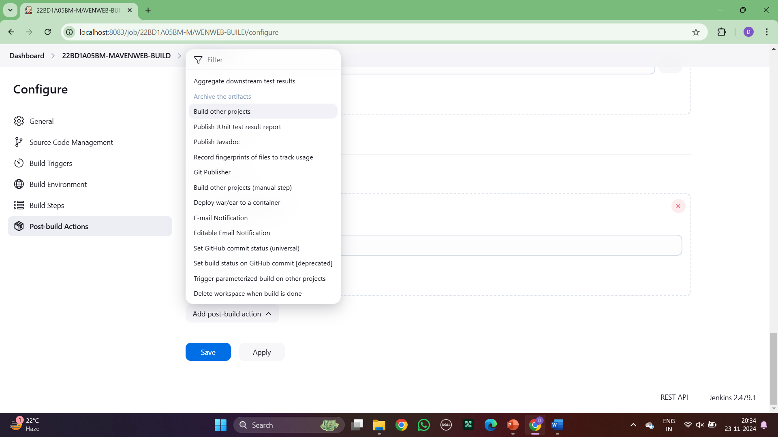

1. Step : Click on apply and save

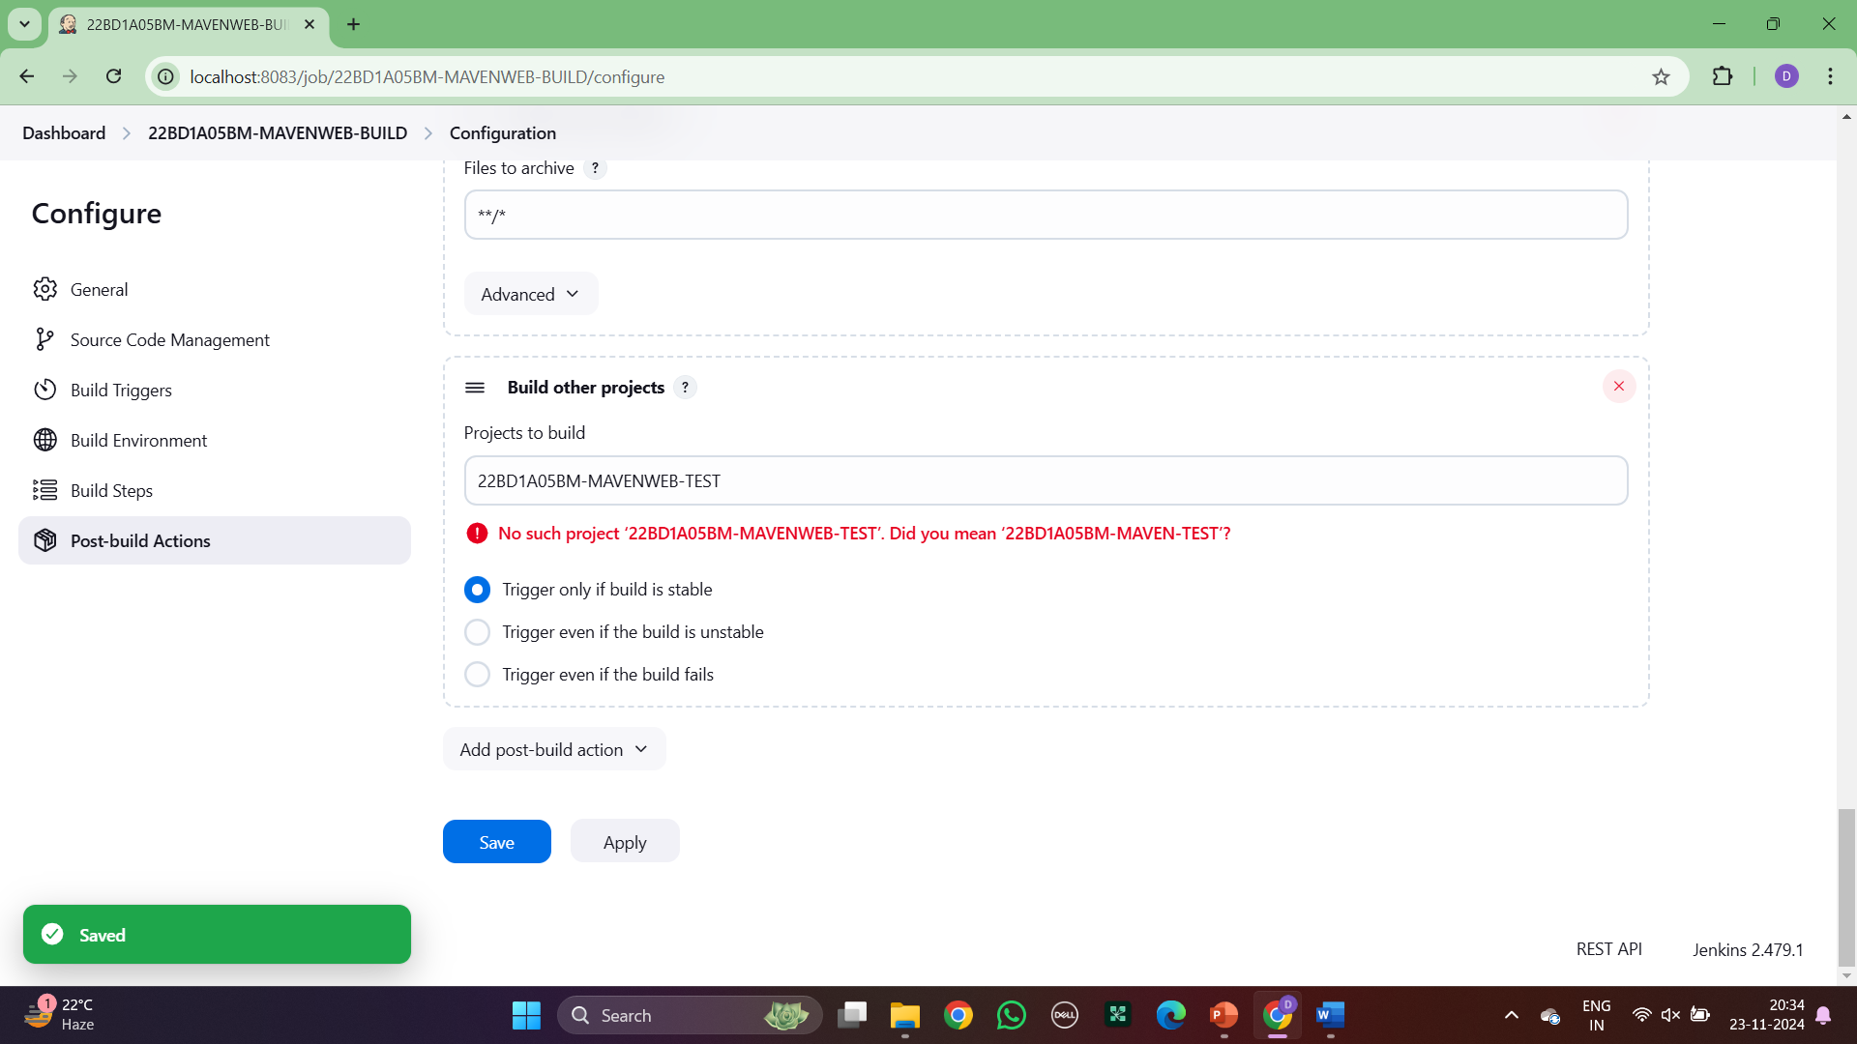

1. Step: Click on New item as ‘Maven Test’

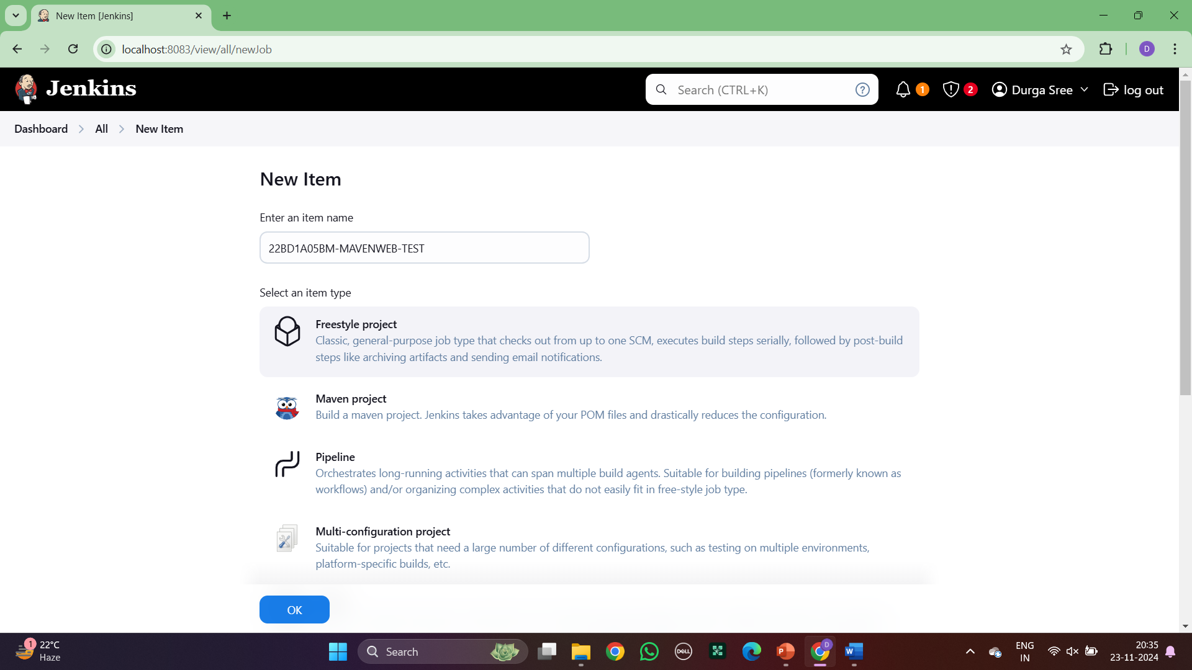

1. Step: Click on ‘Delete workspace ‘ in Build Environment

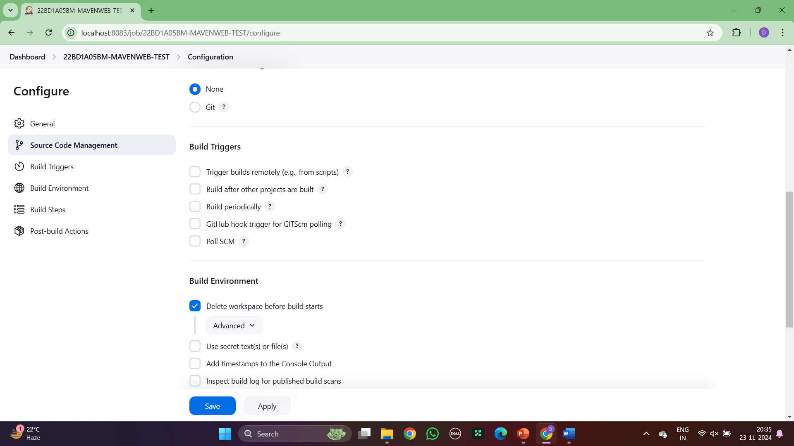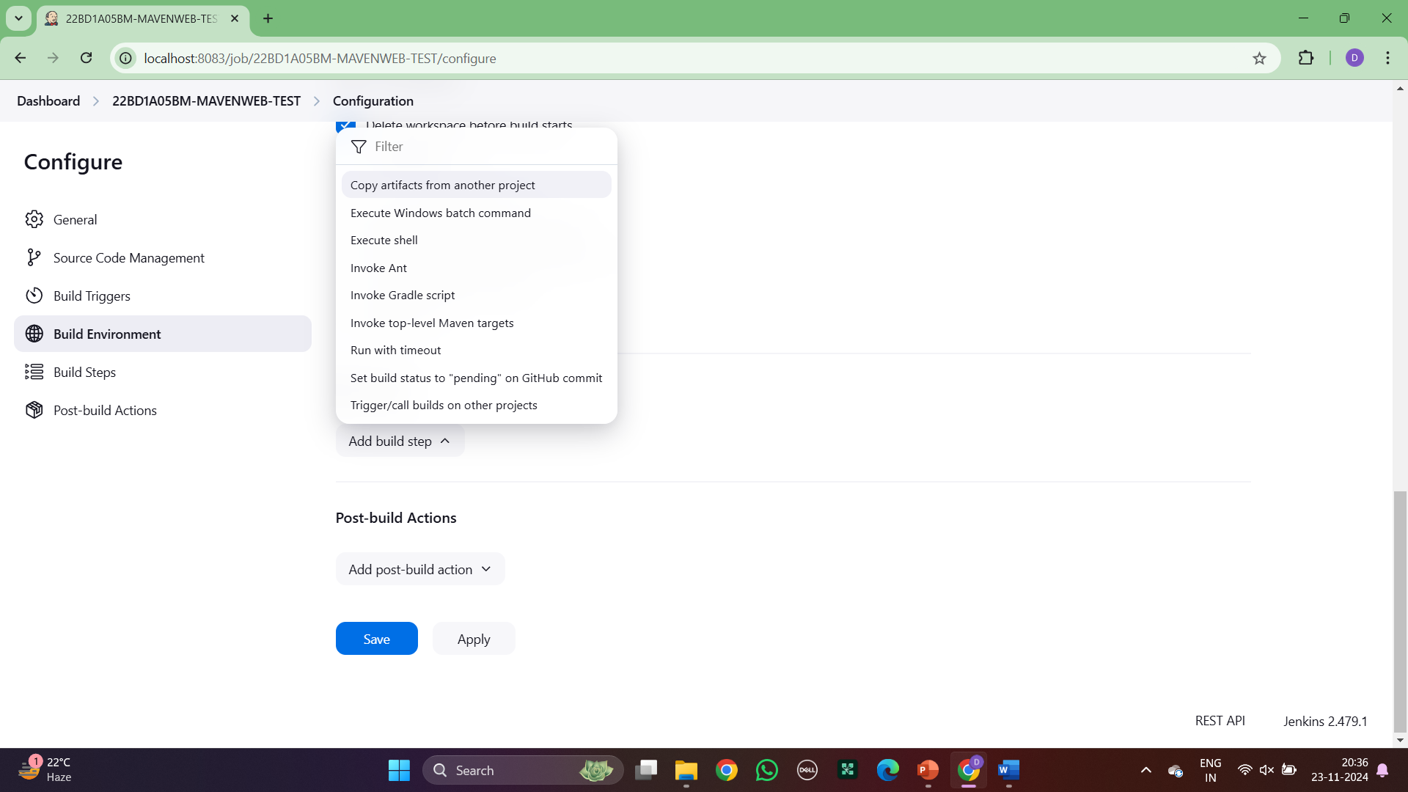

1. Step : Click on copy artifacts from another project and enter project name as maven build

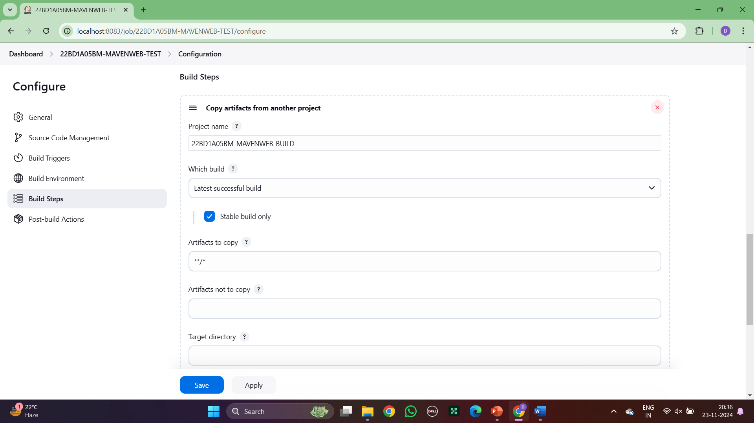

1. Step : Add build step as Invoke top level maven targets

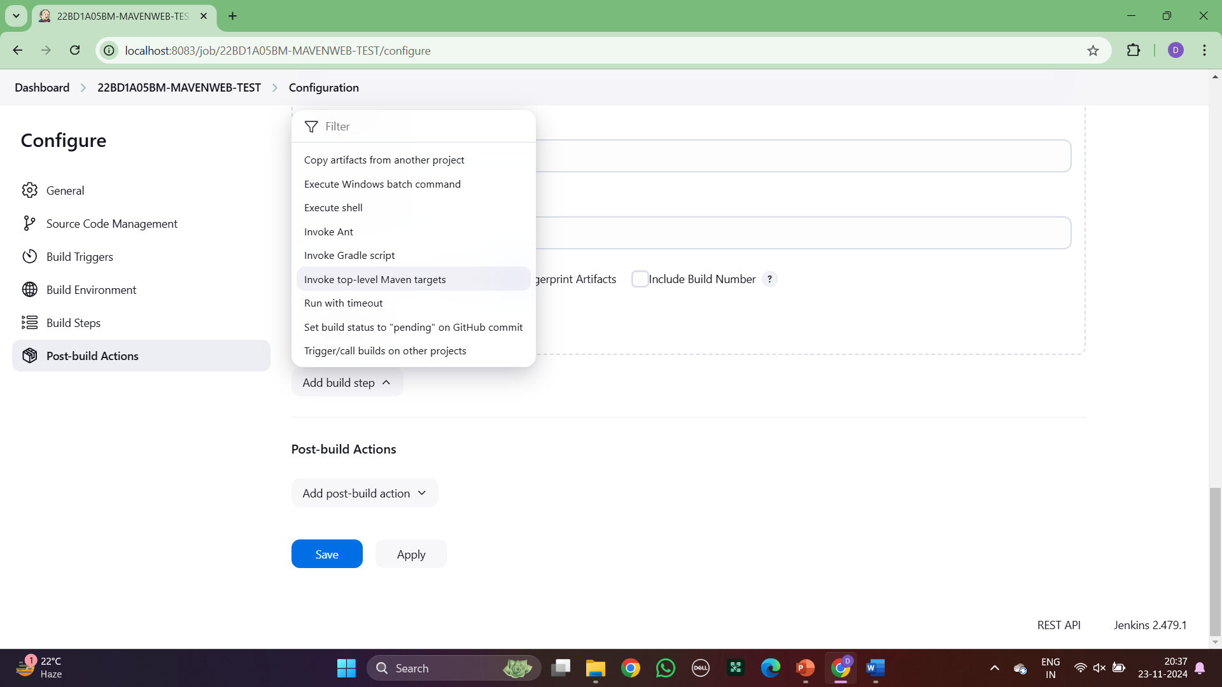

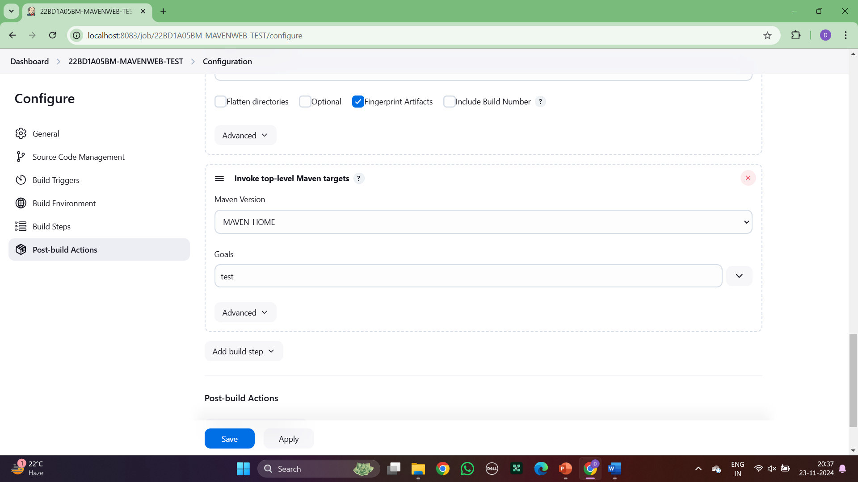

1. Step : Click on archive the artifacts

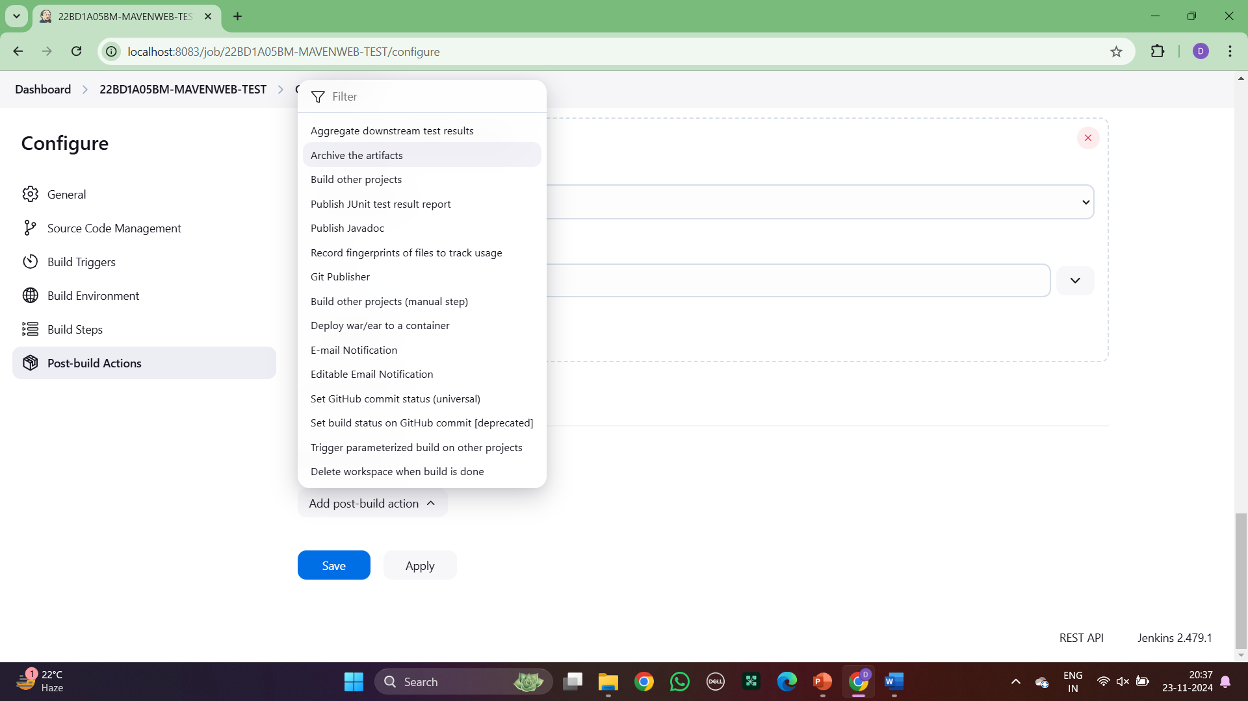

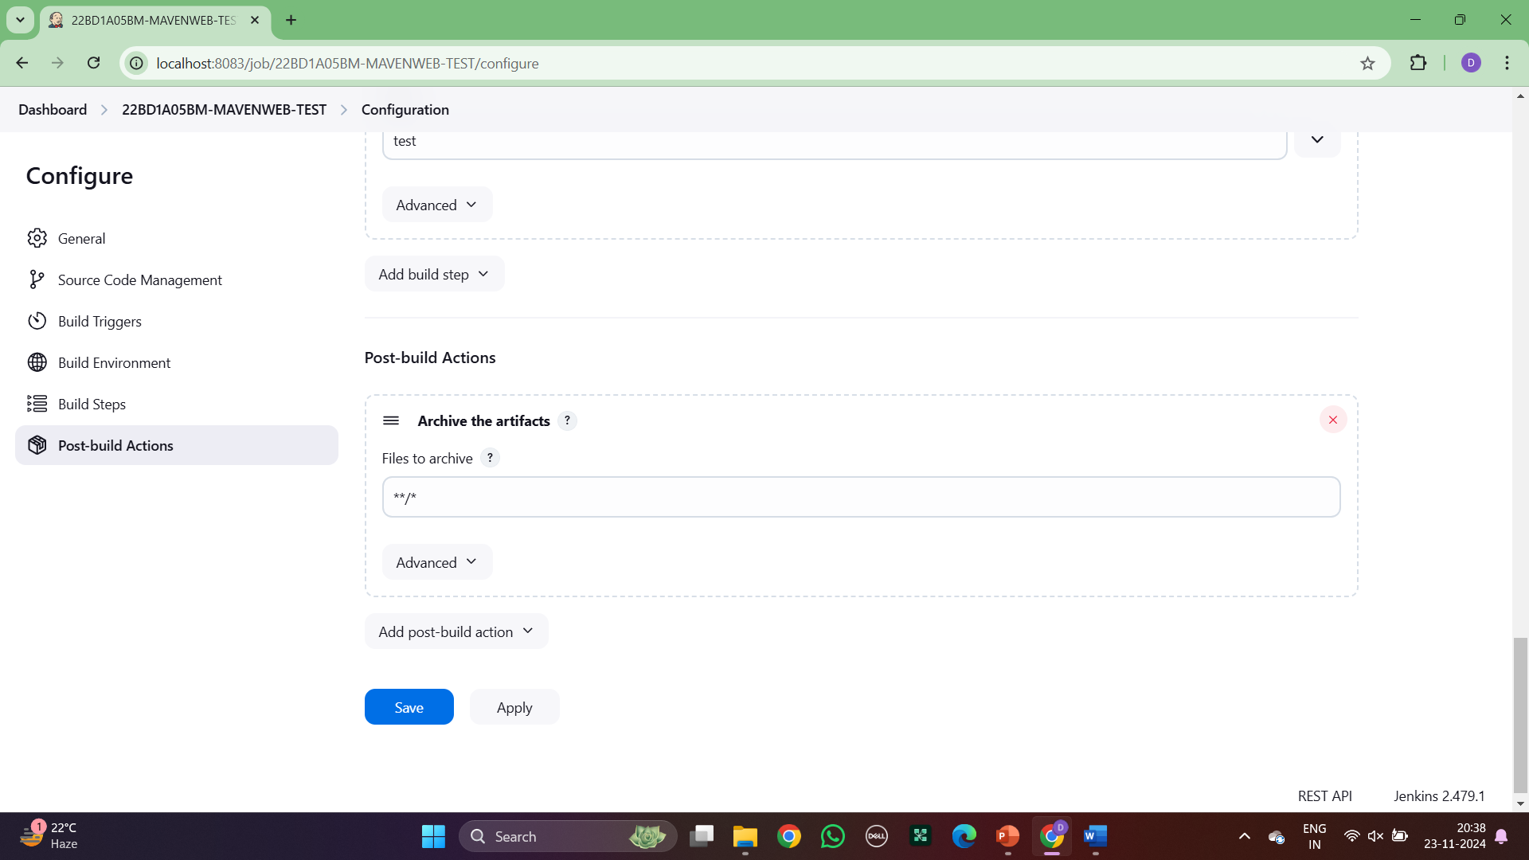

1. Step: Click on build other projects and select project names as maven deploy

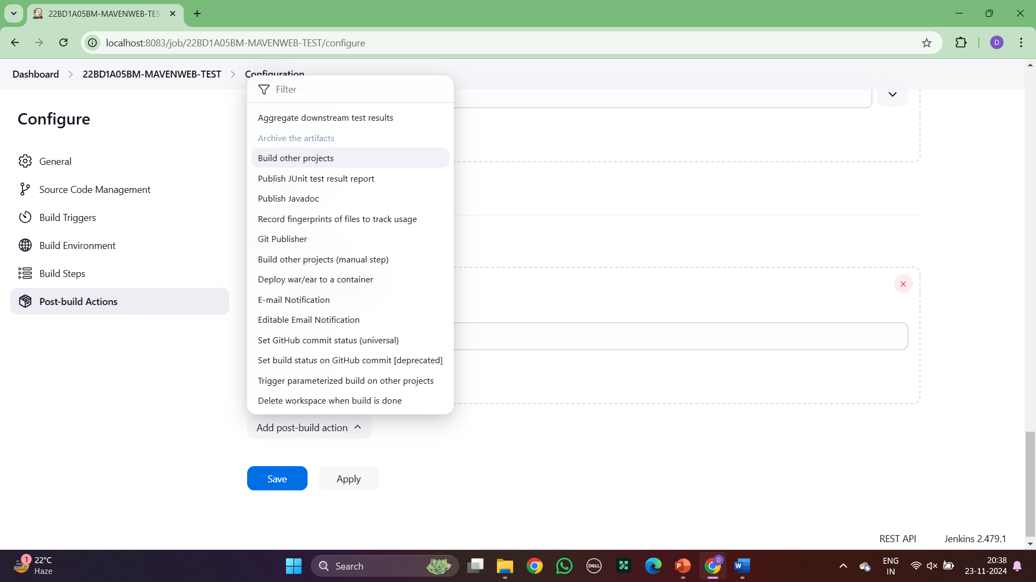

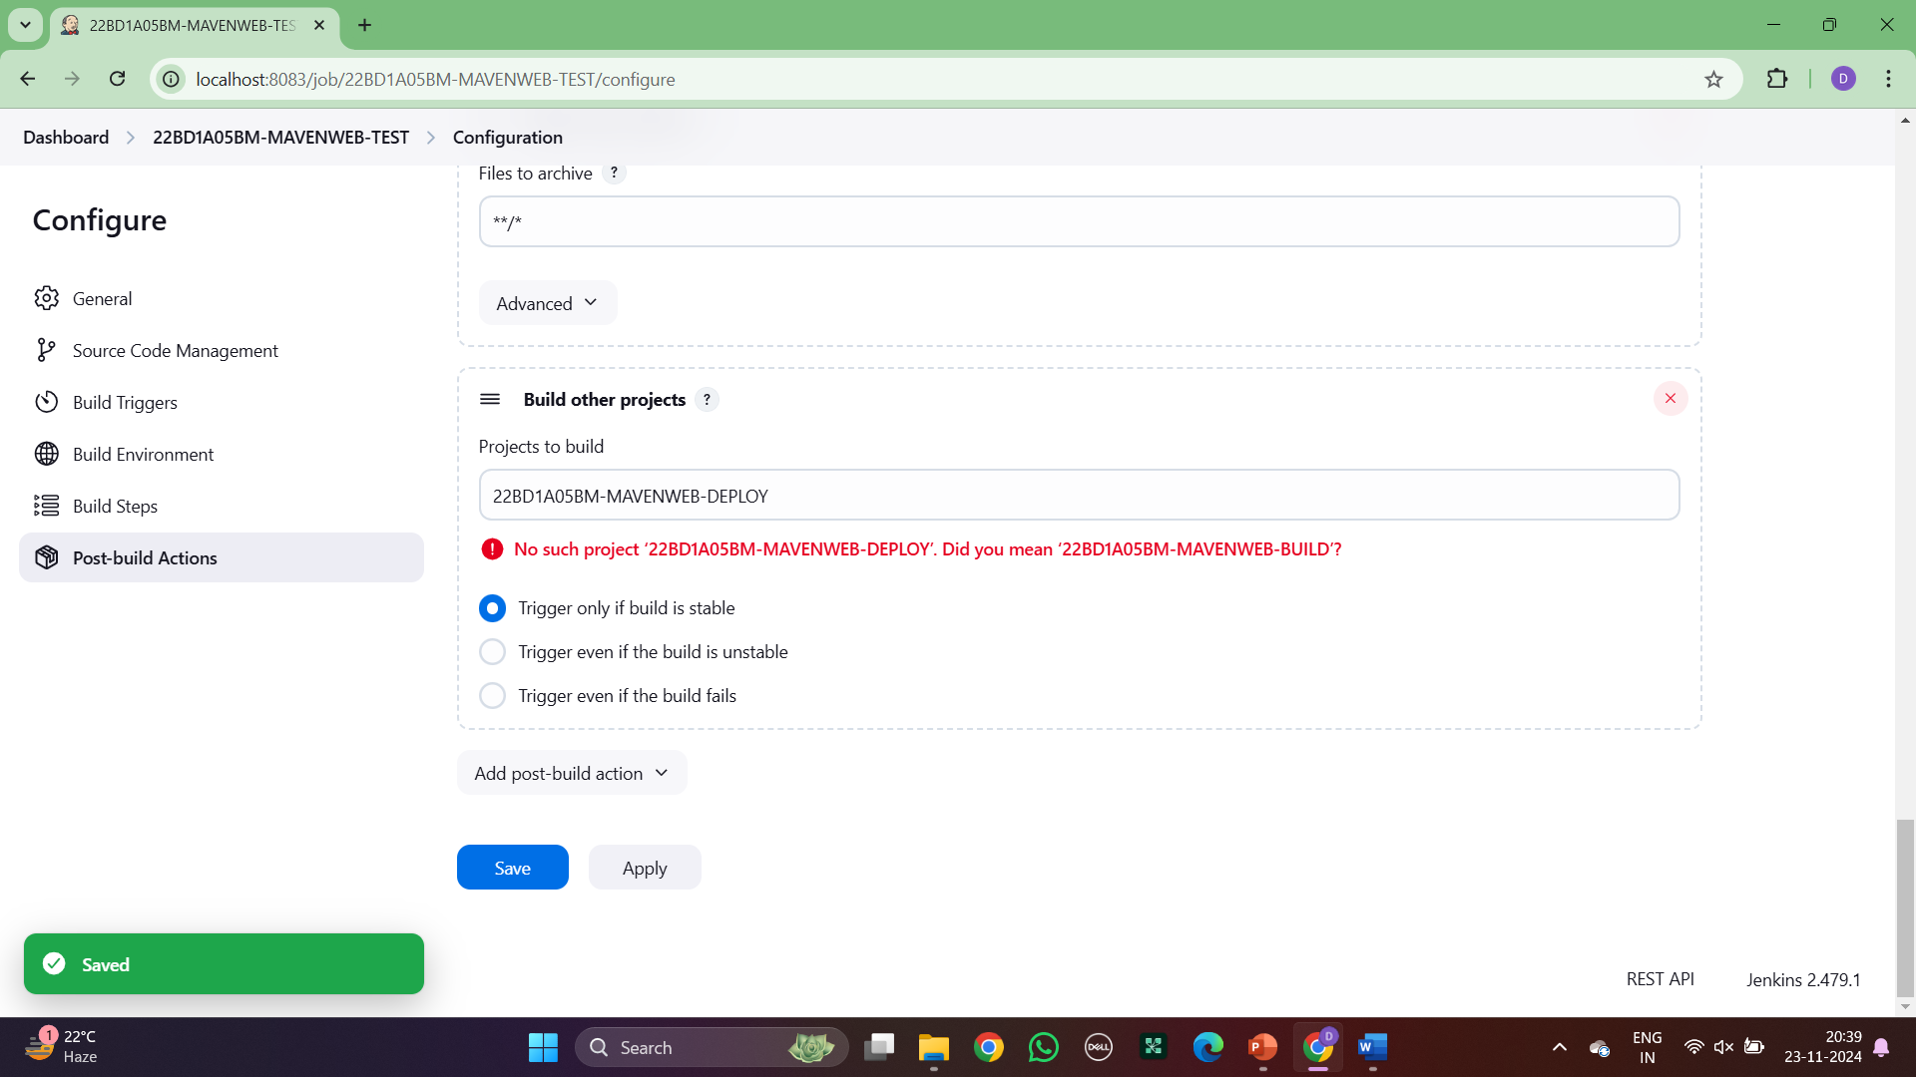

1. Step: Enter a new item as MavenWeb Deploy

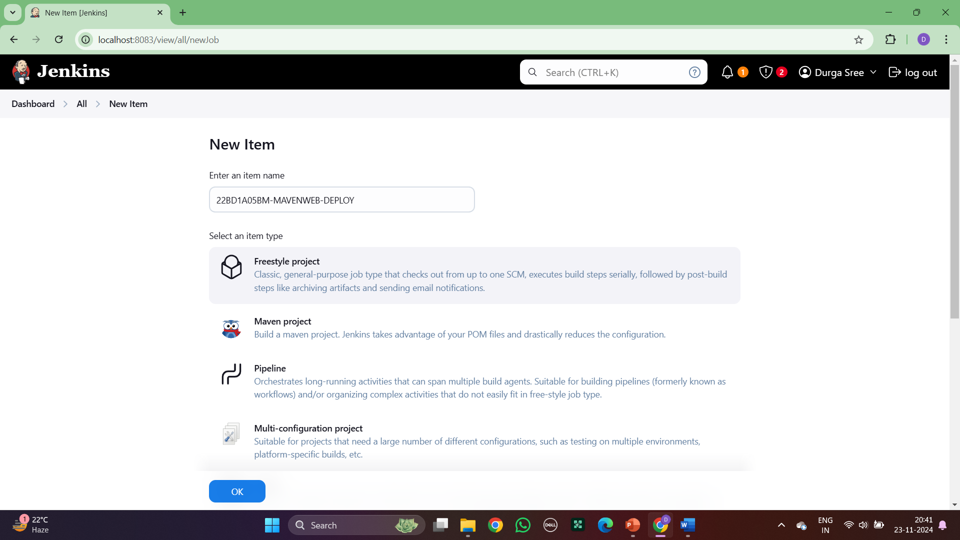

1. Step: In build environment, click on artifacts from another project

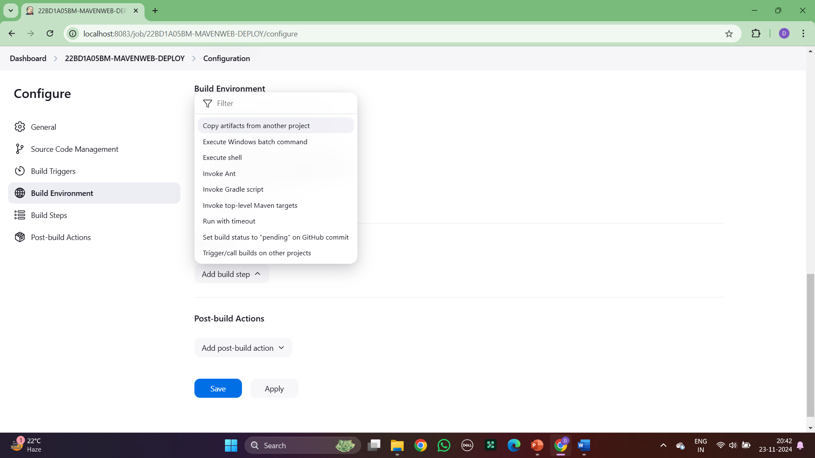

1. Step: In build steps, click on copy artifacts from another project

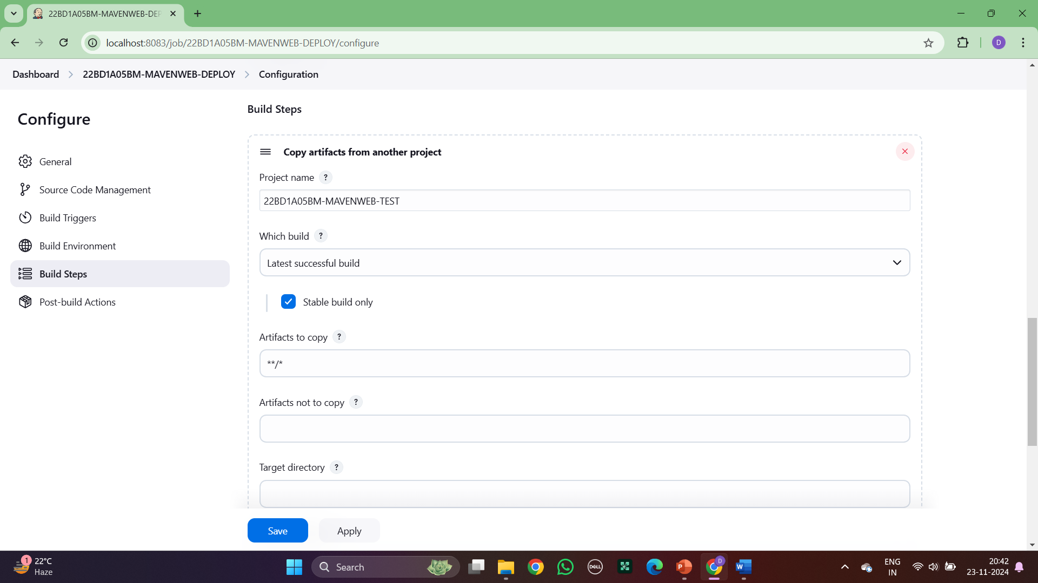

1. Step : Add post build action as Deploy war/ear to a container

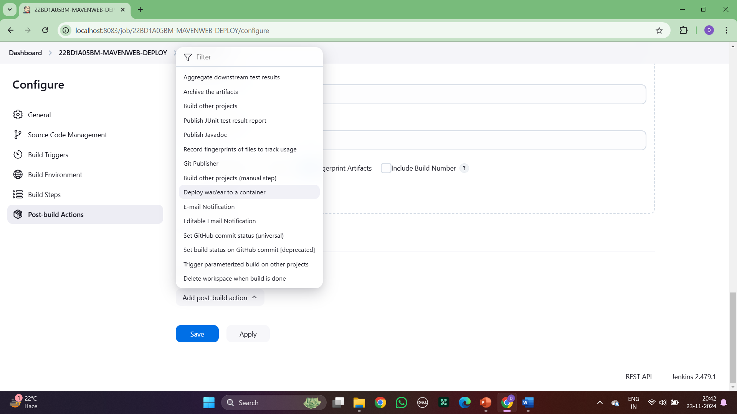

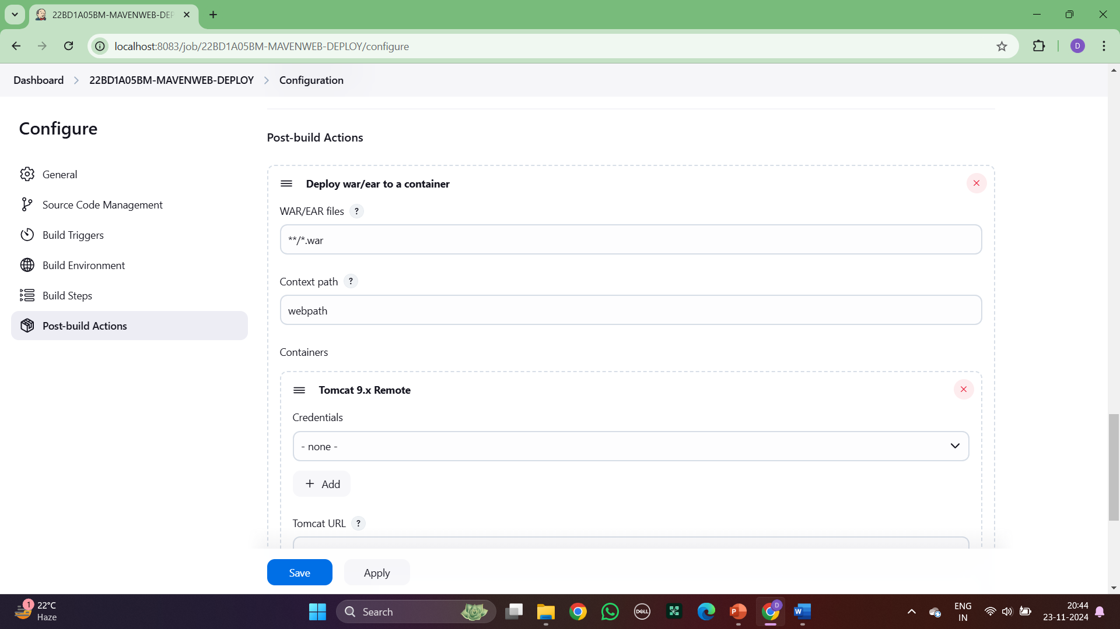

1. Step : Give the credentials of tomcat

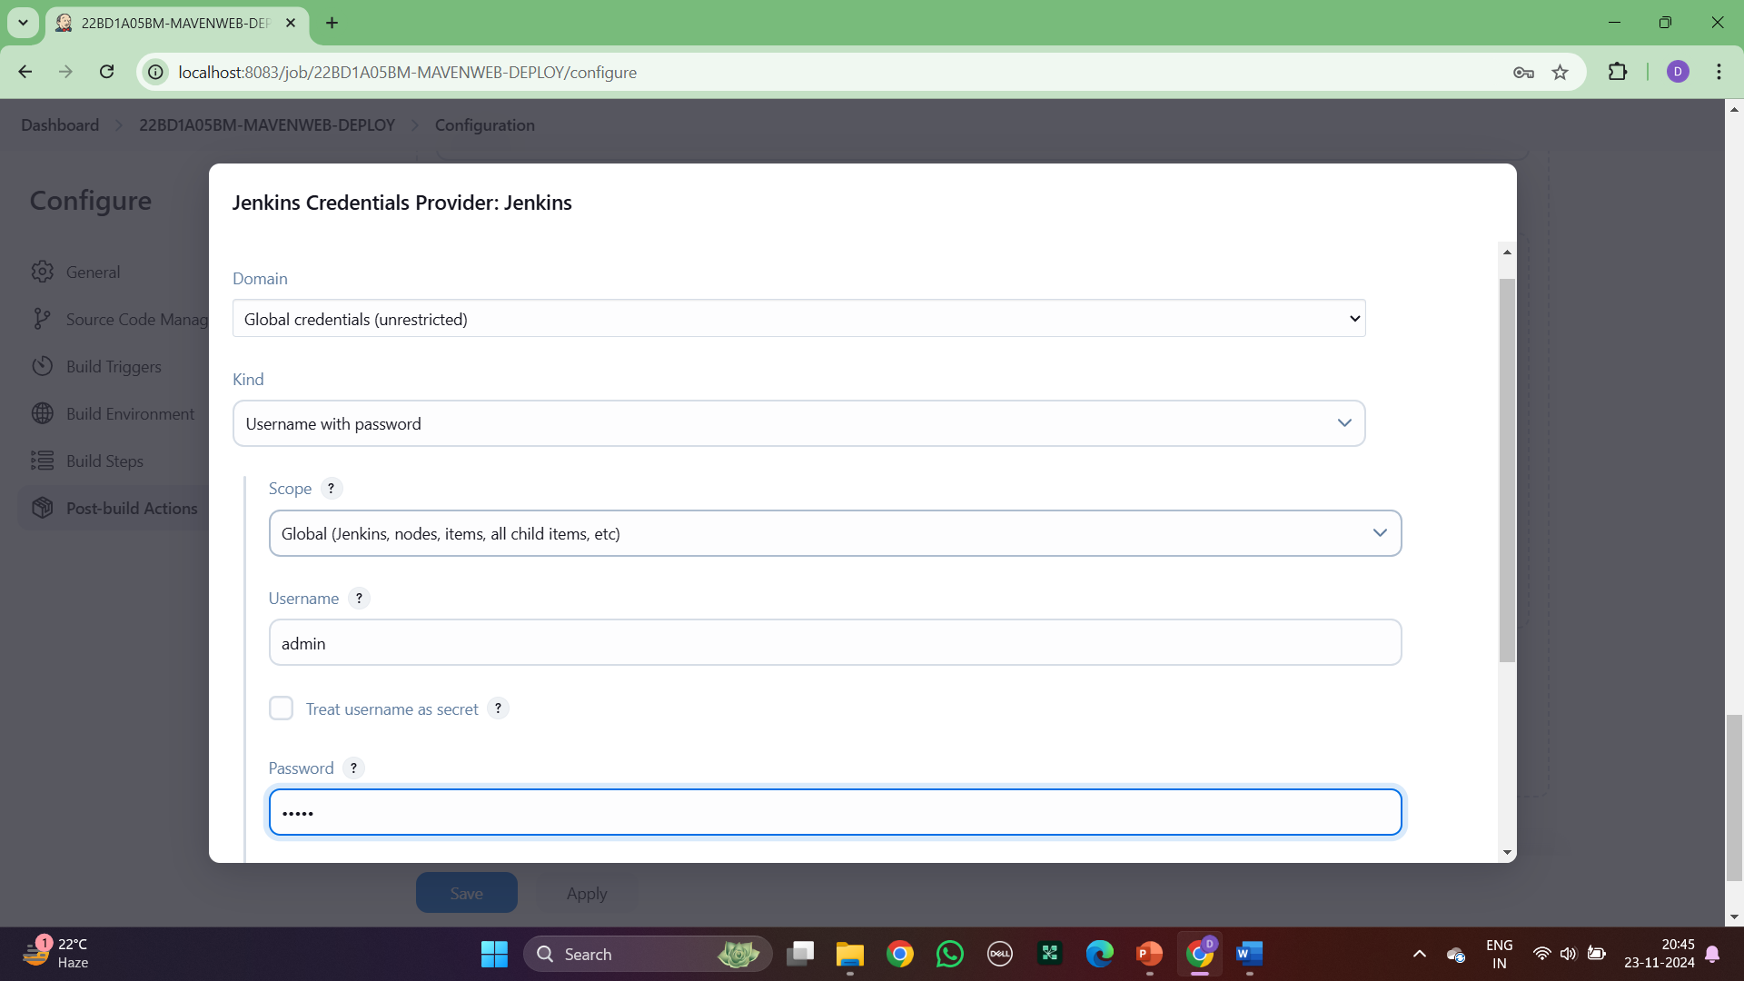

1. Step: Give the tomcat URL

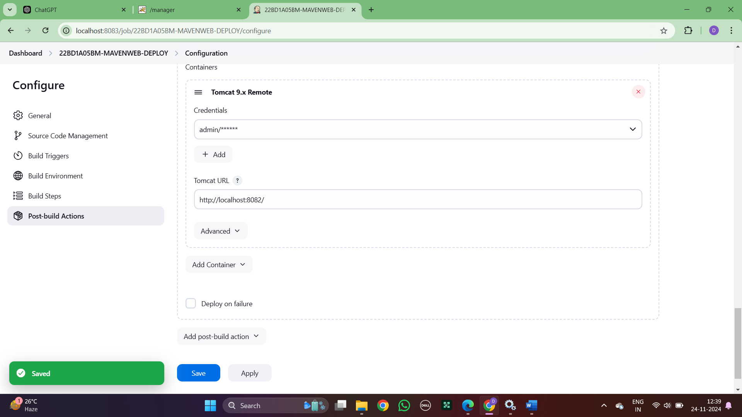

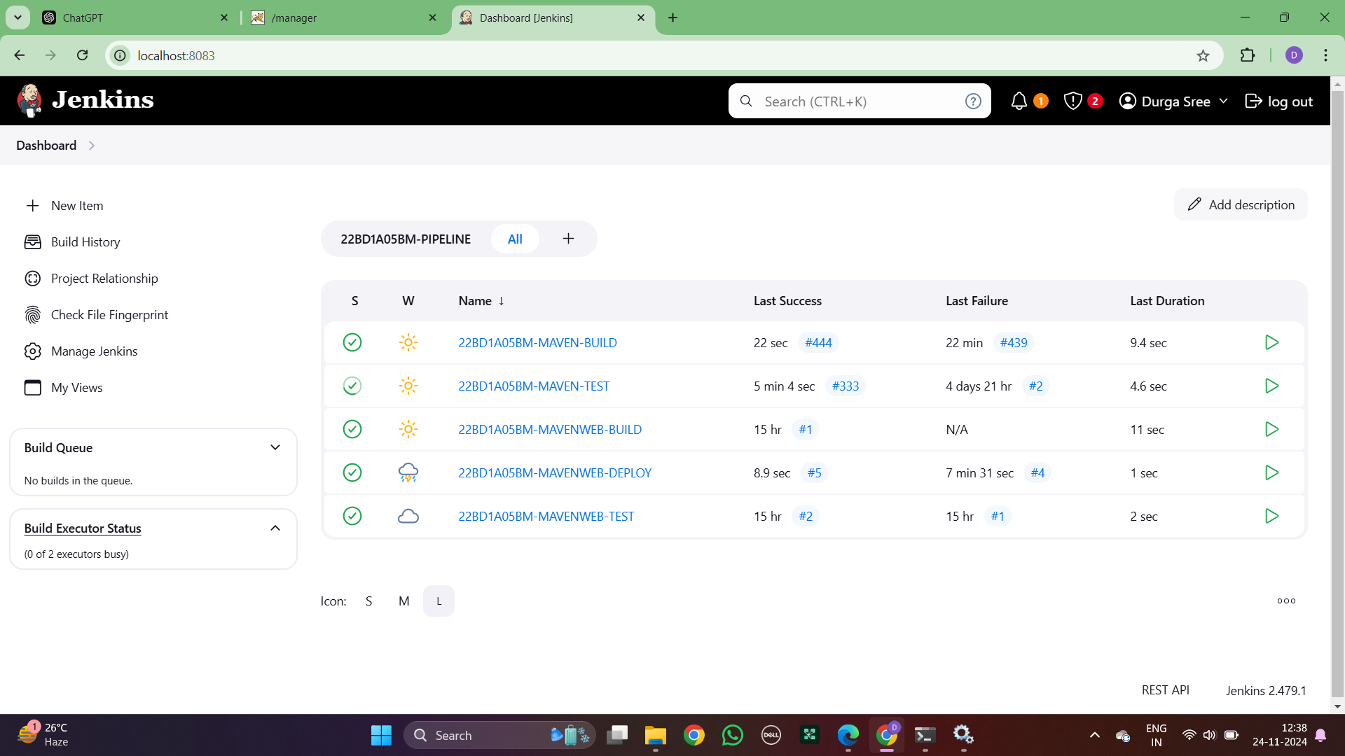

1. Step : Create a new view as maven web pipeline and click on build pipeline view

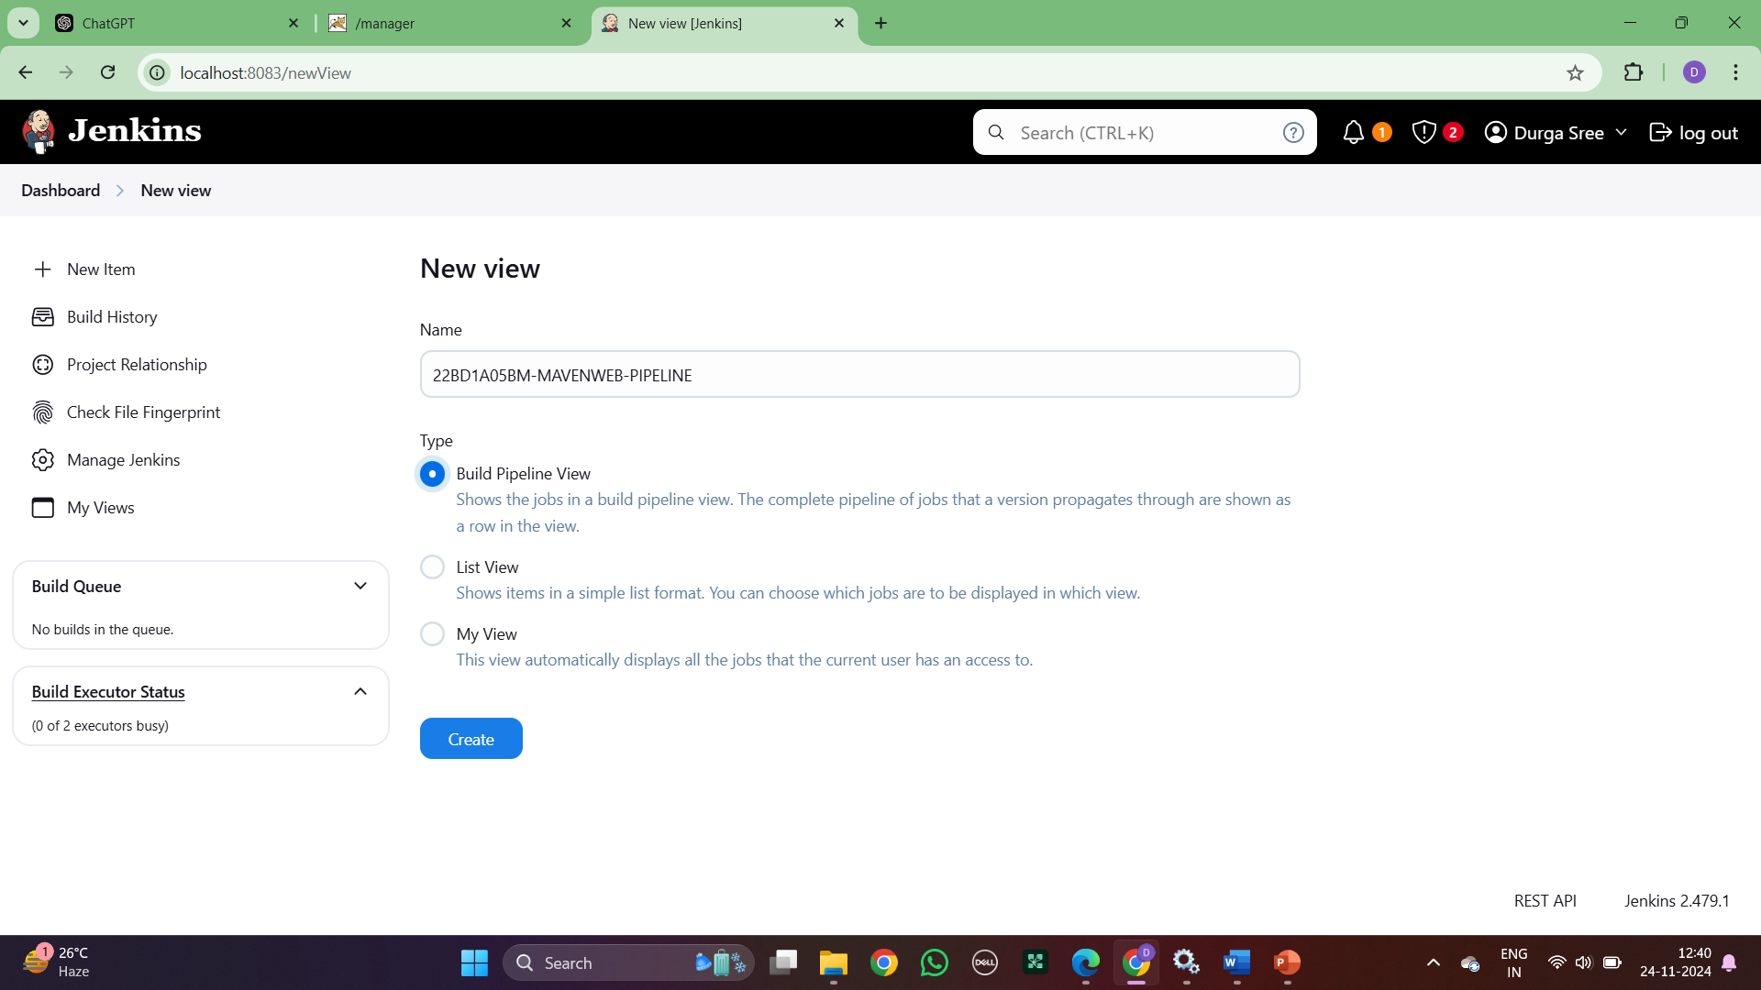

1. Step : Select initial job as mavenweb build

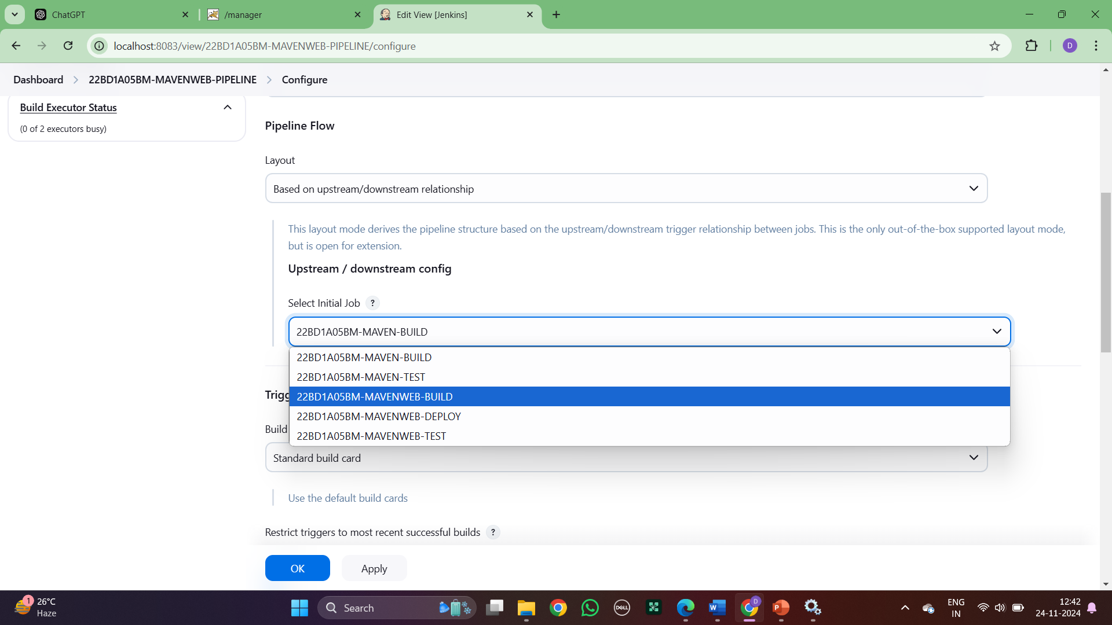

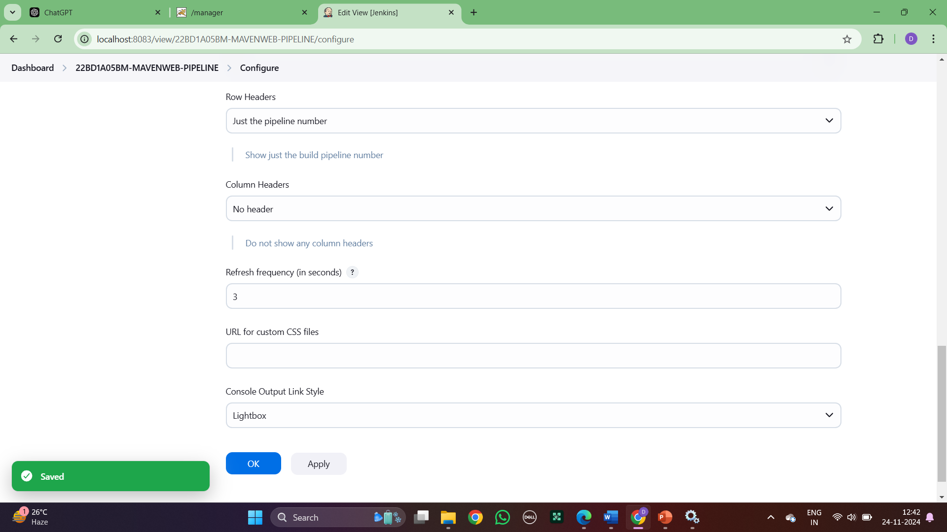

1. Step: This is the three pipeline

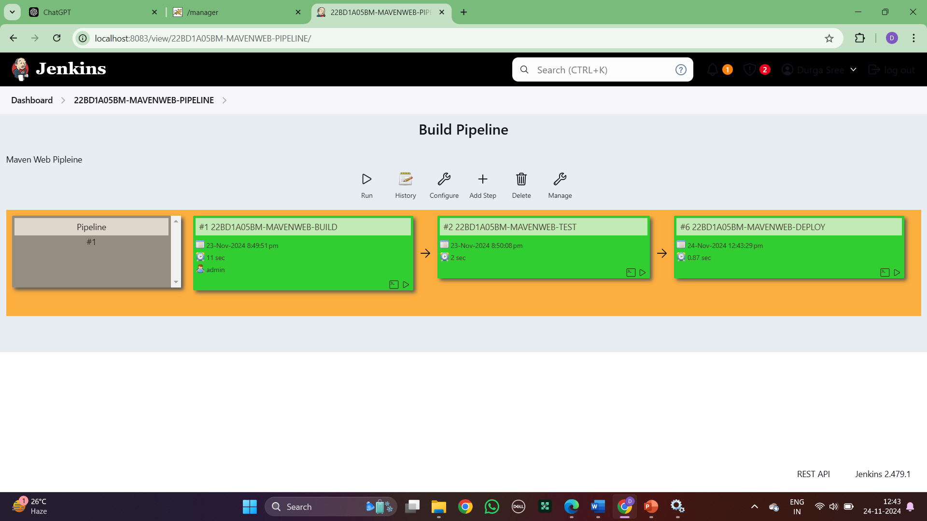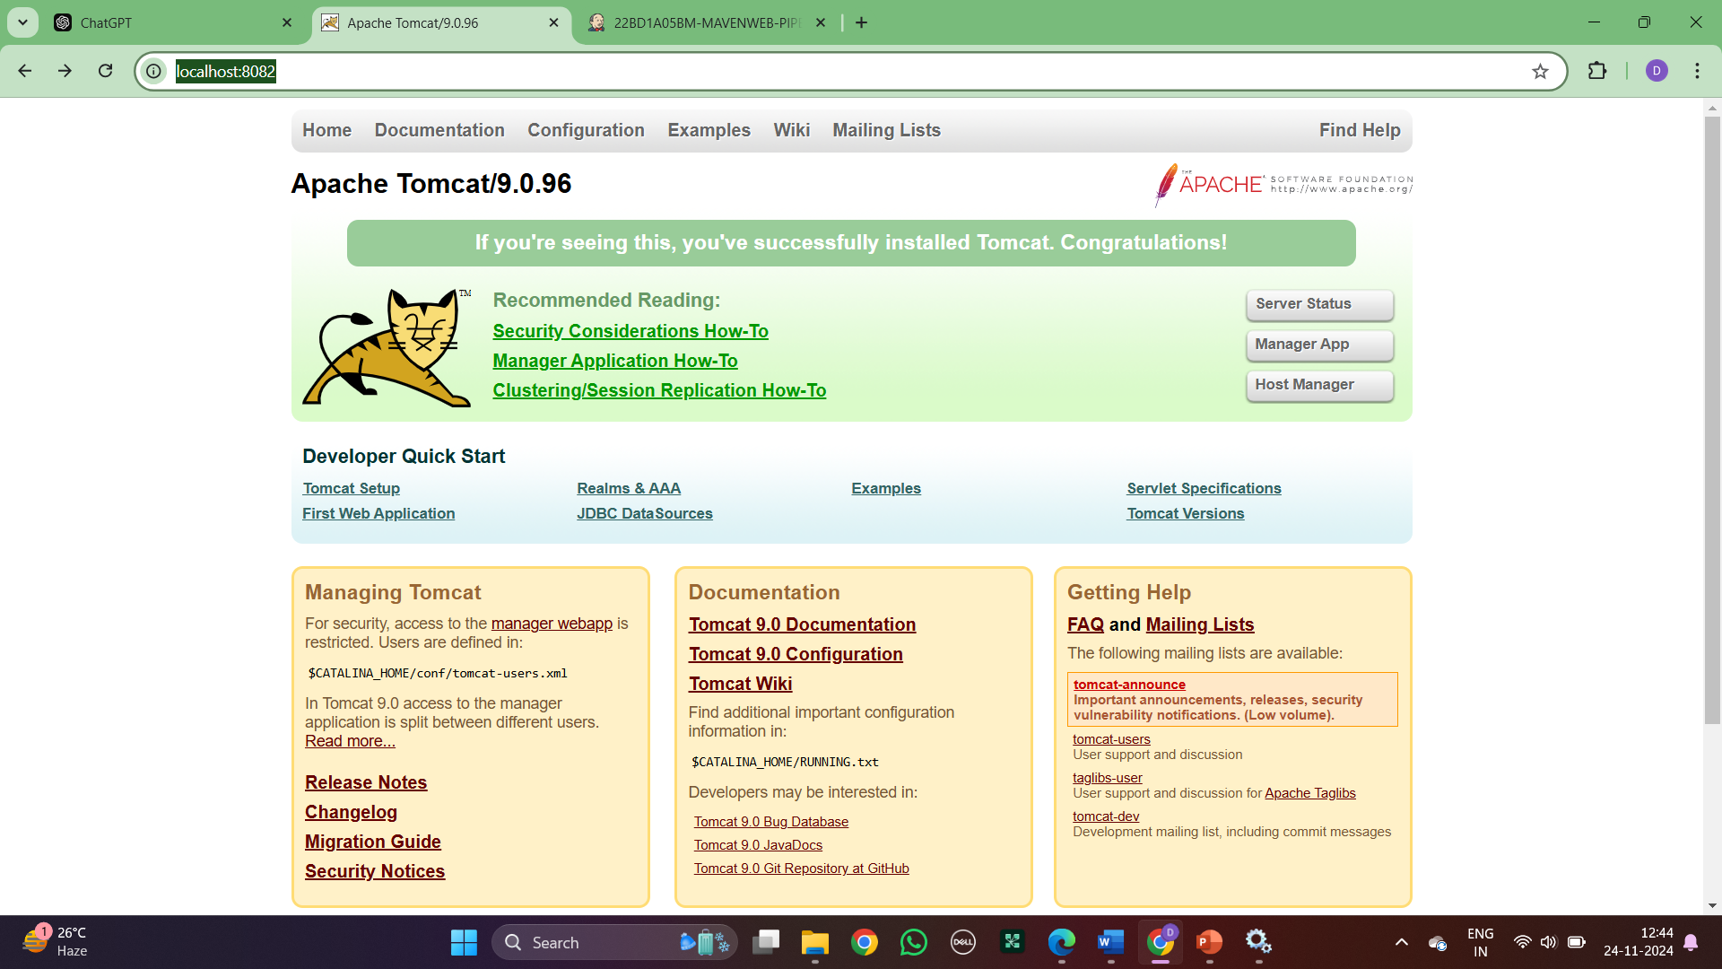

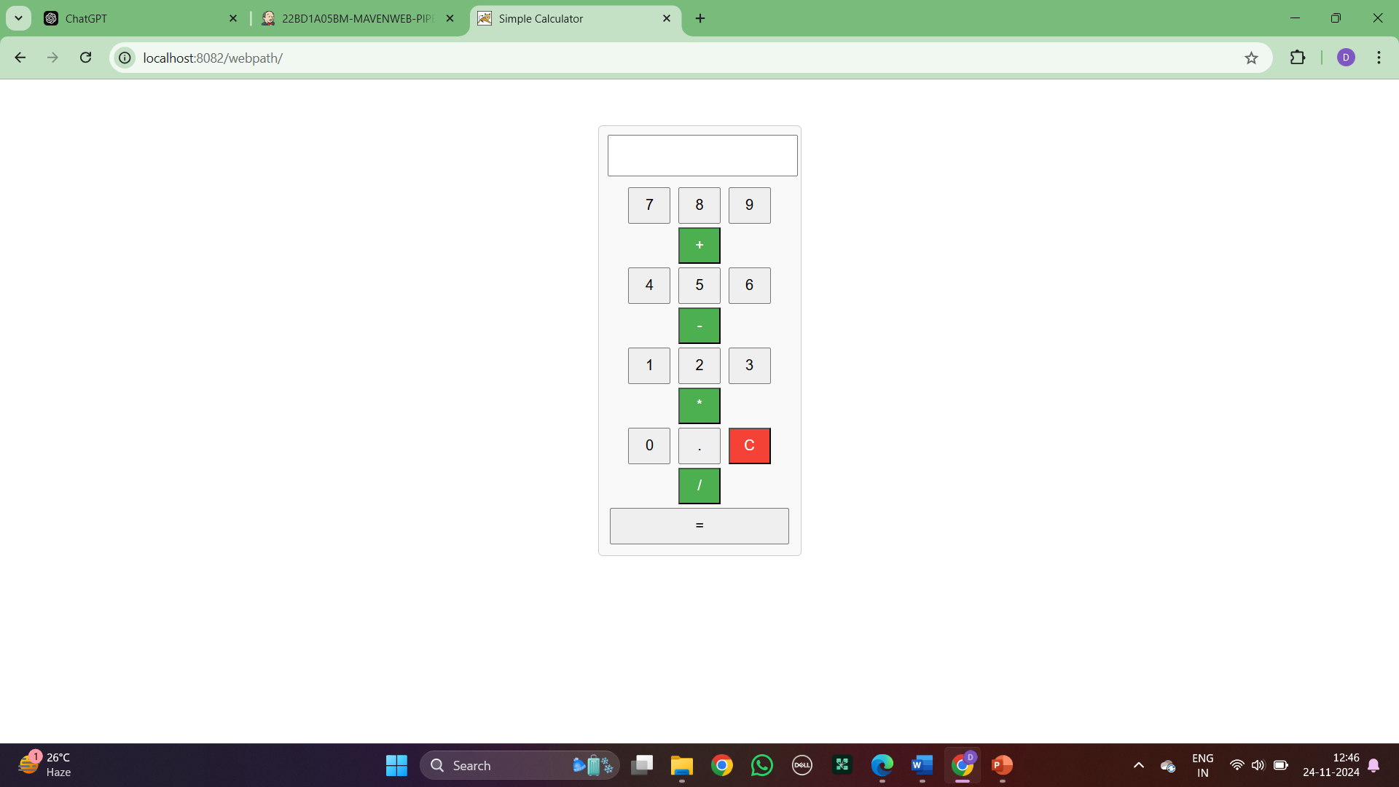

**b) BUILDING THE CI/CD SCRIPTED PIPELINE USING JENKINS FOR MAVEN JAVA PROJECT WITH POLL SCM**

**JENKINS-SCRIPT**

Step 1: Create a new item as jenkins script and opt for pipeline

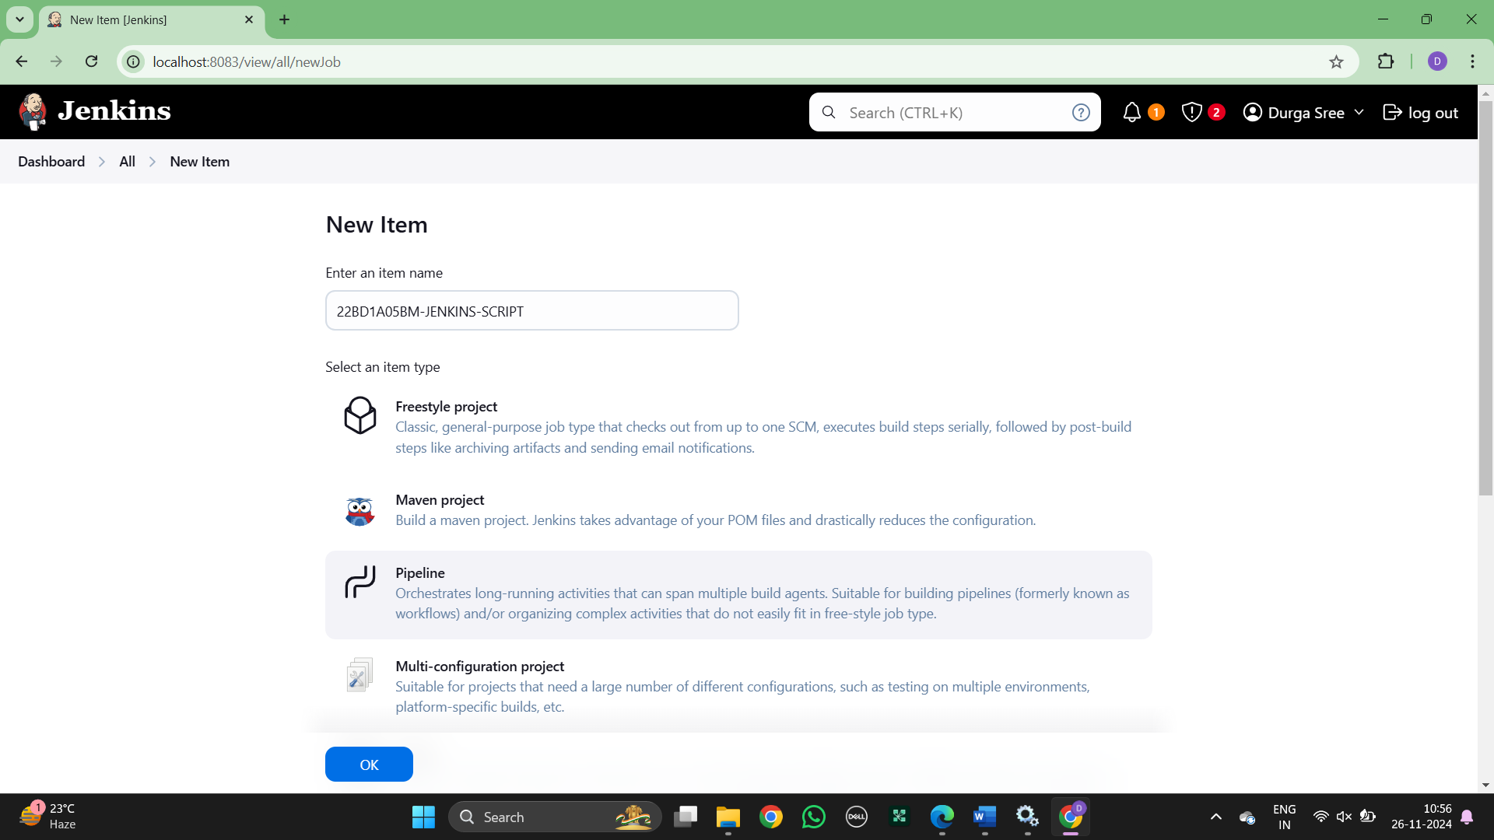

Step 2: Write the Script code with git hub link

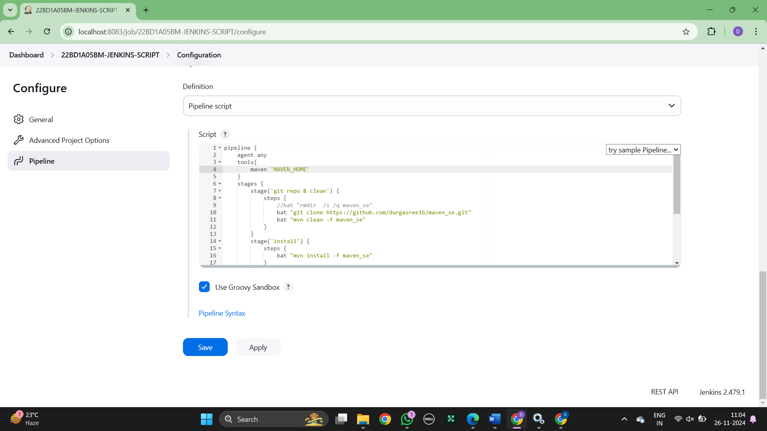

Step 3: Run the script as stages

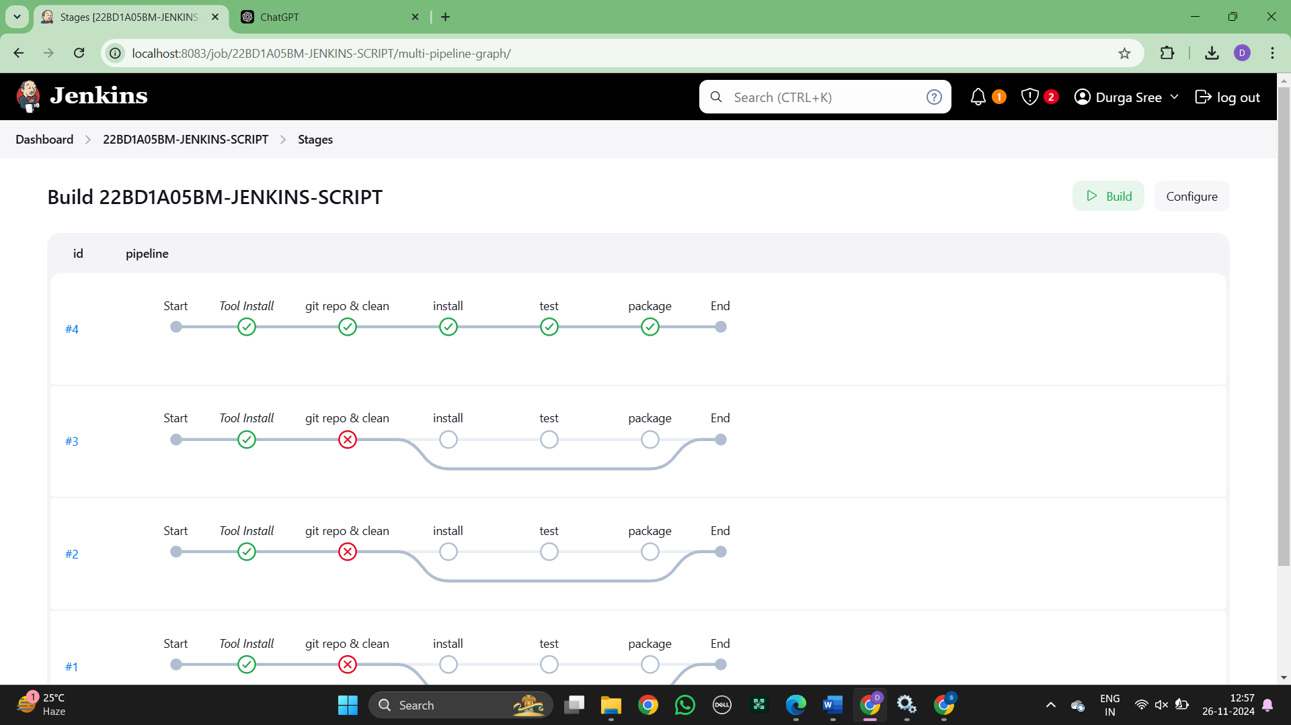



Step 4 : Install the Stage View Pipeline from plugins and the below stages are displayed

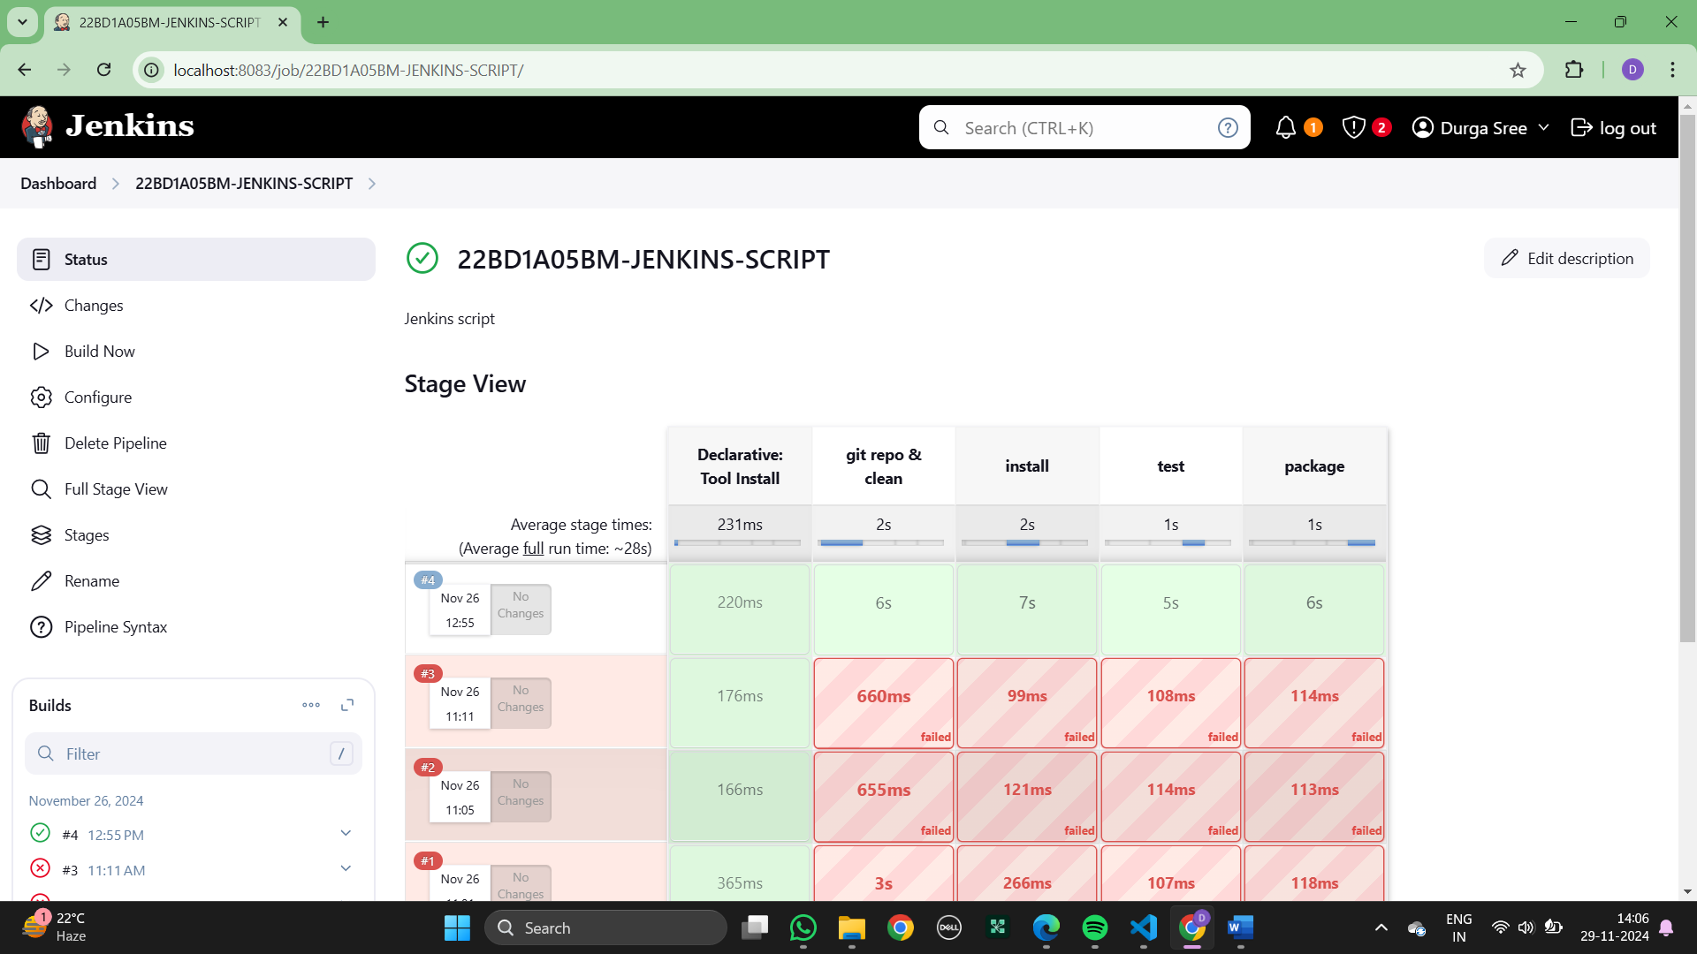

### Experiment 7:

* 1. **INSTALLATION OF DOCKER, MINIKUBE, ACCOUNT IN DOCKERHUB**   
       
     **DOCKERS INSTALLATION**

Click on the following link to download the executable file

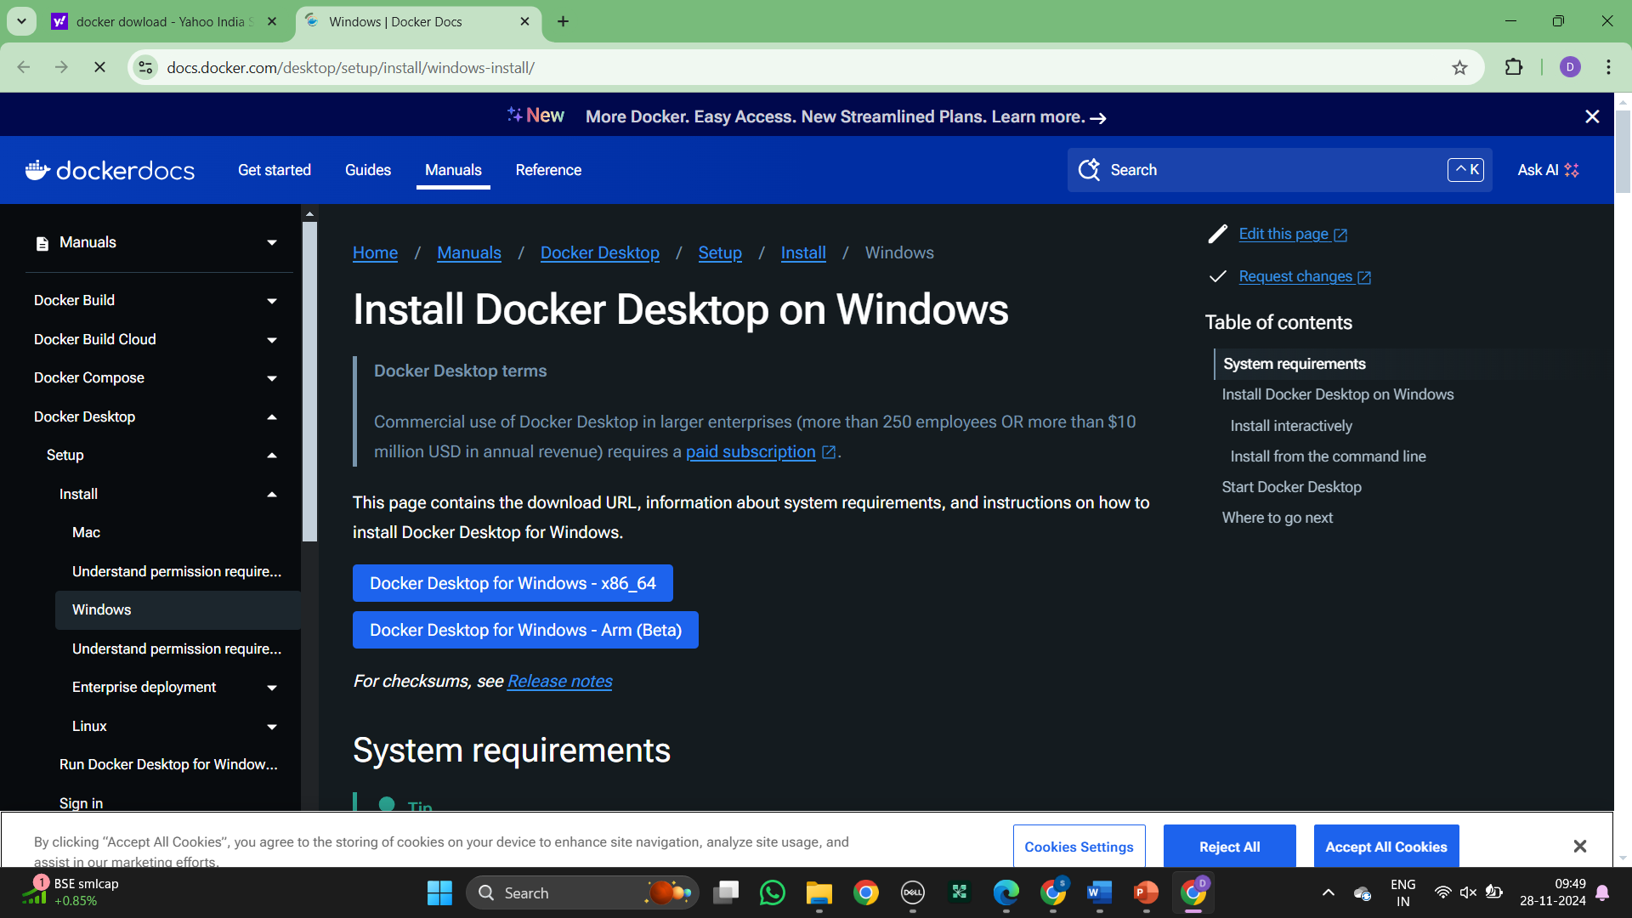

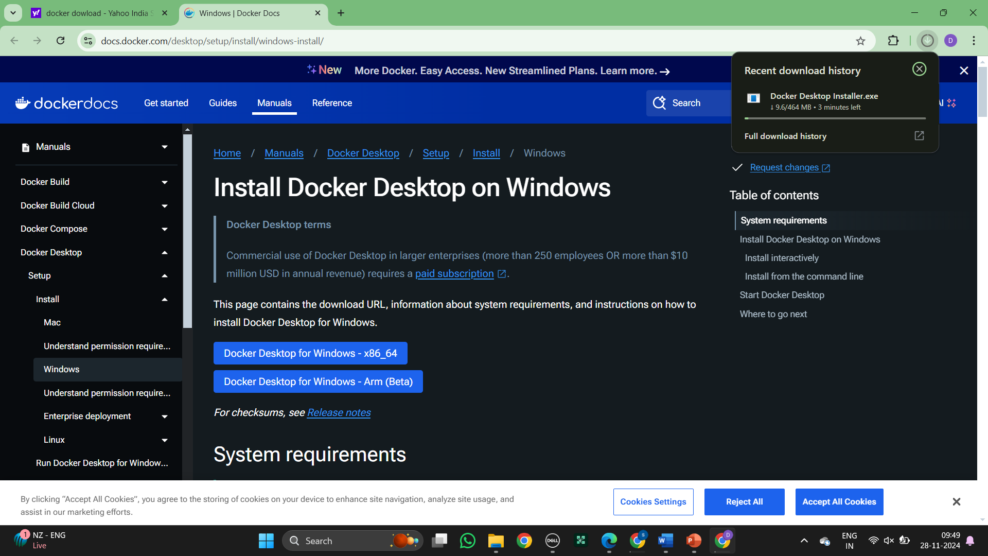

Make sure Virtualization is enabled in the system, we can check it in task manager as shown

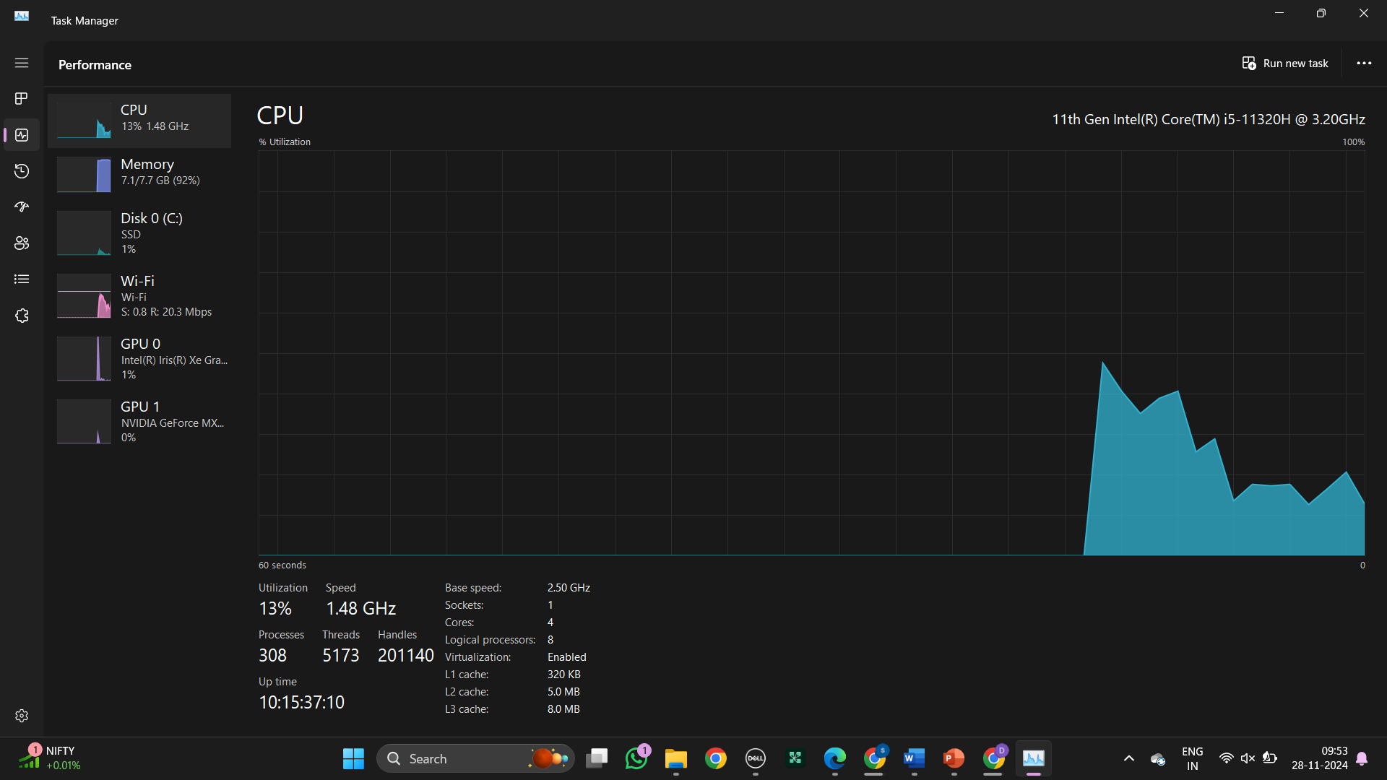

Make sure to check the Hyper-V, Virtual Machine Platform, Windows Hypervisor Platform and Windows subsystem for Linux checkboxes and click ok

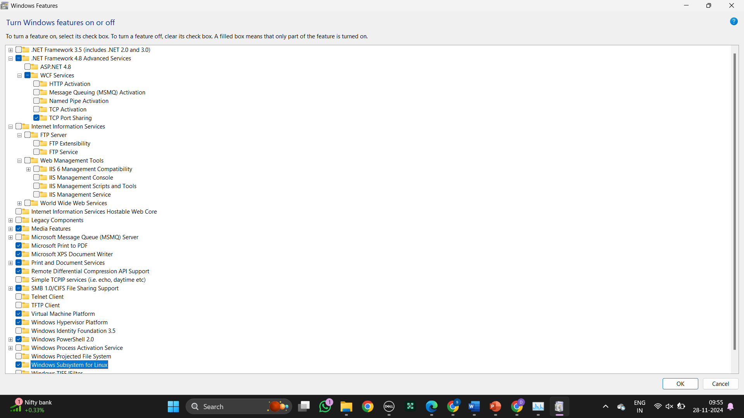

The download has started

Double click the executable file and click ok as shown, make sure the following check boxes are selected

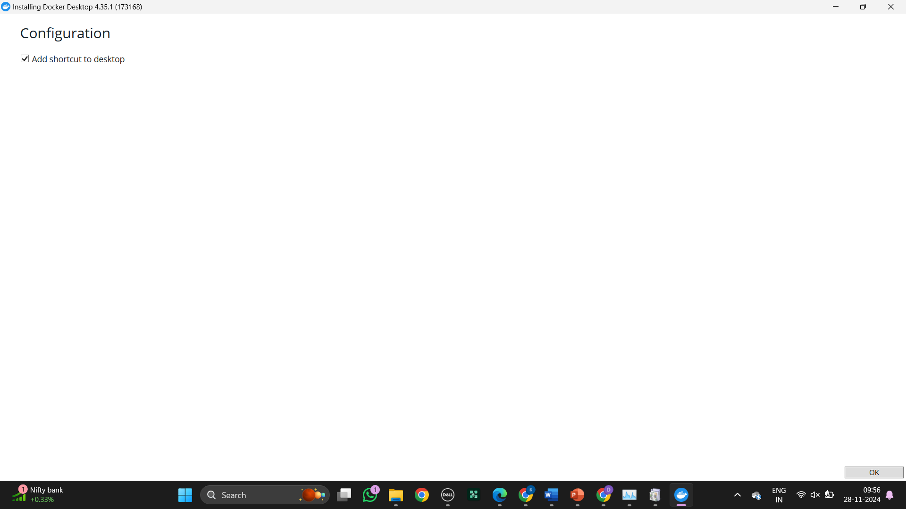

The download has started

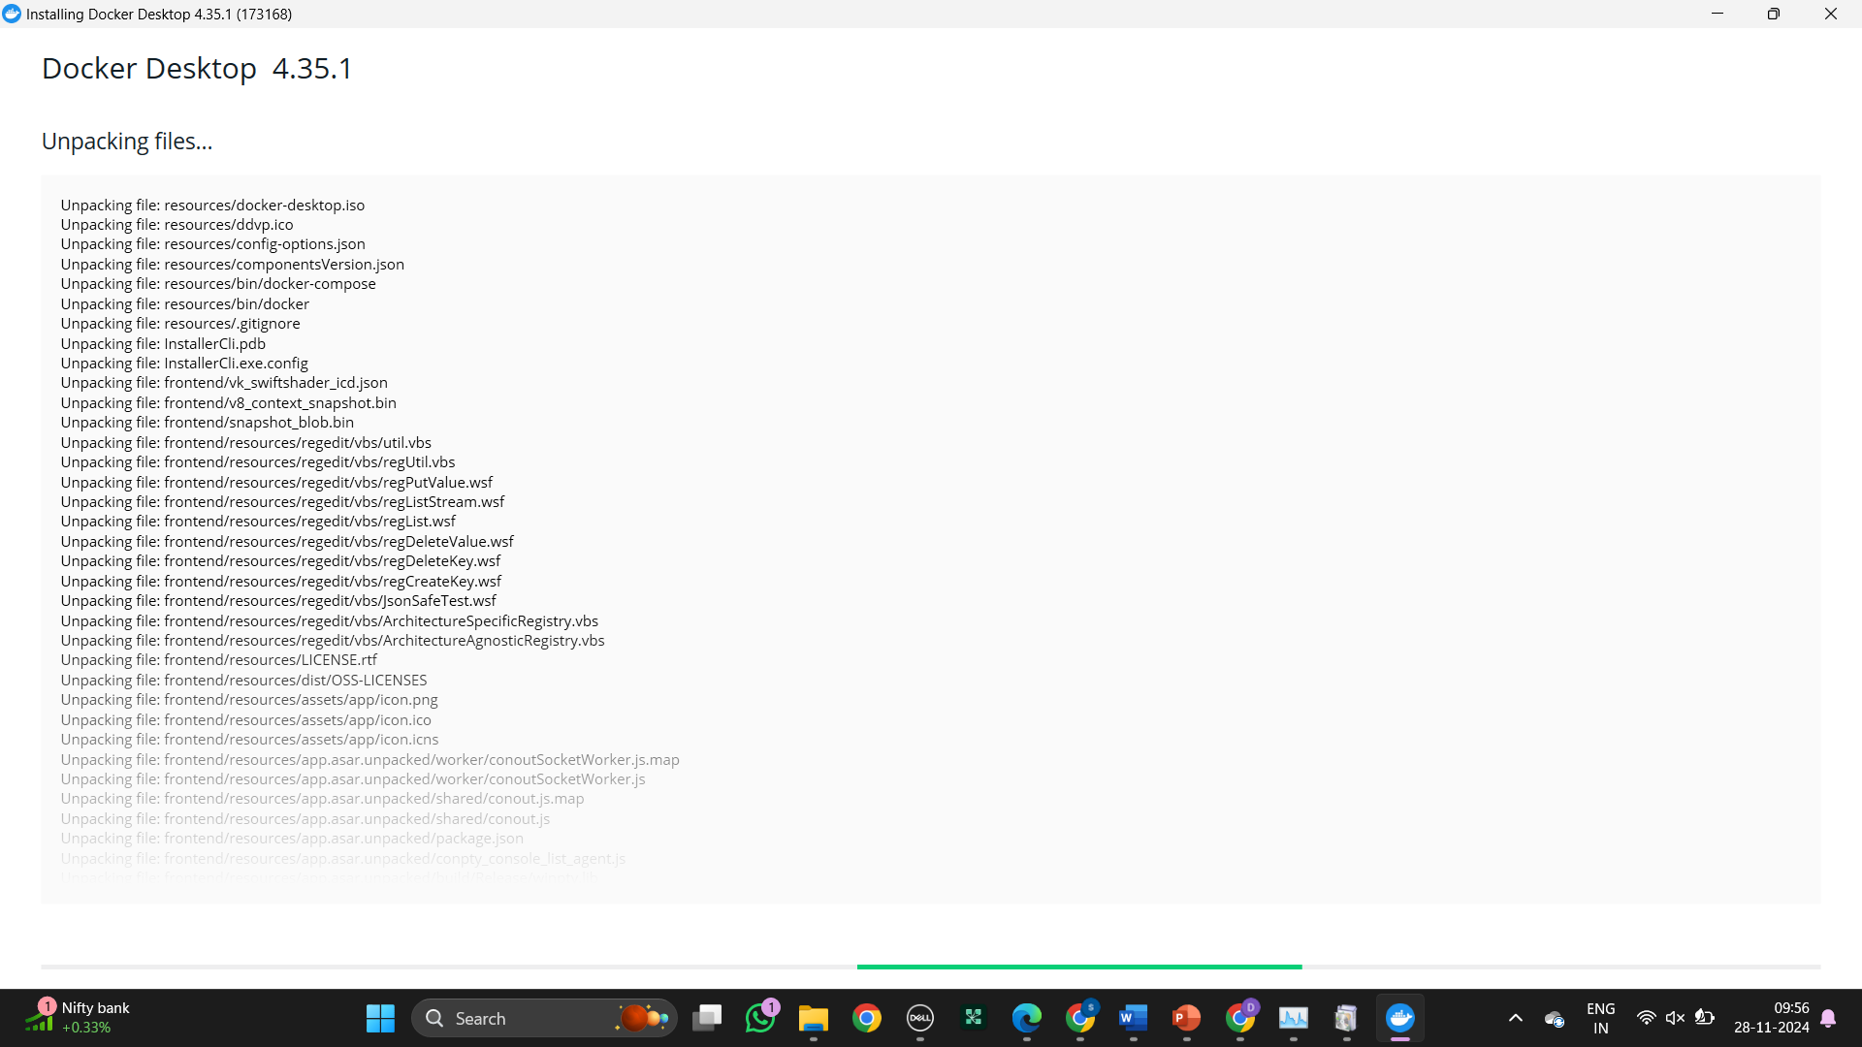

The local Docker Hub is created

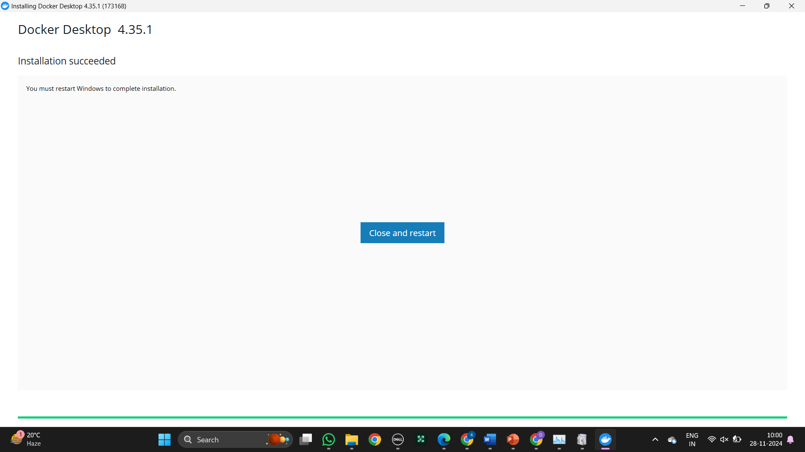

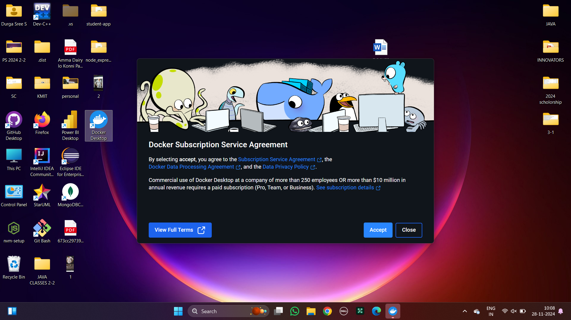

Open Windows PowerShell and enter the command as shown

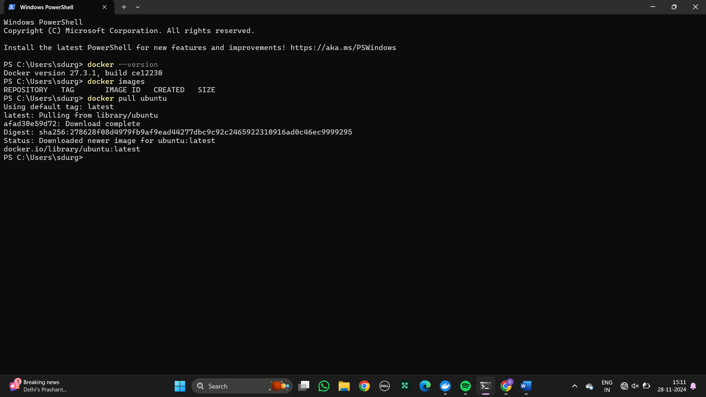

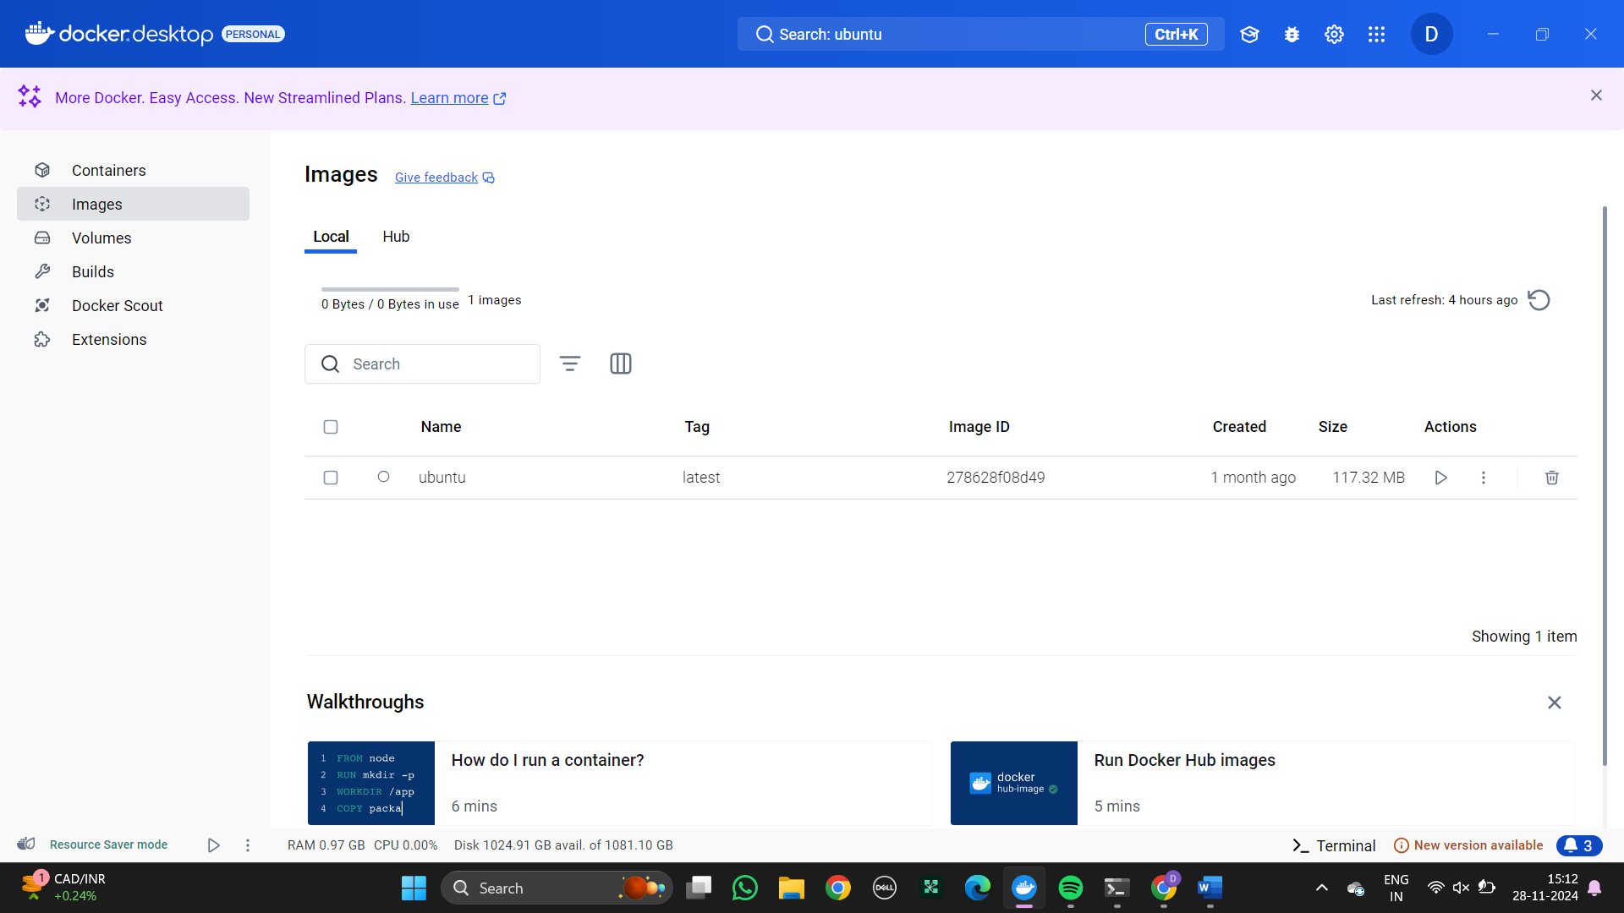

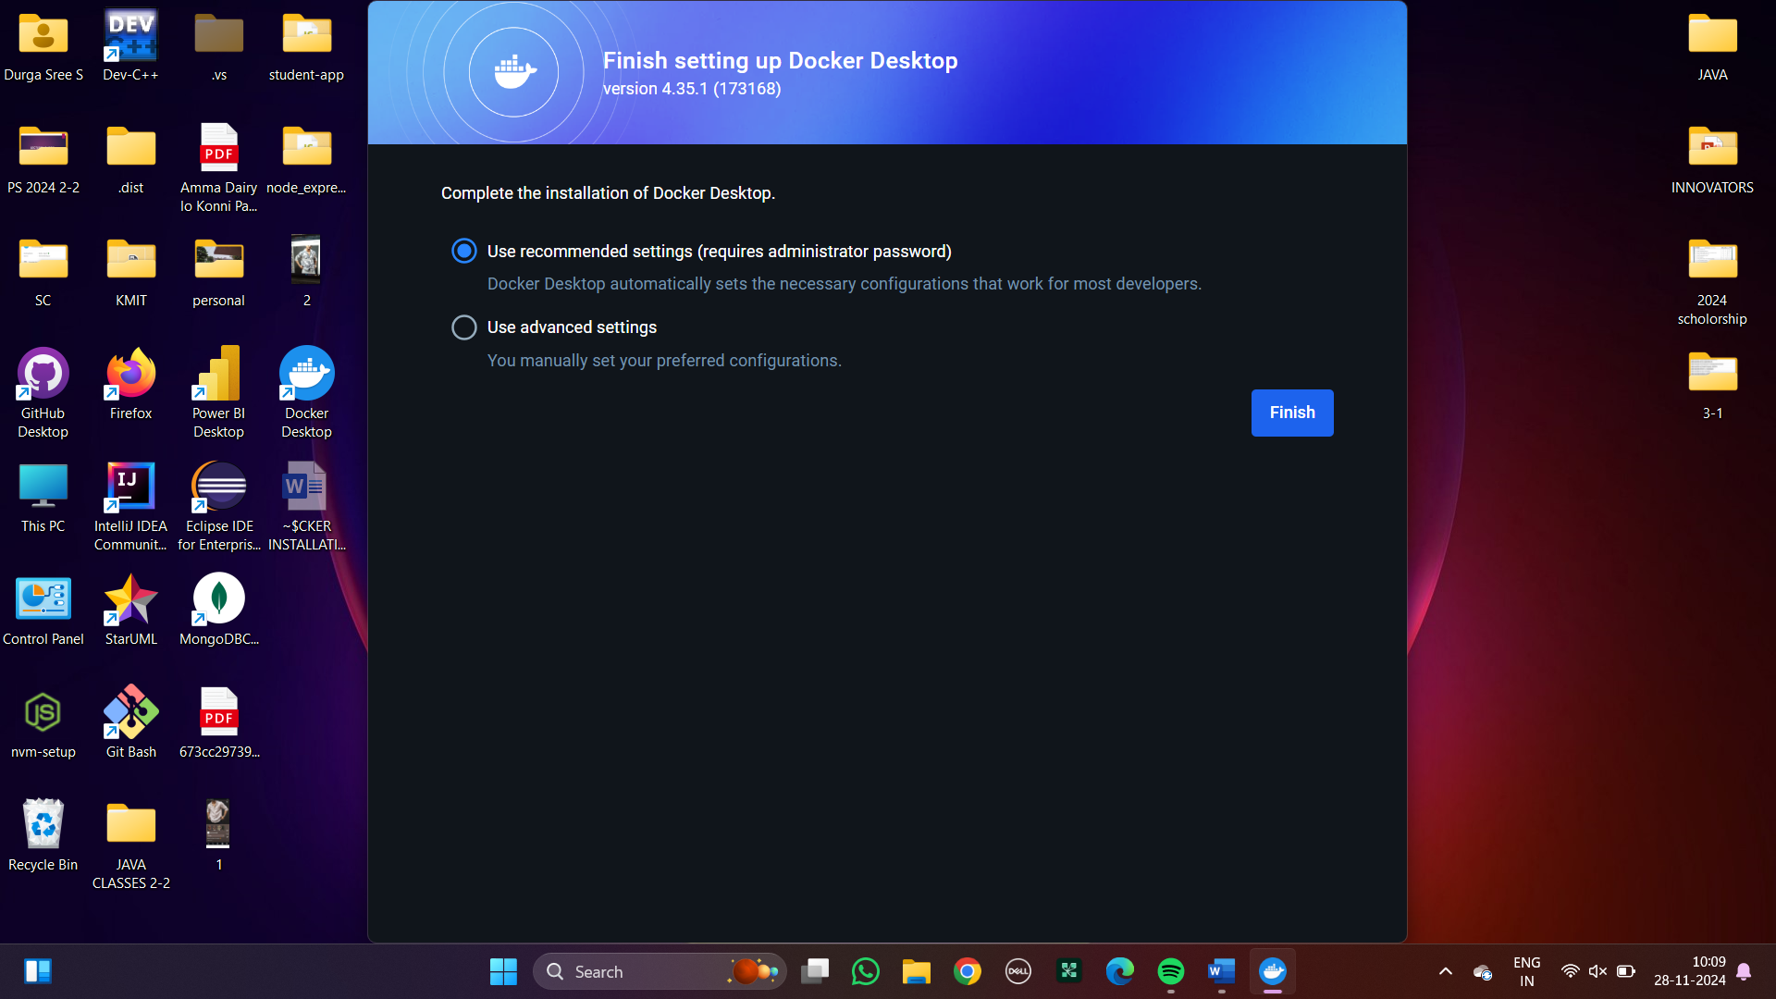

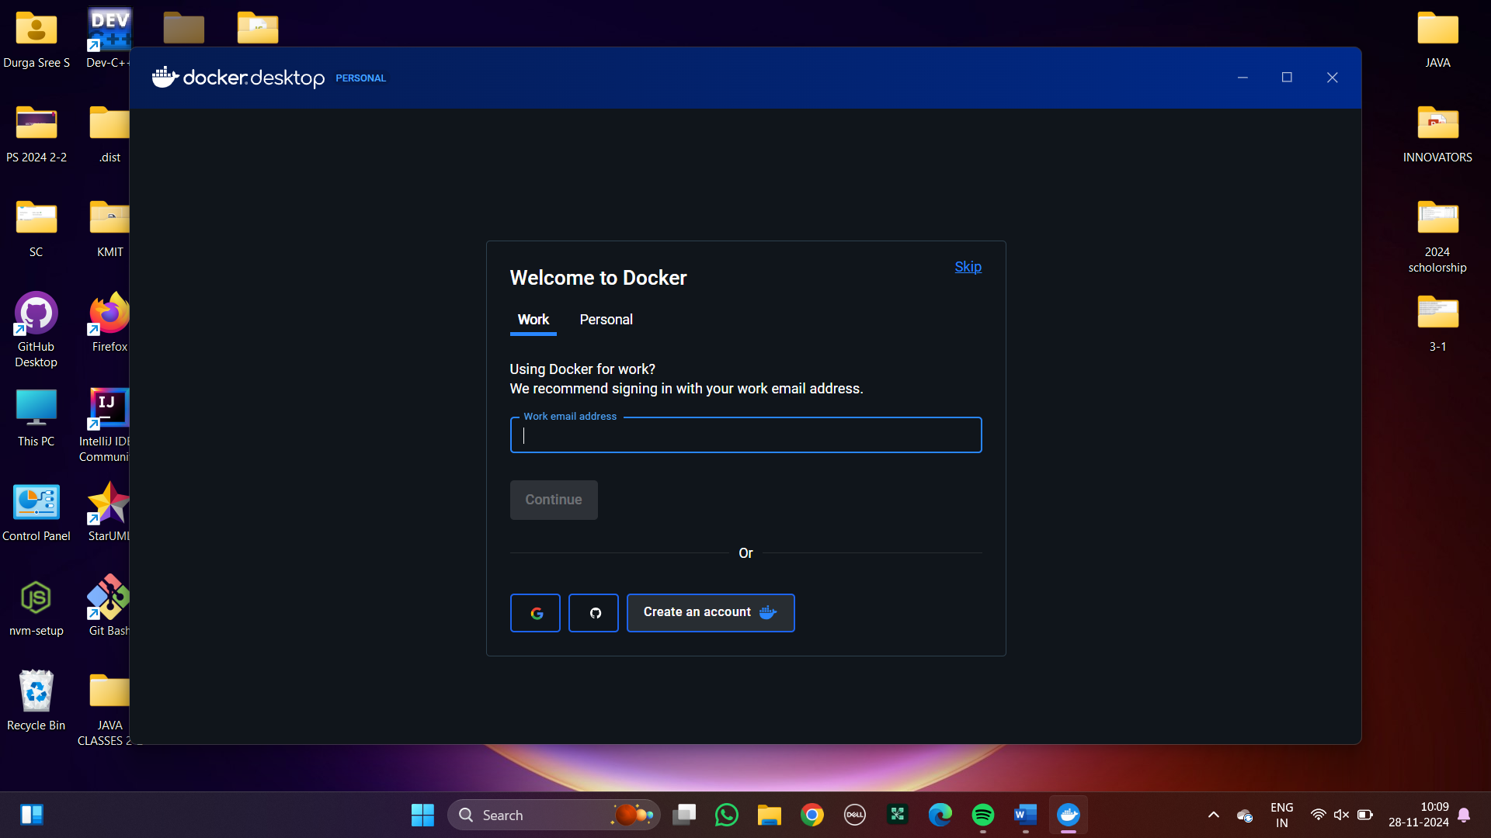

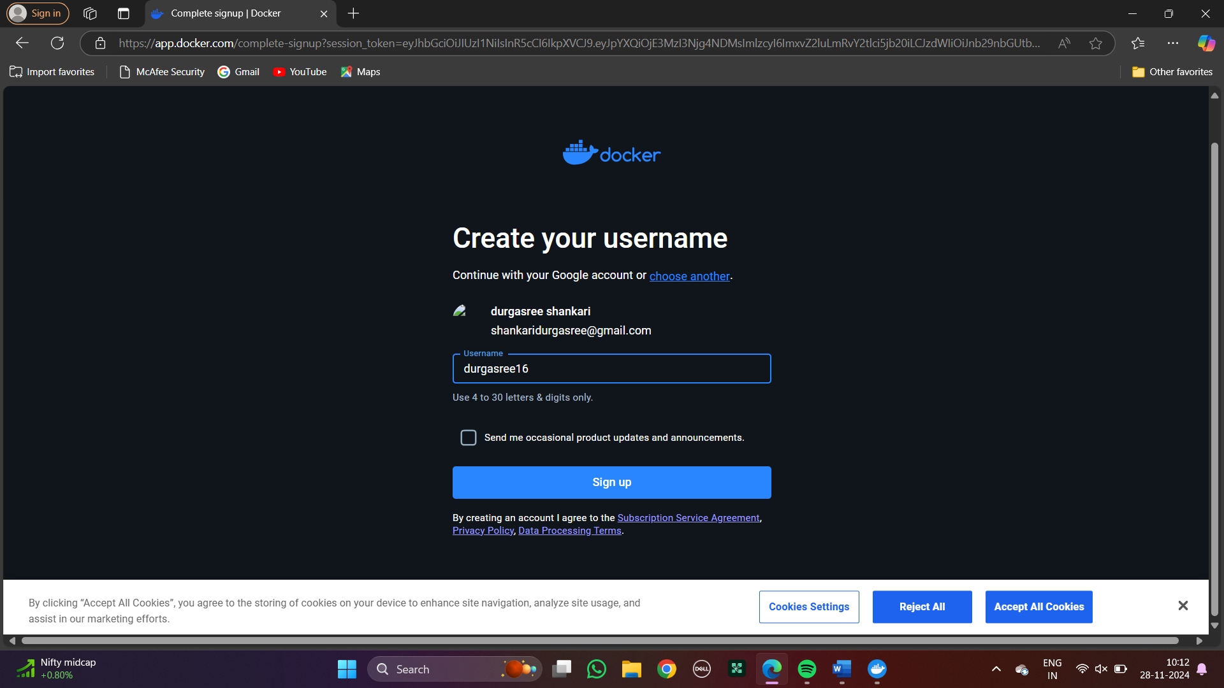

### DOCKER CLI COMMANDS

1)–version: It is used to get the current version of the docker.

Syntax: docker –version (or) docker version

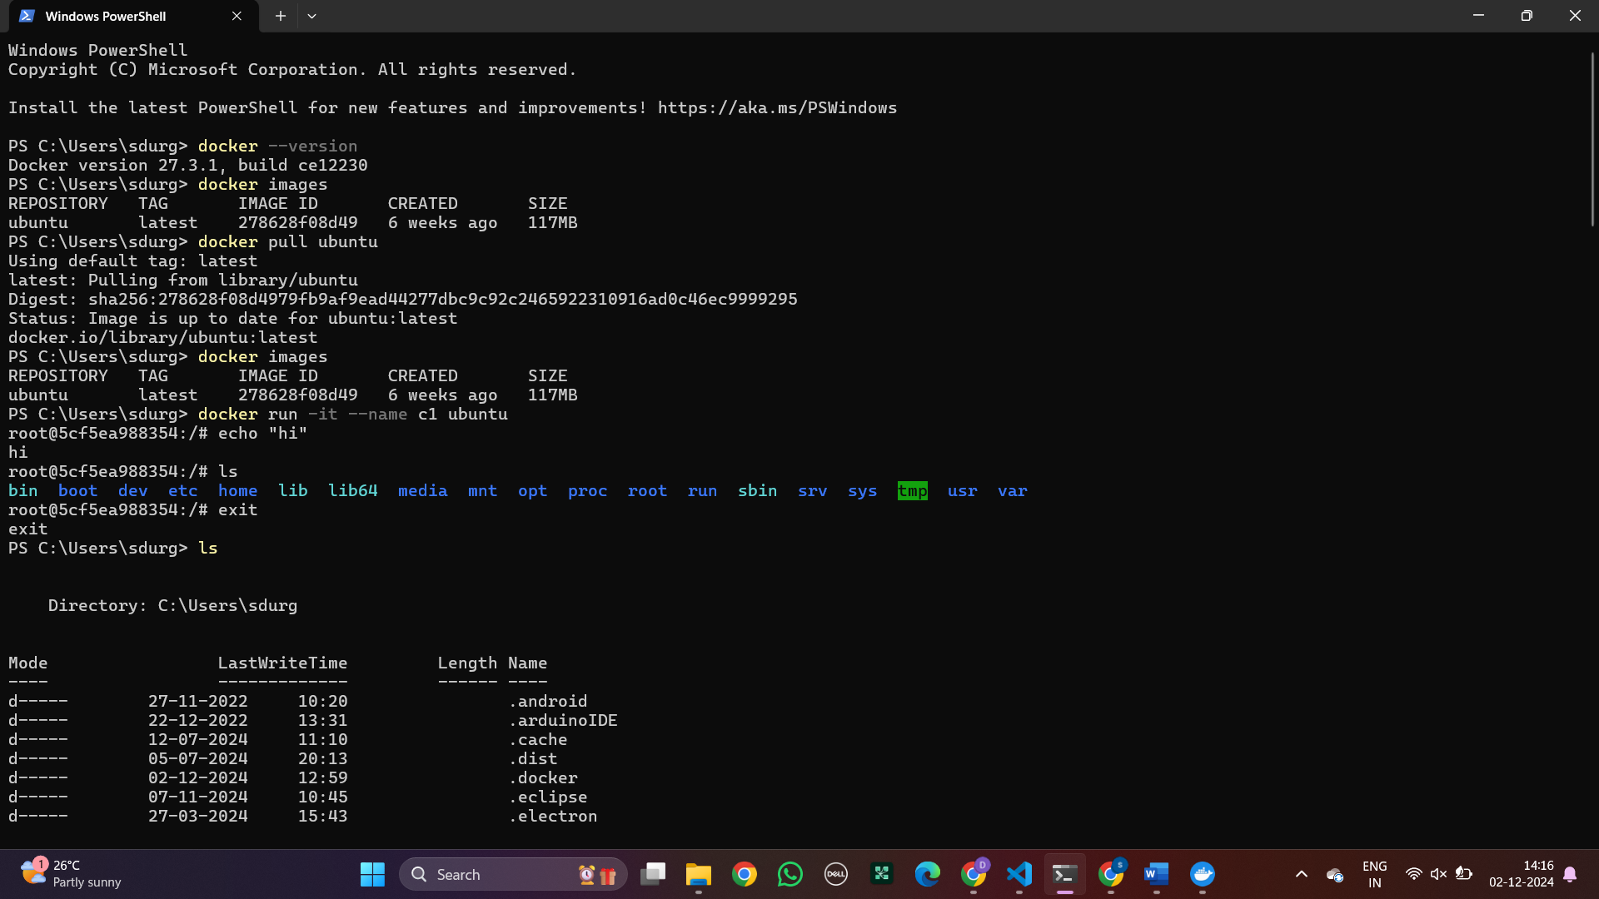

2)images: Docker Image is an executable package of software that includes everything needed to run an application. 

3)pull: The docker pull command is used to download Docker images from a registry. Here we have pulled ubuntu and

nginx  
 

4)run: The docker run command runs a command in a new container, pulling the image if needed and starting the container.



5) echo: echo is a command that outputs the strings that are passed to it as arguments.-



6)ls: It returns all the files in the present working directory.



7)exit: It comes out from the loop.



In the same way, pull nginx and tome

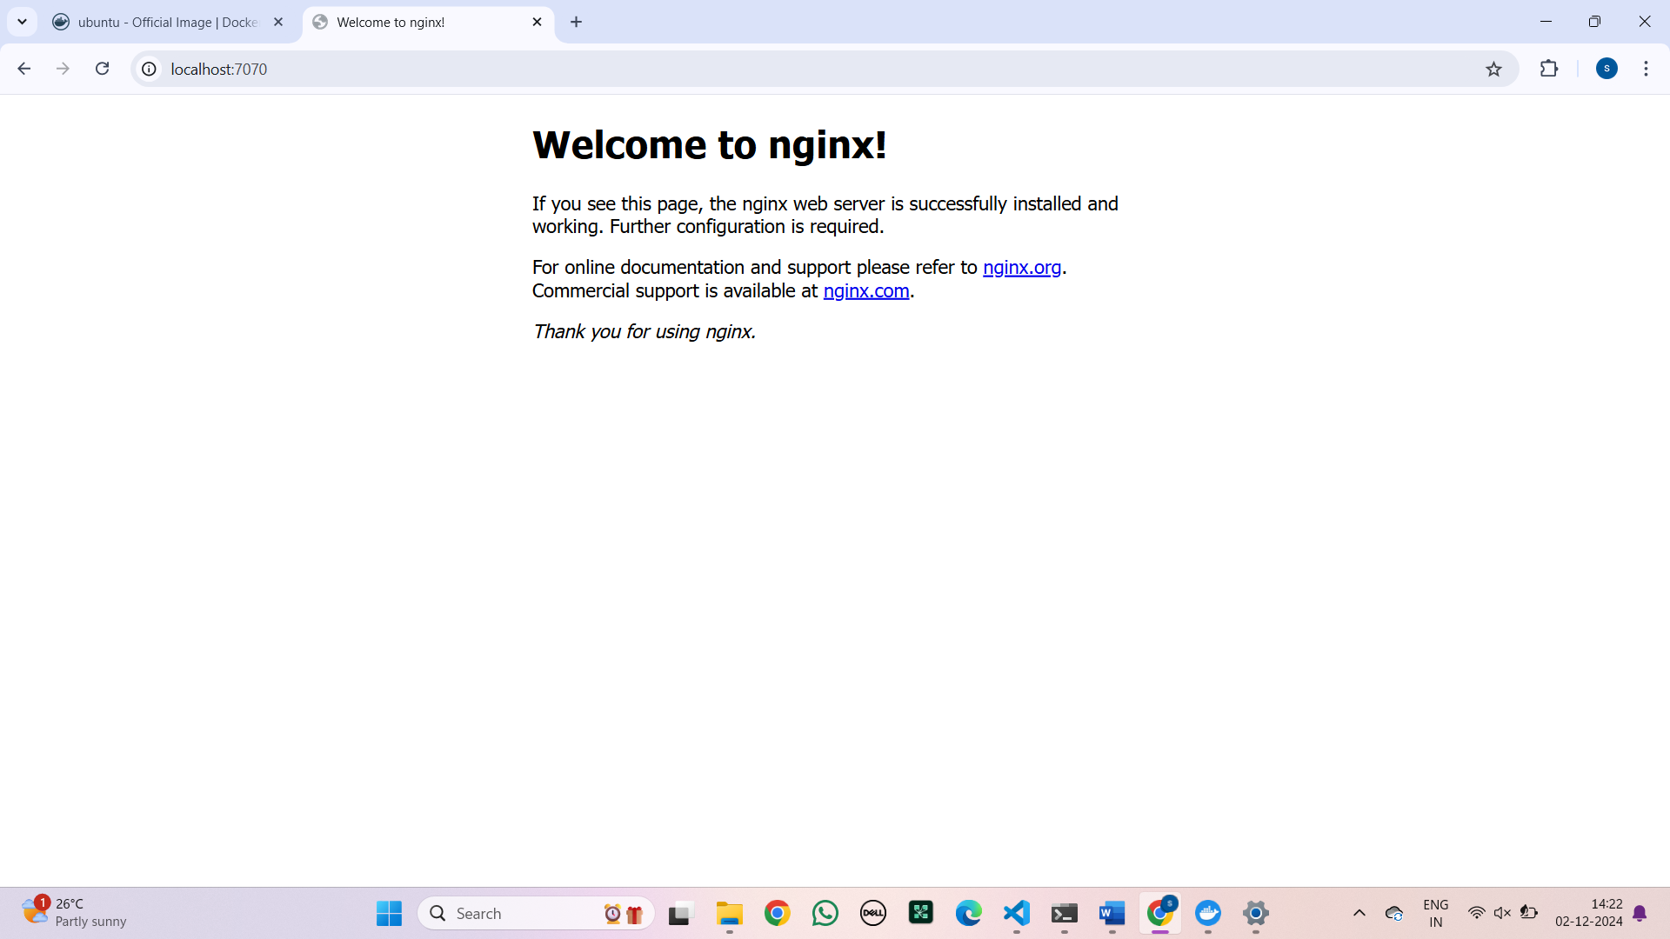

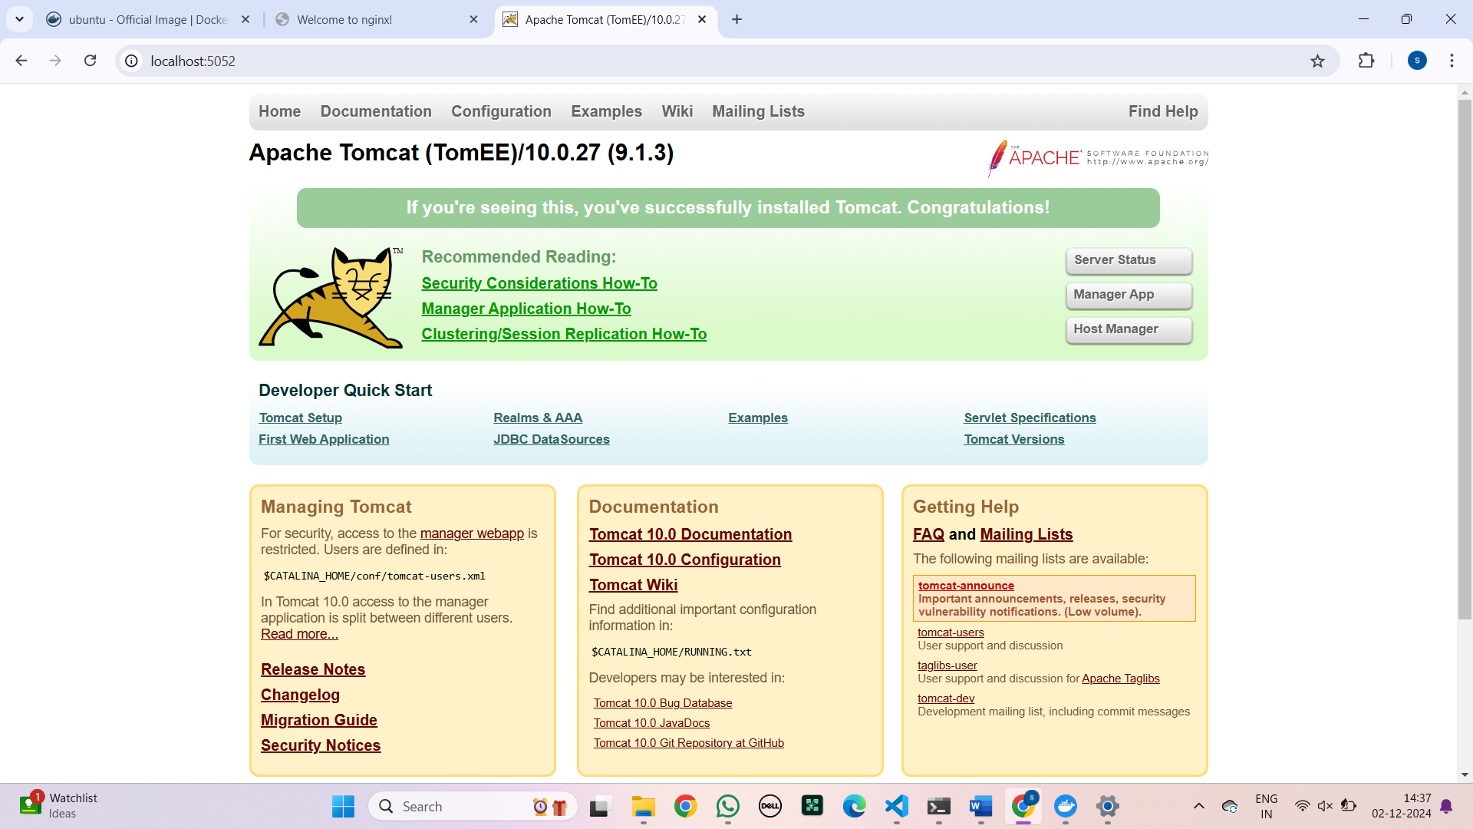

Type the localhost number that you have given above and the following page will be opened.

8)ps: docker ps command is used to list all the running containers in the docker host.

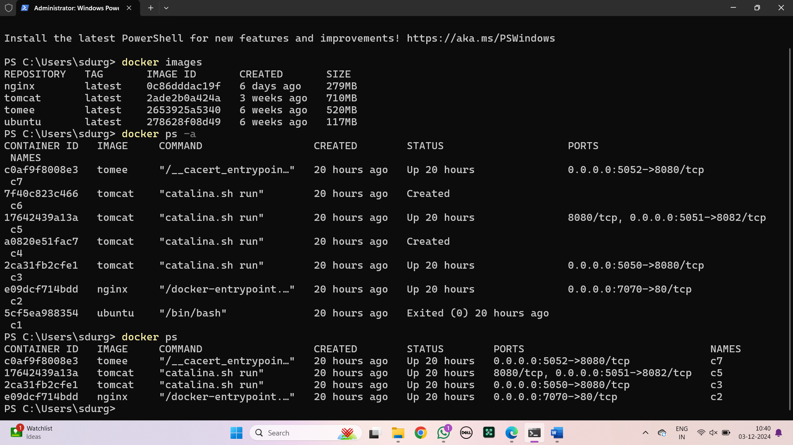

9)ps -a: This command lists all the containers on your system including running, stopped and exited containers.

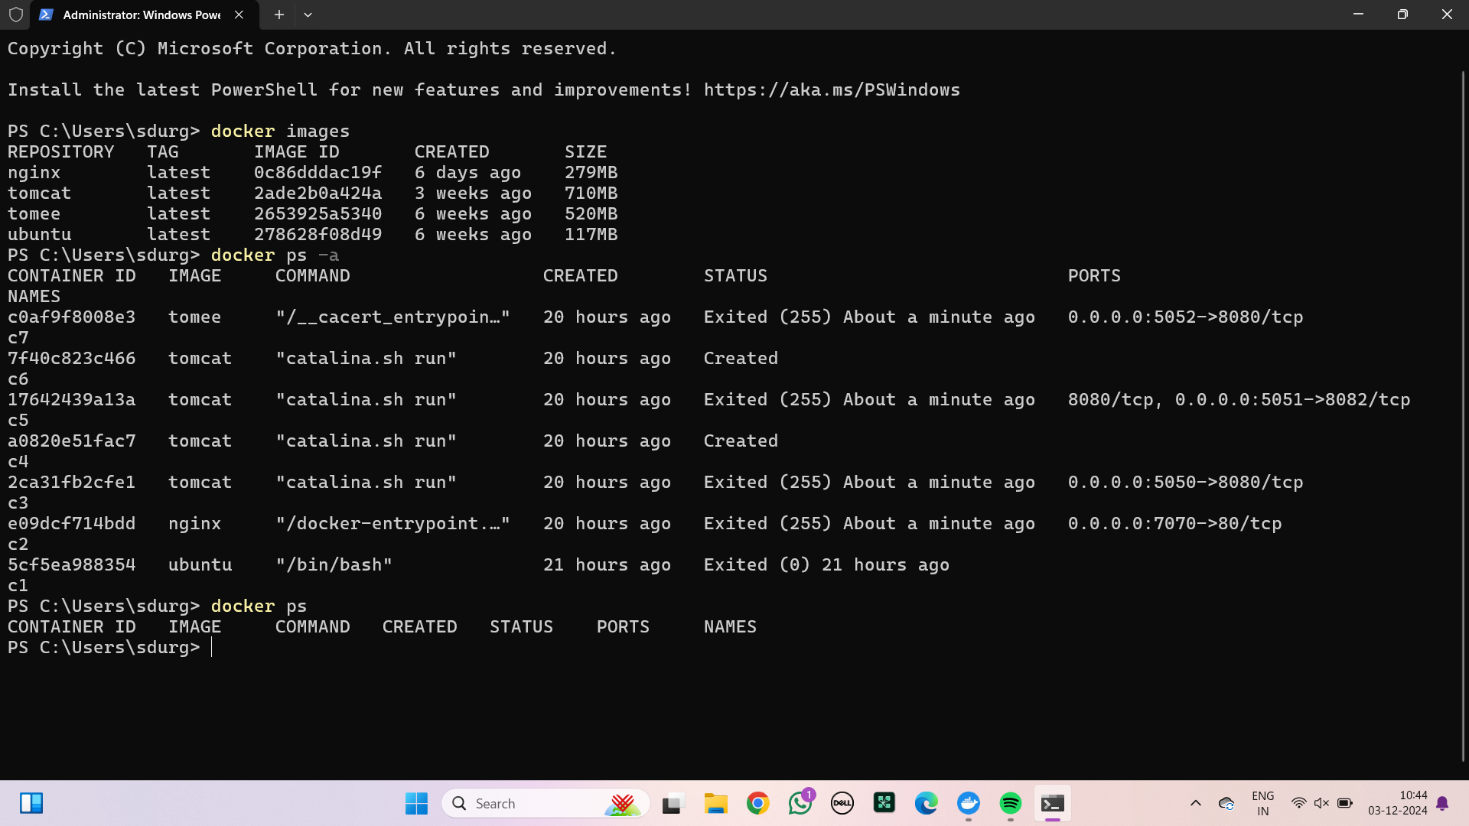

10)start: The docker start command is used to start a stopped container in Docker. It will not create a new container but will resume a previously created or stopped one.

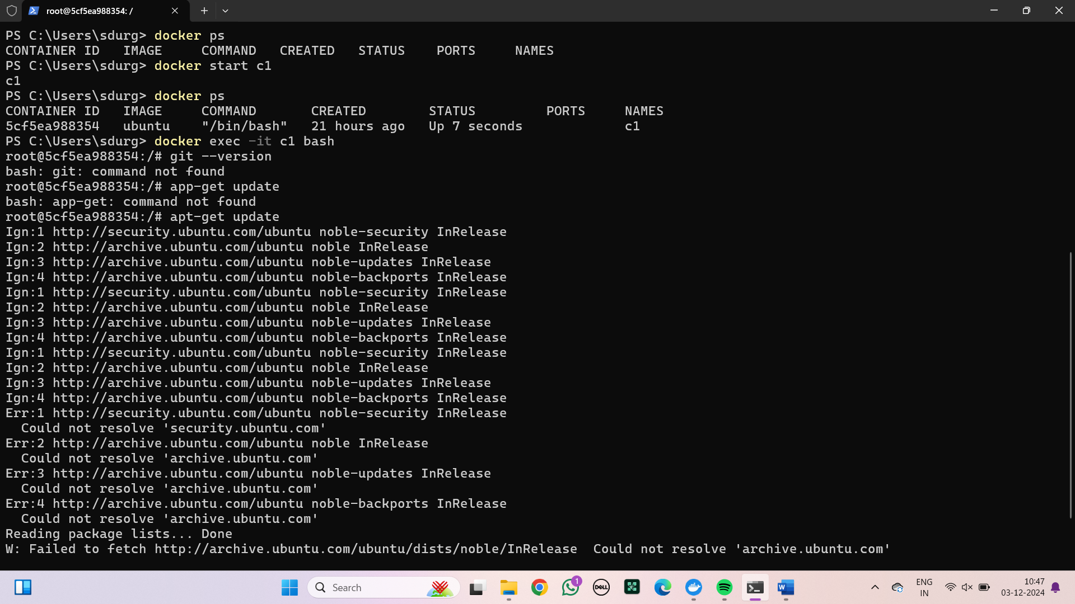

11)exec -it: The docker exec -it command is used to run a command interactively inside a running container.



12)apt-get update: The apt-get update command in Docker is used to update the package lists from the repositories inside a container's operating system.



13) apt-get install: The apt-get install command in Docker is used to install packages within a container's operating system.

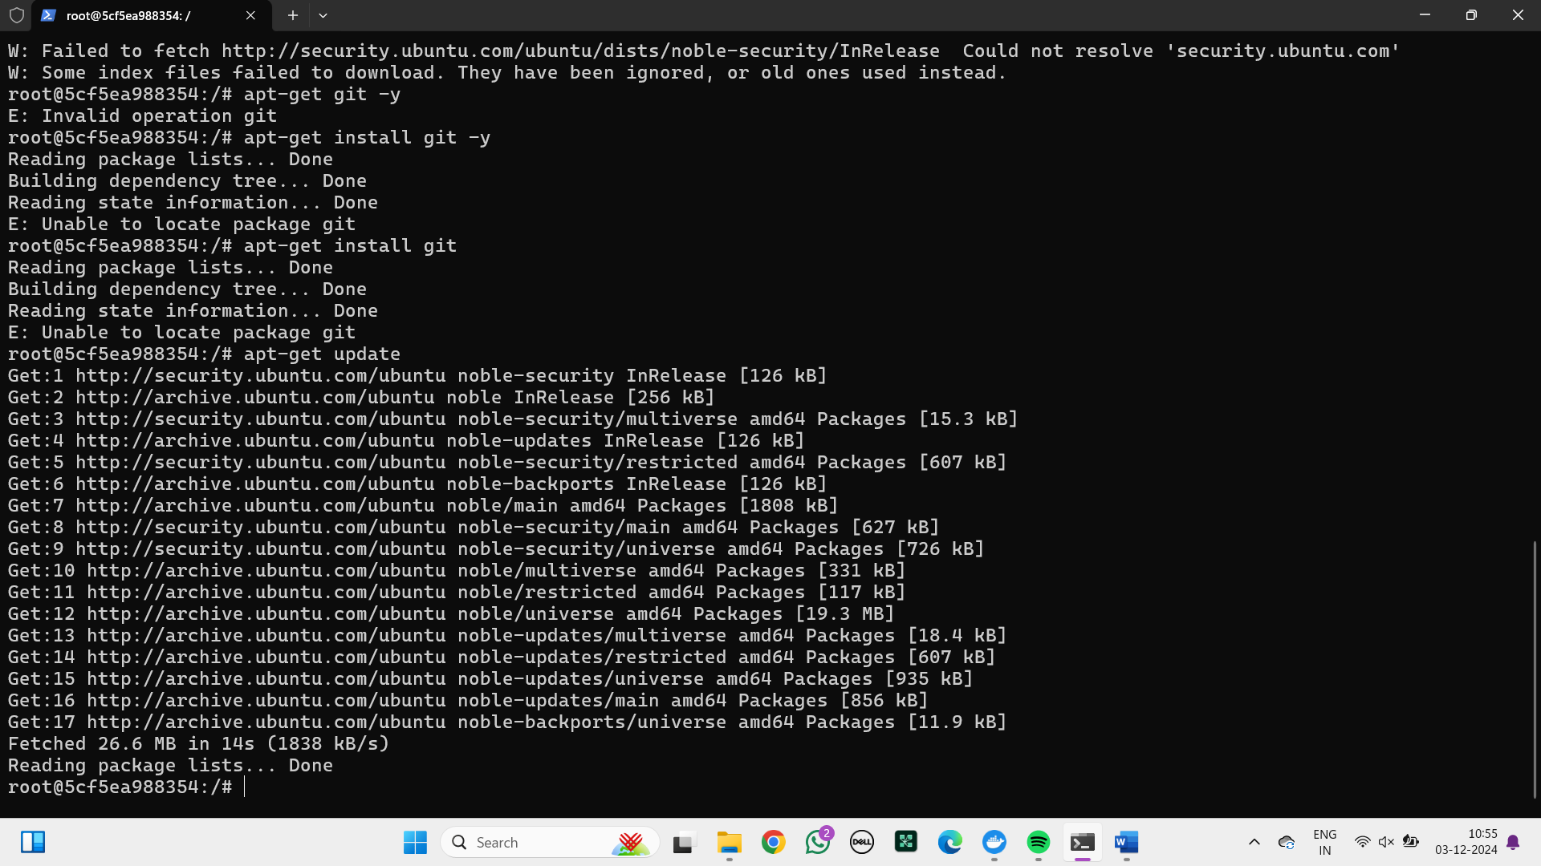

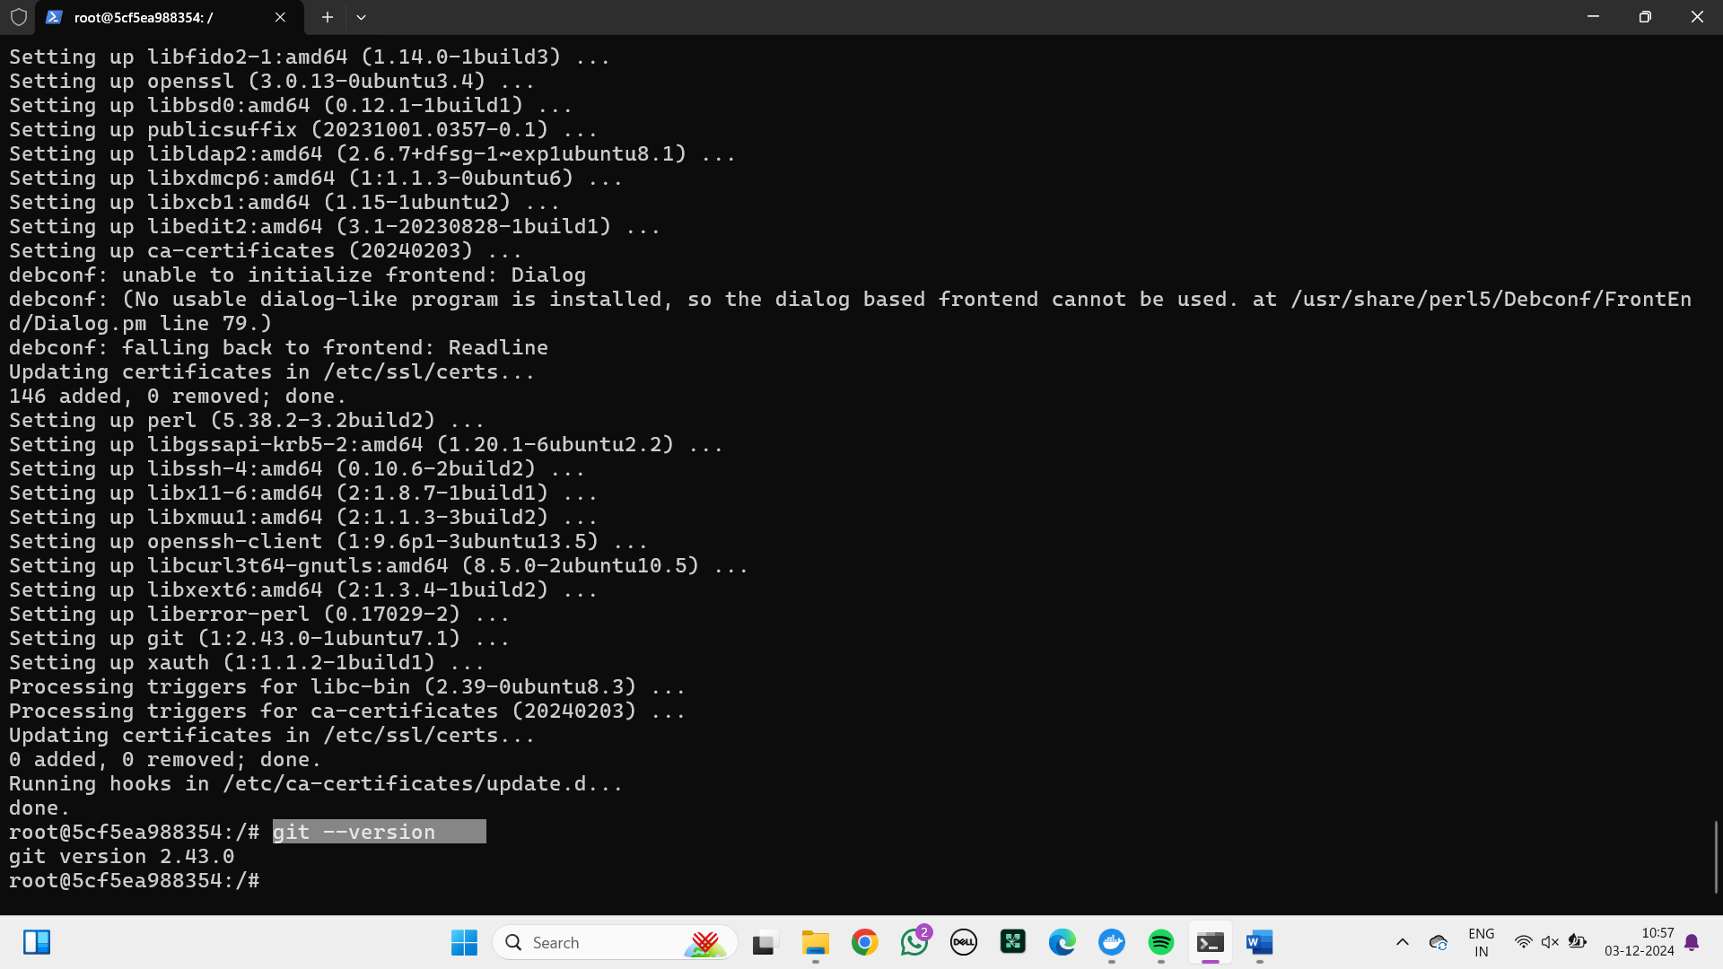

After the installation of git within the container check the version by typing the command “git –version”.



14)mkdir: This command is used to create a directory.

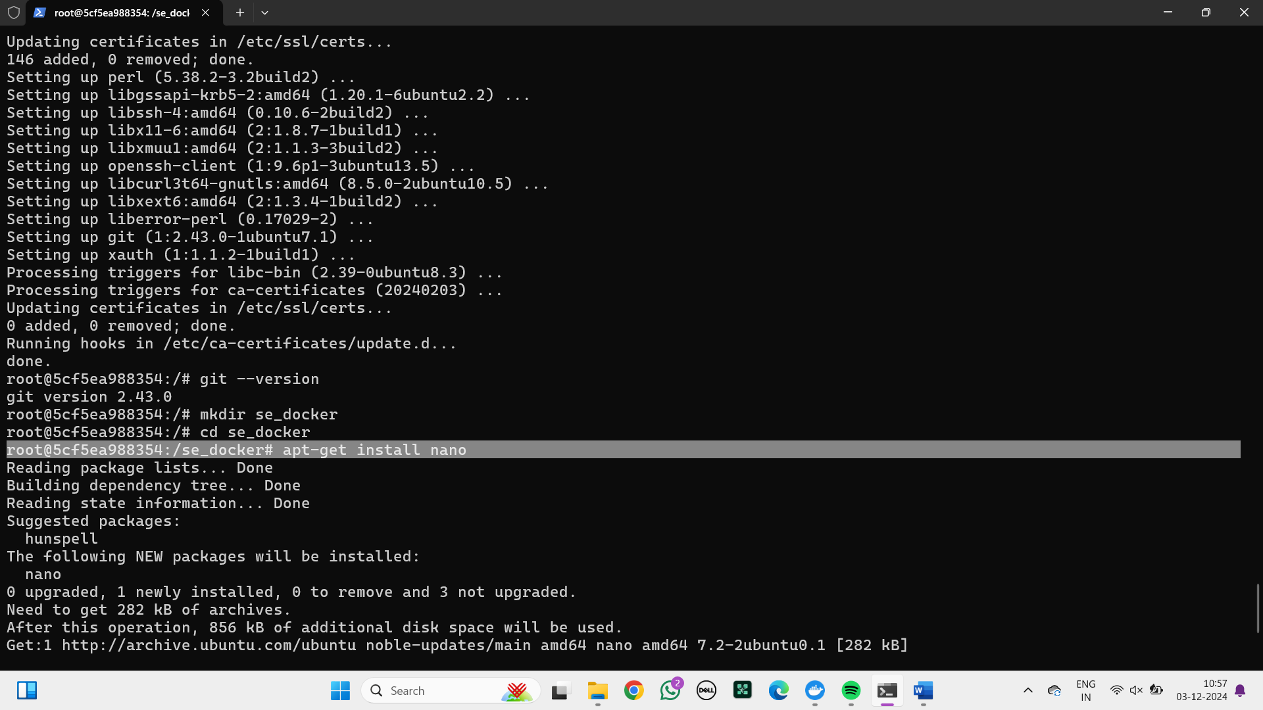

15)cd: This cd command stands for "change directory" is used to navigate between directories in a file system.



16)git init: This command initializes a new Git repository in the specified directory. When executed inside a Docker container, it creates a .git folder in the directory, marking it as a Git repository.

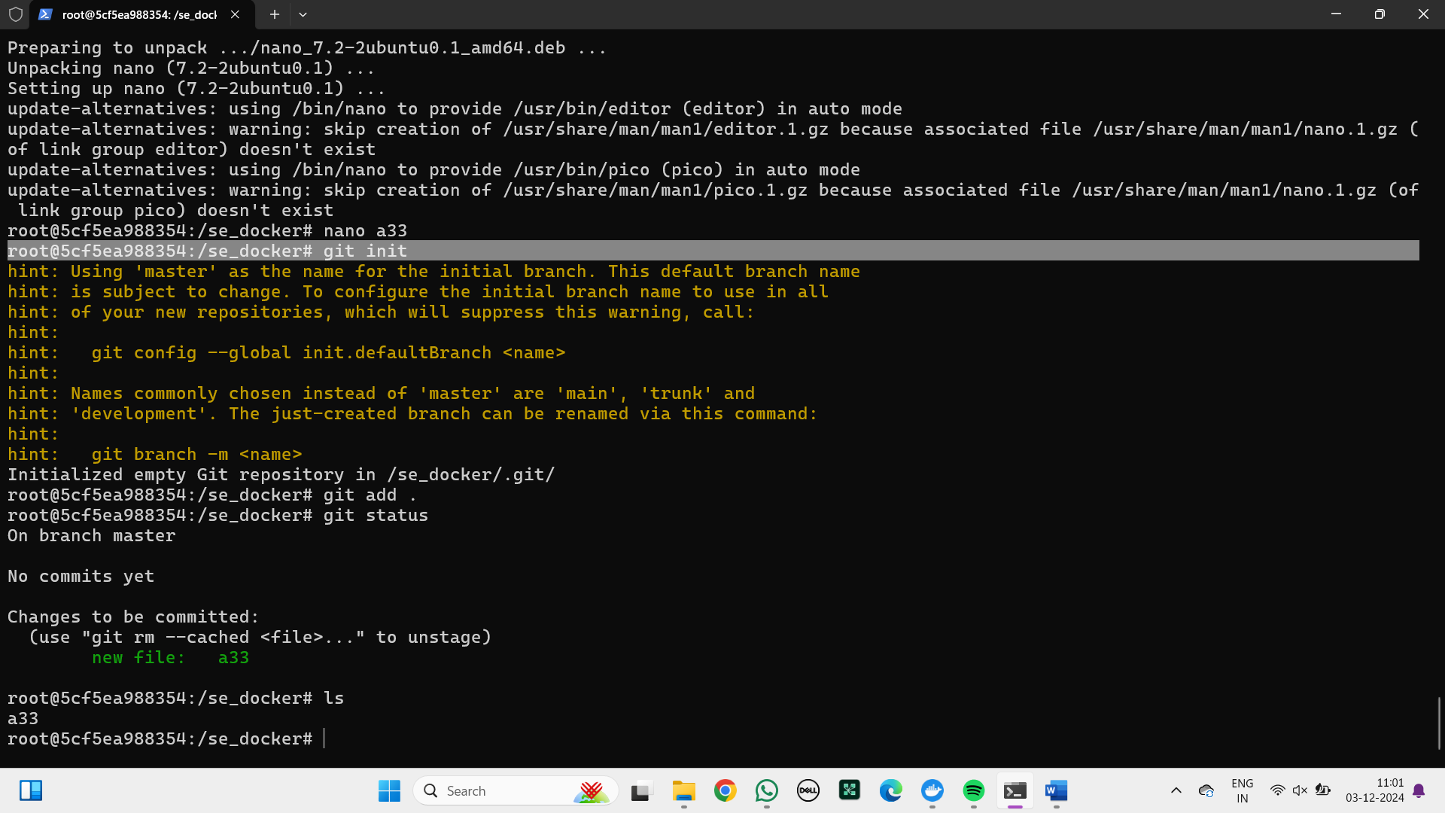

17)nano: The nano command is used to open the Nano text editor, a simple and easy-to-use command-line text editor for Unix-like systems. It is commonly used for creating and editing text files directly in the terminal.



18)ls: This command list outs all the files and directories.

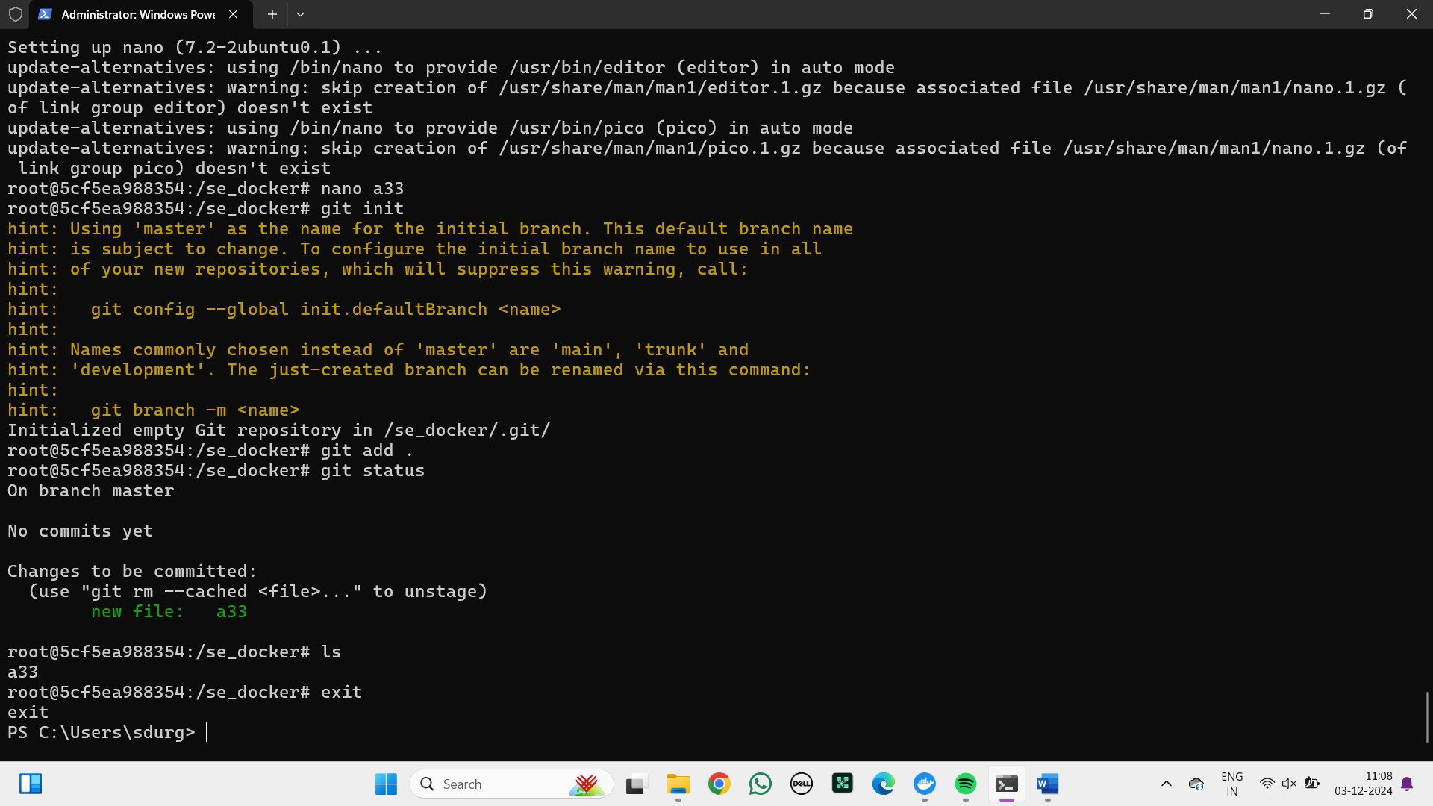

### 

### MODIFYAND PUSH DOCKER IMAGE

**COMMANDS TO CREATE A CONTAINER IN AN IMAGE**

Step-1: Create an image and create a container in the image using the following command.

run: The docker run command runs a command in a new container, pulling the image if needed and starting the container.

-it: The -it option is commonly used to run a container interactively.

--name: This is used to name the container.

apt-get: The apt-get update command is used to update the package lists on a system that uses the Advanced Package Tool (APT).

**CREATING AN IMAGE USING COMMIT AND PUSHING THE IMAGE**

Step-1: Pull the nginx image by using pull command.

run: The docker run command runs a command in a new container, pulling the image if needed and starting the container.

-d -p: The docker run -d -p command is used to start a Docker container in detached mode (-d) and map a host port to a container port (-p).

Syntax: docker run -d -p <host port>:<container port> <container> <image>

Step-2: After enter the host port in the chrome the following page is visible.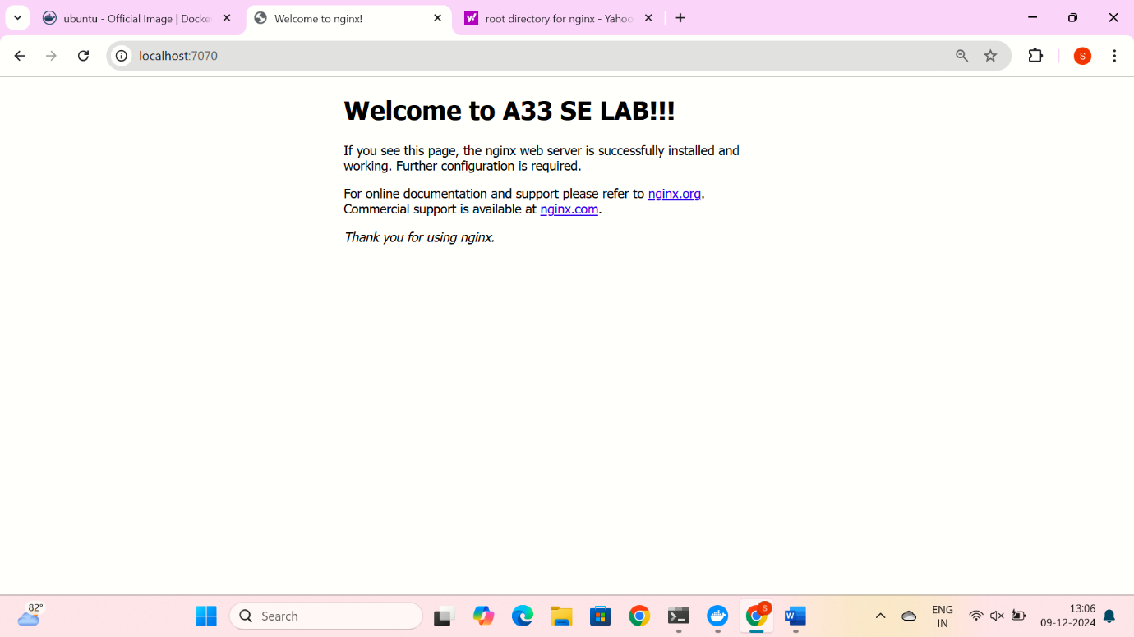

Step-3: The following command is used to create the container name and the image name.

run -it –name: The docker run -it --name command is used to start a new Docker container with an interactive terminal session (-it) and assign it a custom name (--name).

Syntax: docker run -it –name <container-name> <image-name>

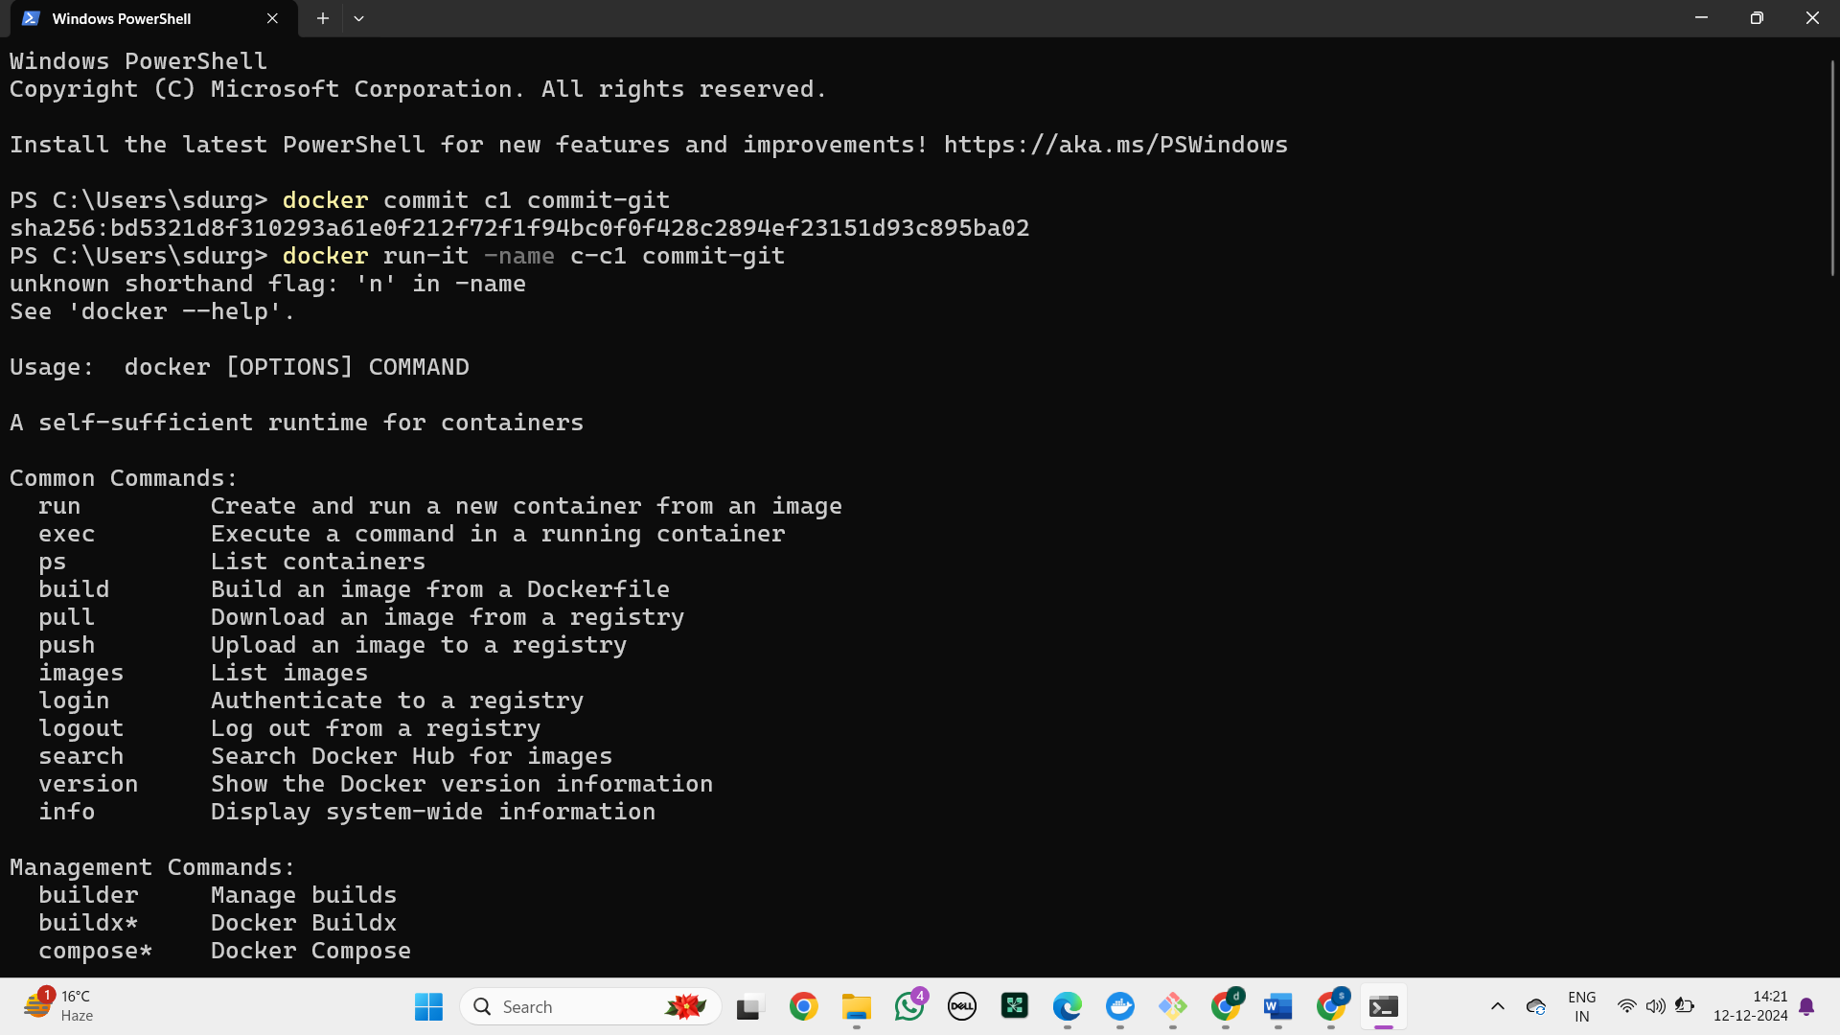

Step-4: The command tag is used to assign a specific identifier to a Docker image.

Syntax: docker tag <filename> <username>/<imagename>



Step-5: The docker login -u command is used to log in to a Docker registry with a specific username. This is often required to push or pull images from a private Docker registry or Docker Hub.

Syntax: docker login -u <emailId>

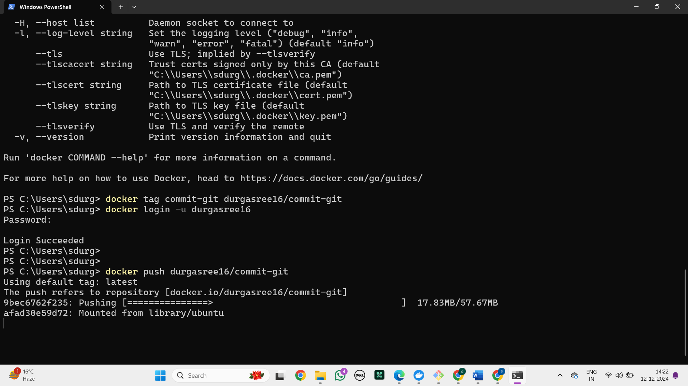

Step-6: This command is used to push into the docker hub.

Syntax: docker push <username>/<imagename>

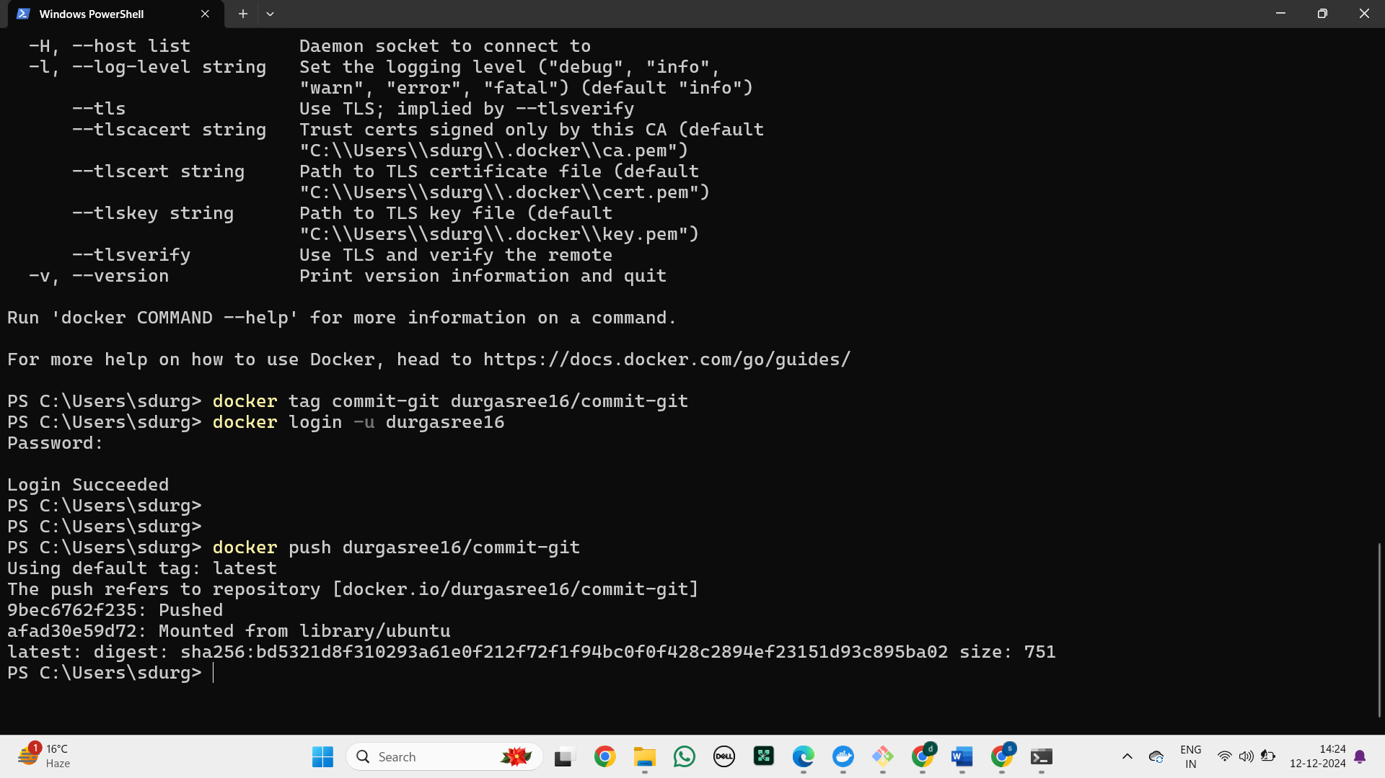

Step-7: Go to docker desktop and check

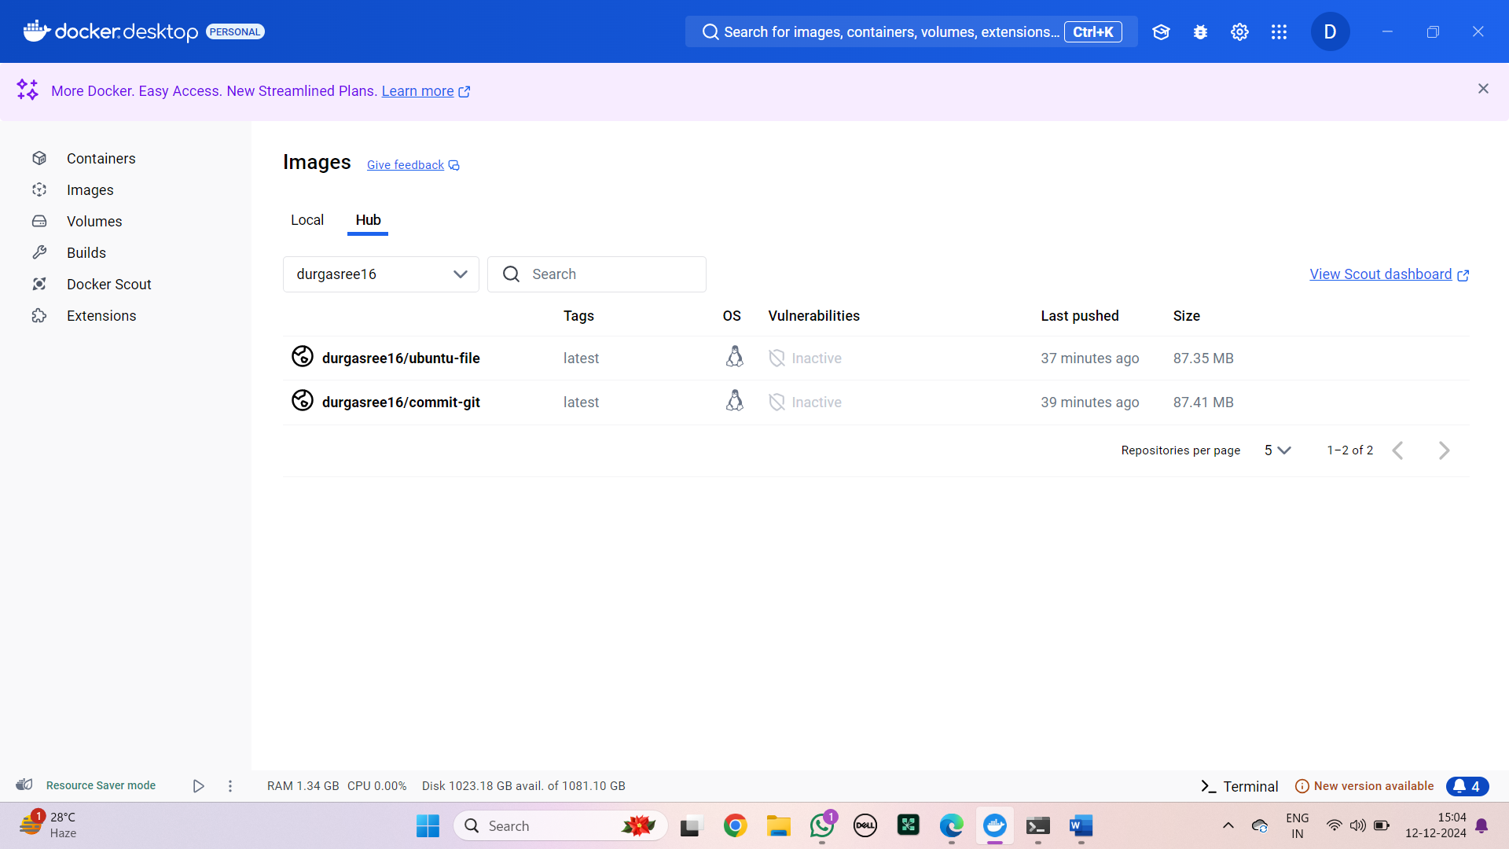

### CREATE AND PUSH DOCKER FILE IMAGE

**CREATING AN IMAGE USING DOCKERFILE AND PUSHING INTO DOCKER HUB**

Step-1: Create a folder

Step-2: Click on the folder and click on git bash here

Step 3: Using vin, write the command

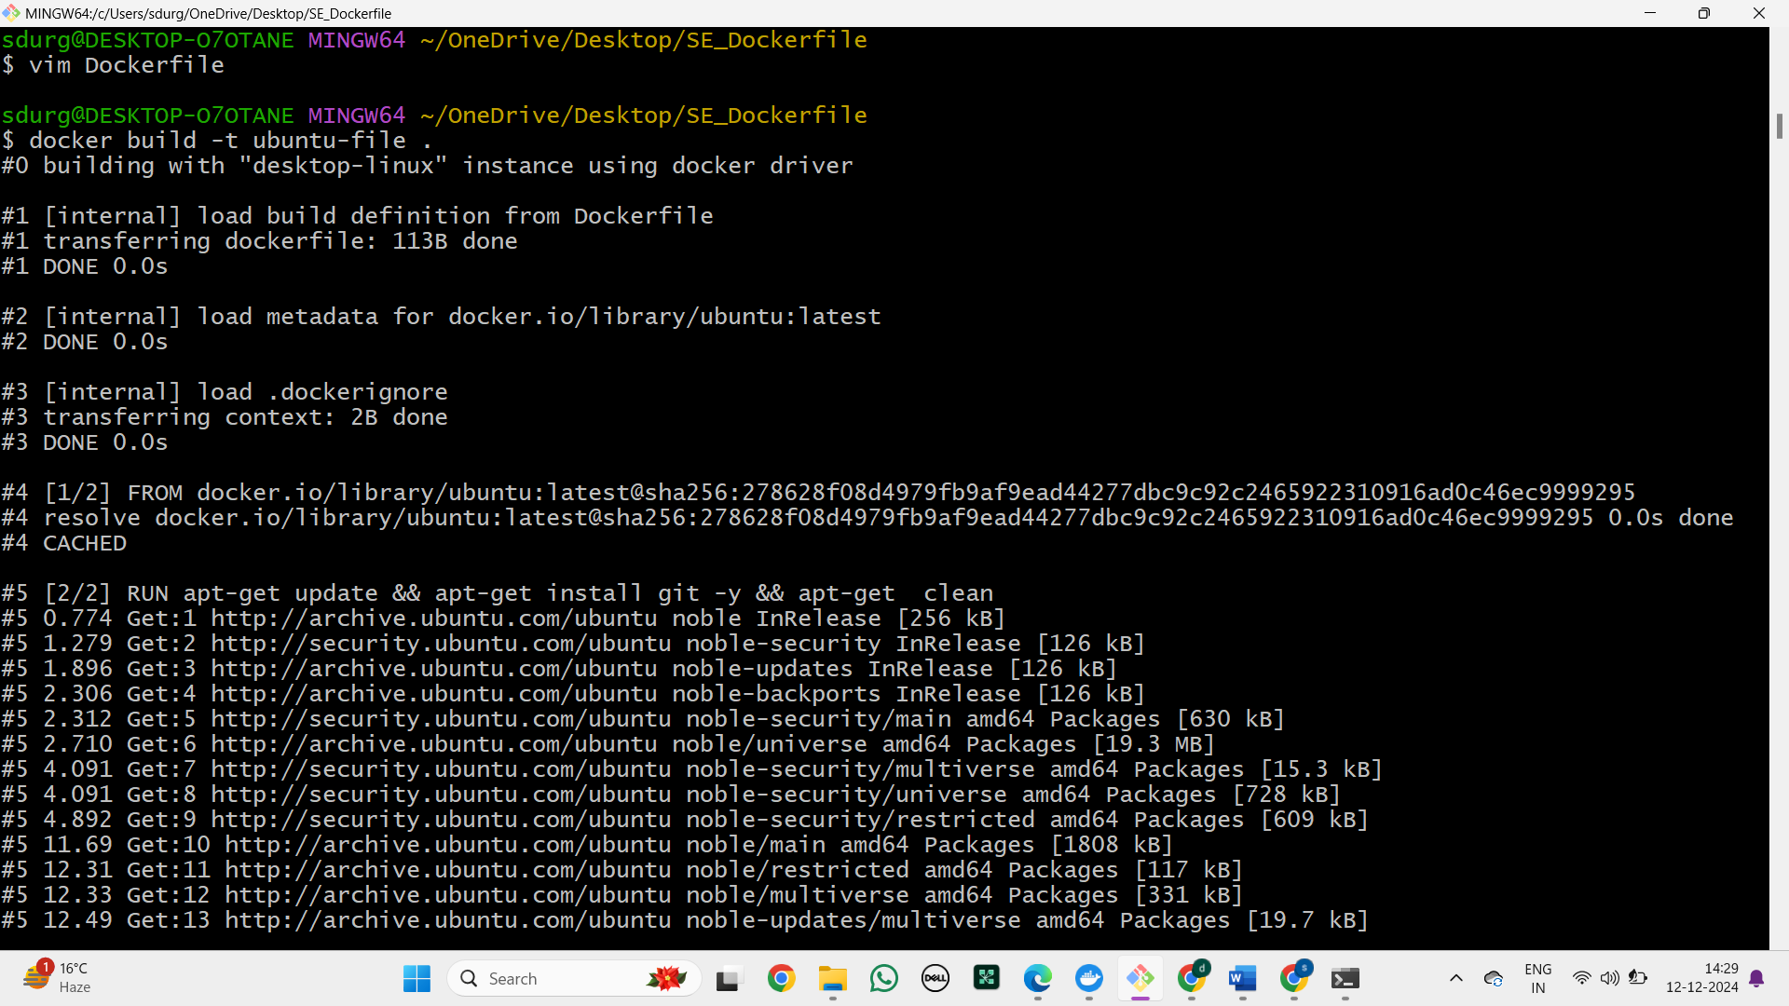

Step-4: To build the image using dockerfile.

build -t: The docker build -t command is used to build a Docker image from a Dockerfile and assign it a name (and optionally a tag) for easier identification and management.



Step-5: See whether the created image is present in the images.

Syntax: docker images

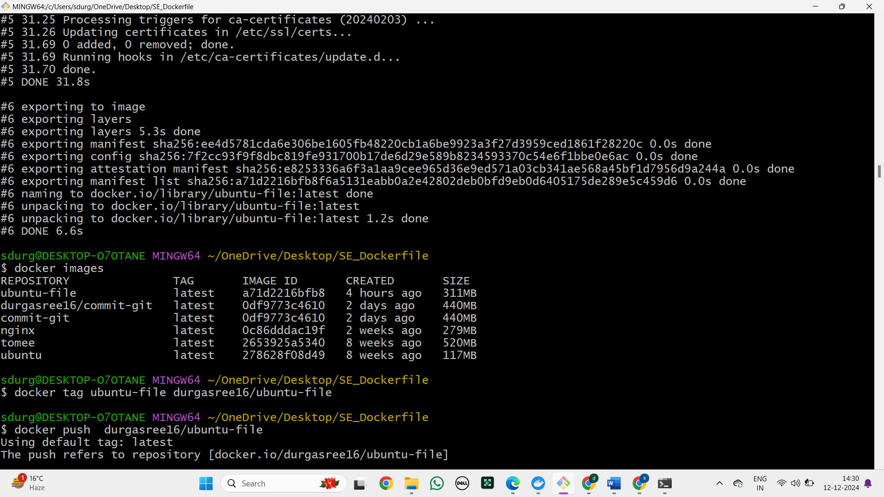

Step-6: The command tag is used to assign a specific identifier to a Docker image.

Syntax: docker tag <filename> <username>/<imagename>



Step-7: We should push the file into docker hub by the following command.

push: The command push is used to push the image created into the docker hub.

Syntax: docker push <username>/<imagename>

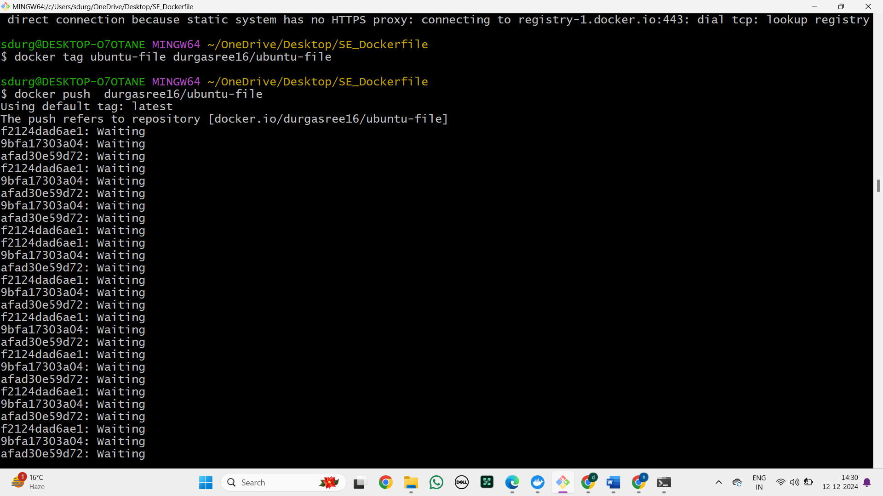

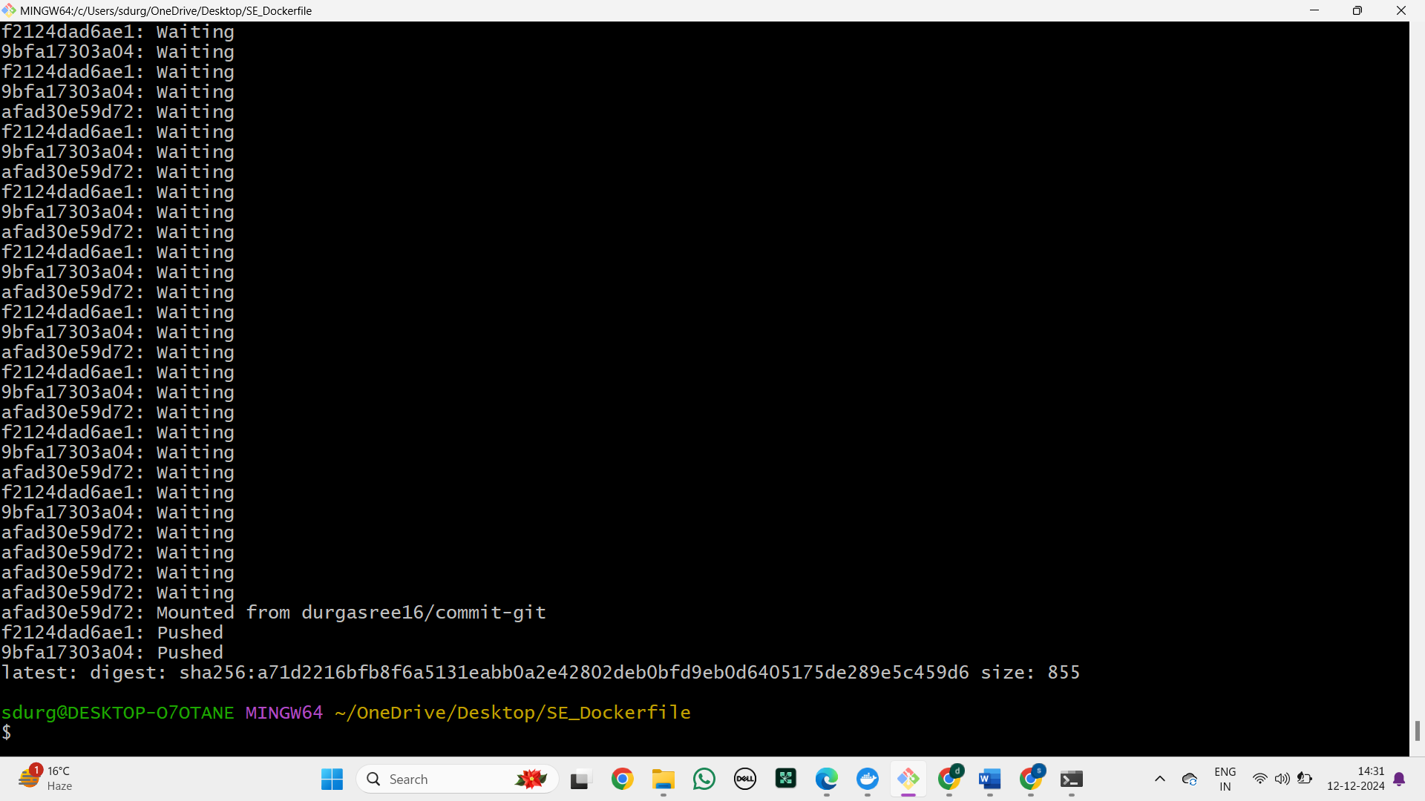

Step-8: Go to docker desktop and see that whether the image is pushed or not.

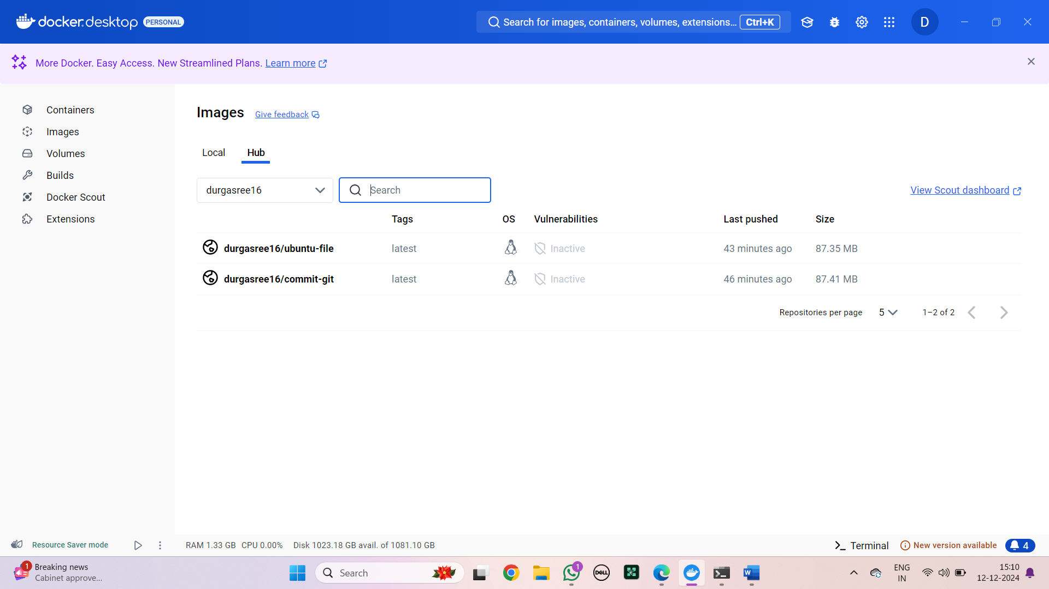

CREATING AN IMAGE USING DOCKERFILE WITH WEBDEP

Step 1: Create a folder with name A33 and create webpage folder in that. Now insert the basic index.html file with a title as “Welcome to CSA33”

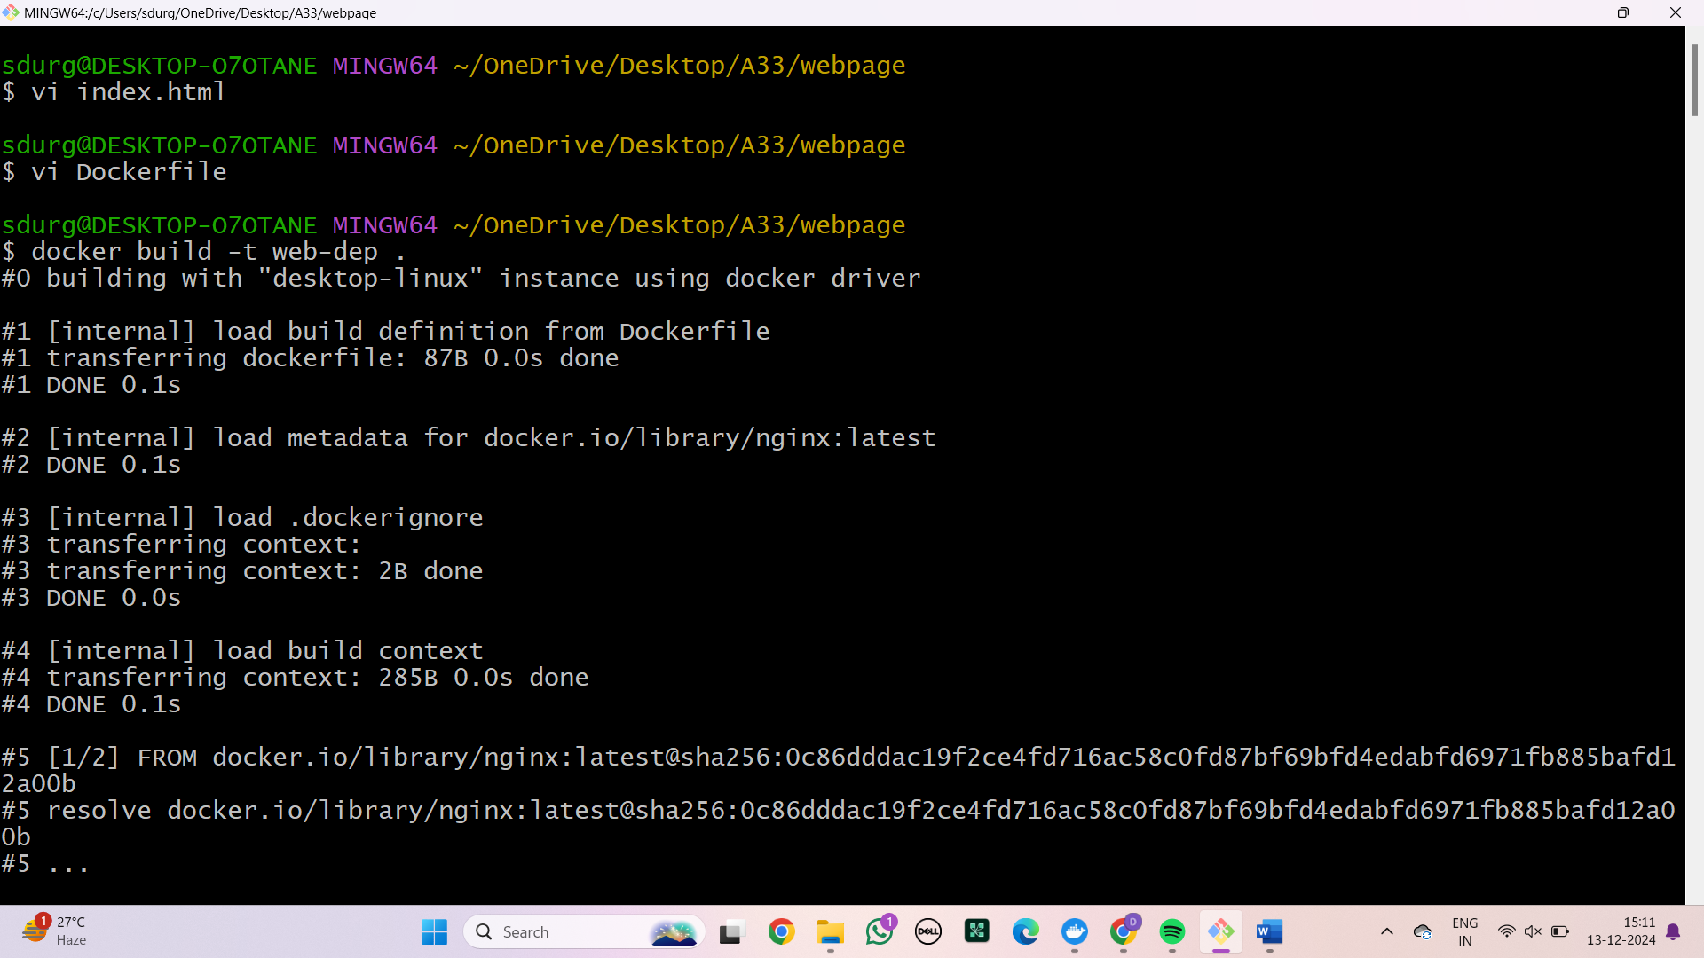

Step 2: Open dockerfile and Write the following commands  
FROM nginx  
COPY index.html /usr/share/nginx/html



Step 3: Now, build the image by the following command



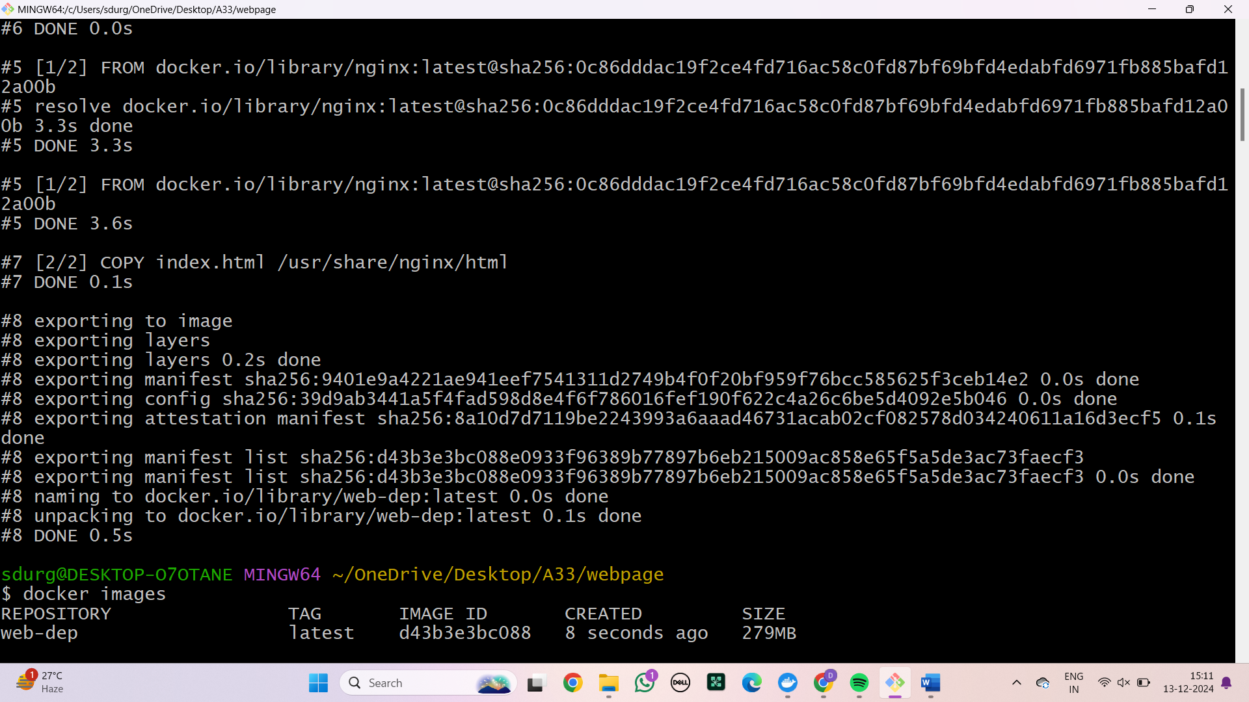

Step 4: Check for the image by using the command docker images

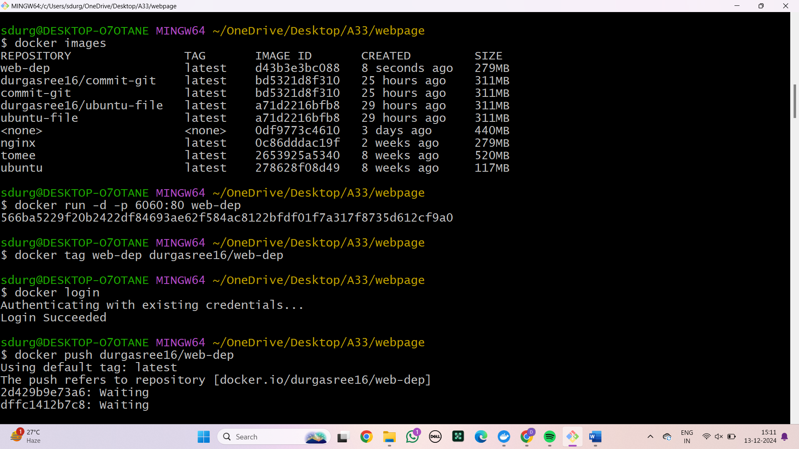

Step 5: Now run the image



Step 6 : Tag the image to be committed



Step 7: Login to your docker to push



Step 8: Push the docker fi;e into the docker



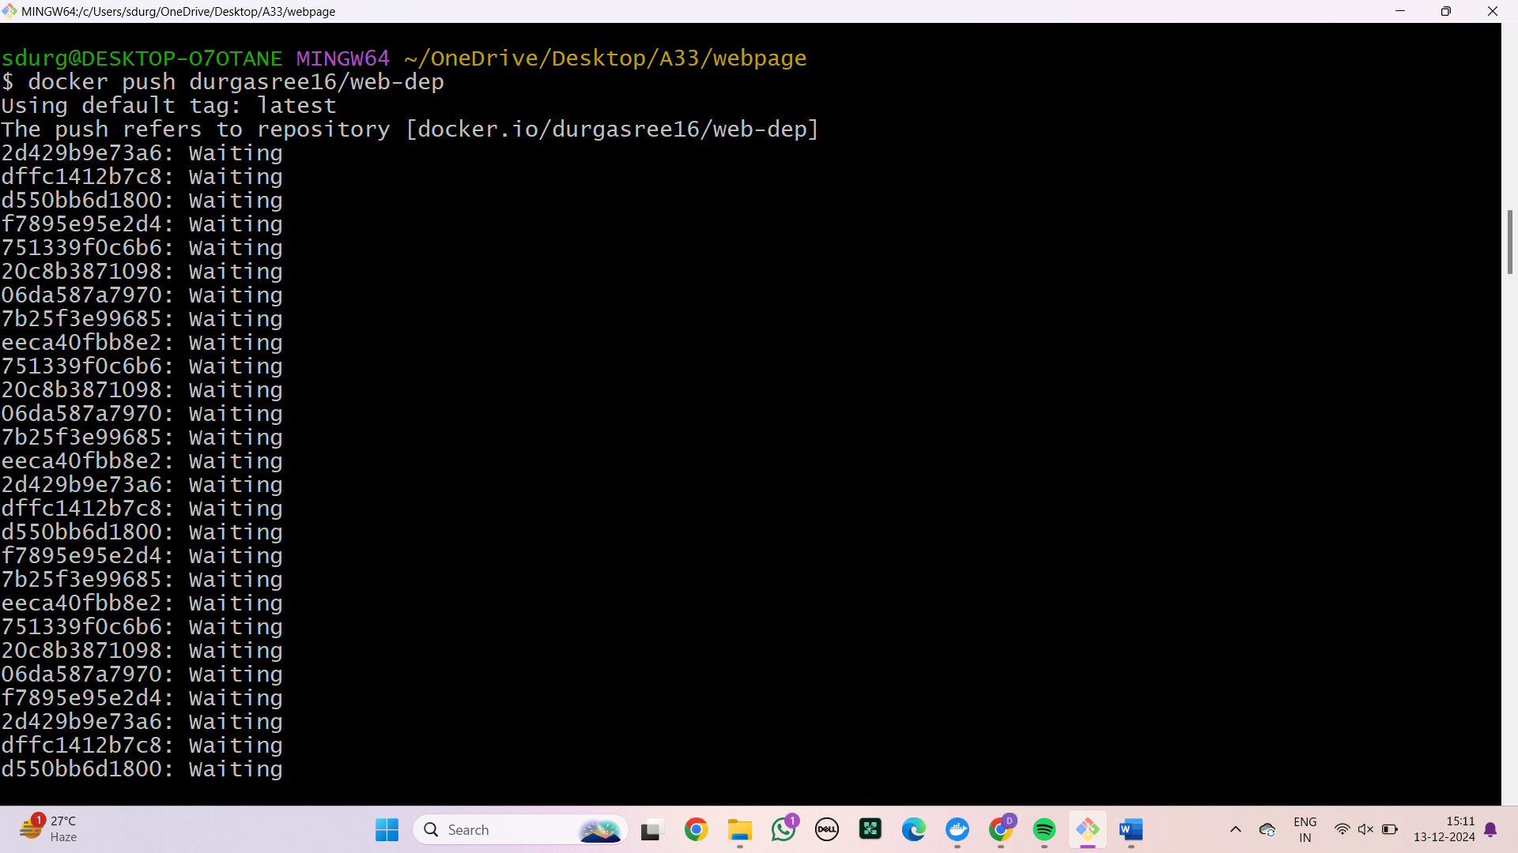

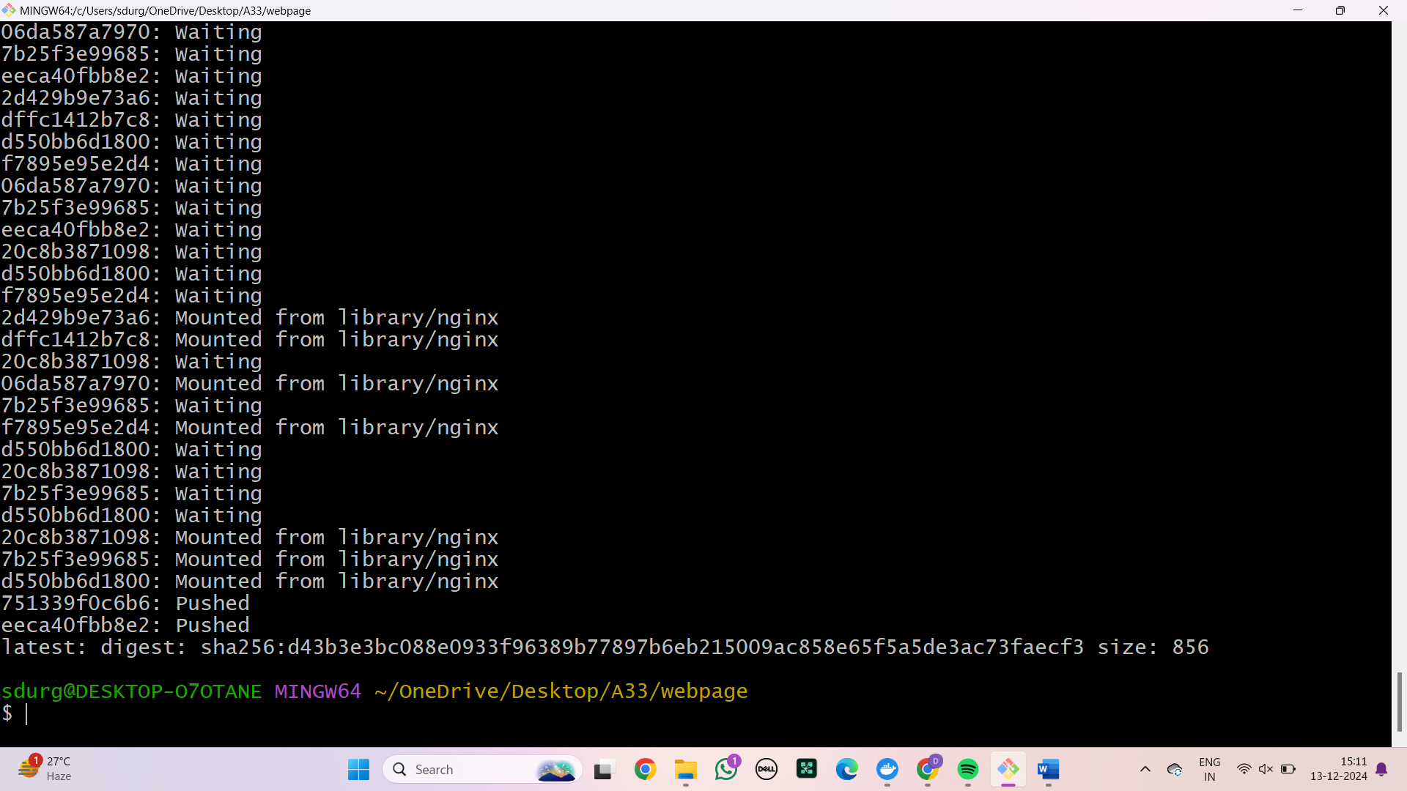

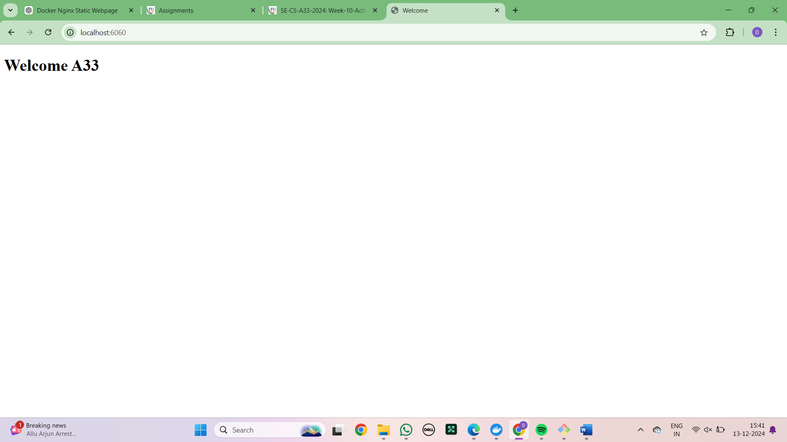

### RUNNING MULTIPLE CONTAINERS USING DOCKER COMPOSE

Step 1: Create a yml file and insert the code

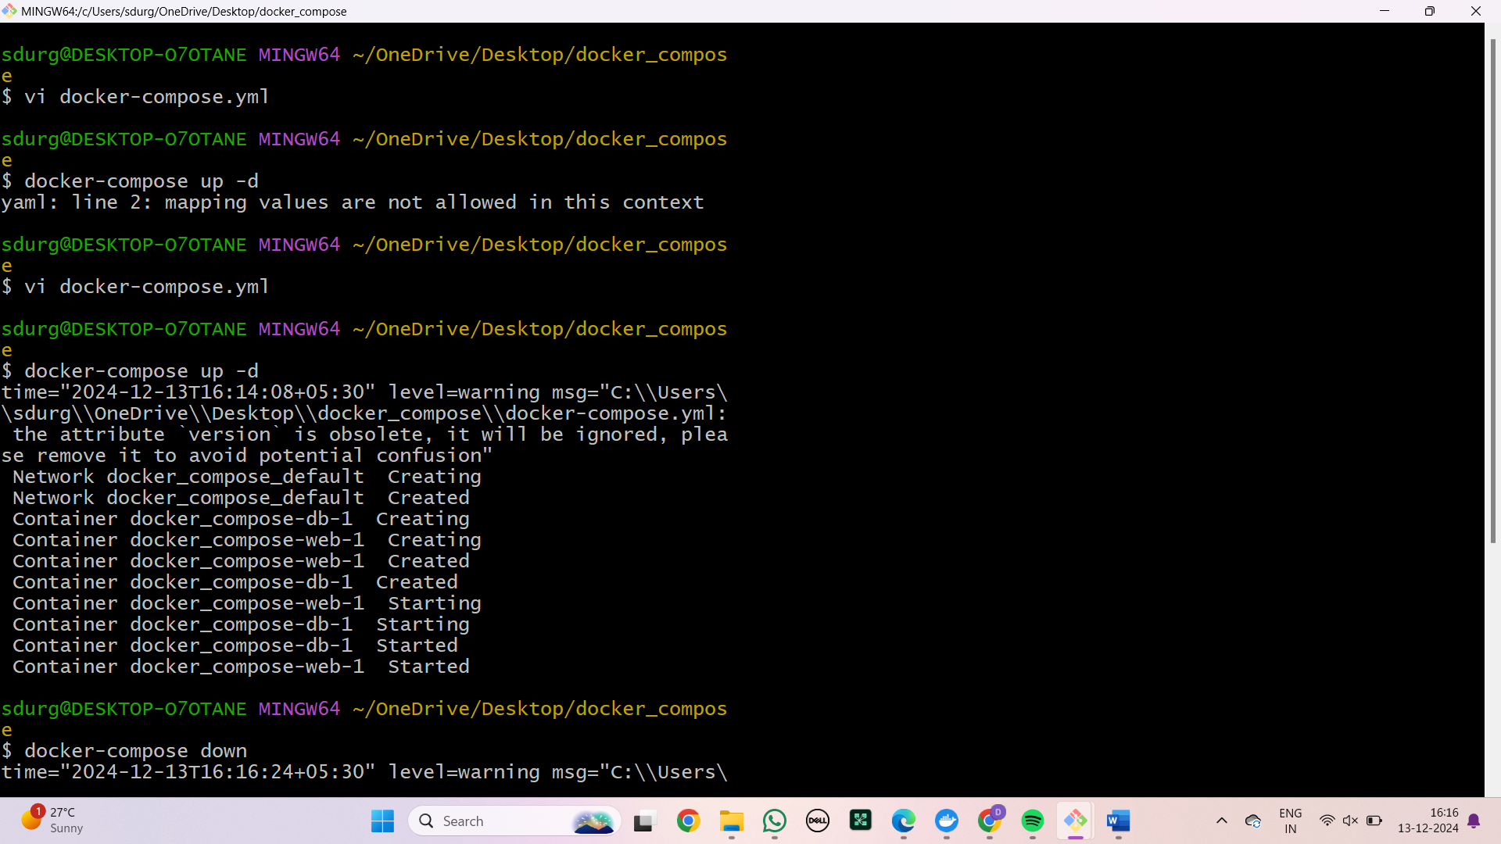

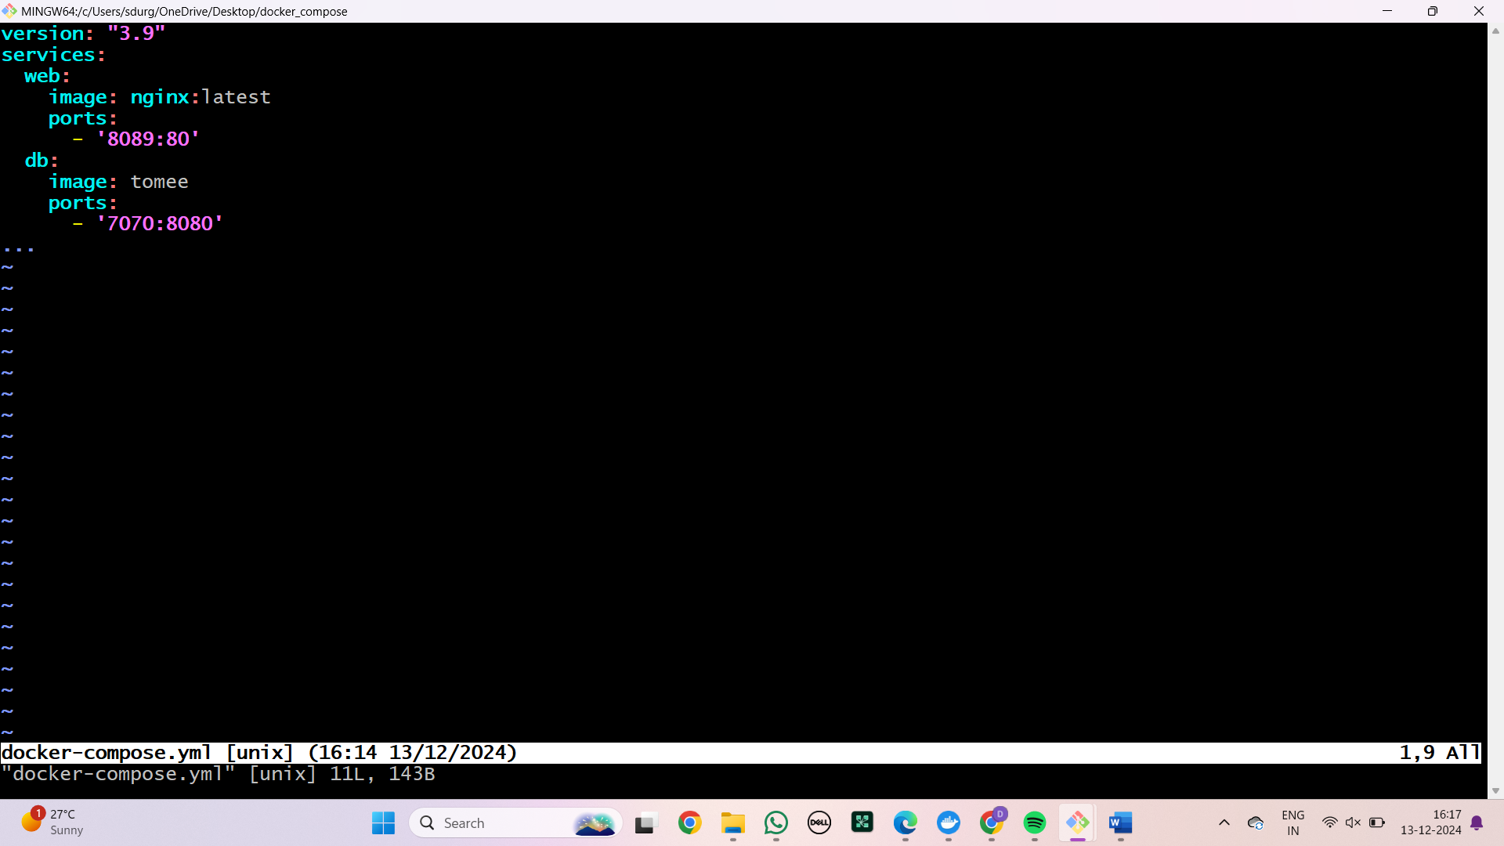

Step 2: Check in the port



Step 3: Shut down the port

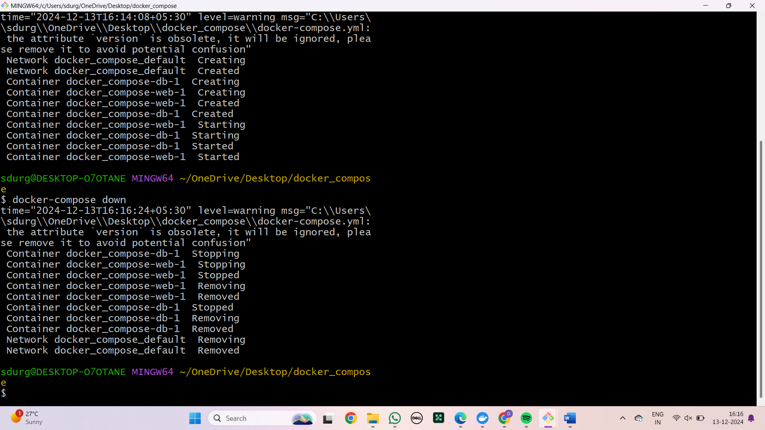

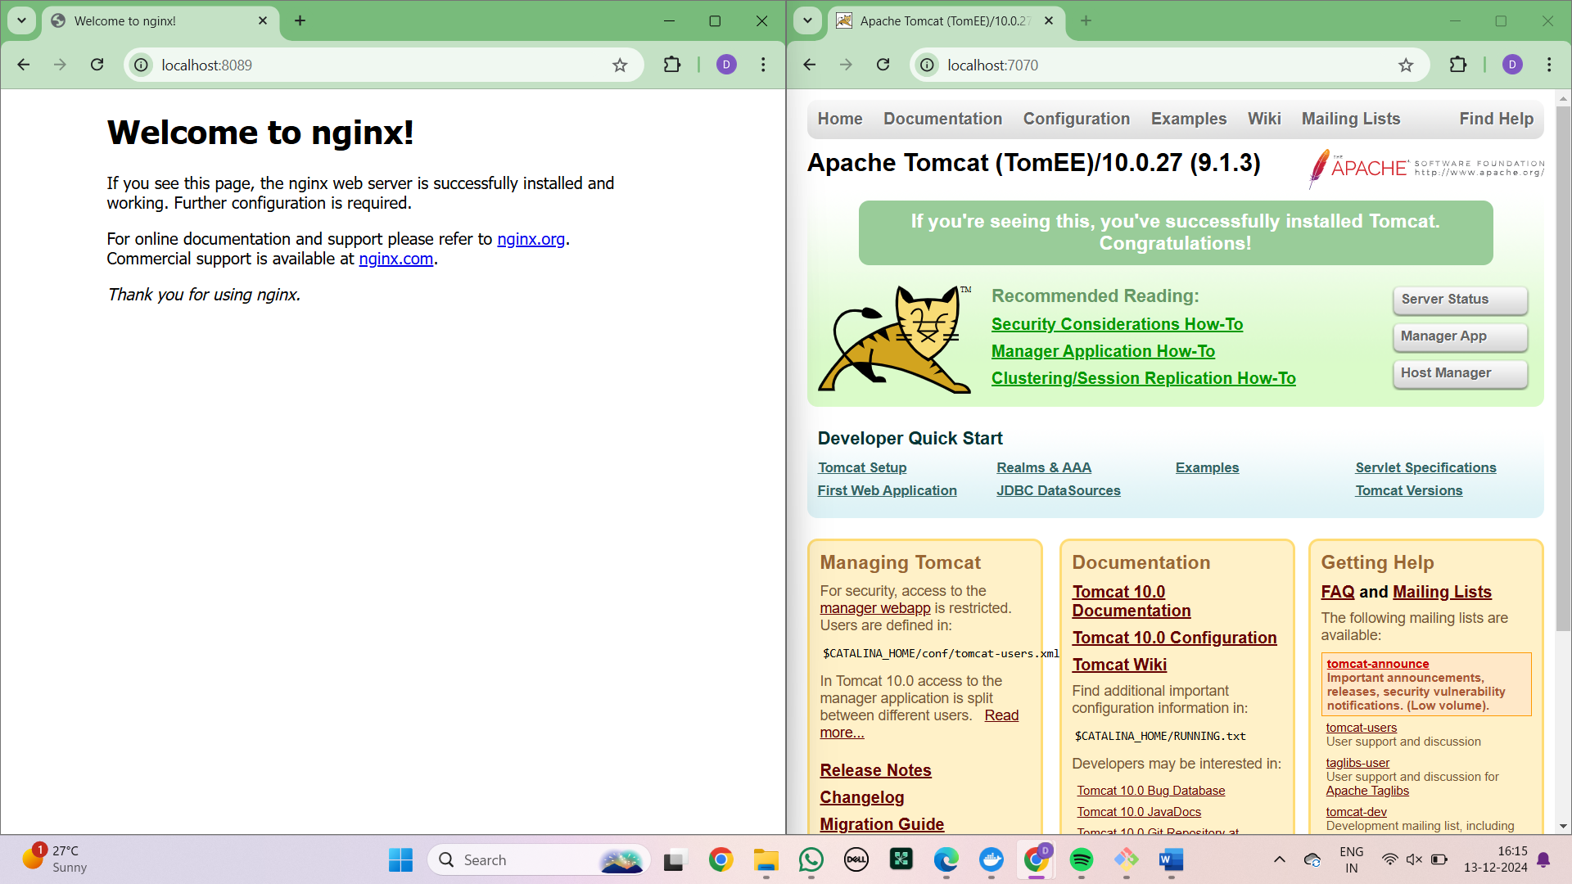

### DEPLOYING AND SCALING APPLICATIONS USING MINIKUBE

**Steps to install the minikube**

Step 1: Search for minikube install in browser

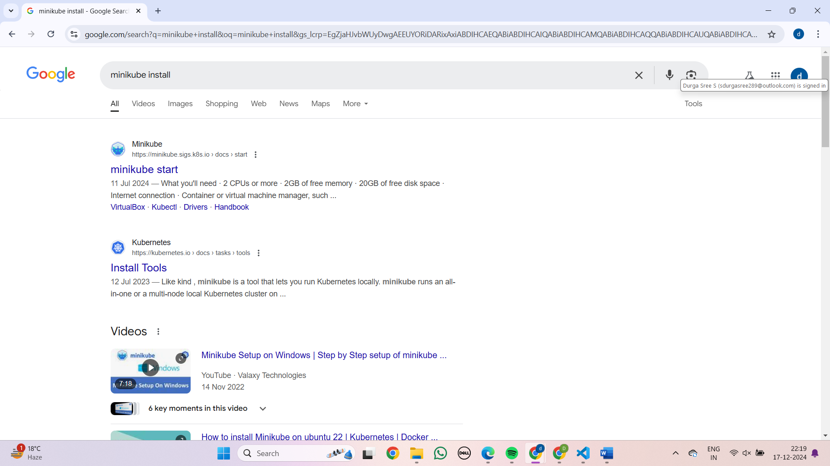

Step 2: Check for the pre-requites

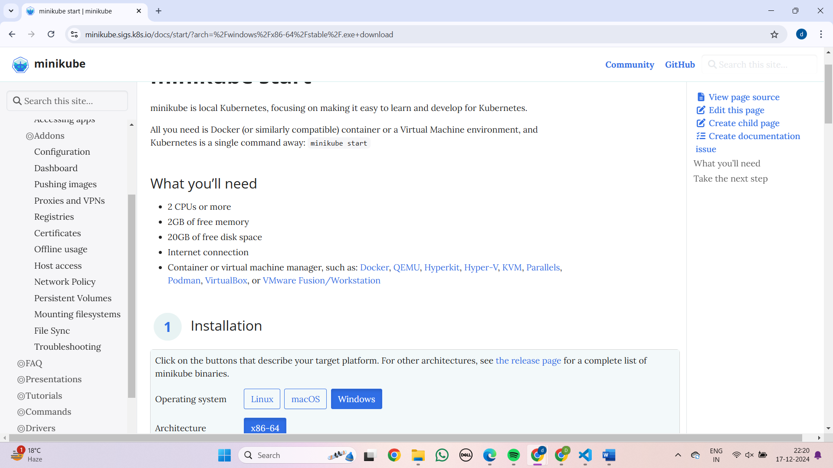

Step 3: Select the operating system here iam going with windows

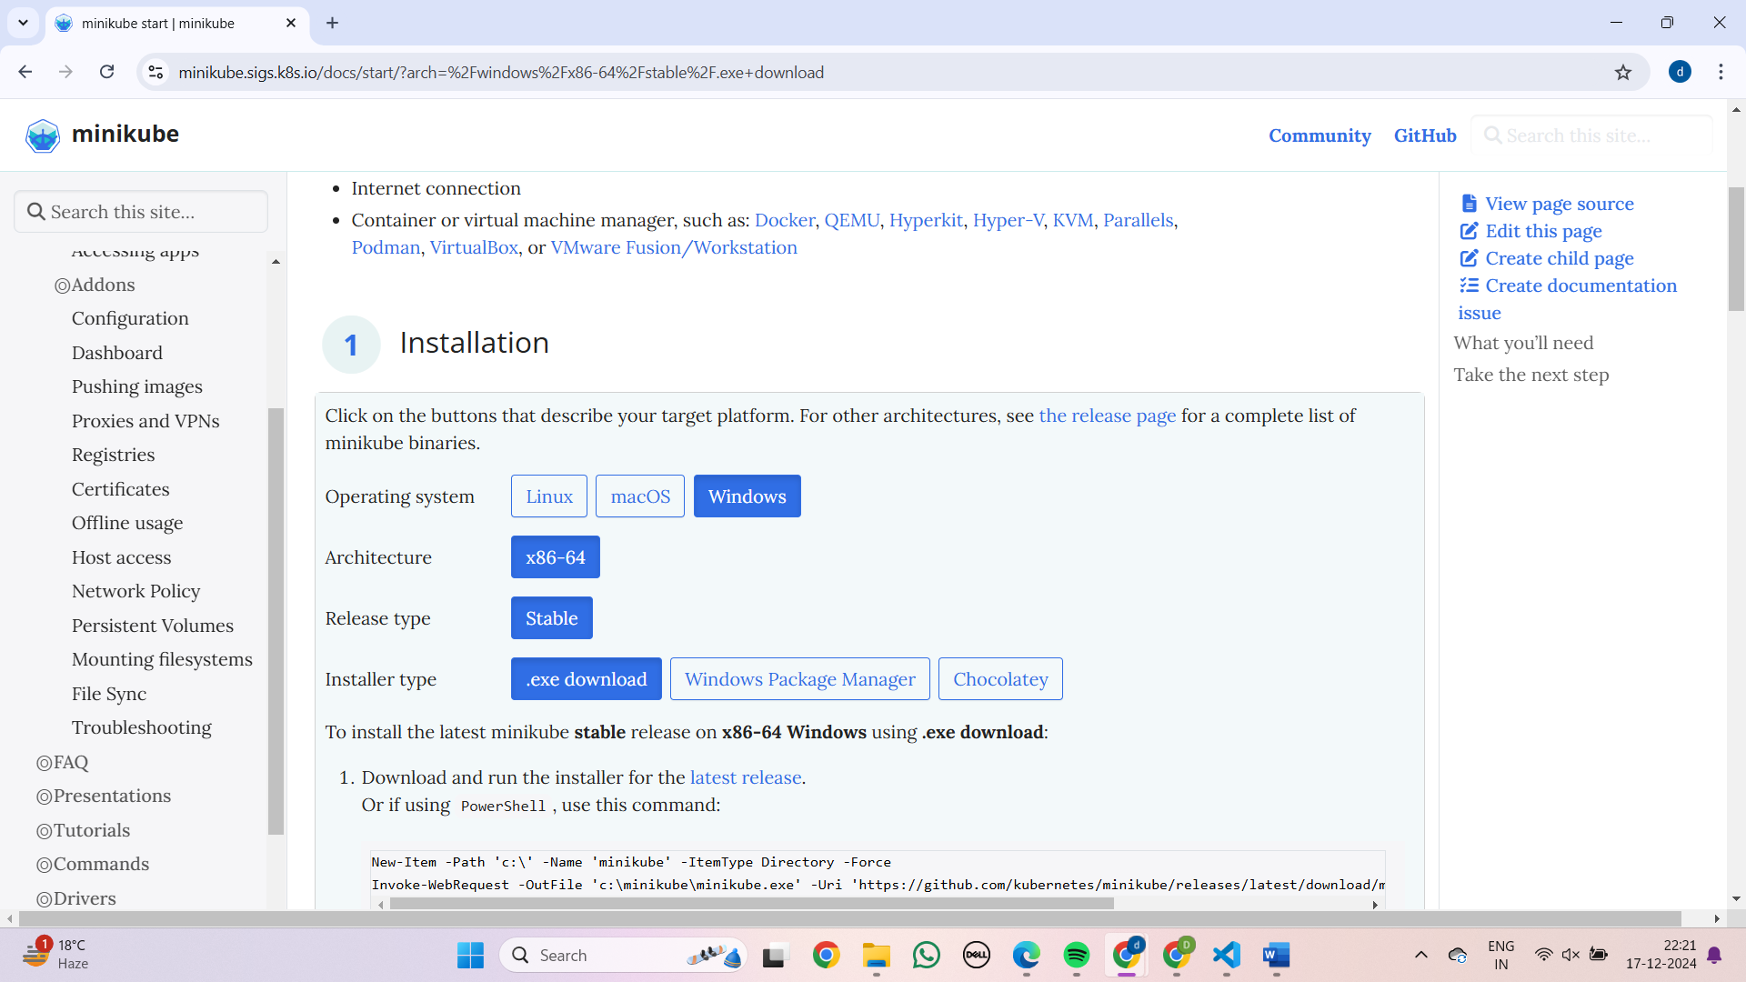

Step 4: Already we have installed the docker than proceed for next steps

Step 5: Copy the commands in powershell

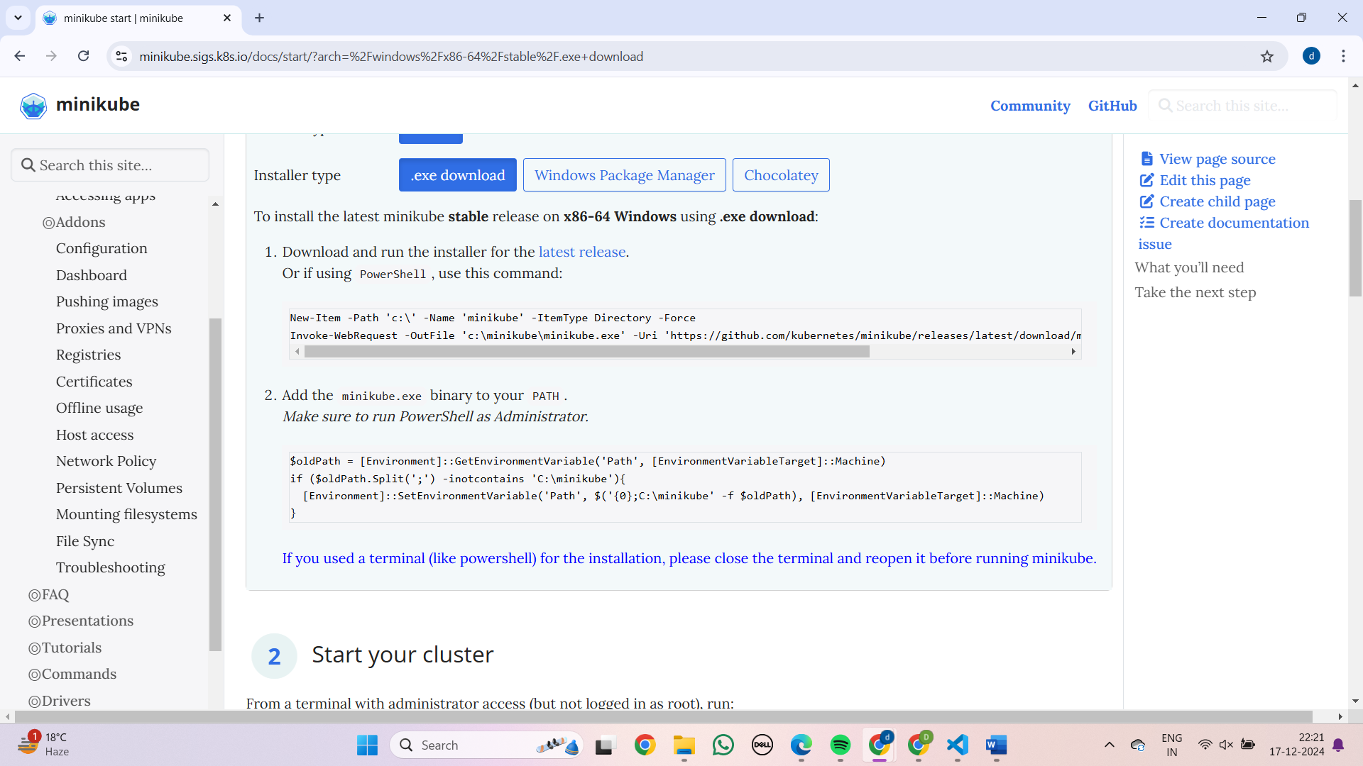

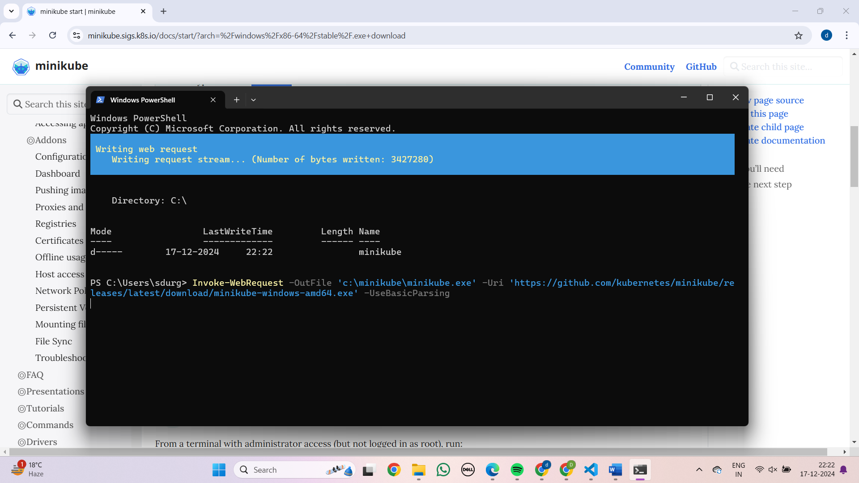

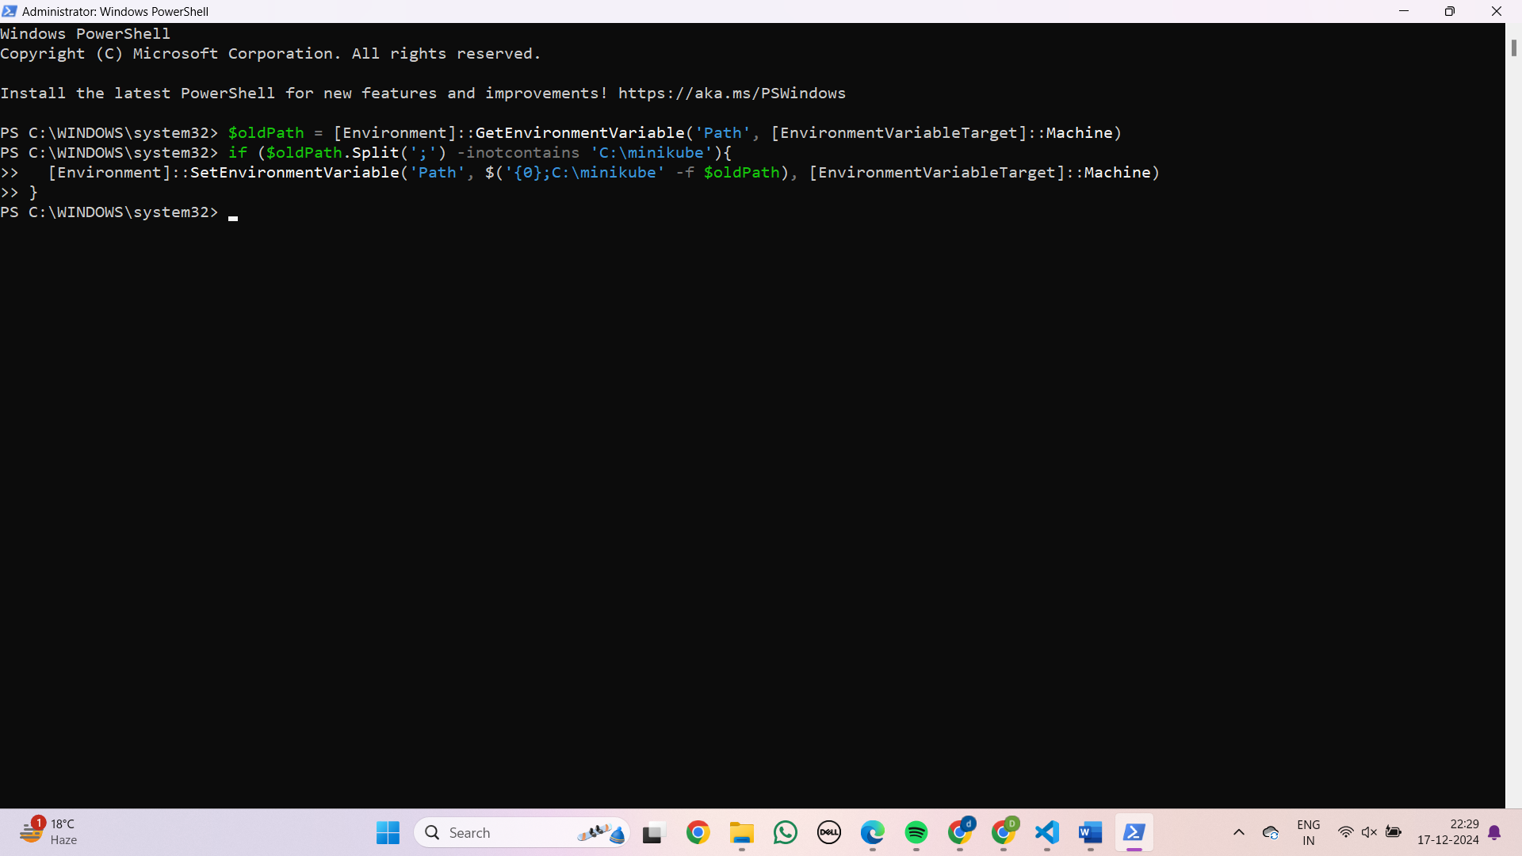

Step 6: Once done with commands start the minikube

Step 7: Run the command -Mini start

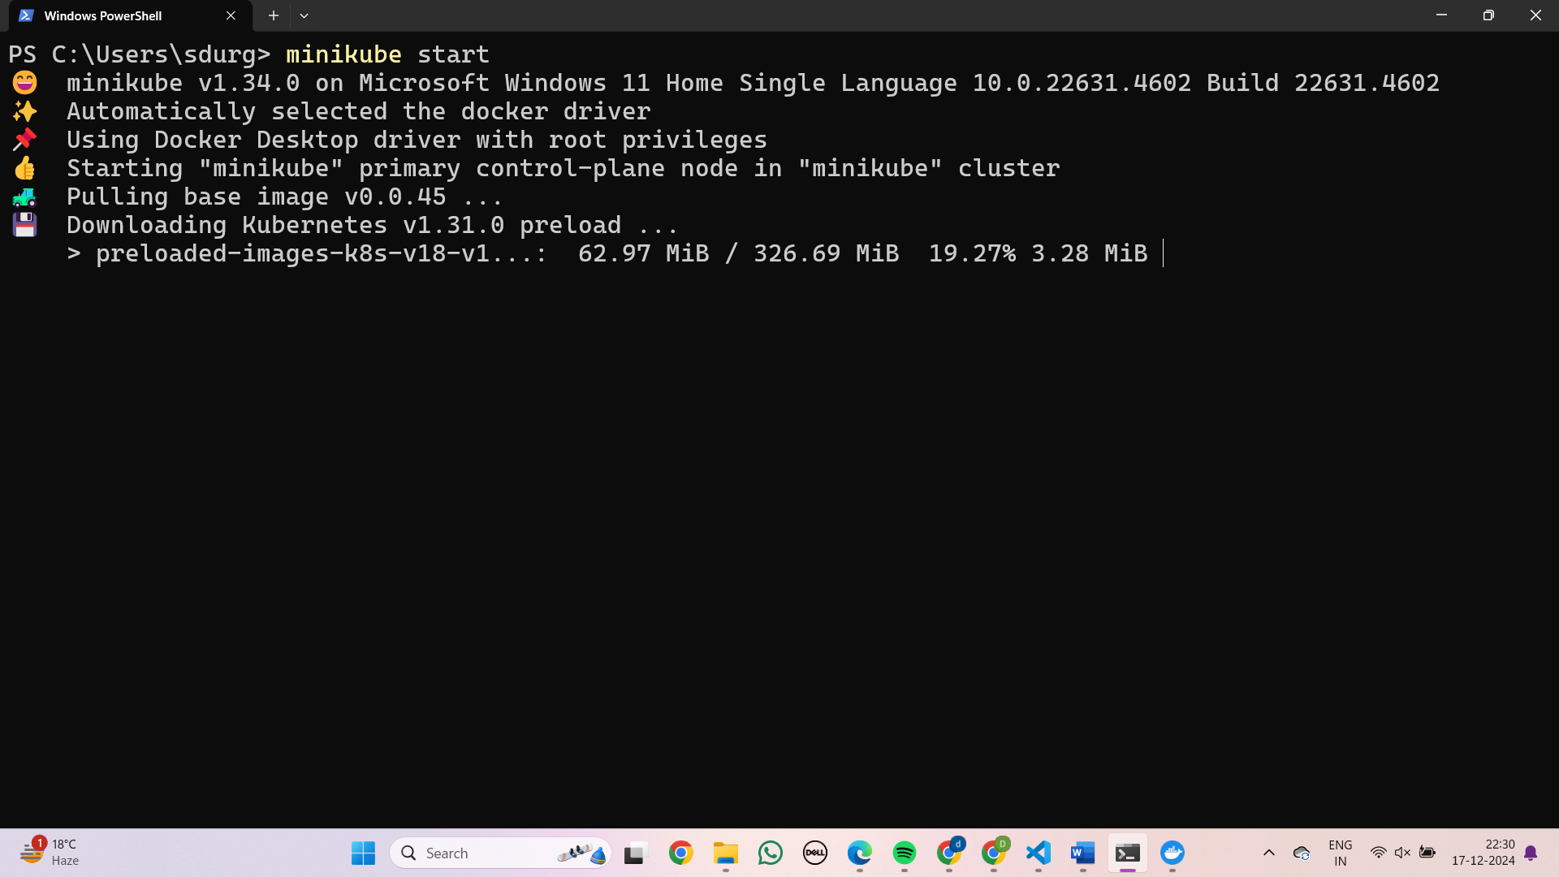

Step 8: Minikube status

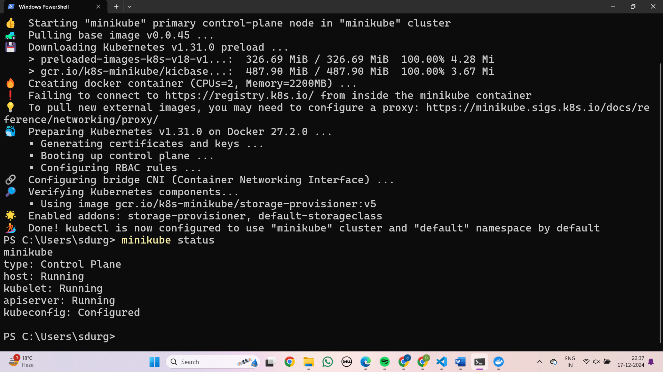

Step 9: Kubectl get nodes

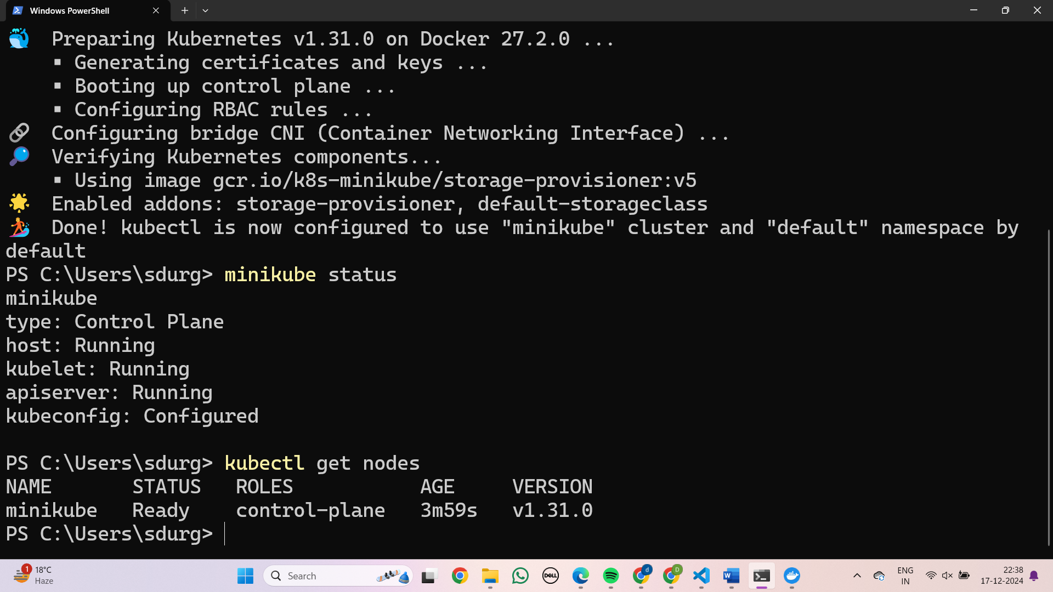

Step 10: Kubectl get pods

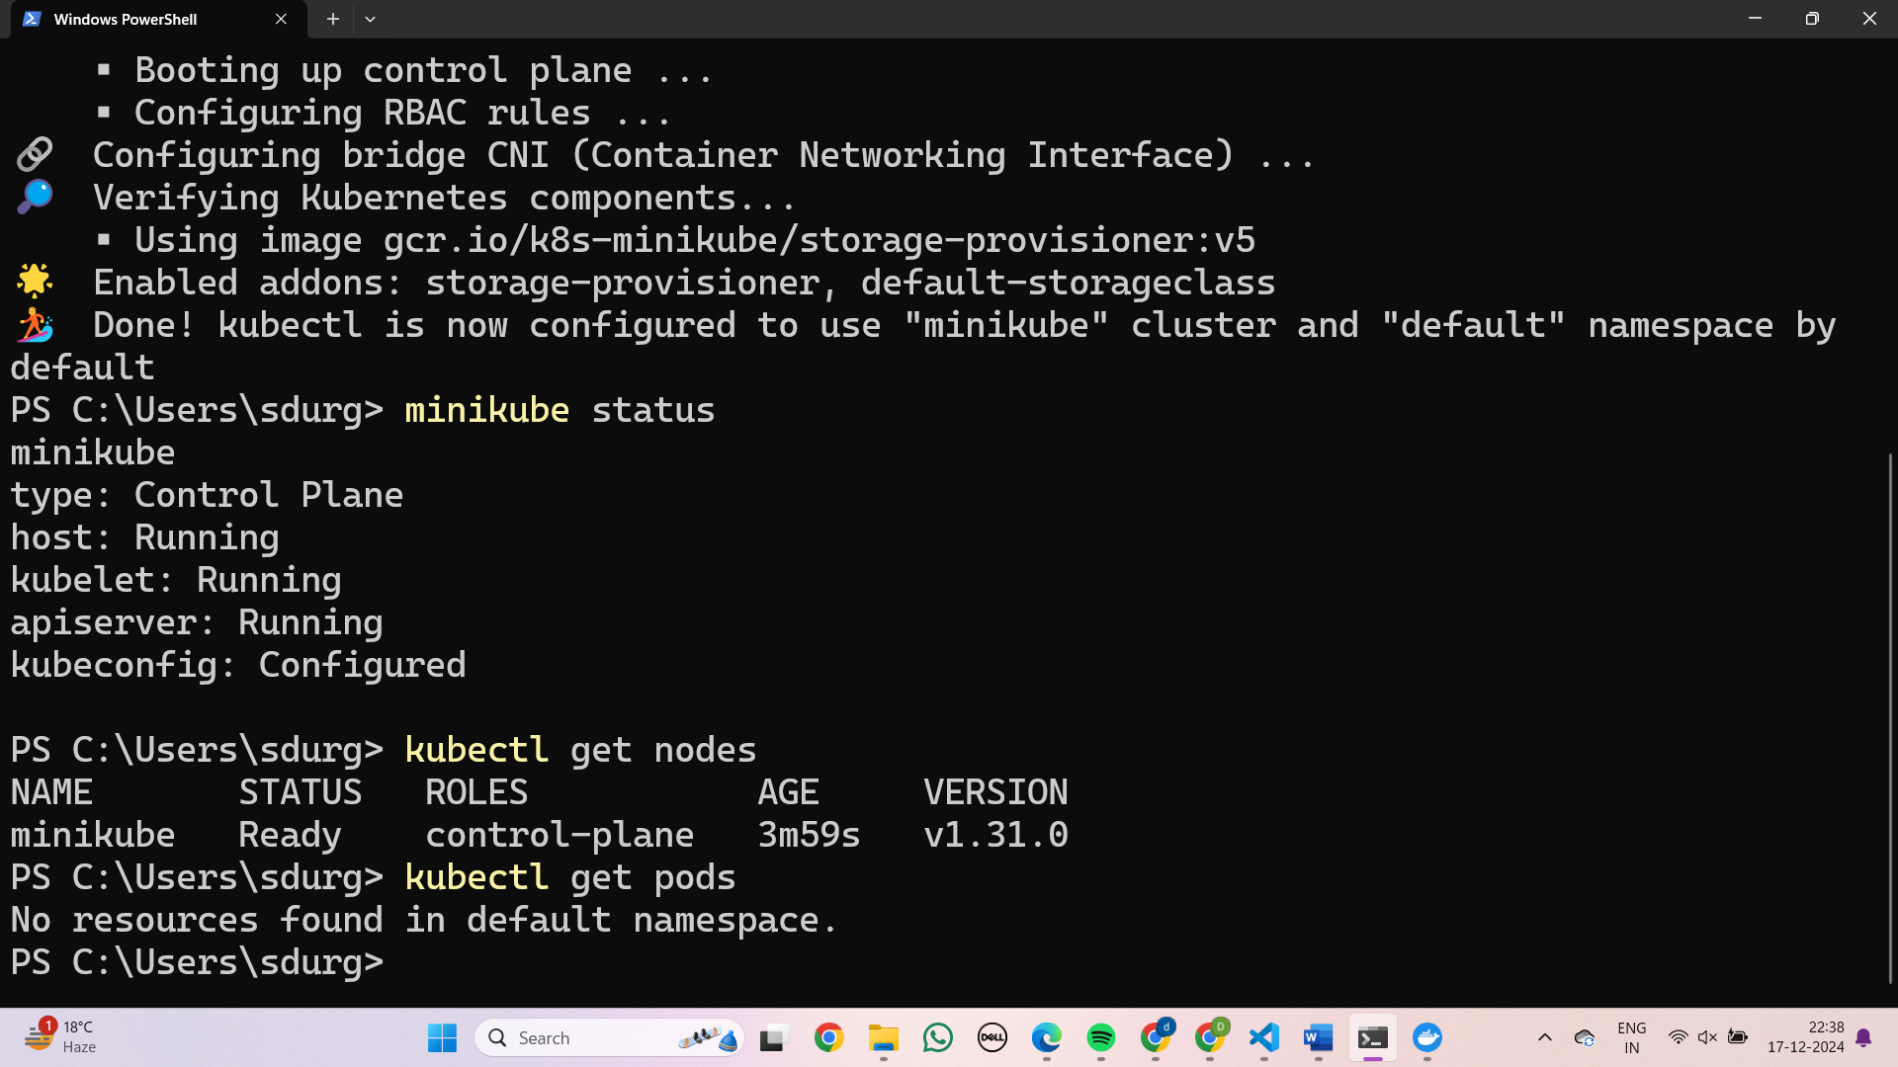

**Creating the nginx deployment**

Step 1: To create the deployment for nginx server

Kubectl create deployment <deployment name > --image=nginx

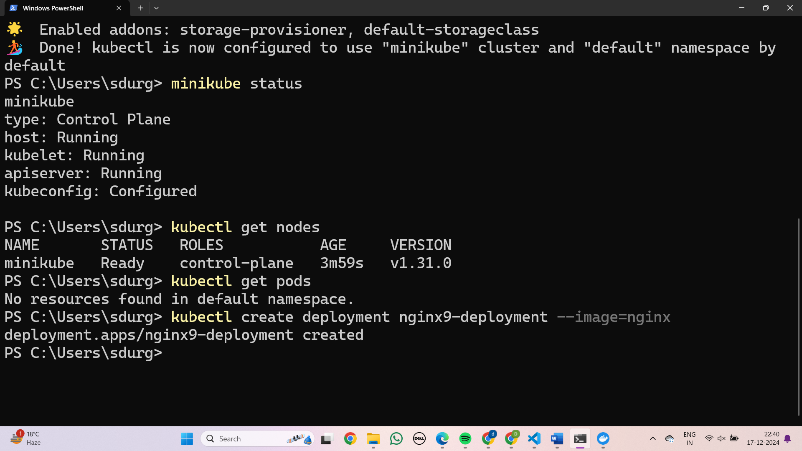

Step 2: To check whether deployment is created or not

Kubectl get deployment

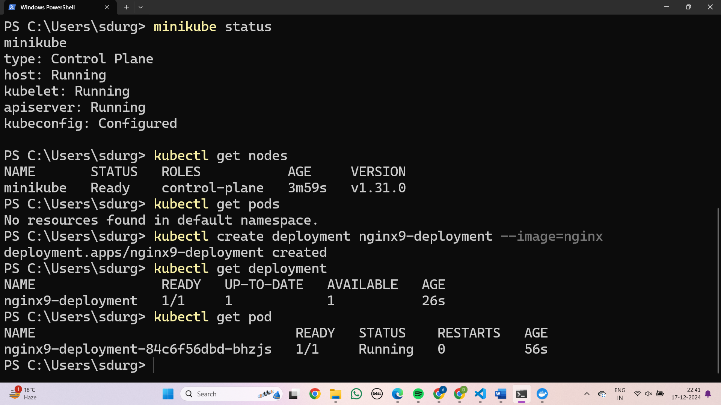

Step 3: To check the pod status

Kubectl get pod

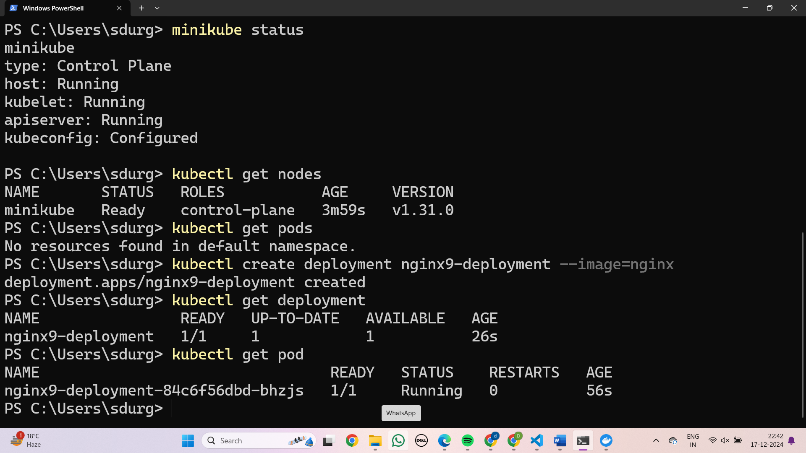

Step 4: To check service

Kubectl get service

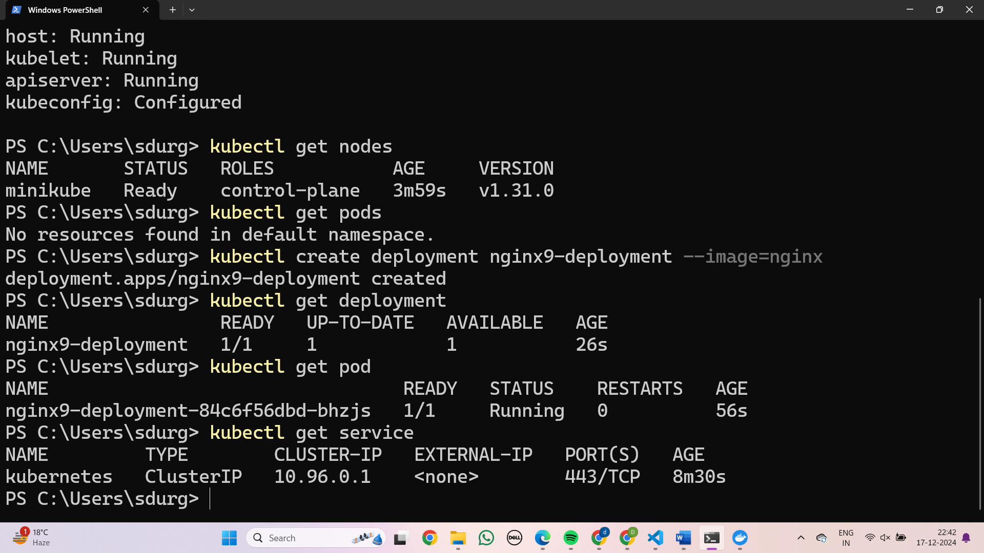

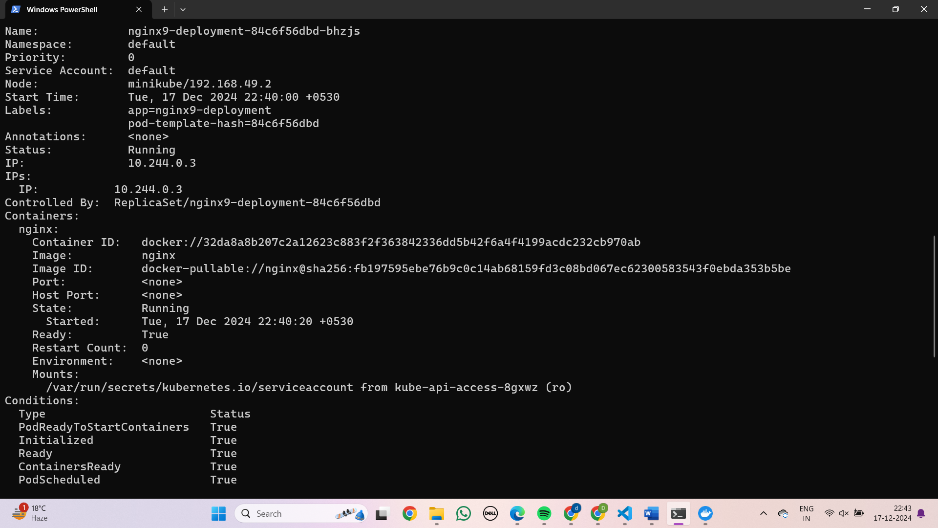

Step 5:To get pod information in more detail

Kubectl get pod –o wide

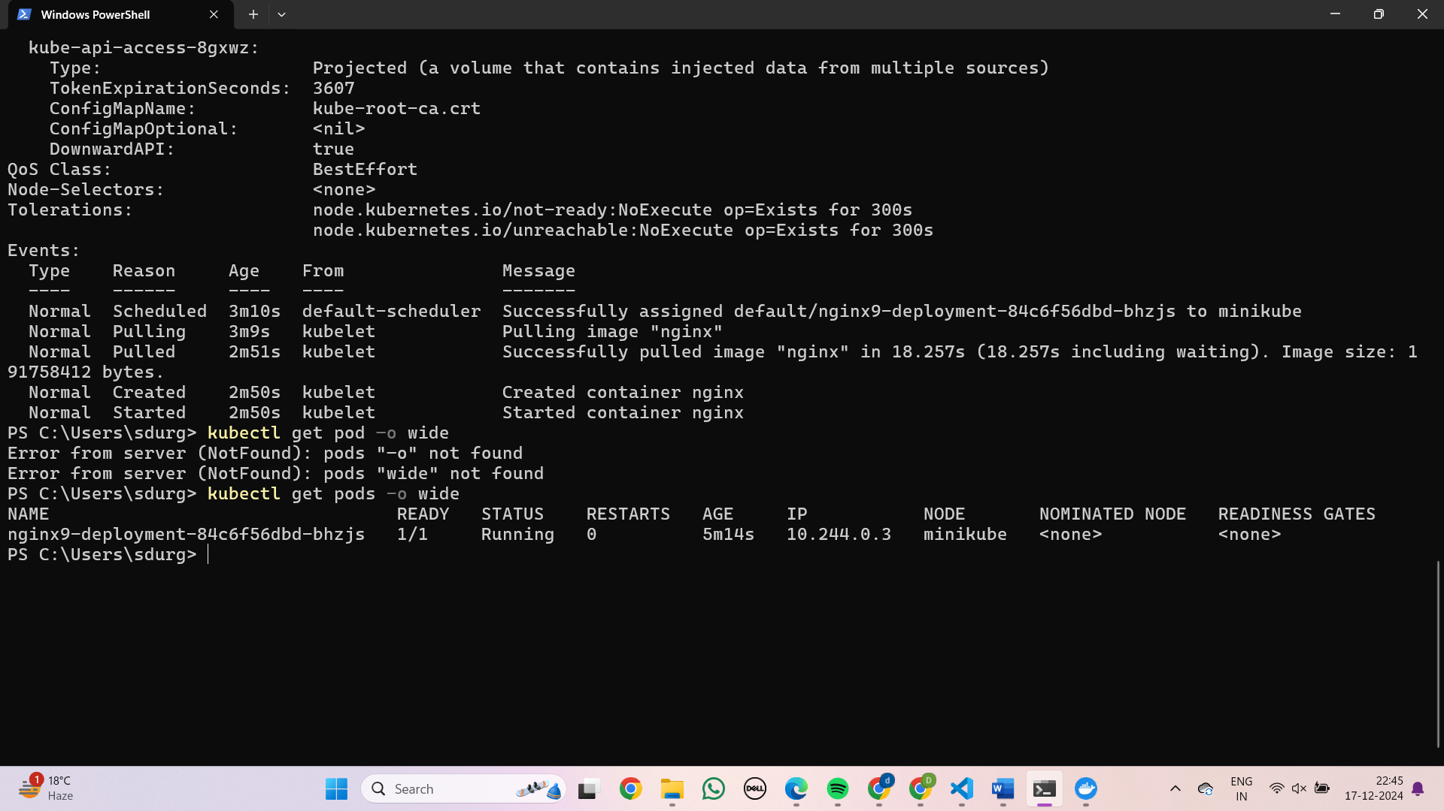

Step 6: To access the nginx page

Kubectl expose deployment nginx-deployment - -type=NodePort - -port=80

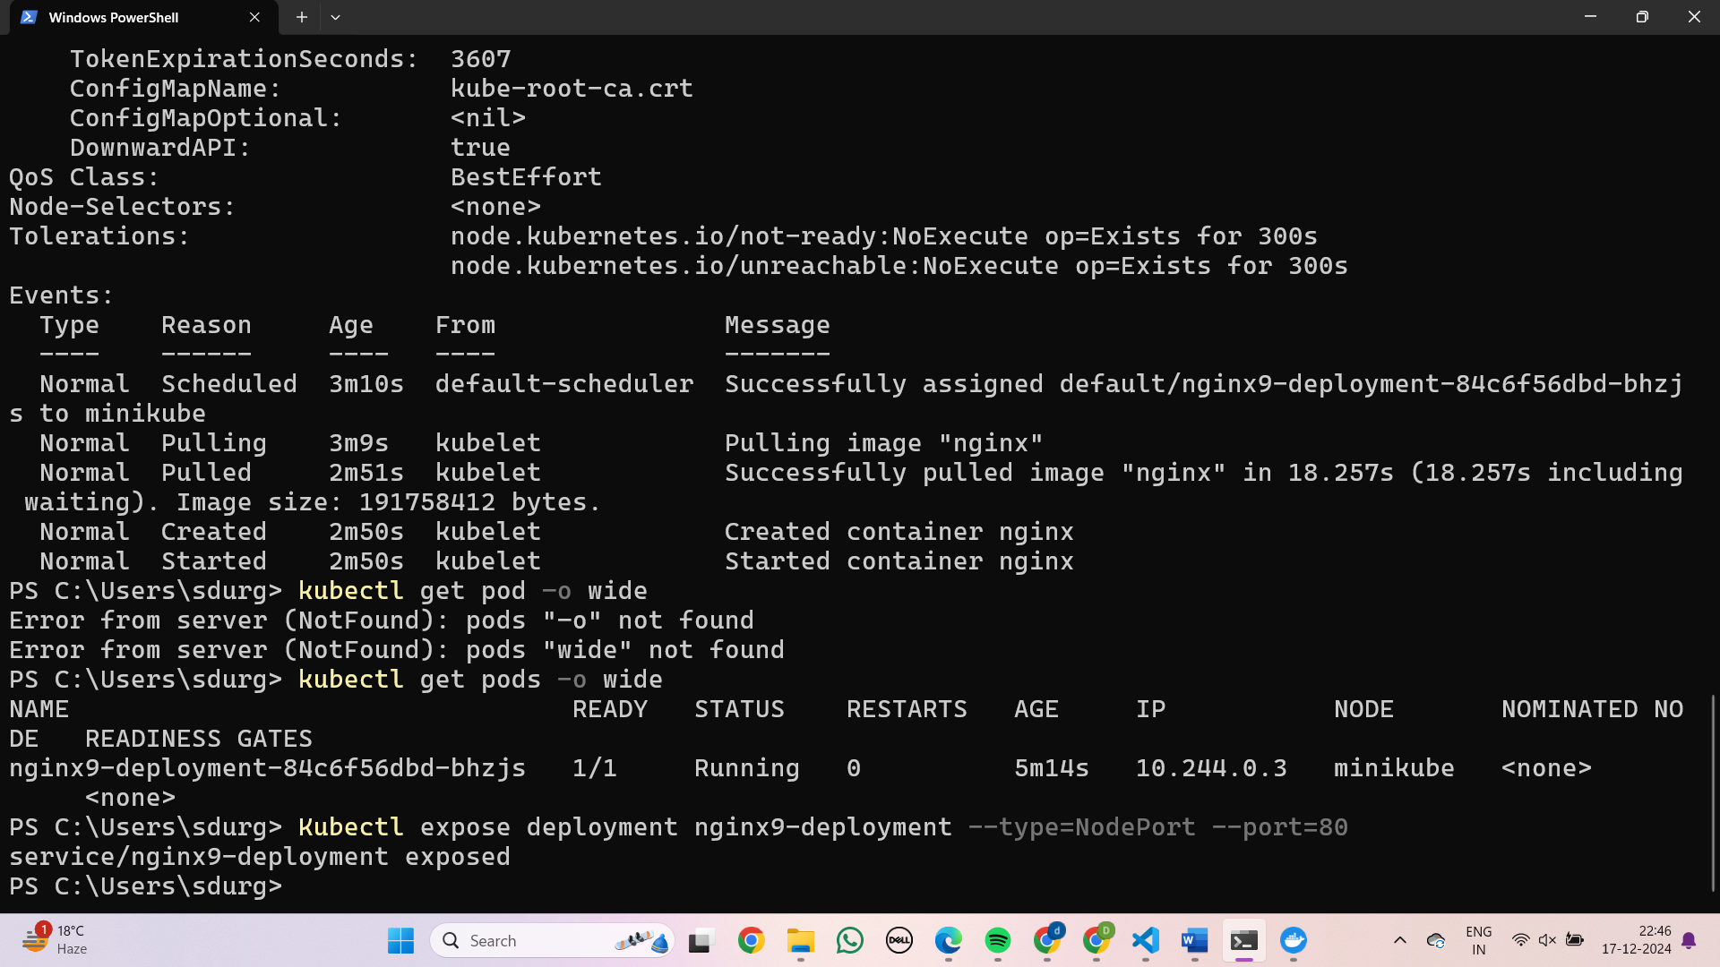

Step 7: To get URL to access the nginx home page

minikube service nginx-deployment –url

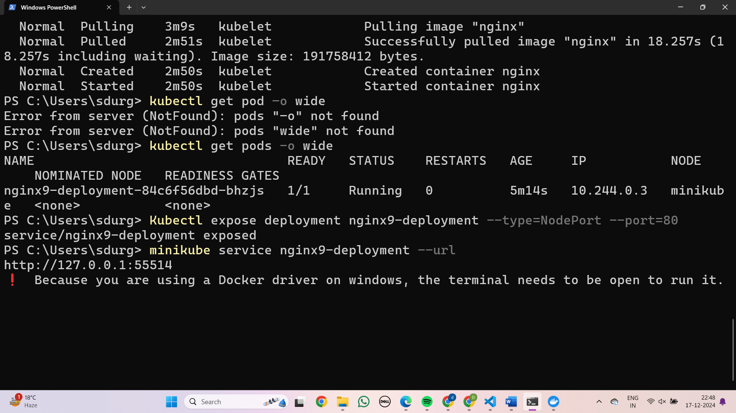

Step 8: Copy the above http path and paste it in browser to access it

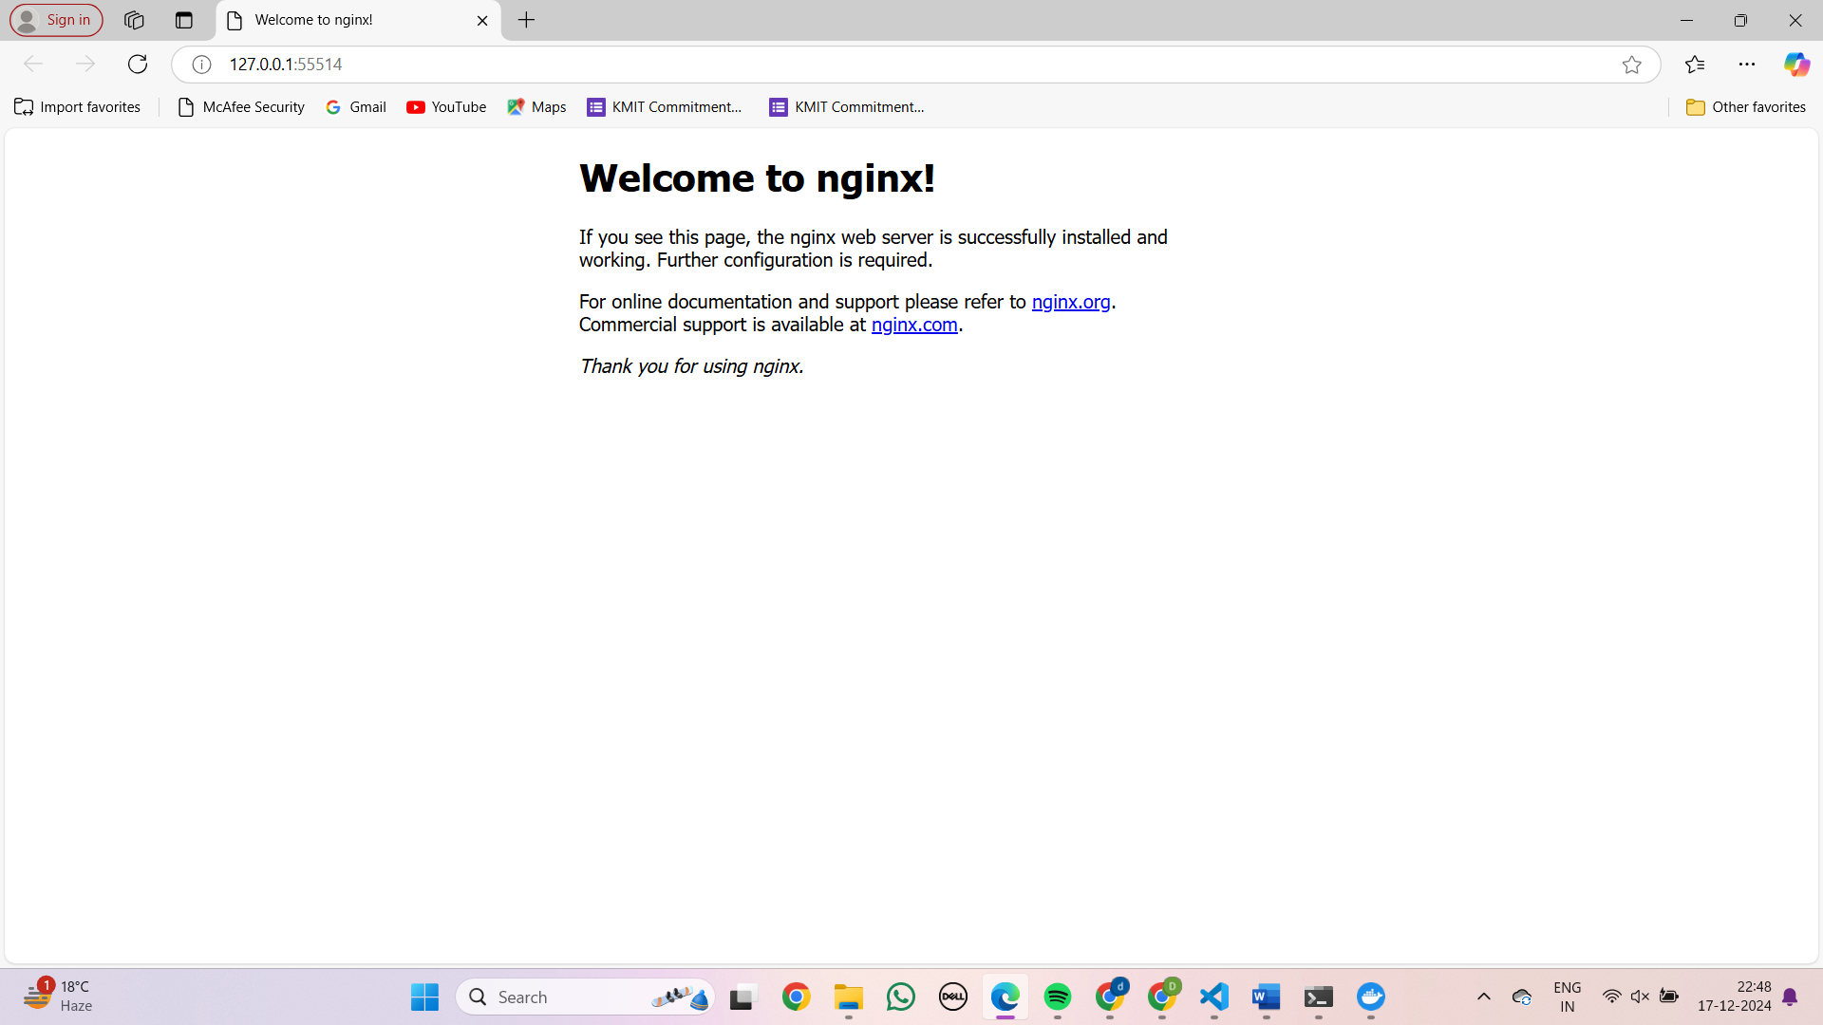

### 

### DEPLOYING AND MANAGING MONITORING SYSTEMS USING NAGIOS IN DOCKER

**Nagios installation**

Step 1: Open <https://hub.docker.com/> and search for jasonrivers/nagios

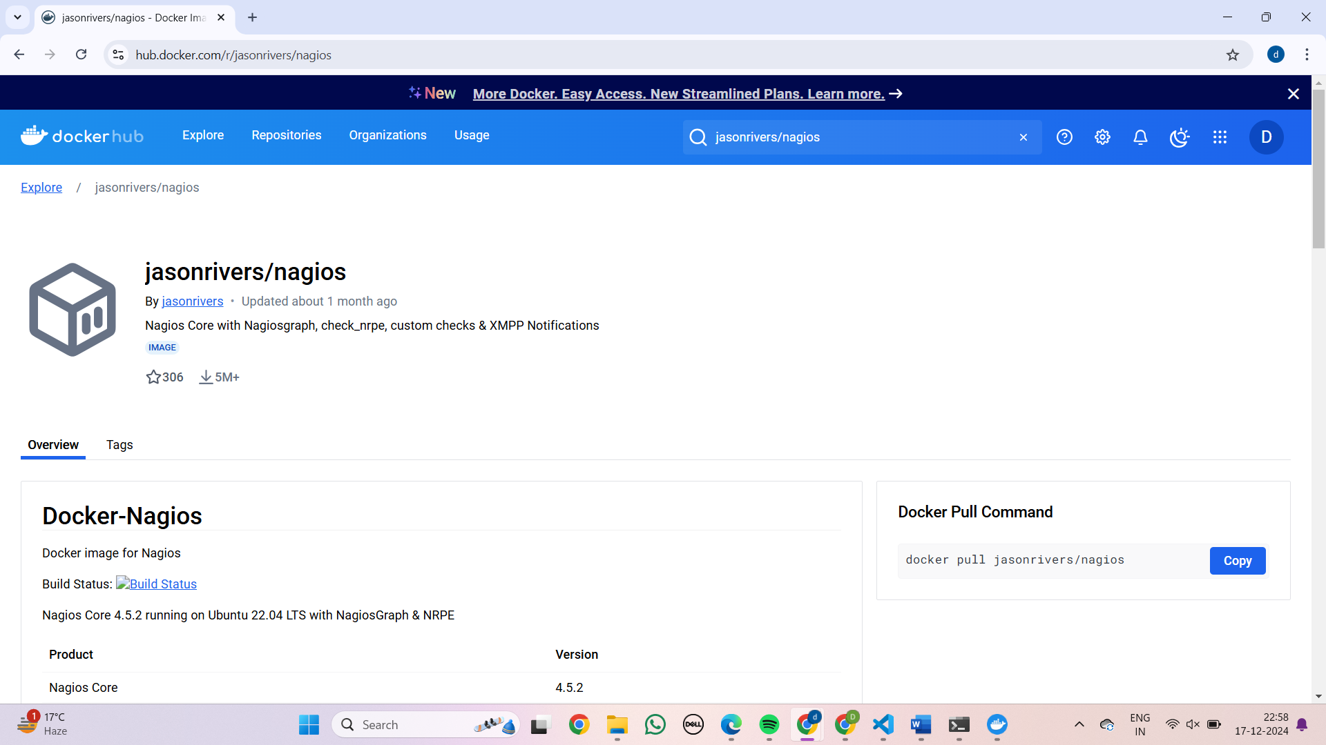

Step 2: Copy the pull command and run in the Power shell

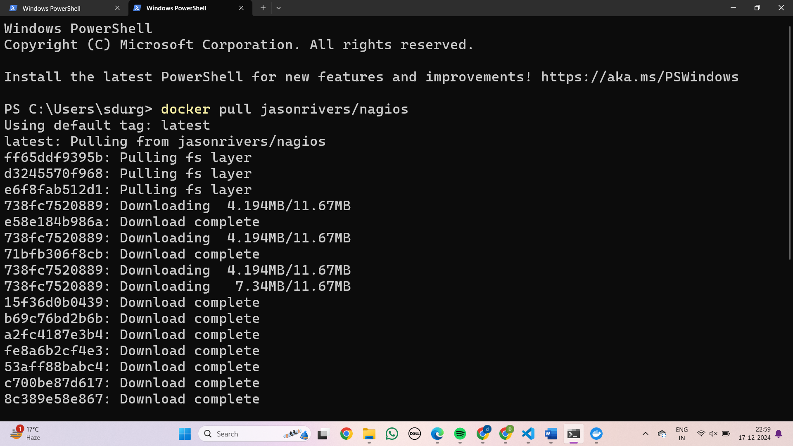

Step 3:It image will be pulled to the docker 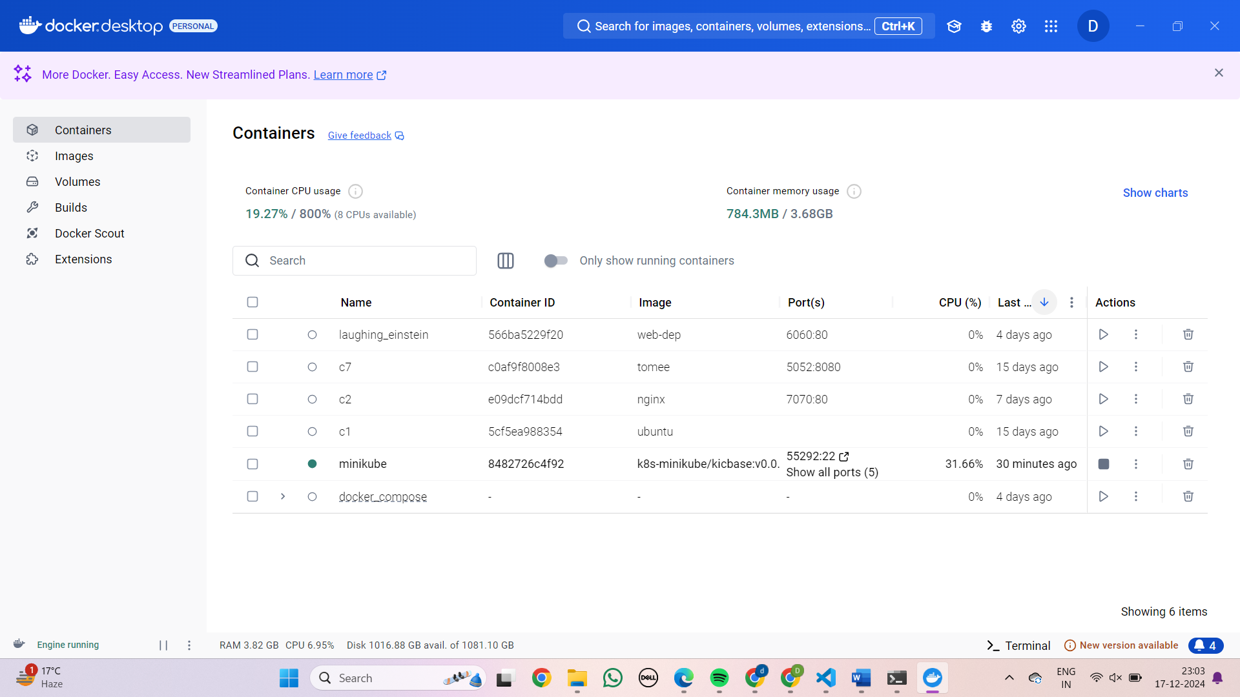

Step 4: Check whether the image is pulled by the command

Docker images

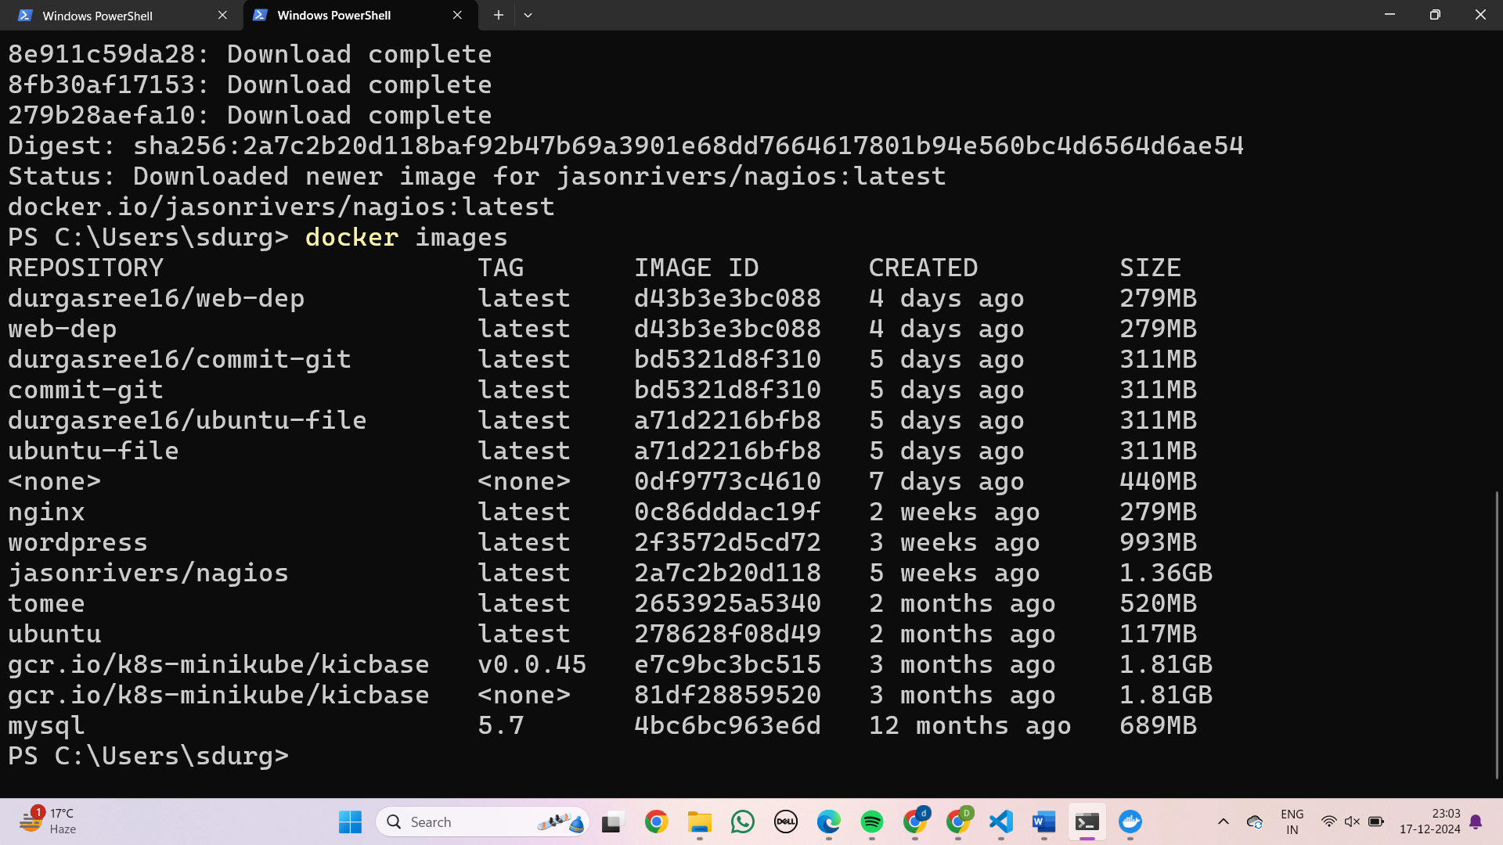

Step 5:In order to open nagios run the command

Docker run - -name nagio -d -p 6060:80 jasonrivers/nagios

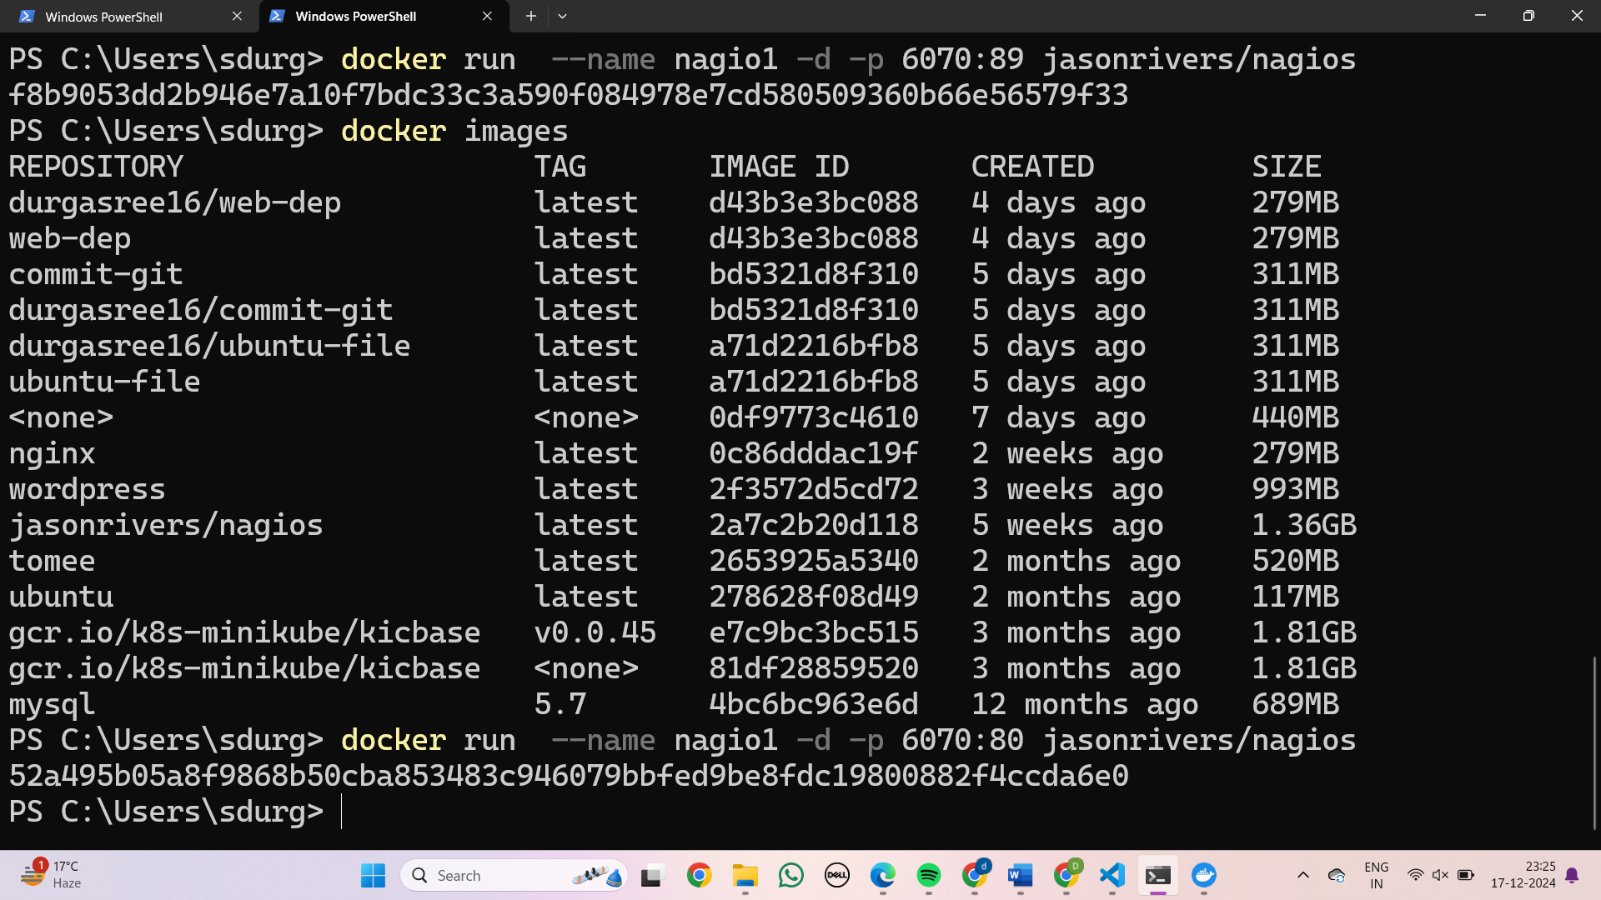

Step 6:Open the localhost with the given port number in the browser

And login with credentials

Username-nagiosadmin

Password-nagios

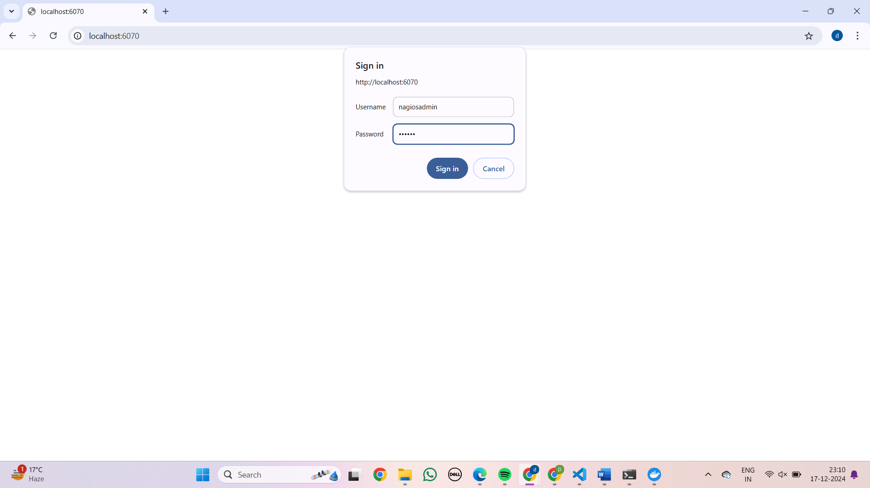

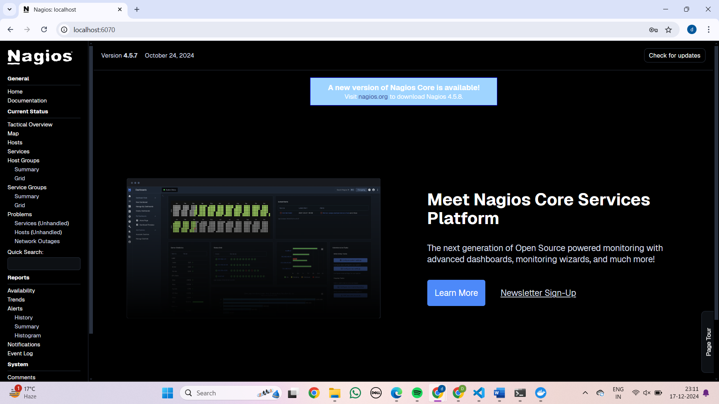

Step 7:Click on the host

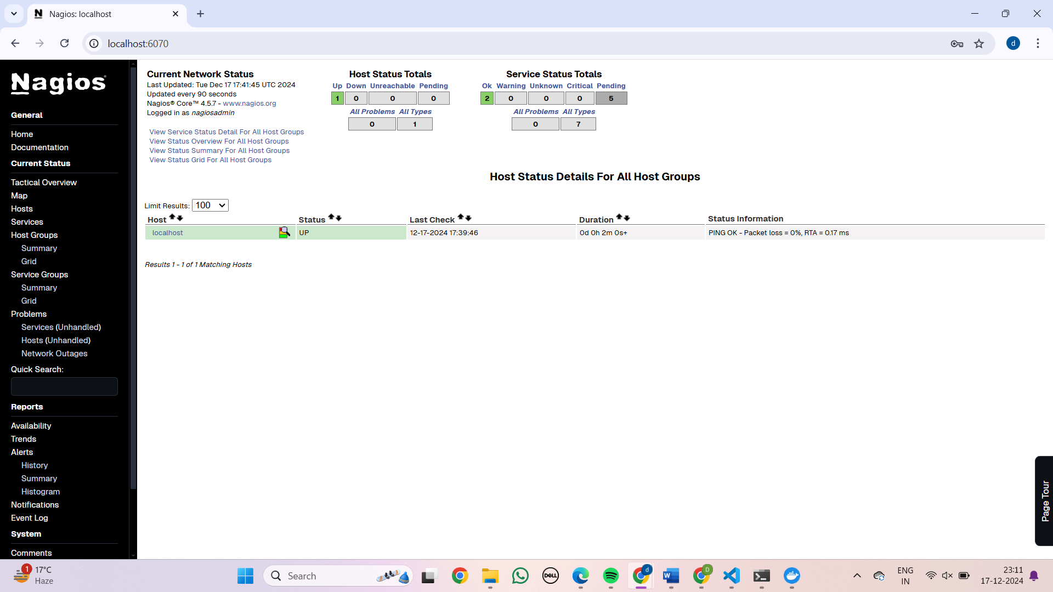

Step 8: select hosts->“view history from this host” to view the history of our computer

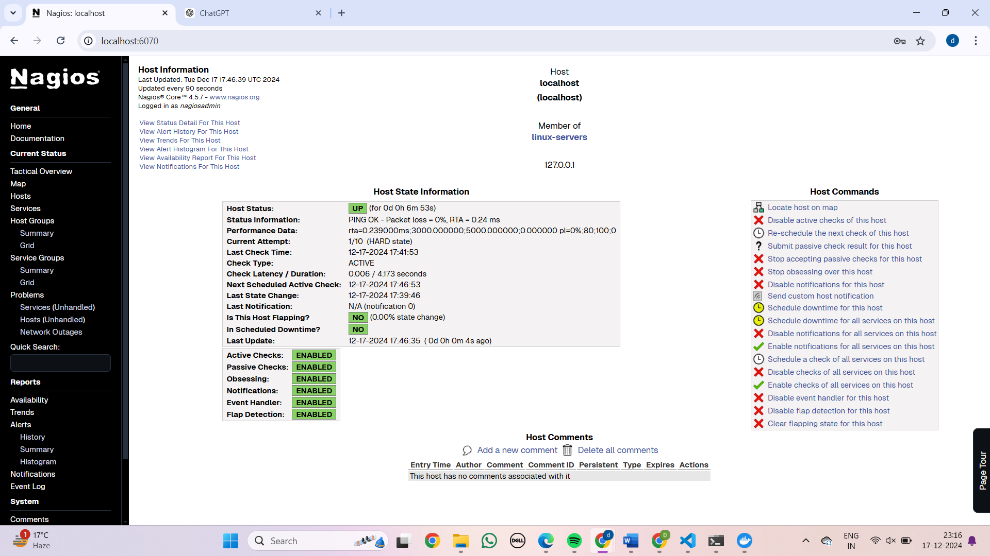

Step 9: select “view status details for this host” in order see the status

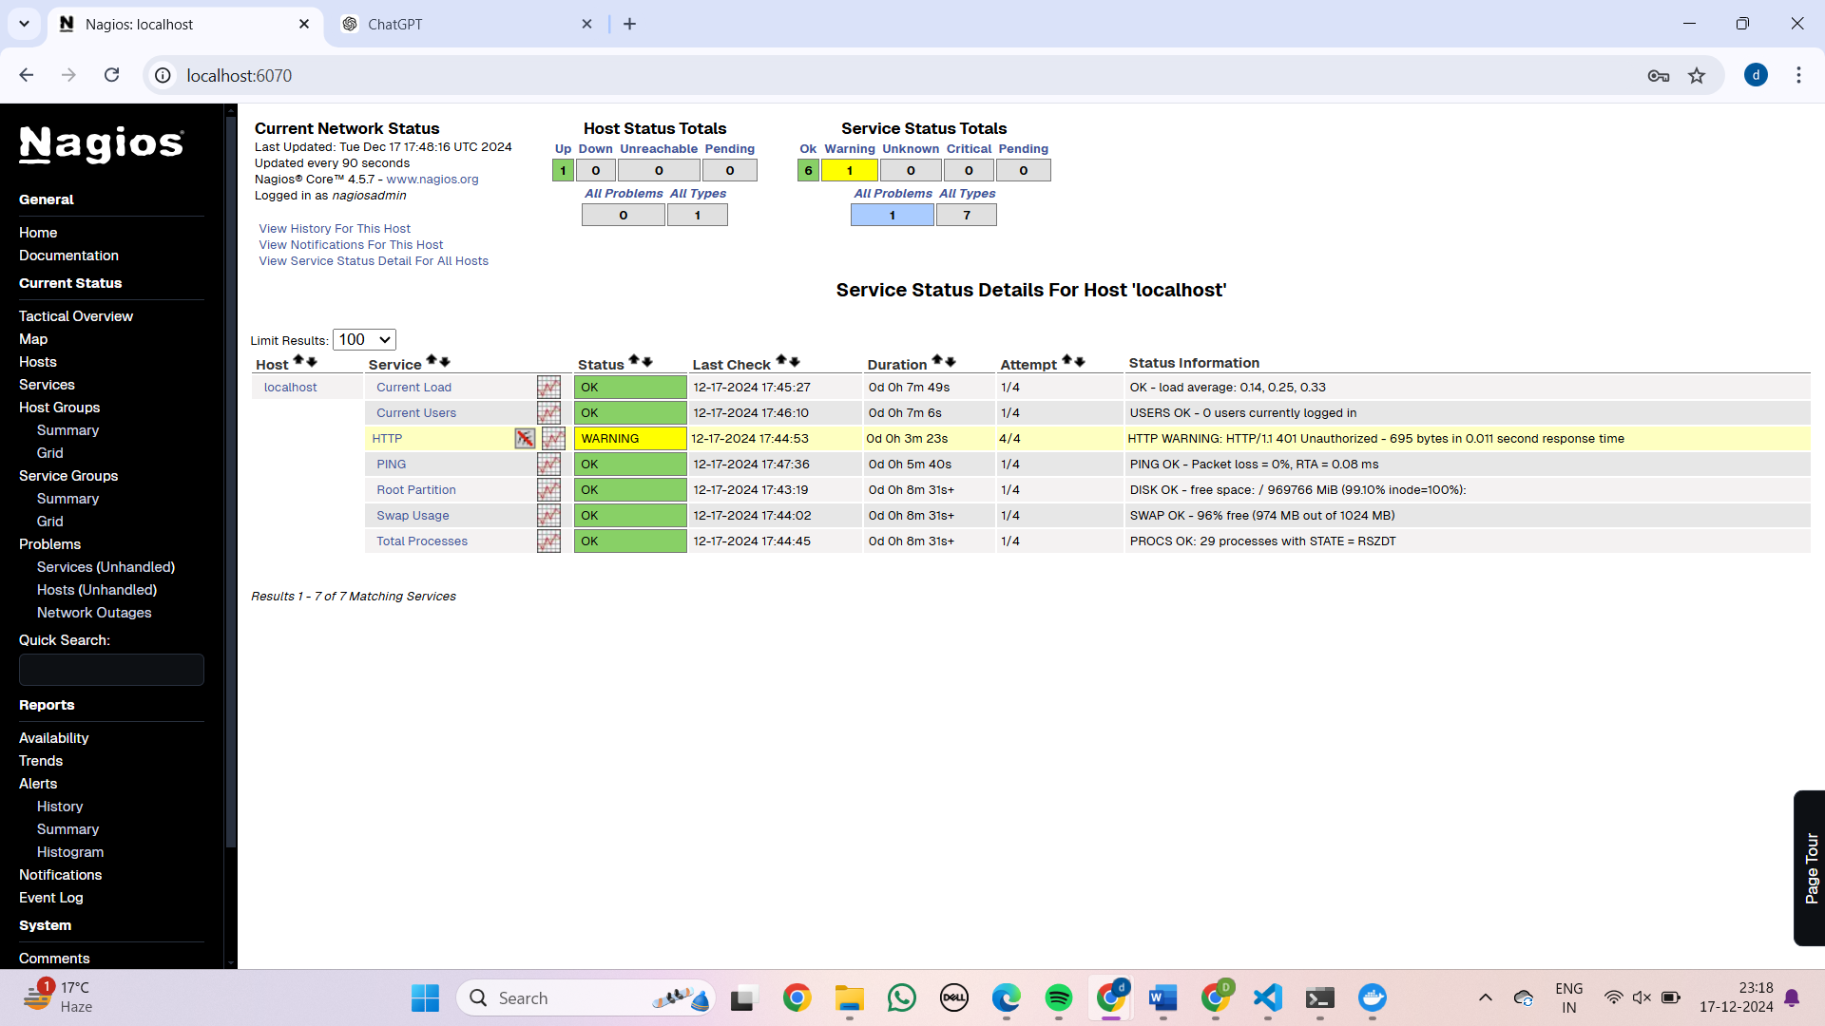

Step 10: We get the status details of the system.

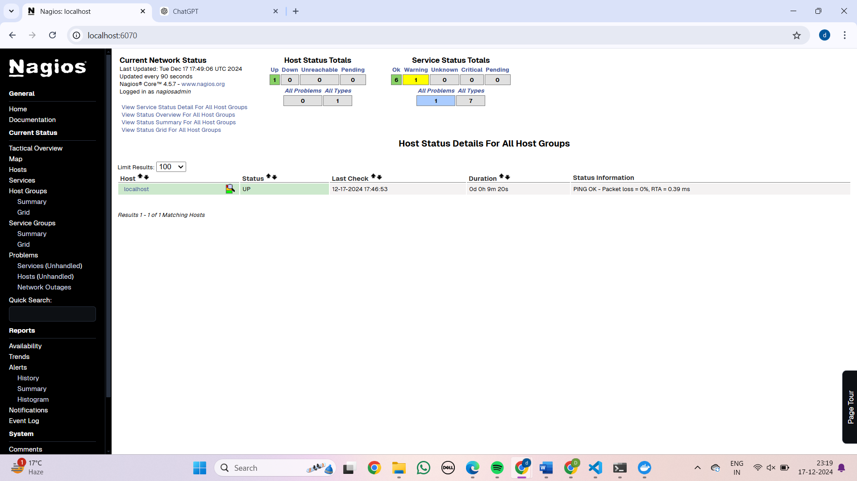

Experiment 8:  
  
**A. AWS ACADEMY LEARNING ACCOUNT CREATION**  
  
**AWS LOGIN**

Direct into your email for the invitation

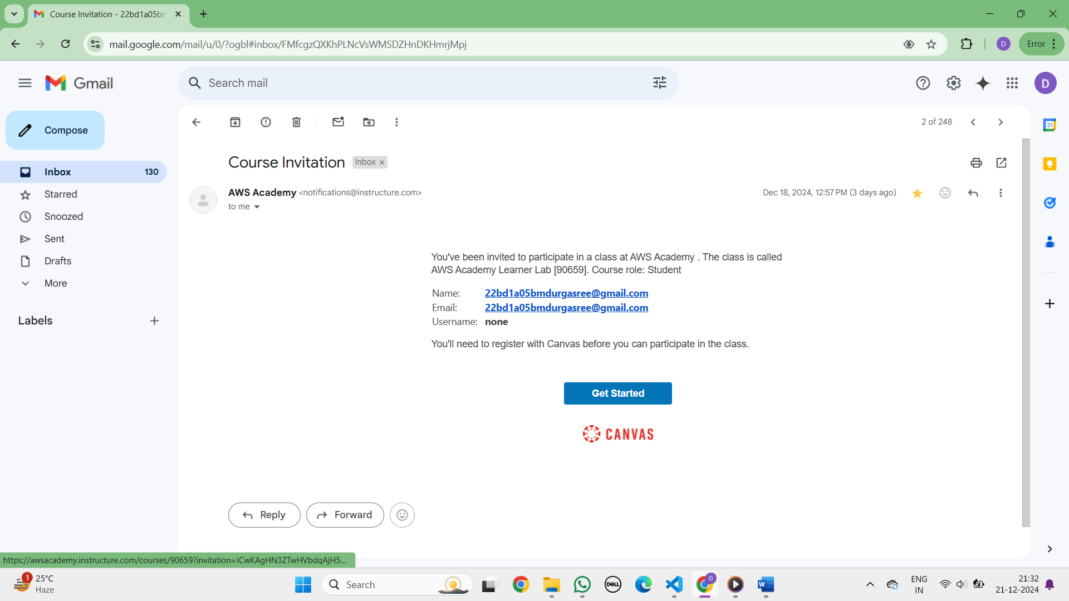

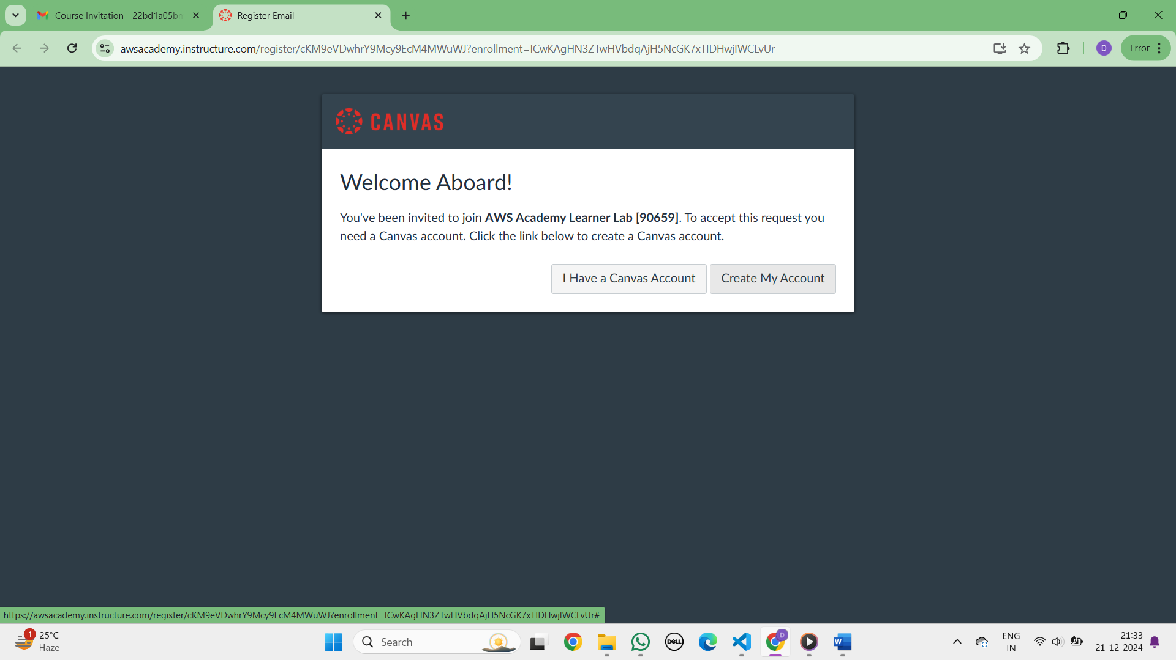

Set up your password for the email you are registered

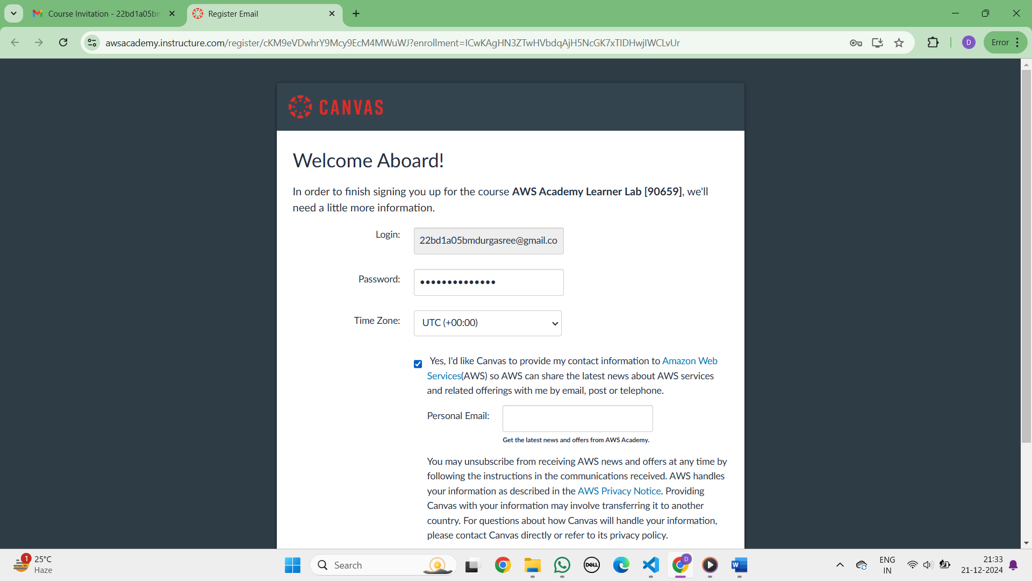

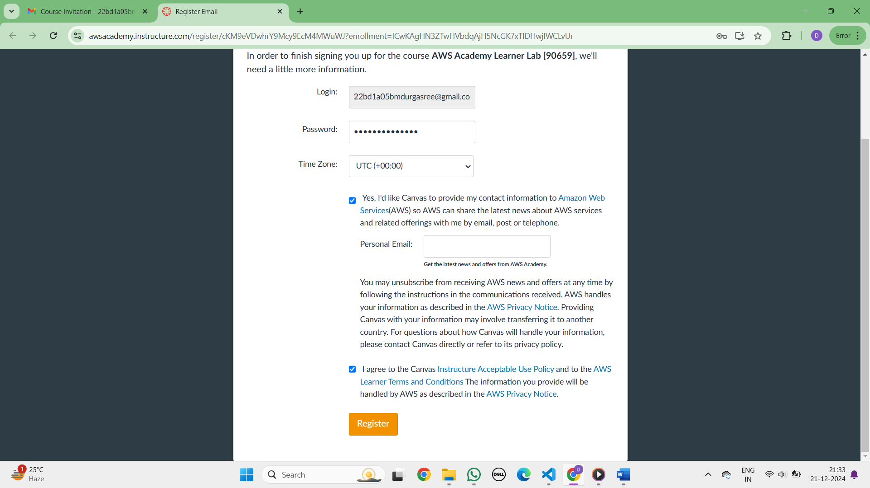

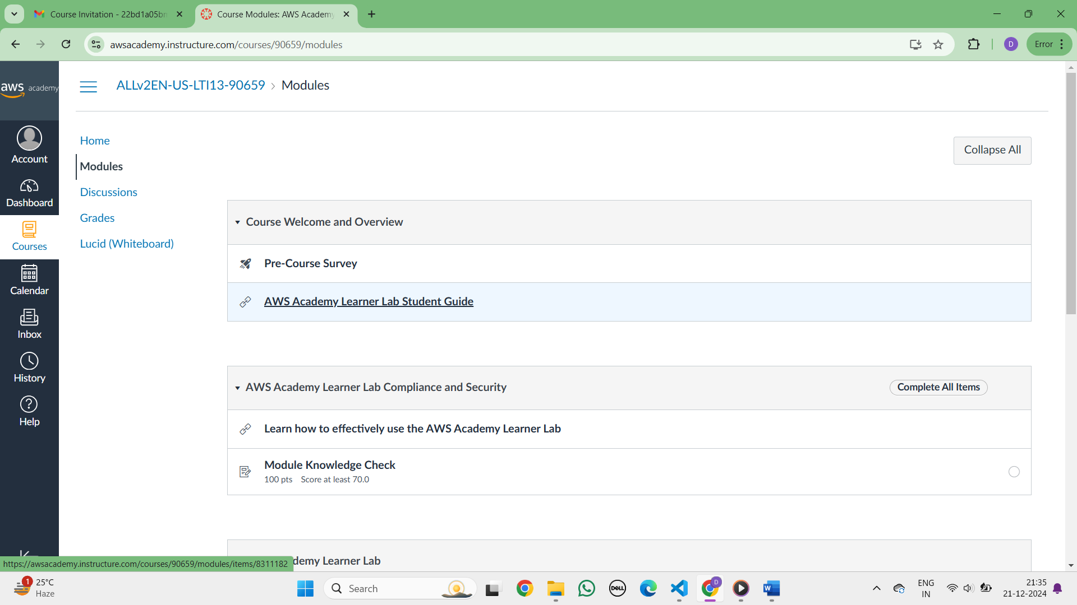The below page is displayed

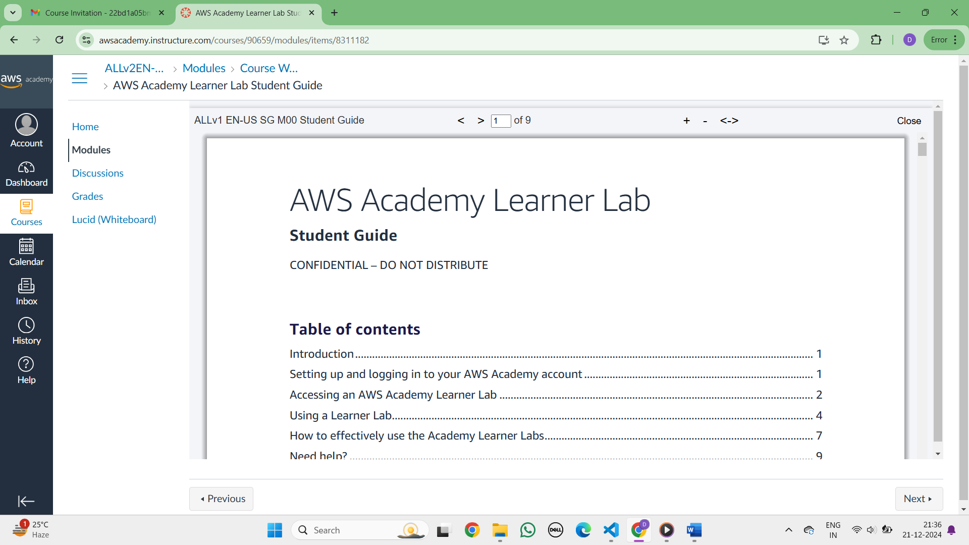

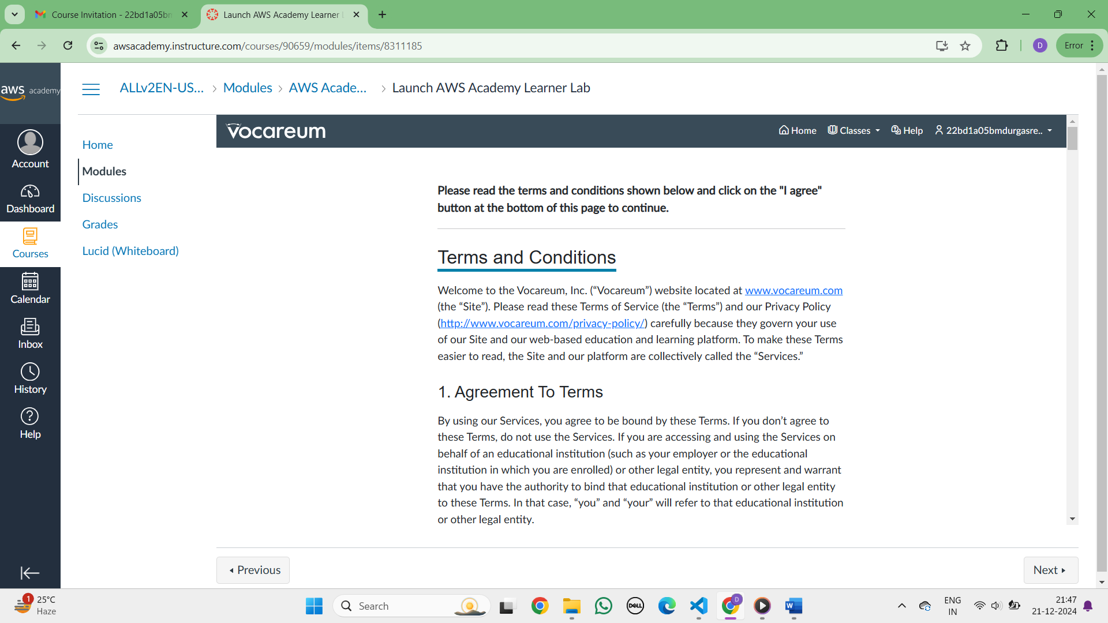click on I agree and continue

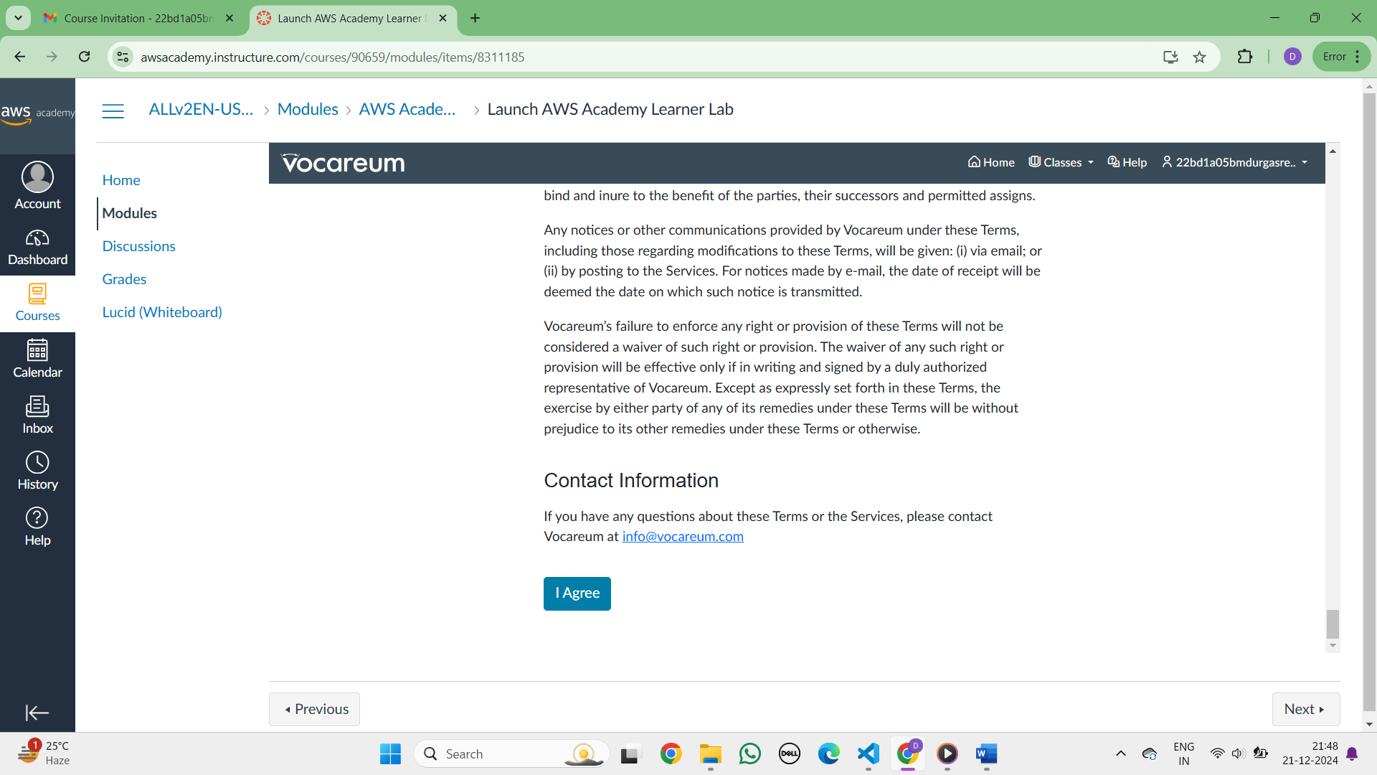

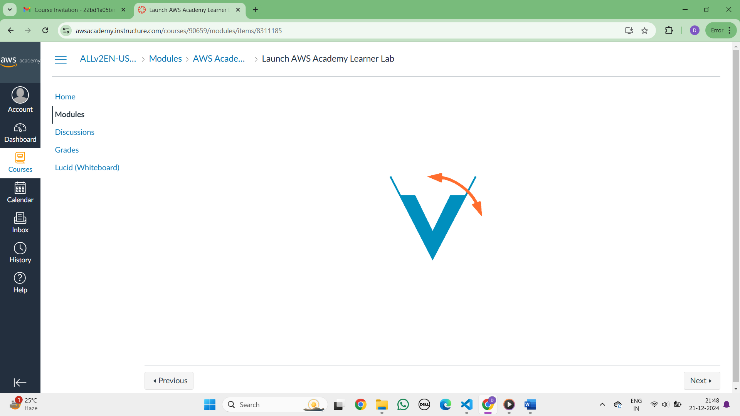The AWS lab is started!

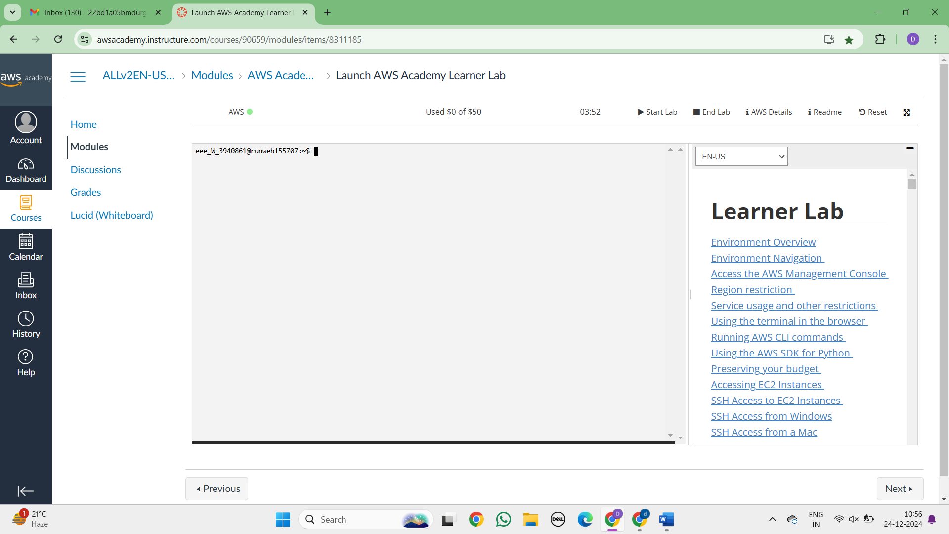

### 

**B. PROJECT DEPLOYMENT IN THE AWS CLOUD USING EC2 INSTANCE  
  
DEPLOYMENT OF INDEX.HTML USING EC2 INSTANCE in AWS**Click on start lab

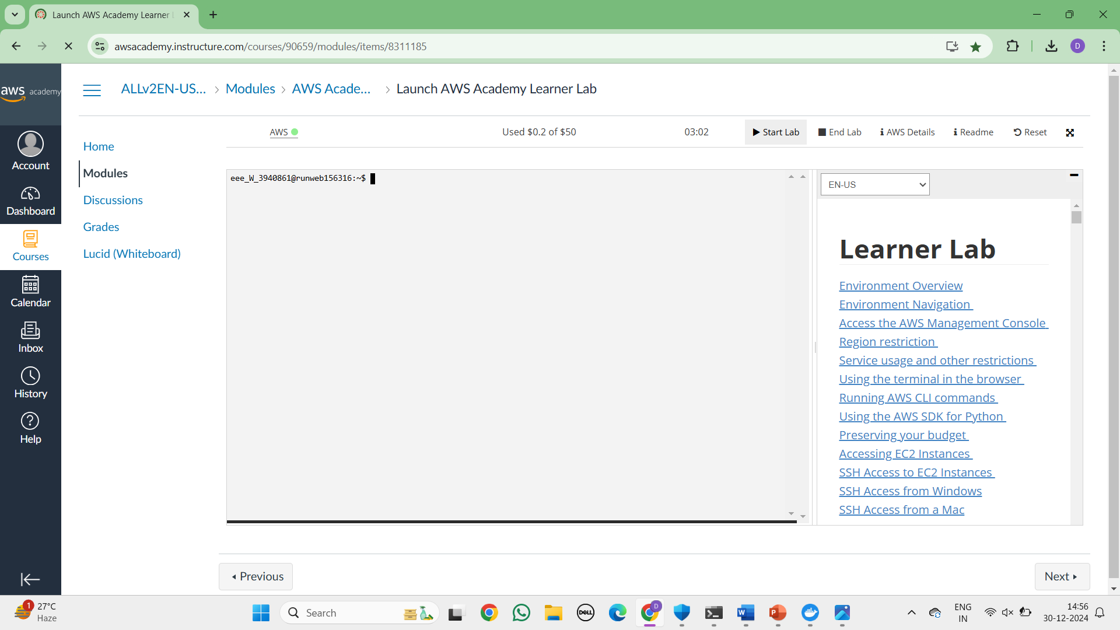

Click on EC2

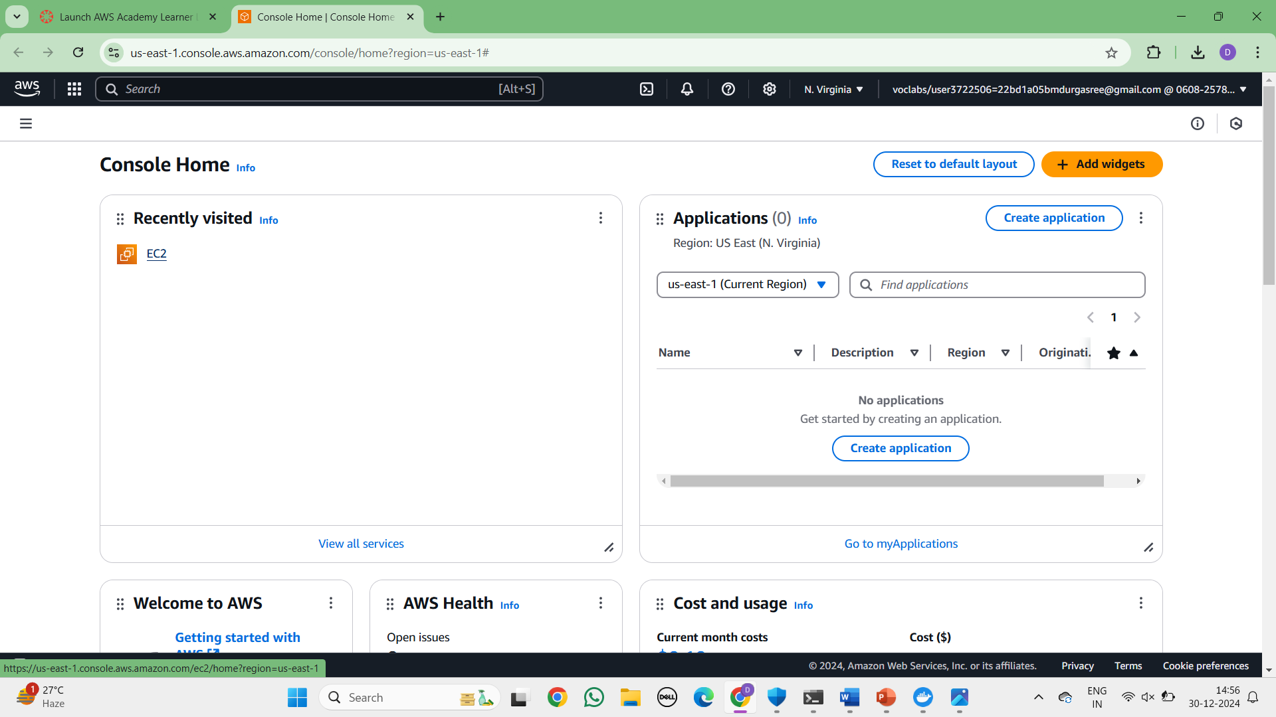  
Click on Launch Instance

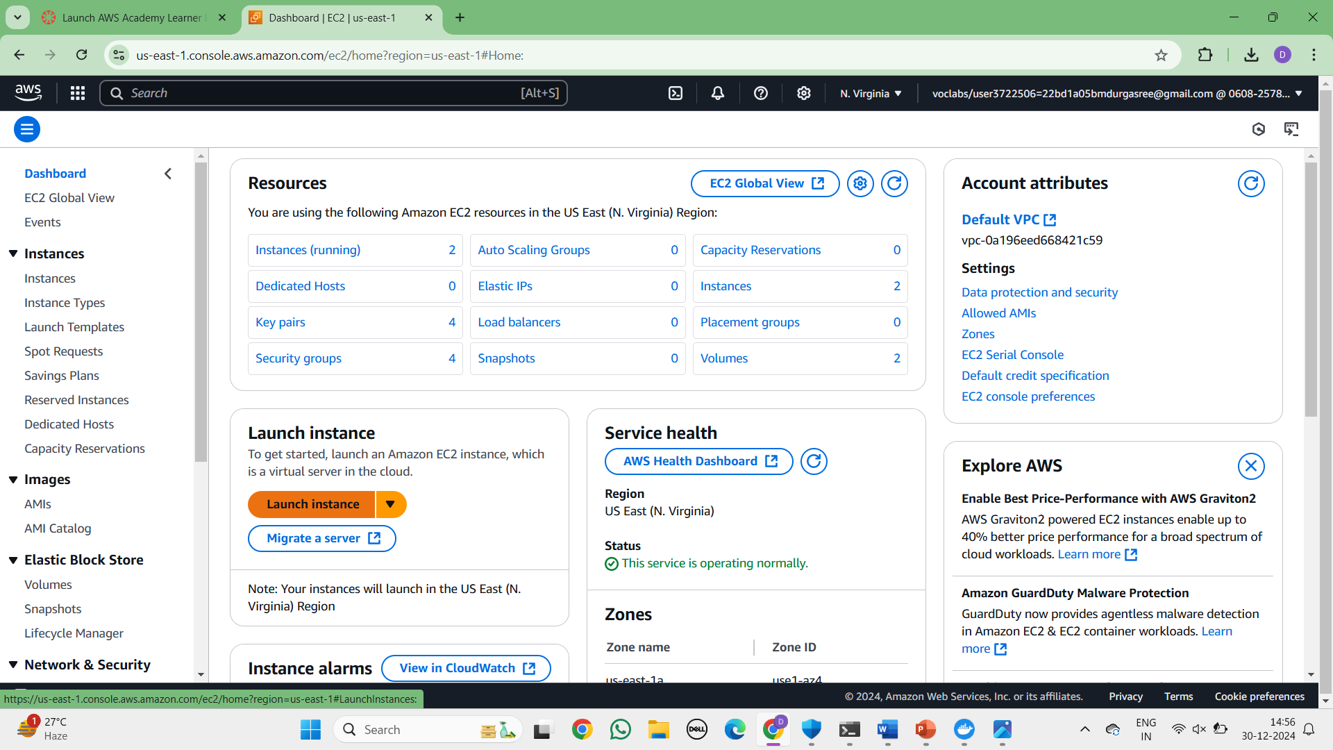  
  
  
  
  
  
  
  
  
  
  
  
  
Give name and select ubuntu under application

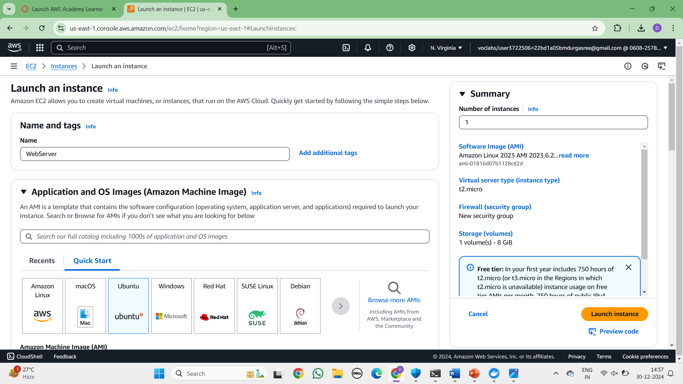  
Make sure AMI and Architecture are there as shown

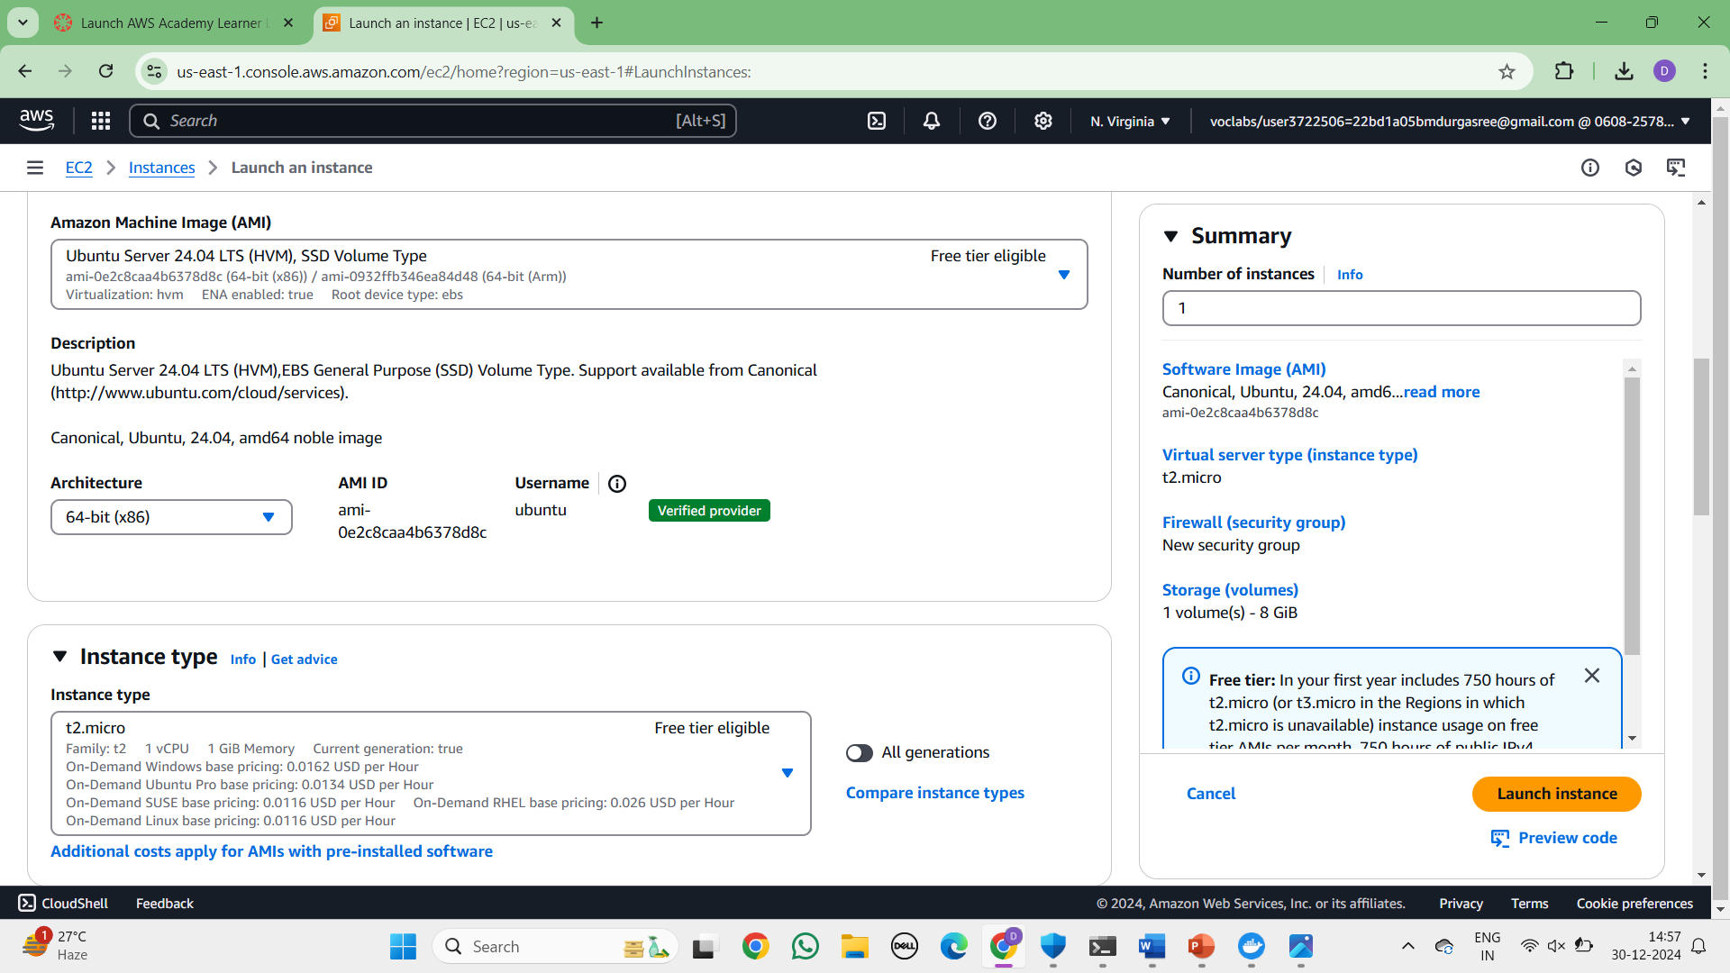

Click on create-new key pair

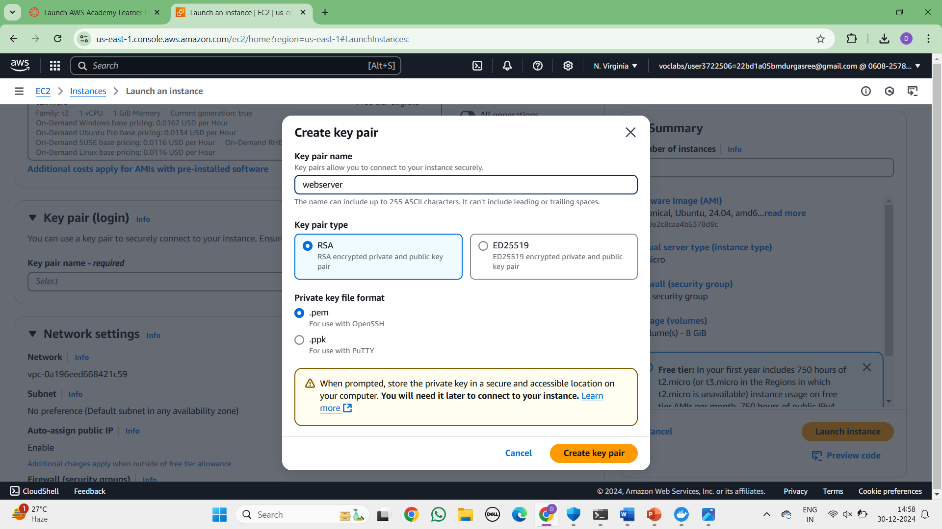  
In network setting check all the checkboxes and click on launch instance which is at the bottom right to the page

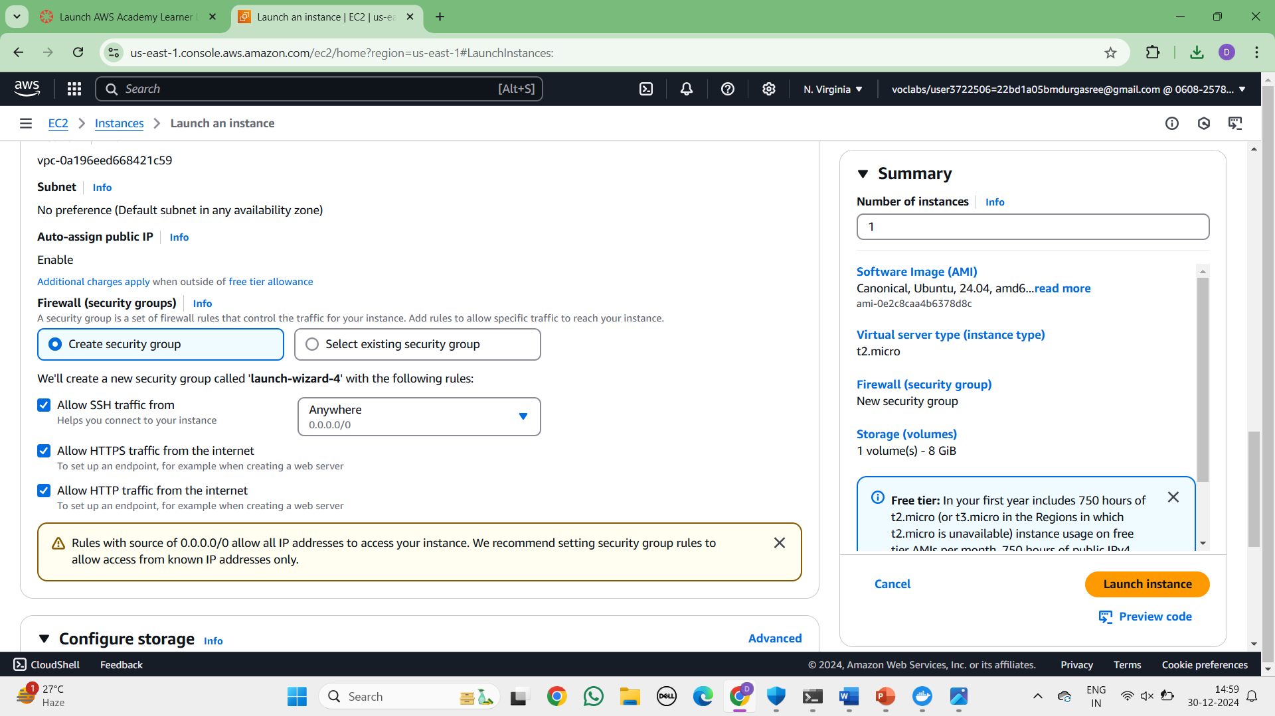

Wait for the Success message.

Now click on the instances

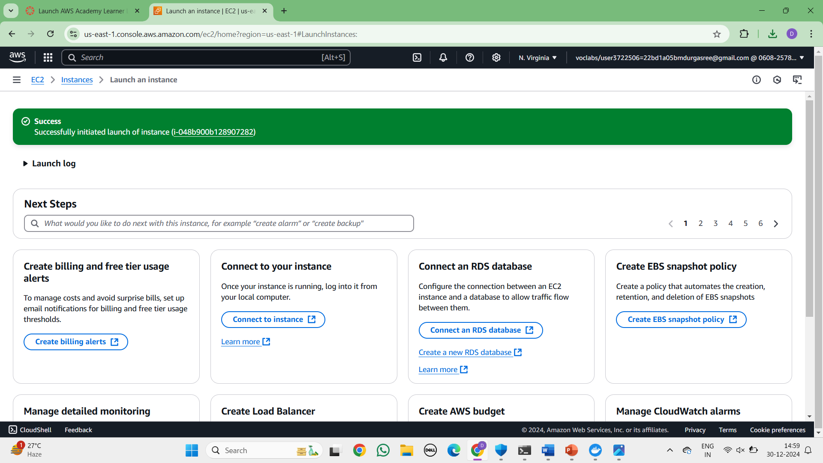  
  
You can see MyExampleWebServer is Running and wait for it to initialize

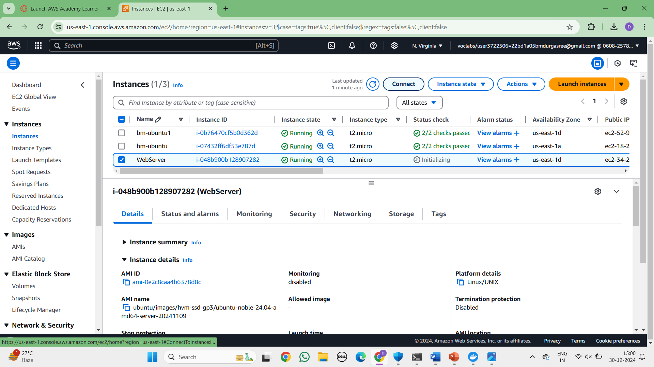  
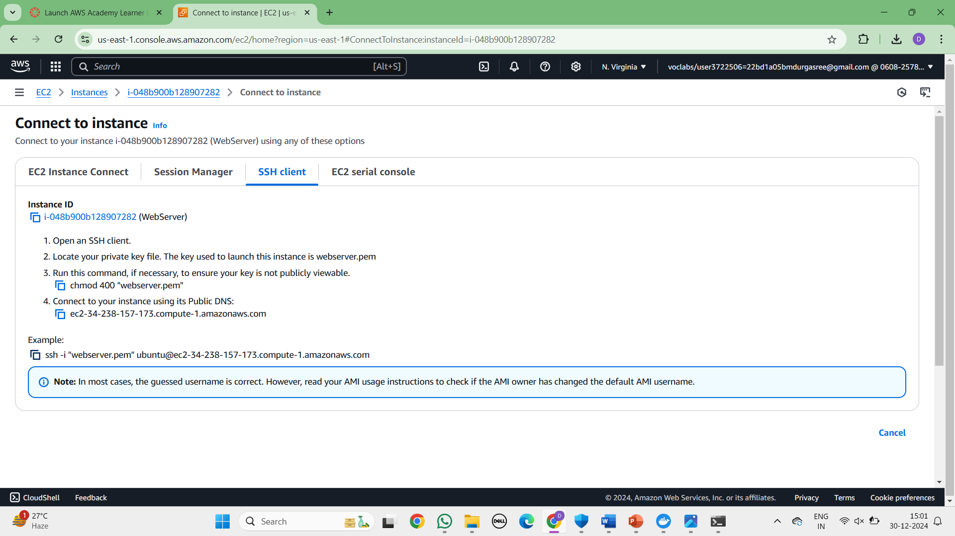  
  
Open CMD and navigate to that path

Go to SSh and copy the command which is present at the below

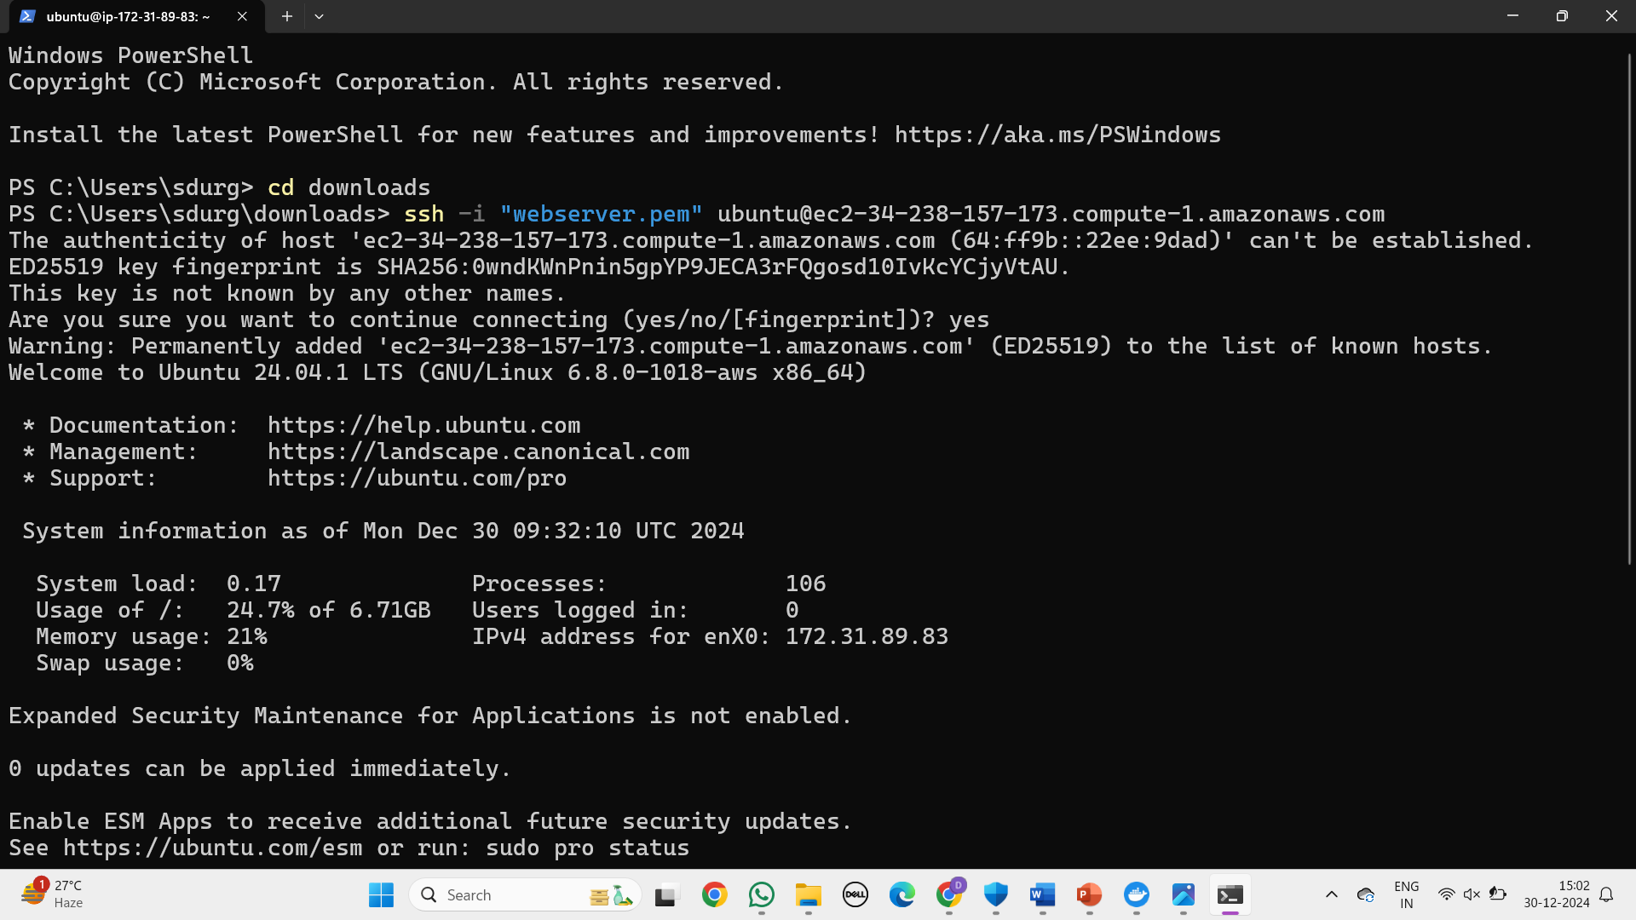  
  
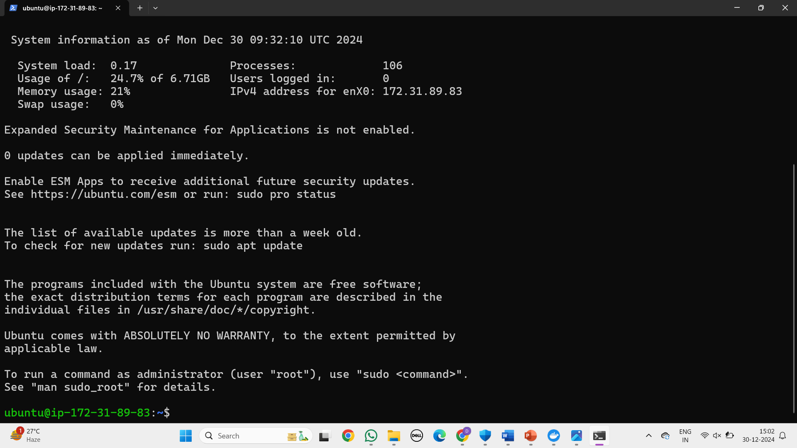  
  
Run the following commands

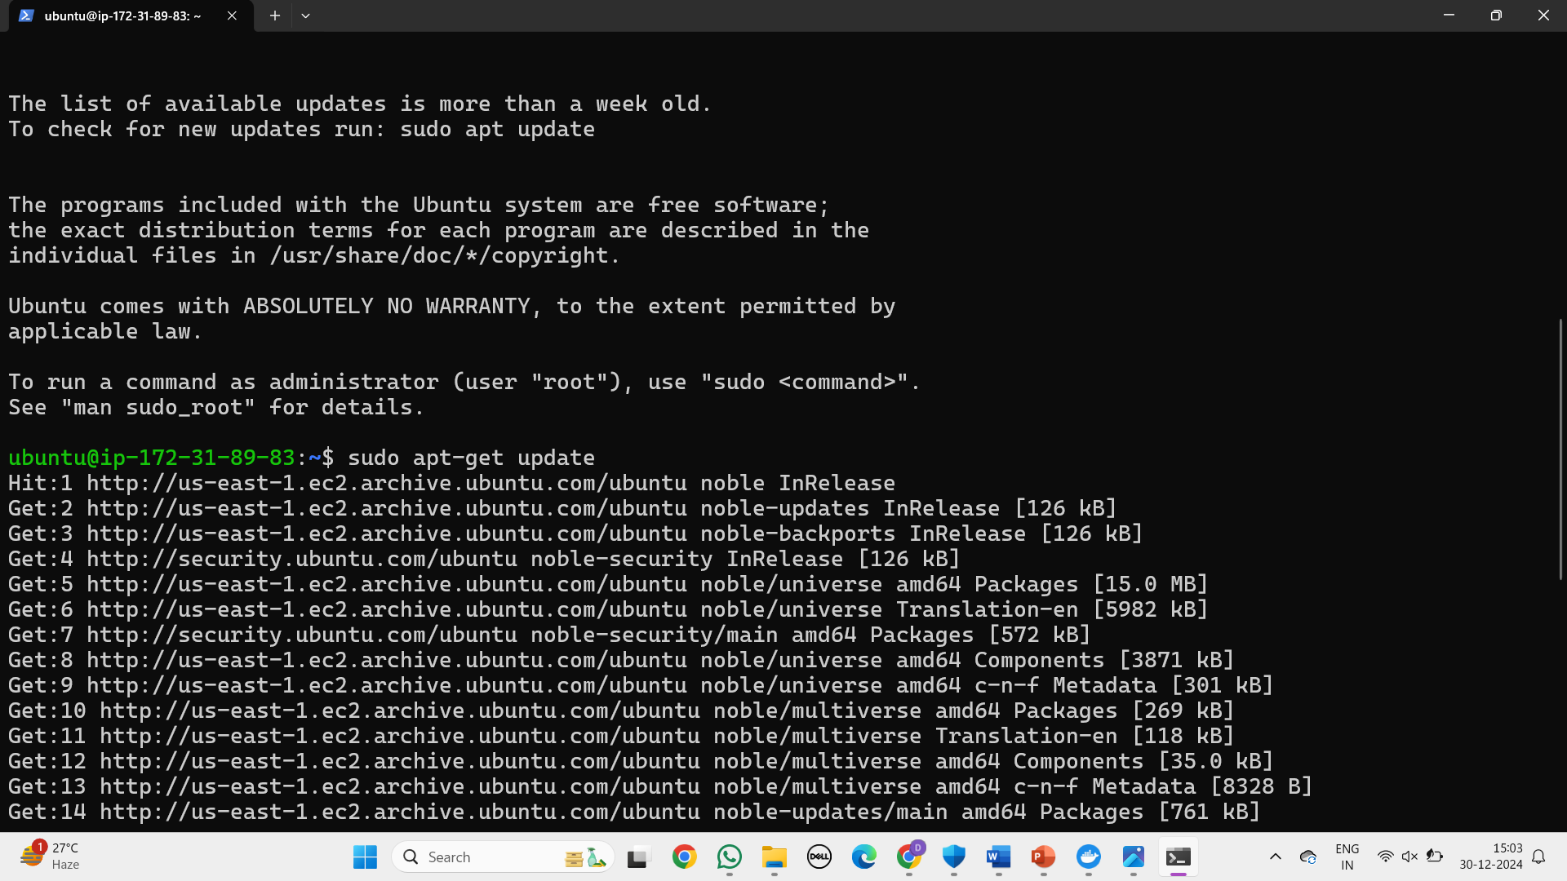  
  
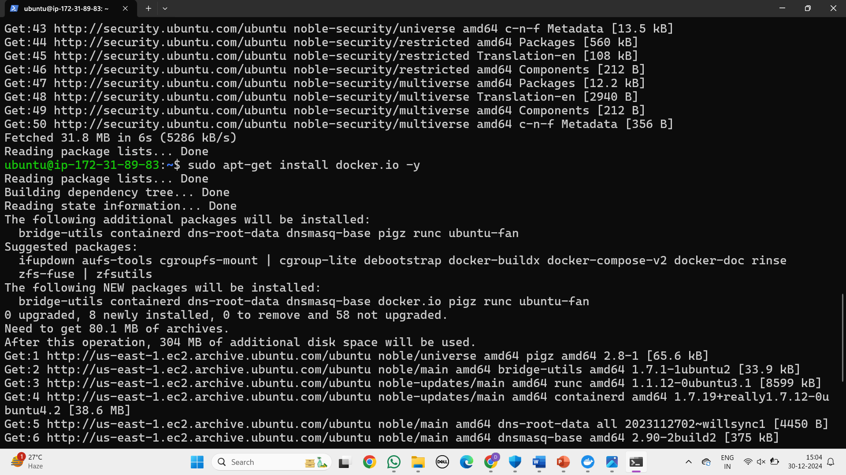  
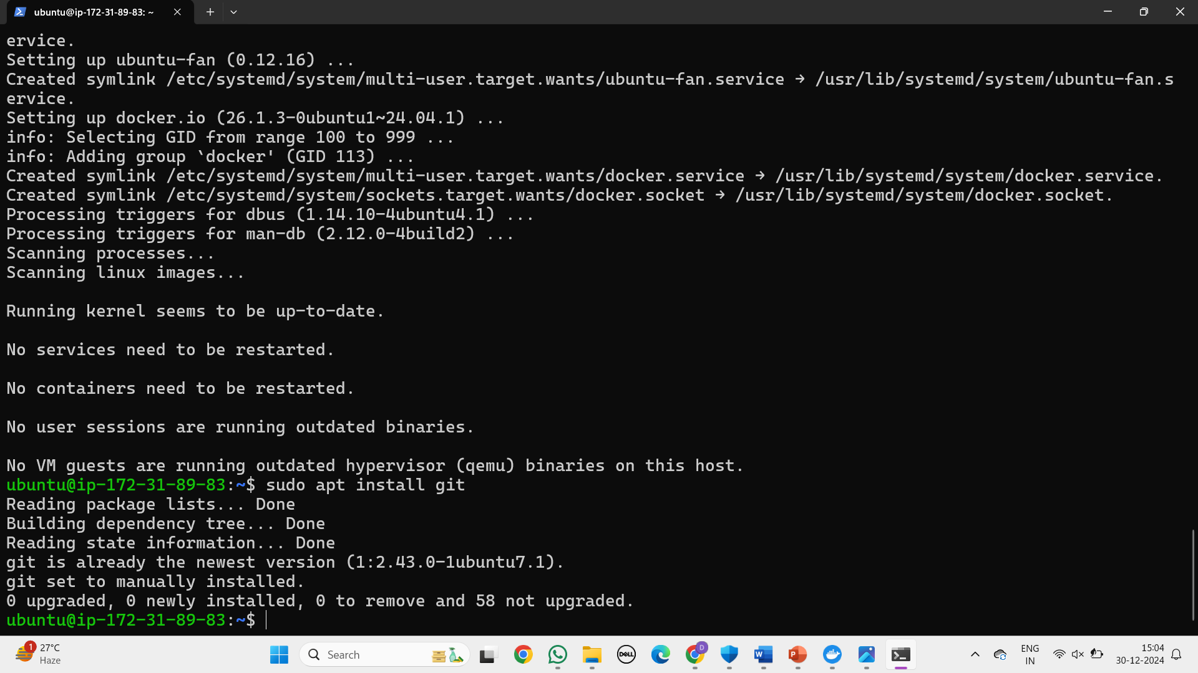

Create basic index.html file

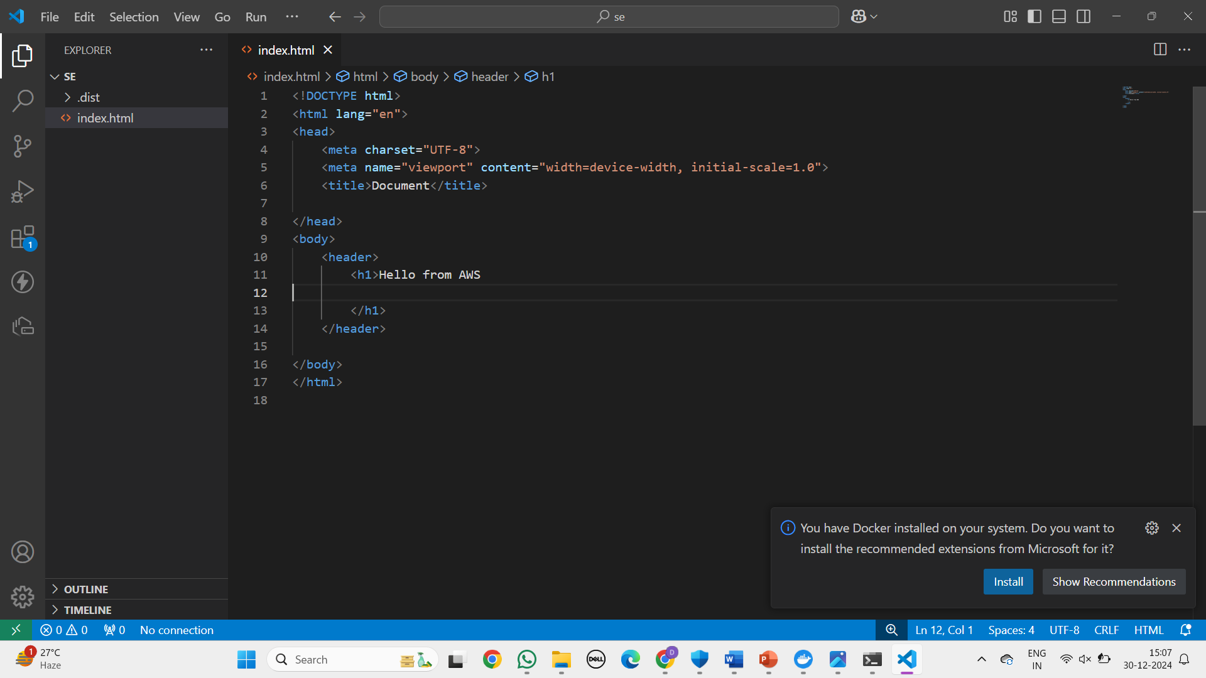

Open git Bash

Run the following commands

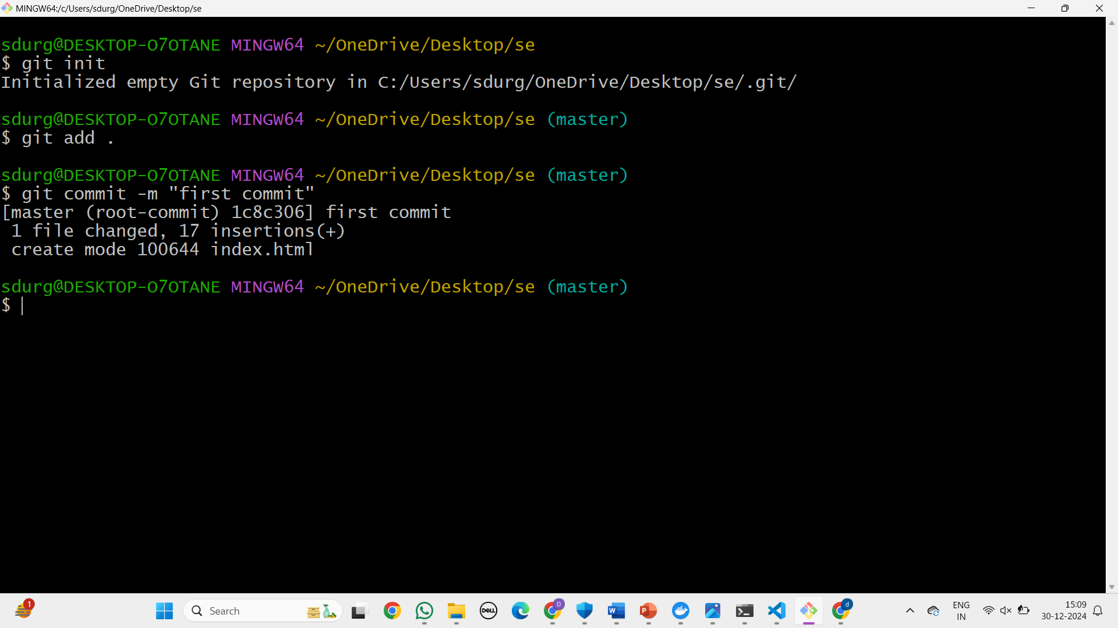

Create git repo

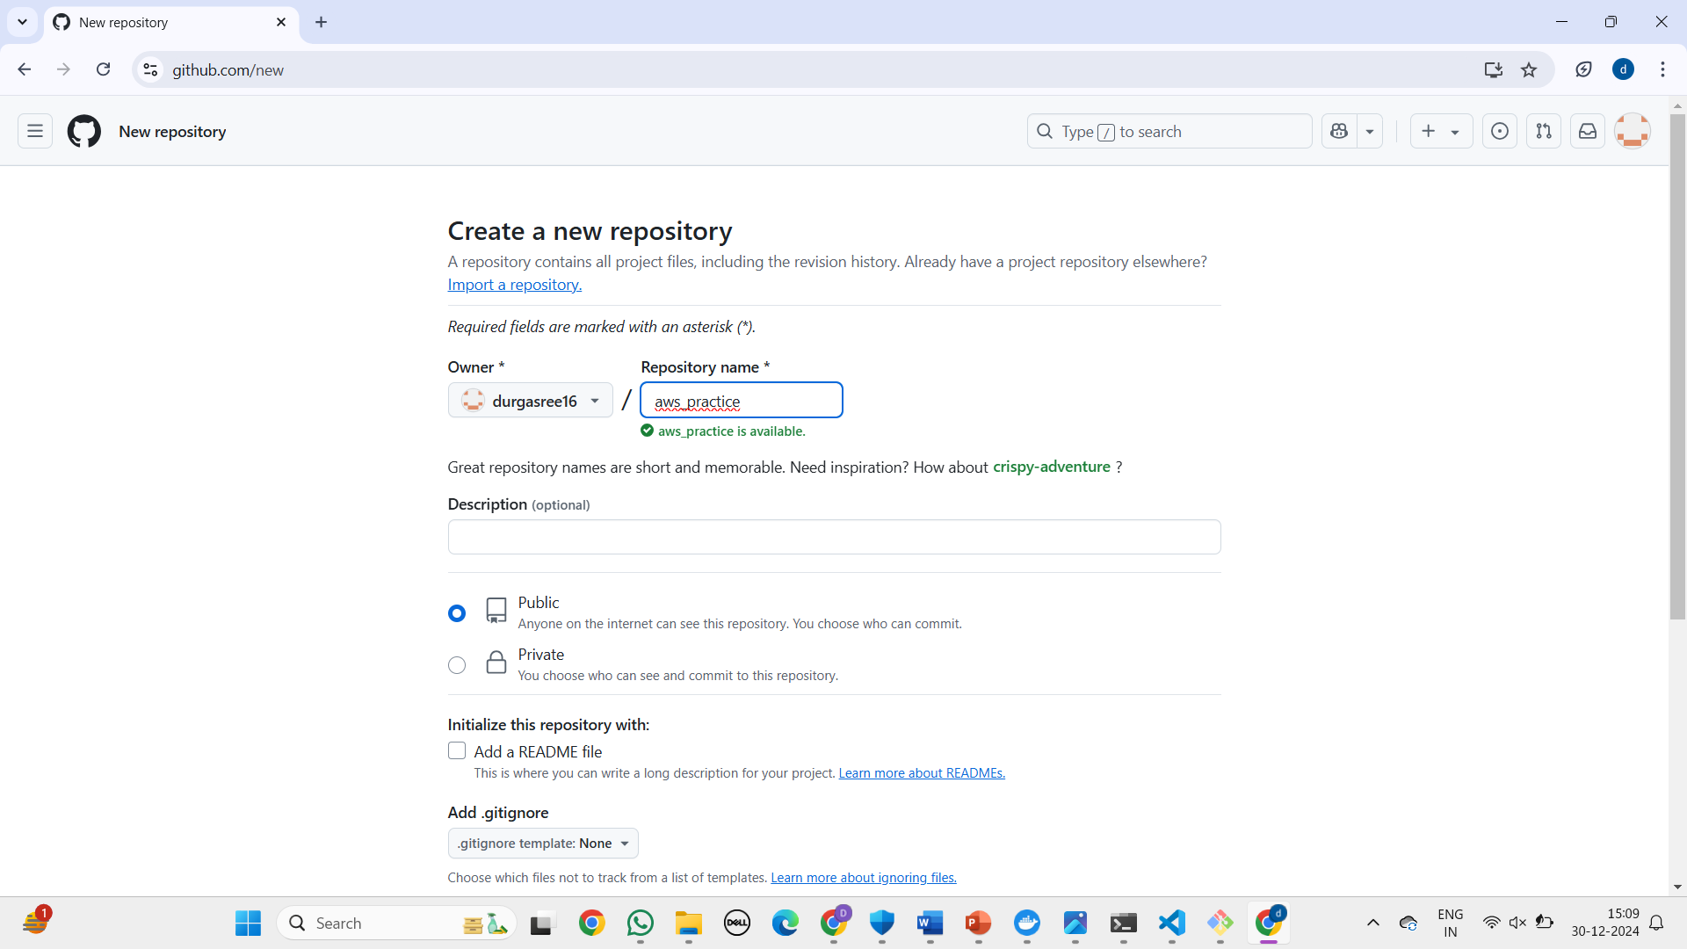  
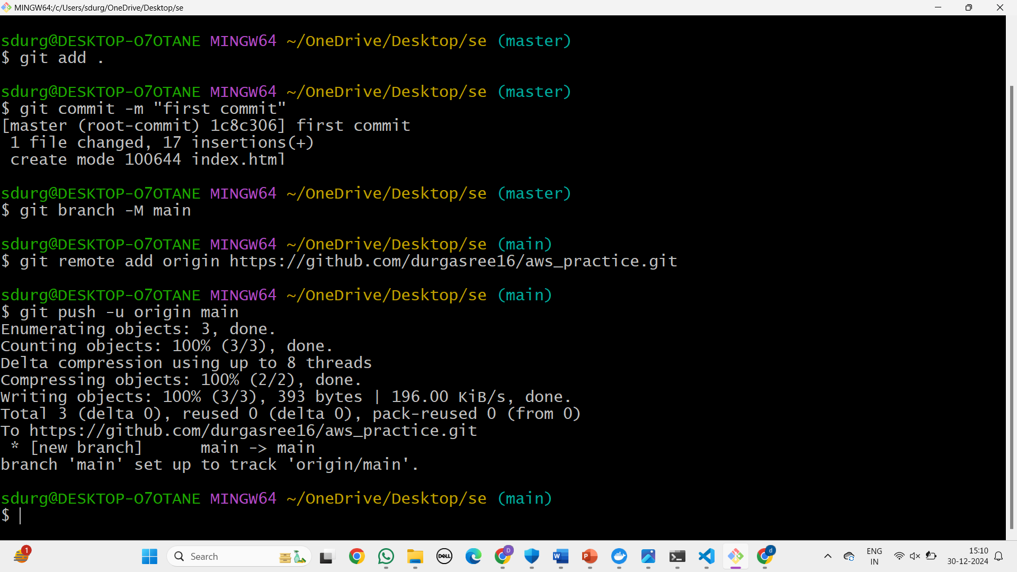  
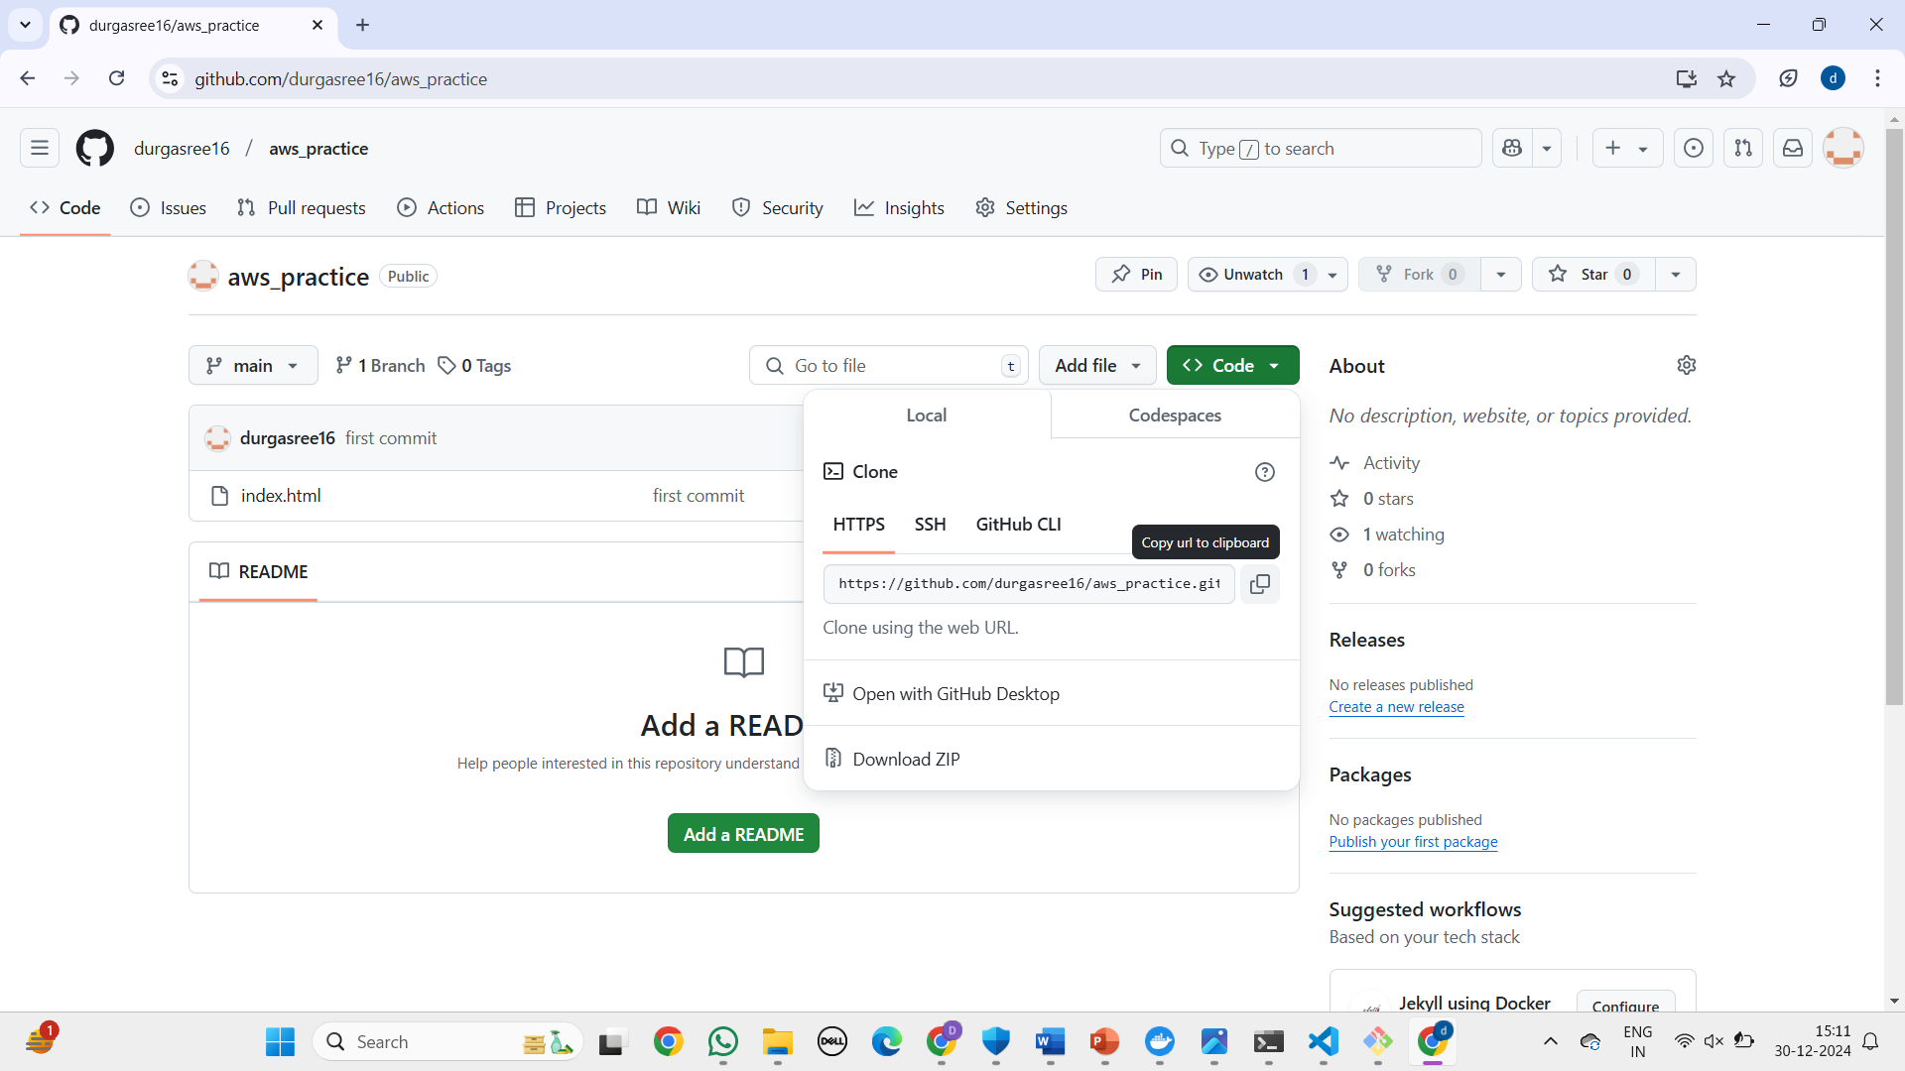  
  
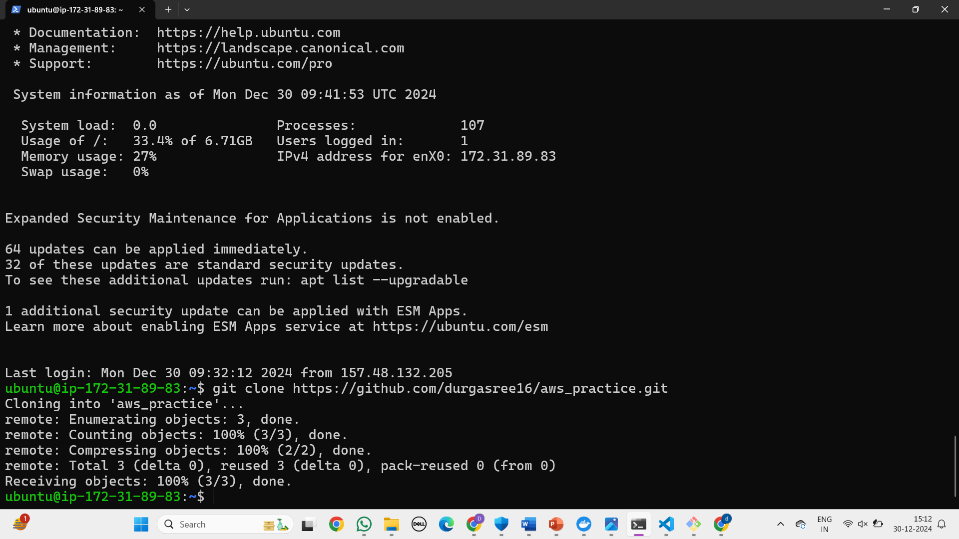  
  
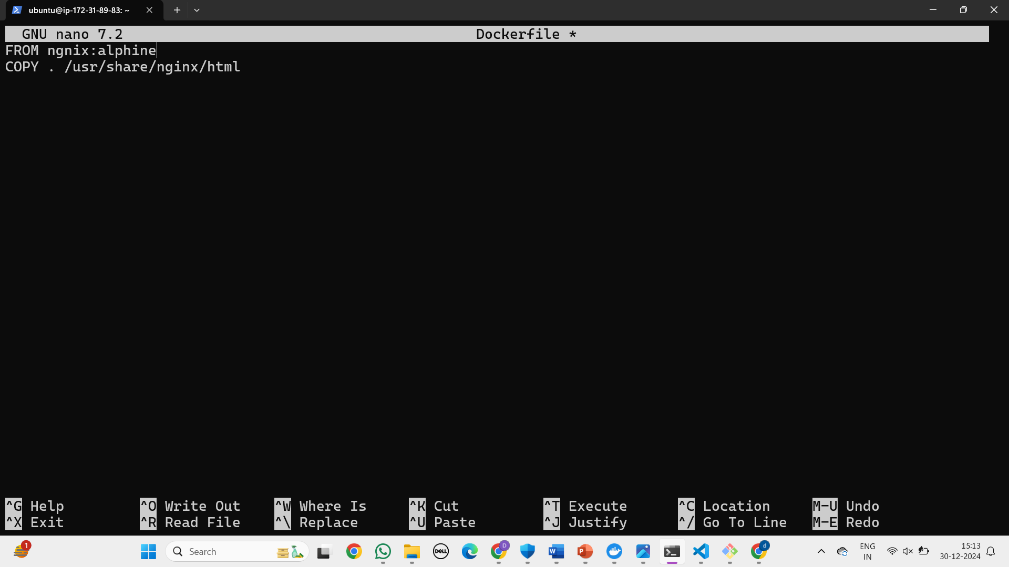  
  
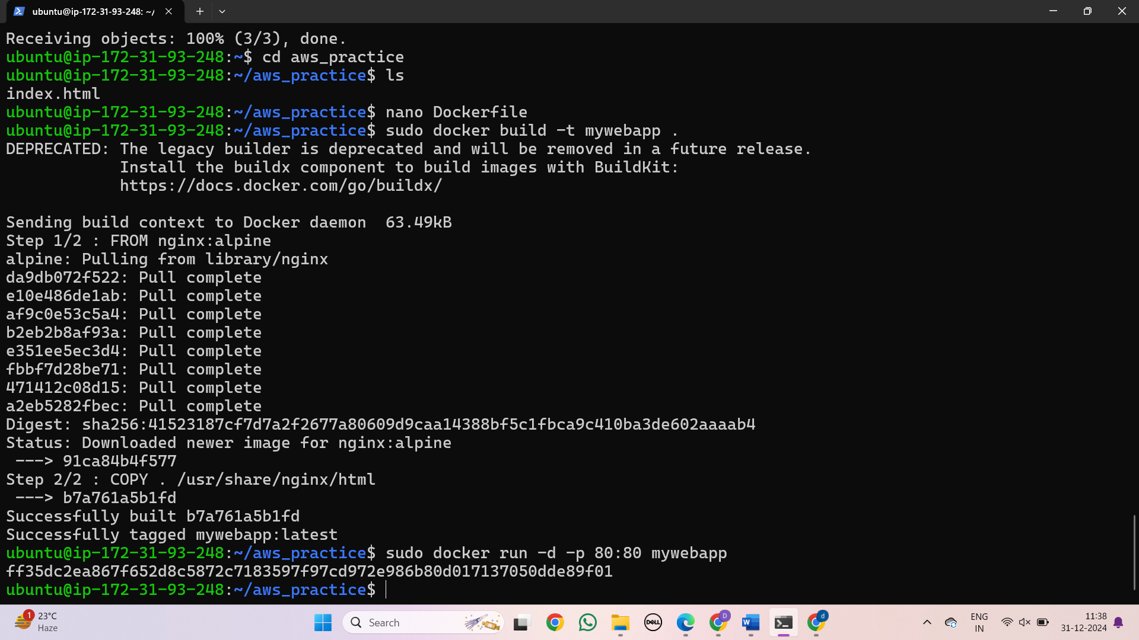  
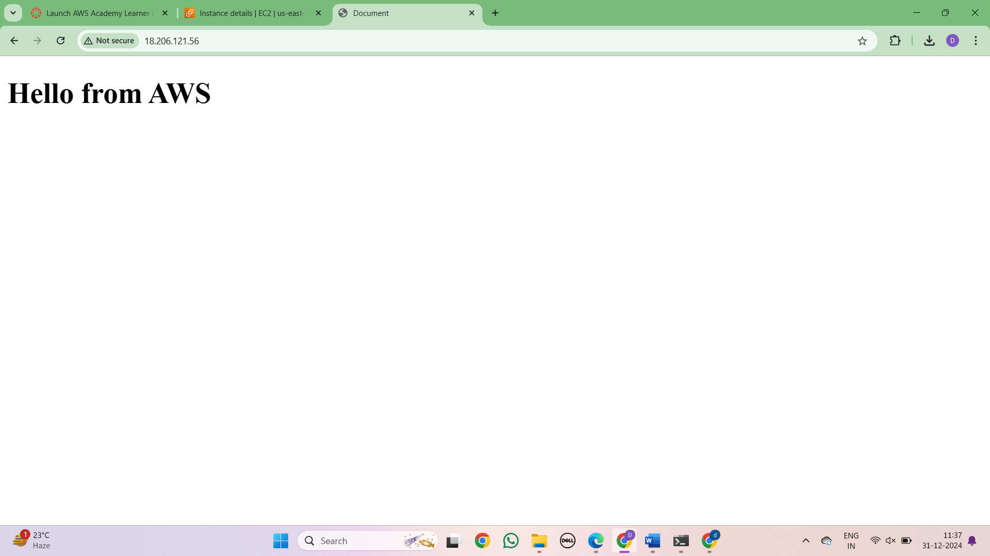

C. MAVEN WEB PROJECT DEPLOYMENT IN THE AWS CLOUD USING EC2 INSTANCE  
**MAVEN WEB PROJECT DEPLOYMENT IN AWS**

Click onEC2 and click on launch instance

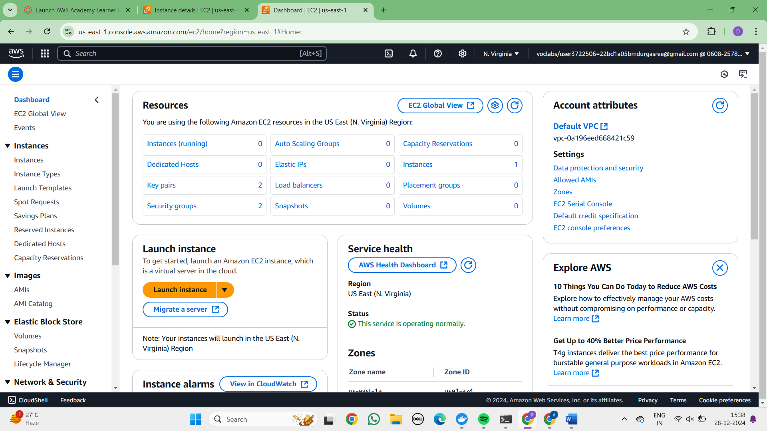Give a name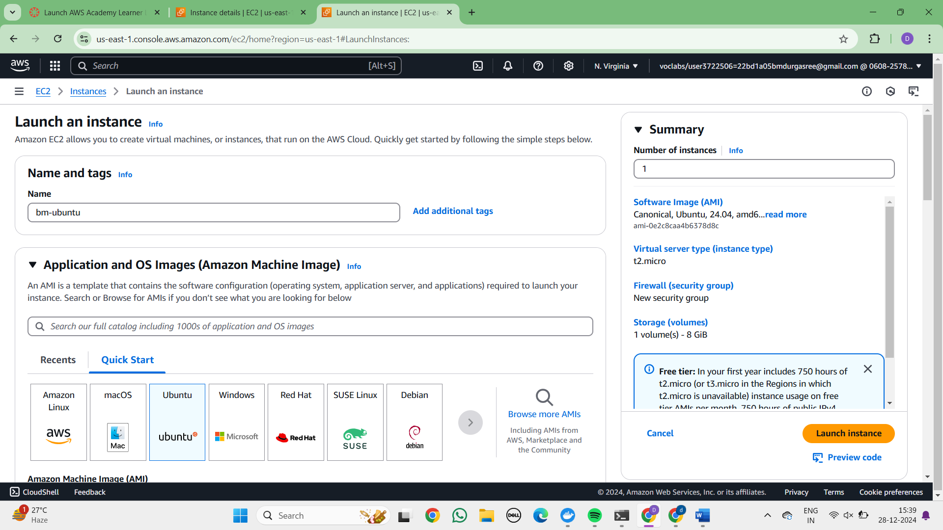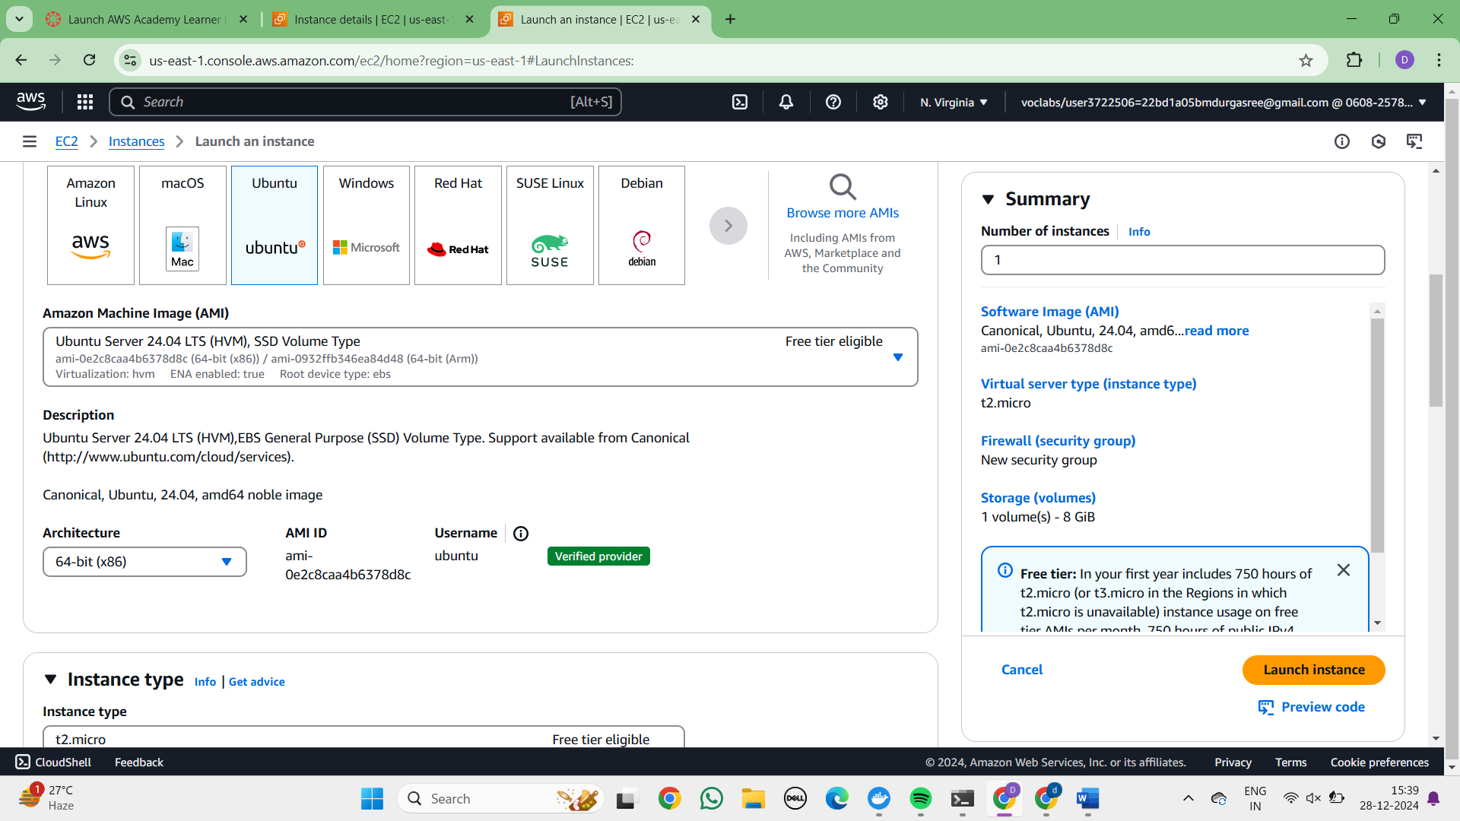  
Create new key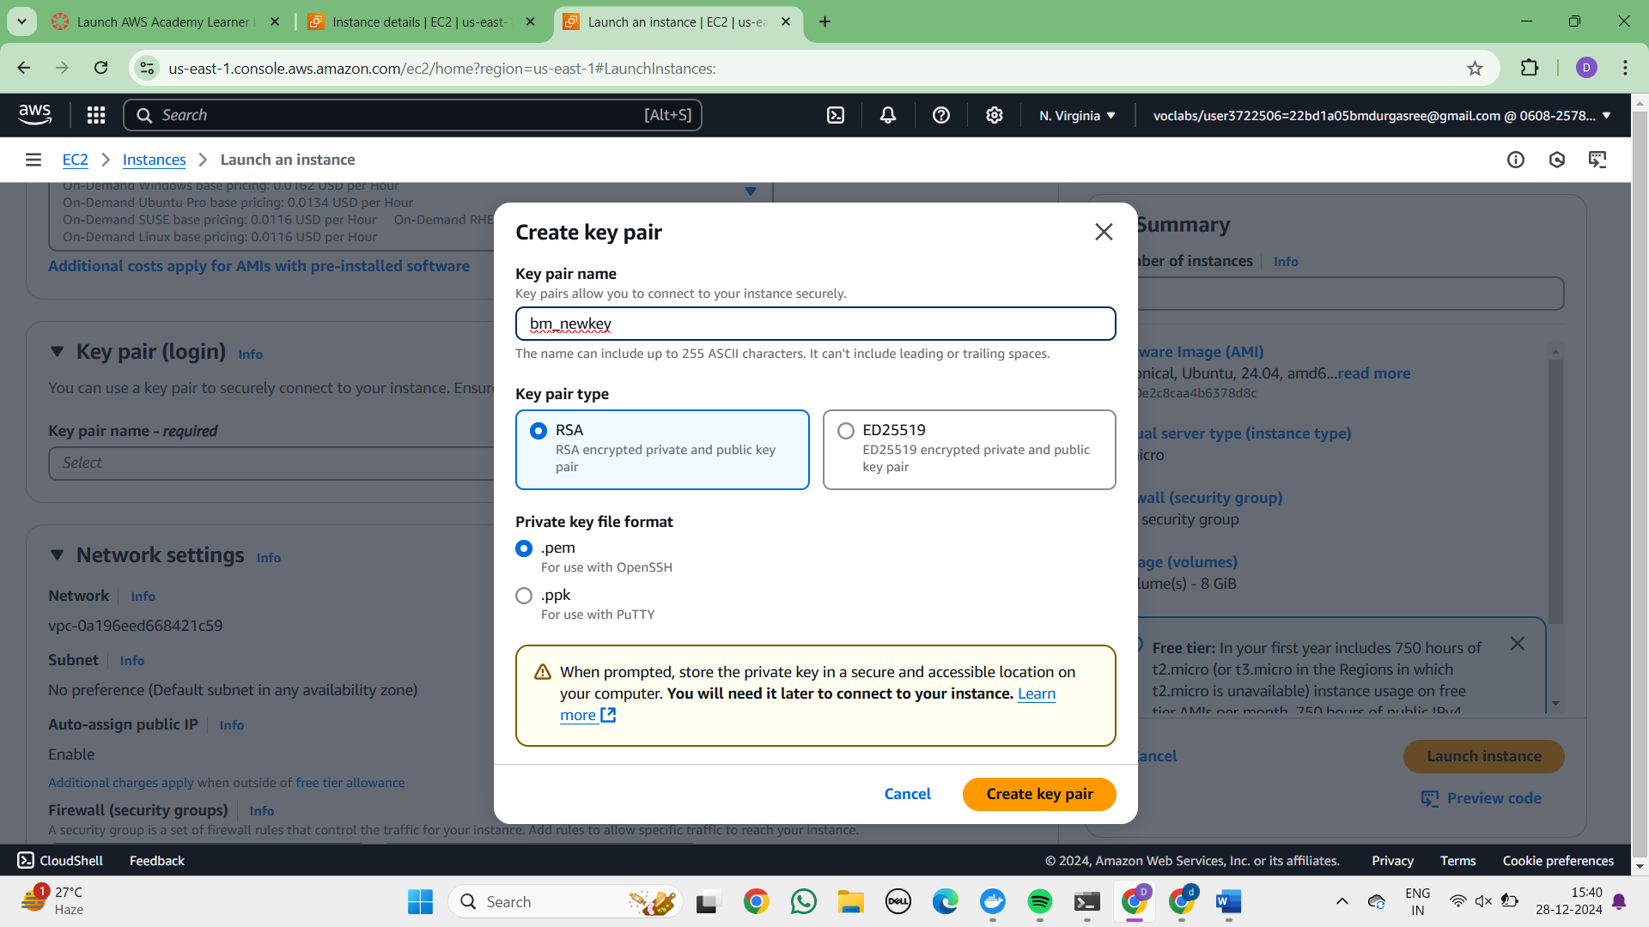

**Check all the boxes under network and click on launch instance**

### 